TRINITY UNITED METHODIST CHURCH
The Rev. Charles Wilbanks ___ Minister
May 23, 2021 Color: Red
PENTECOST SUNDAY
"We welcome you to our service this morning and pray that your time with us will be a blessing to you"
THE ORDER FOR WORSHIP
Prelude Mr. Eddie Welborn
The Prelude is a time for silent preparation for worship.
Welcome and Announcements Rev. Charles Wilbanks
The Chiming of the Hour Mr. Eddie Welborn
The Lighting of the Candles
The Processional of the Cross
The Call to Worship Rev. Charles Wilbanks
Opening Prayer Rev. Charles Wilbanks
The Children’s Time Rev. Charles Wilbanks
The Hymn of Adoration: “This Is My Father’s World” Page 144
*Responsive Reading: Psalm 104:1-13 Page 826
*The Apostles Creed Page 881
*The Gloria Patri: “Glory Be to the Father”
Prayer Concerns and Praises Mr. Grady Senn
The Pastoral Prayer/The Lord’s Prayer Rev. Charles Wilbanks
Tithes and Offering Ushers / Mr. Grady Senn
*The Doxology: “Praise God From Whom All Blessings Flow”
*The Hymn of Preparation: “Spirit Song” Page 347
First Reading: Acts 2:1-21 Rev. Charles Wilbanks
Second Reading: Romans 8:22-27 Mr. Grady Senn
*Gospel: John 15:26-27, 16:4b-15 Rev. Charles Wilbanks
Transitional Music
The Sermon: Happy Birthday! Rev. Charles Wilbanks
*The Hymn of Service: “My Hope is Built” Page 368
*The Returning of the Light

*The Benediction Rev. Charles Wilbanks

*Three-Fold Amen Mr. Eddie Welborn
*The Postlude Mr. Eddie Welborn
*All who are able stand. The altar is open for prayer during the last hymn.
Technician: Miss Caroline Senn

The Altar Flowers are to the Glory of God.

Next Sunday – May 30

Altar Flowers: Open; Technician: Josh Pitts

Our Faithfulness
Live Streaming, May 9: 71
Live Streaming, May 16: 96
Worship Attendance for May 16, 2021: 54
Total Budget for 2021: $ 149,647.00
Weekly Offering Needed: $ 2,877.83
Offering Received May 9, 2021: $ 2,589.50
Offering Received May 16, 2021: $ 1,302.00
2021 Average Weekly Offering YTD: $ 2,343.00
Epworth Donations on May 9, 2021: $ 447.00
Epworth Donations on May 16, 2021: $ 230.00
2021 Epworth Total Donations: $ 677.00

The Concerns of Trinity
Our Known Hospitalized:
Recent Hospitalizations and/or Surgeries:
Nursing Home:
Continued Prayers: Jane and Robert Pollard, James and Jeanette Poag, Cheryl Longshore, Shirley Berry, Jim Waldrop, Gloria Brehmer, Rebecca Bundrick,, Alice and John Longshore, Frieda Kesler, Beverly Pitts, Joan Morris, Wayne Black

Family and Friends of Trinity: Blake Hendrix, Jennie O’Shields. Phillip Sanders, Richard Douglas, Wilson Bowles, Charlotte Berry, Sal Welborn, Harriett Connelly, Merle Singleton Reynolds, Megan Wainwright

JOIN THE CHOIR!
The Bishop has authorized churches to assemble choirs again.
If you would like to add your voice to the Voices of Trinity,
please let Jane Pollard or the Pastor know.
Help us to make a Joyful Noise to the Lord!

UPDATE!
Trinity UMC’s weekly bulletin and bi-monthly newsletter, Trinity Times,
can be found on our website. You may access this information by visiting
www.trinityumcnewberry.net. Visit our website frequently
for updated information.

If you would like to place flowers in the church, please leave
Peggy Bogart, secretary, a note to that effect.

WELCOME VISITORS

Thank you for coming today! We are delighted you are here! We hope
you will join us again as we continue to discover the difference God’s love makes in our lives. If you have questions or desire to become a member of Trinity UMC, please speak to pastor. We’re blessed because you’re here.

Trinity United Methodist Church Please visit our website:
1160 Trinity Church Road www.trinityumcnewberry.net
Newberry, SC 29108
Rev. Charles Wilbanks, Pastor
803-276-1245 (Church Office)
803-768-7687 (Church’s cellphone)
803-206-4623 (Pastor’s Cell)
clwilbanks@bellsouth.net

Trinity
United
Methodist
Church

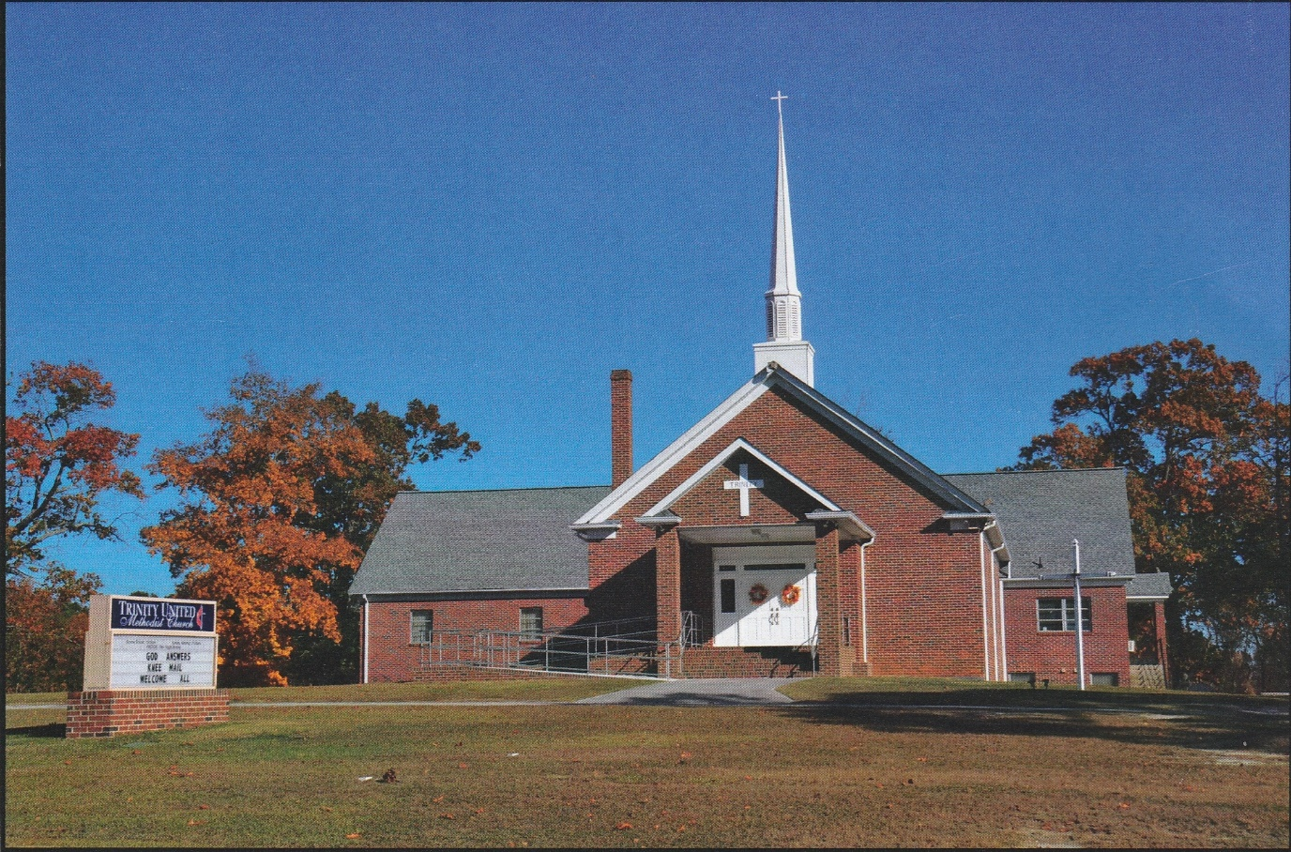

1160 Trinity Church Road
Newberry, SC 29108
Trinityumcnewberry@gmail.com

