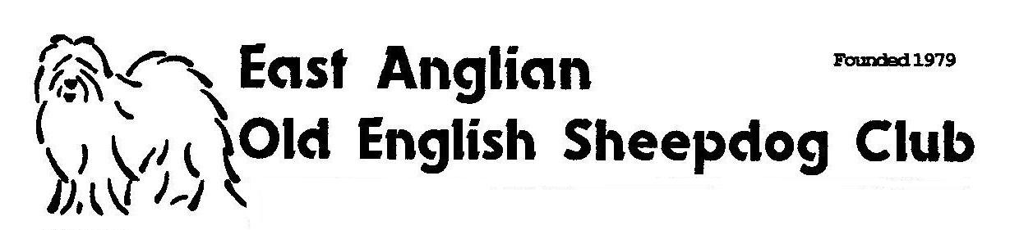

Secretary
Mrs V Burns
Sunnyend cottage
Brockford Green
Wetheringsett
Suffolk. IP14 5NJ

Membership renewal for 2016/17

As we approach our AGM may I remind you that your membership is due for renewal. The membership year is from 1st November 2016 to 31st October 2017.
Please return the completed form, with the appropriate fee to me at the above address.
Payment by cheque or postal order only please made out to the East Anglian OESDC

Name………………………………………………………………………………

Address……………………………………………………………………………

……………………………………………………………………………………

Post Code……………………………. Telephone………………………………

Email……………………………………………………………………………..

Please note the membership rates are as follows.
Please tick the appropriate box

Single membership £7.00 per year

Joint membership £8.00 per year

Junior membership £3.00 per year
-up to 18 years of age
Life Membership - single £50.00

Life Membership – joint £65.00

Overseas £10.00 per year

*Names and addresses will be held on computer for mailing purposes
Please tick if you want your details withheld from our mailing list……….

Why not visit the club website at www.eaoesclub.co.uk

