Beartooth Garage Shirts
Dickies Work Shirt

$40 - up to XL
$42 - for XXL and up

For Shirts mailed individually, please include $6 for shipping
Save some money and do a chapter order for a flat $20 shipping fee

Pricing includes

Circle logo on back
Chapter Name and Nickname on Front Patches

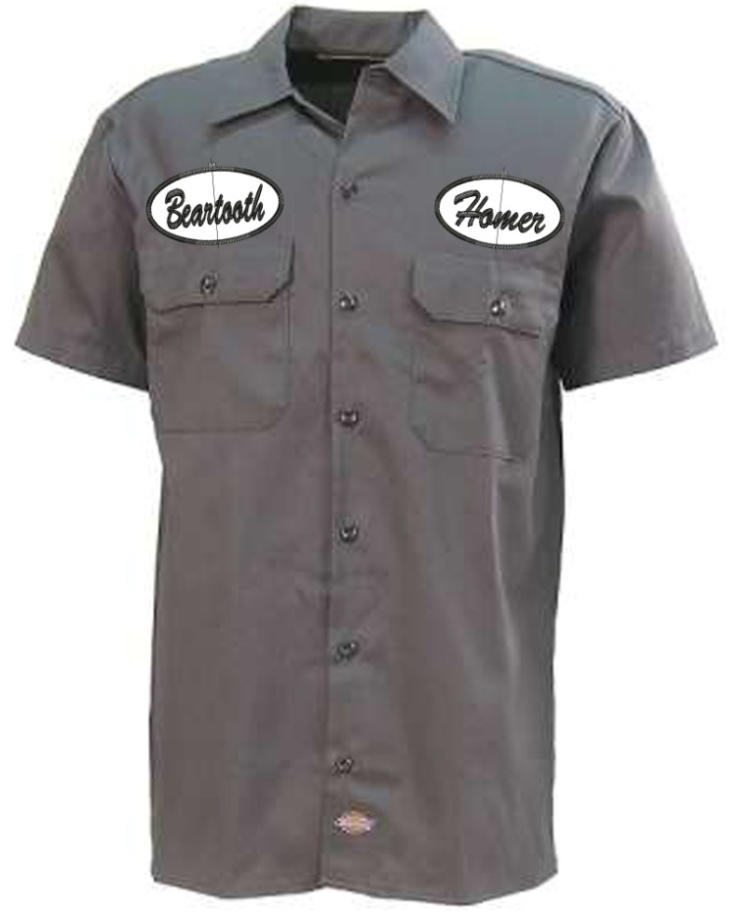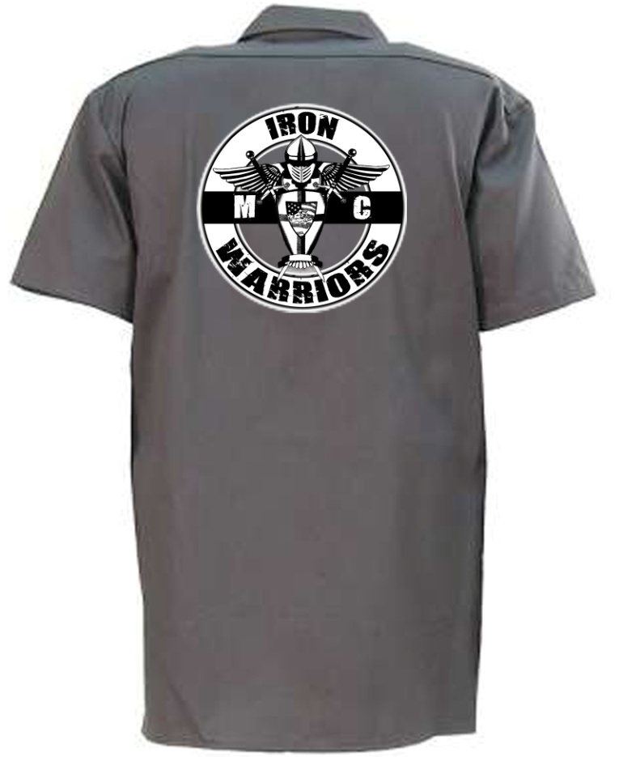

Please send order information to:

Chris "Homer" Simpson
1236 Dublin Street
Billings, MT 59105

Use for Individual or Chapter Order

Name
Street Address
City, State, Zip
Phone
email
IWMC Chapter

SHIRTS
Size | QTY | Cost
S
M
L
XL
XXL
XXXL
4XL
5XL
 | TOTAL

Name Patch  Name | Chapter Patch  Chapter
ie. Mr. Clean | ie. River City

