LEGO

HEAD STEWARDESS: Tracey & Neil Smith

ENTRY: $2.
Display only – Free
Entries close the Wednesday before the Show – Deliver exhibits to Nathalia Showgrounds Multipurpose rooms between 9am-12 noon Friday 30th Sep. Judging to commence Friday at 1pm

Prizes: Classes 1, 2 & 3: 1st LEGO sets Sponsored by Neil & Tracey Smith, Nathalia, 2nd $10. Class 4: Certificate. Class 5: 1st $100, 2ND $50, 3rd $20. With thanks to our generous anonymous sponsor for helping bring LEGO to Nathalia & also contributing toward these cash prizes & Lego sets.
- Collect entries: After 3.30pm Sat or Sunday between 10am and 11 am
- Exhibit ticket must be firmly attached to entry – no names or identifying marks are accepted
- Must be genuine LEGO
- Theme for all classes is ‘Wonderful World of LEGO, celebrating 90 years of LEGO’ (open to build anything).
- Exhibits to be displayed on a base plate no larger than 32 x 32cm for classes 1-3

Classes:
- Junior LEGO 5-8 years (on 32x32cm base plate)
- Junior LEGO 9-12 years (on 32x32cm base plate)
- Advanced LEGO 13 years and over (on 32x32cm base plate)
- Best School Display. No size restrictions.
- Best Display by an AFOL (Adult Fan of Lego). No size restrictions.

Neil & Tracey Smith. Ph 0405513001 / honeyhaloney@hotmail.com for more information

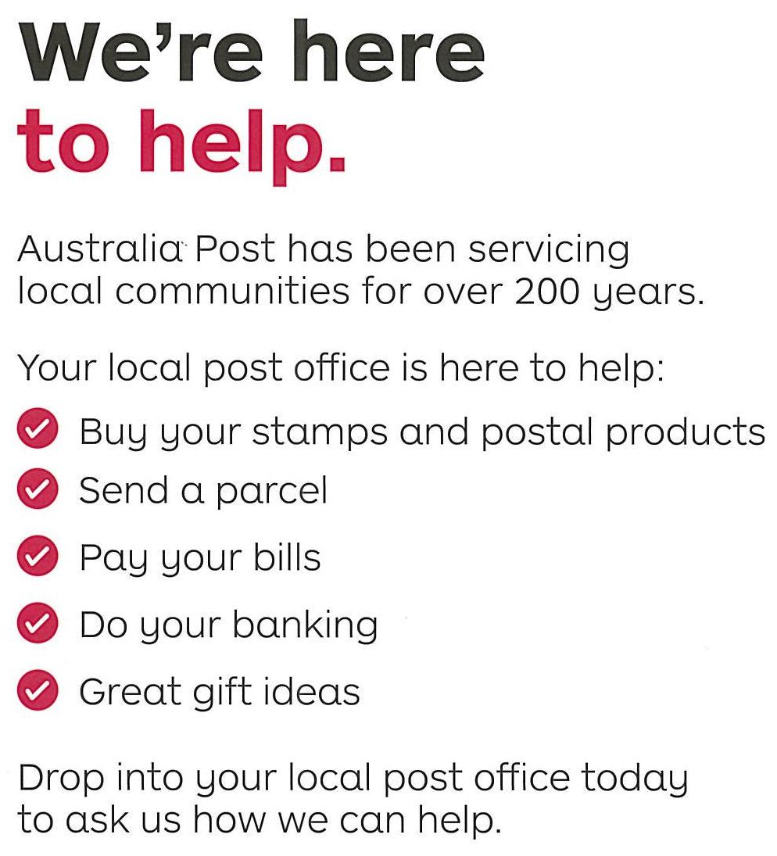
NATHALIA POST OFFICE
Official Lotto Agent

