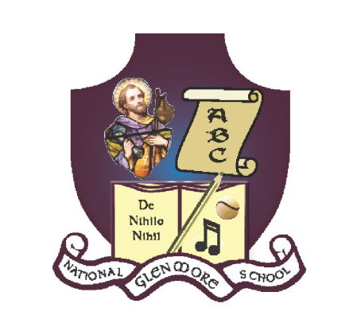
GLENMORE NATIONAL SCHOOL
S.N. SEAMUS NAOFA
GLENMORE, CO. KILKENNY

051-880269 glenmorens@gmail.com www.glenmorenationalschool.com

Glenmore National School
ANNUAL ADMISSION NOTICE
in respect of admissions to the 2021-2022 school year

Admission Policy and Application Form
A copy of the school’s Admission Policy and the Application Form for Admission for the [insert school year] is available as follows: –
To download at: www.glenmorens@gmail.com
On request: By emailing: glenmorens@gmail.com or writing to: Glenmore National School, Glenmore, Co. Kilkenny

PART 1 - Admissions to the 2021-2022 school year

Application and Decision Dates for admission to 2021-2022
The following are the dates applicable for admission to Junior Infants

The school will commence accepting applications for admission on | October 2nd 2020
The school shall cease accepting applications for admission on | April 1st 2020
The date by which applicants will be notified of the decision on their application is | April 20th 2020
The period within which applicants must confirm acceptance of an offer of admission is | Within 2 weeks of offer

*Failure to accept an offer within the prescribed period above may result in the offer being withdrawn

Note: the school will consider and issue decisions on late applications in accordance with the school’s admission policy.

Number of places being made available in 2021-2022

The number of places being made available in junior infants is | 20

PART 2 - Admissions to the 2020-2021 school year
Information regarding the admission process for the Intake Group for Junior Infants

In respect of 2020-2021 school year, the total number of applications for admission received by the school was____(yet to be completed)___________
Breakdown of places allocated for the 2020-2021 school year:
Number of places available: | N/A
Number of applications received: | N/A
Number of Offers made and accepted under each criteria: | A description of each criterion used and the number of places offered and accepted under that criterion must be entered here.  Example, as follows:  Criterion One: Applicants living in the catchment area – 40 places offered, 38 places accepted.  Criterion Two: Applicants with siblings attending the school – 20 places offered, 20 places accepted.
Total number of offers made | N/A
Number of names placed on waiting list for the school year concerned. | N/A

Note:
This notice must be published at least 1 week before the school can accept applications for admission.
This notice must be published on the school’s website and must remain there for the duration of the school year.
This notice must also be made available on written request.

