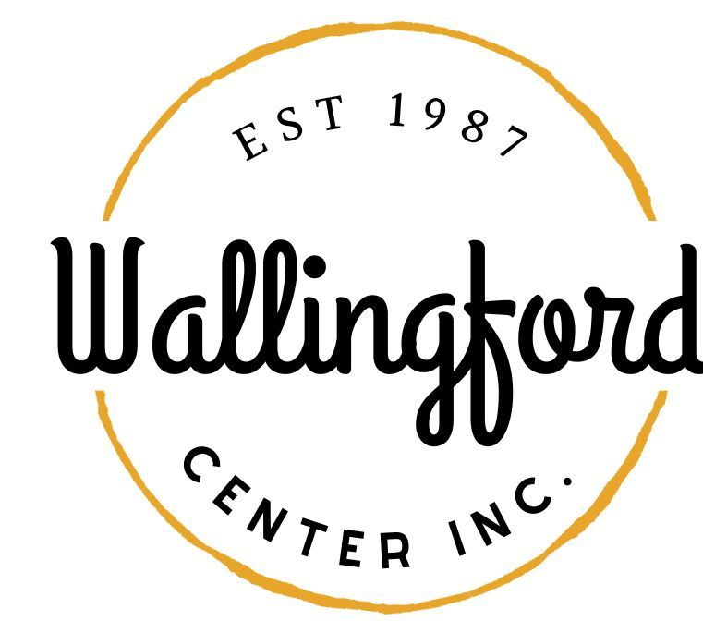
Regular Meeting
Tuesday, March 7, 2023
Wallingford Hubcap
128 Center Street Wallingford, Ct 06492
5:30pm in person

- Call to Order
  - Appointment of Temporary Secretary
  - Appointment of Alternates
  - Training
- Approval of Minutes
  - Regular Meeting Tuesday, February 7, 2023, and Special Meeting Thursday, February 23, 2023
- Public Comment - Comments are asked to be limited to 2 minutes
- Treasurer Report
- Follow up from last meeting (Liz Davis)
  - Progress on the Hop Checklist
  - Progress on Celebrate
  - Progress on social media contractor
- New Items
  - Landscaper quotes
  - June fundraiser - Wing Fest June 21, 2023
  - Façade Update and Budget
  - Streetscape Update and Budget
  - April Meeting Invitees
  - CT Main Street Assessment
- Communications
  - Executive Director Report
- Report from other committees
  - Hubcap
  - Downtown Collaborative
  - Other committees
- Adjournment

