Equine Haven Recovery Care and Equestrian Centre Ltd
HoHoHo-liday Horse Show
Simple Jumpers and Jumpers Dec. 3rd-5th, 2021 Indoors

Ribbons to 6th place; Prize Money to 5th place.
Champion and Reserve Champion in Each Division
Entries Limited to 50 Riders/Day
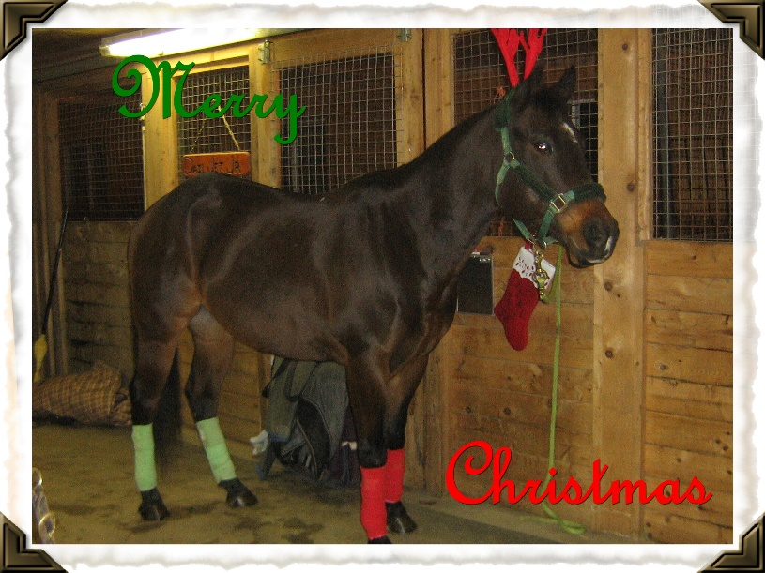
Course Designer: Crystal Turko
Judge: Sadie Turko
General Inquiries and Entry Forms: info@equinehaven.ca
Entry Forms can be found at www.equinehaven.ca
E-transfers for entry fees can be sent to sadie.turko@equinehaven.ca
Closing Date: November 27th, 2021

EQUINE HAVEN HO HO HO HOLIDAY HORSE SHOW
DECEMBER 3 - 5, 2021, ClOSING DATE NOV 27, 2021 INDOORS
SCHOOLING FRIDAY FROM 9AM TO 9PM
Ribbons to 6th. Champion and Reserve will be awarded for each division. DIVISION 3, 4, 5, 6 ARE HELD OVER BOTH DAYS. $35 Office Fee. $15 Paramedic Fee. SAVE $10.00 BY ENTERING FULL DIVISION $15 CLEAR ROUNDS (TREATS FOR YOU OR YOUR HORSE FOR CLEAR ROUNDS) $25 per Jumper class. $40 per Jumper Add Back Stake class ($15 from each entry will be added back as prize money: 1st - 30%, 2nd - 25%, 3rd - 20%, 4th - 15%, 5th - 10%).

SATURDAY
DIVISION 1: 1’ CROSS RAILS. $95
- CLEAR ROUND
- MATCH THE CLOCK
- MATCH THE CLOCK
- JUMPER EQUITATION ADD BACK STAKE
DIVISION 2: .5M SIMPLE JUMPERS (VERTICALS) $95
- CLEAR ROUND
- MATCH THE CLOCK
- MATCH THE CLOCK
- JUMPER EQUITATION ADD BACK STAKE
DIVISION 3: .6M SIMPLE JUMPERS (VERTICLES) $150
- CLEAR ROUND
- MATCH THE CLOCK
- JUMPER EQUITATION ADD BACK STAKE
DIVISION 4: .7M SIMPLE JUMPERS $150
15. CLEAR ROUND
16. MATCH THE CLOCK
17. JUMPER EQUITATION ADD BACK STAKE
DIVISION 5: .8M SIMPLE JUMPERS $150
21. CLEAR ROUND
22. MATCH THE CLOCK
23. JUMPER EQUITATION (2 ROUNDS)
DIVISION 6: .9 SIMPLE JUMPERS $150
27. CLEAR ROUND
28. MATCH THE CLOCK
29. JUMPER EQUITATION (2 ROUNDS)

SUNDAY
DIVISION 3: .6 M JUMPERS (VERTICLES)
- CLEAR ROUND
13. TABLE A 2.1 SPEED
14. TABLE A 2.2 JUMP OFF ADD BACK
DIVISION 4: .7 M JUMPERS
18. CLEAR ROUND
19. TABLE A 2.1 SPEED
20. TABLE A 2.2 ADD BACK STAKE
DIVISION 5: .8M JUMPERS
24. CLEAR ROUND
25. TABLE A 2.1 SPEED
26. TABLE A 2.2 JUMP OFF ADD BACK STAKE
DIVISION 6: .9M JUMPERS
30. CLEAR ROUND
31. TABLE A 2.1 SPEED 32. TABLE A 2.2 JUMP, OFF ADD BACK STAKE
INDIVIDUAL FUN CLASSES ADD BACK $40 EACH 33. .85M GAMBLERS CHOICE
34. 1M GAMBLERS CHOICE
DIVISION 7: 1M JUMPERS $95
35. CLEAR ROUND 36. TABLE A 2.1 SPEED
37. ACCUMULATOR 38. TABLE A 2.2 JUMP OFF ADD BACK STAKE
DIVISION 8: 1.10M JUMPERS $95
39. CLEAR ROUND
40. TABLE 2.1 SPEED
41. ACCUMULATOR
42. TABLE A 2.2 JUMP OFF ADD BACK STAKE

EQUINE HAVEN HO HO HO HOLIDAY HORSE SHOW ENTRY FORM
DECEMBER 3 - 5, 2021
WAIVER
I understand that I enter the Equine Haven Schooling Show and participate in horse activities at my own risk. I or any person related to me will not hold Equine Haven, owners, partners, staff, volunteers, or paid officials, responsible for any injury or damages to myself, horses, or equipment.
RIDER’S NAME __________________________ SIGNATURE _________________________ DATE ____________,2021
AGE (IF UNDER 18) ______ GUARDIAN’S SIGNATURE ______________________ EMAIL ______________________________
HORSE _________________________ TRAINER ___________________________________ PHONE #_______________ TRAINERS EMAIL ___________________________________STABLE__________________________________________
PLEASE CIRCLE CLASSES ENTERED. SAVE $10.00 BY ENTERING FULL DIVISION.
FEES | _{DIVISION} | _{CLASS $15} | _{CLASS $25} | _{CLASS $25} | _{CLASS $40} | _{CLASS $15} | _{CLASS $25} | _{CLASS $40} | _{TOTAL}
DIVISION 1: CROSS RAILS | $95 | 1 | 2 | 3 | 4
DIVISION 2: .5M JUMPERS | $95 | 5 | 6 | 7 | 8
DIVISION 3: .6M JUMPERS | $150 | 9 | 10 |  | 11 | 12 | 13 | 14
DIVISION 4: .7M JUMPERS | $150 | 15 | 16 |  | 17 | 18 | 19 | 20
DIVISION 5: .8M JUMPERS | $150 | 21 | 22 |  | 23 | 24 | 25 | 26
DIVISION 6: .9M JUMPERS | $150 | 27 | 28 |  | 29 | 30 | 31 | 32
INDIVIDUAL FUN CLASSES |  |  |  |  | 33 |  |  | 34
DIVISION 7: 1M JUMPERS | $95 | 35 | 36 | 37 | 38
DIVISION 8: 1.10M JUMPERS | $95 | 39 | 40 | 41 | 42
FRIDAY SCHOOLING | $25
OFFICE FEE $35.00 |  |  |  |  |  |  |  |  | $ 35.00
PARAMEDIC FEE $15.00 |  |  |  |  |  |  |  |  | $ 15.00
DAY STALL $35.00 PLEASE CIRCLE DAY(S): FRI, SAT, SUN
WEEKEND STALL $100.00 FRIDAY TO SUNDAY OVERNIGHT
DAY PADDOCK $20.00
OVERNIGHT PADDOCK $40
TOTAL
G.S.T
TOTAL
PRIZE MONEY
COMMENTS:
PLEASE CIRCLE THE CLASS NUMBER ABOVE. SAVE $10.00 BY ENTERING A WHOLE DIVISION OR ENTER CLASSES INDIVIDUALLY. FILL IN THE TOTAL AMOUNT FOR YOUR ENTRIES AND STALL OR PADDOCK FEES.
LIMITED NUMBER OF PADDOCKS AND STALLS (INCLUDES BEDDING) AVAILABLE.
PLEASE CONTACT SADIE AT 250-520-2018 FOR STALL & PADDOCK AVAILABILITY BEFORE ENTERING.
PRIZE MONEY WILL ONLY BE PAID UPON SIGNOUT AT THE SHOW OFFICE
(IF YOU HAVE QUESTIONS, PLEASE CONTACT US at info@equinehaven.ca OR CALL/TEXT 250 520 2018(Sadie)/403-973-9693 (Heidi)). PLEASE E-MAIL ENTRIES AND E-TRANSFERS TO info@equinehaven.ca
Show Details
ADMINISTRATION: Equine Haven Ltd reserves the right to cancel or combine any given classes that do not fill to their satisfaction. All exhibitors in cancelled classes will be notified by either email or telephone (if number is provided on entry form) and any entry fees refunded. No advanced notification will be given for combined classes.

ADMINISTRATION: The HoHoHo-liday Horse Show hosted by Equine Haven Ltd is open to all riders; however, we reserved the right to refuse any entry, to make changes to arena classes run in, judges, or class order to best facilitate the running of the show. We also reserve the right to start each division up to 30 minutes earlier than the posted schedule if number of entries permit.

SAFETY: The judge reserves the right to eliminate any horse/rider combination that exhibits excessive speed, abuse to the horse, unsafe or unsportsmanlike behaviour, or lack of control, with no refund of fees.

ENTRY FORMS: Please fill out one entry form per horse/rider combination.

CANCELLATION POLICY: Cancellation before closing date of entries will receive a full refund. Cancellation after closing date but before the start of the horse show will receive a refund less the office fee. Cancellation after the start of the horse show, with proof of Vet Certificate, class fees for remaining classes will be refunded.

ADD/SCRATCHES: There will be no charge for adds/scratches the day before classes for horses already entered. Same day adds/scratches are acceptable but at a $10 charge, in addition to the class fee. Classes scratched the day before will be refunded; however, same day scratches are non-refundable.

LATE FEES: Entries received after the closing date for the show will pay a post entry fee of $20. Horses showing in a class without being entered will pay DOUBLE the class fee.

OPEN SCHOOLING/WARM-UP: Open schooling will be held on Friday, Dec 3rd and can be booked from 9am to 9pm (last schooling available to start at 9pm). Coaches may book schooling times for their students. A maximum of 6 riders allowed in the ring at any one time. Time allotment for schooling is based on number of riders per block. Cost is $25/rider. Warm ups will be held in the indoor arena prior to the commencement of each group of riders.

ACCOMODATIONS: Limited stalls available for the weekend. Day stalls are available for a fee of $35/day, overnight stalls are $100 for the weekend. Bedding is included. Stalls are limited and priority will be assigned in the order entry forms are received.

HAUL INS: Trailering in is welcome for no additional fee; however, all horses and riders must be entered in the show and be assigned a number. Space for RVs will be made available on request. There will be no service hookups.

REFUSALS: Riders with two refusals will not be buzzed out of the ring. The top pole of the fence refused twice will be dropped to the ground and the rider will be allowed to continue to the conclusion of the course. Riders with 2 or more refusals will be placed last, but not eliminated.

PROTECTIVE HEADGEAR: All competitors must wear proper fitting and approve headgear, with safety harness correctly secured, at all times while mounted on the event grounds. Helmets must meet ASTM standards and display the SEI seal. The British standard BSI is also acceptable. Any rider found violating this rule will be prohibited from further riding on event grounds until a helmet is properly in place.
DOGS: No dogs are permitted on the event grounds.

ADD BACK STAKES: $15 from each entry will be added back as prize money. Distribution of prize money will be done according to the following: 1st – 30%; 2nd - $25%; 3rd – 20%; 4th – 15%, and 5th – 10%. Prize money will only be paid upon sign out at the show office.

CONCESSIONS: Concessions will be available for sale on site.

SEATING: Please bring your own chairs for viewing ring.

SIMPLE JUMPERS: The simple jumpers divisions are designed as an introduction to jumpers for riders wanting to explore jumper classes, and fences over simpler courses. This division will be run over hunter, hunter equitation, and handy hunter style courses. There will be no speed classes or jump offs on theSaturday. In the 0.8m and 0.9m divisions the equitation class’s top 6 will come back for a second non jump off scored round. Second round will be posted prior to the start of the class.

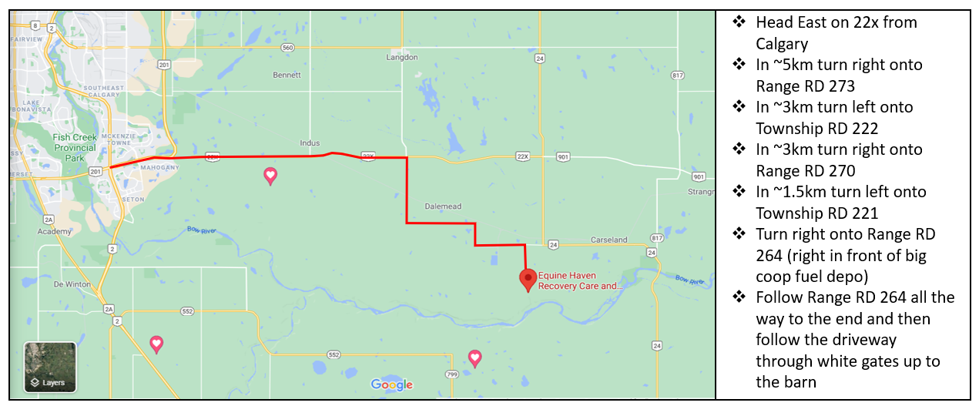
NOTE: Please DO NOT try to use google maps to find us. It will not take you to the right location. Apple maps will if you have an iphone. Please contact Heidi at 403-973-9693 if you require help with directions.

