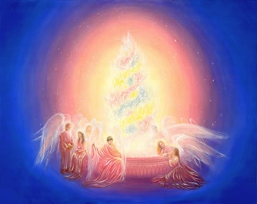

Self Attuning Manual
Just Read Activate

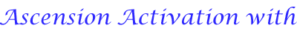
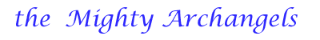
We call forth Beloved Archangels Michael and Faith and we ask for a Downpouring of their Loving energies of protection ~ with help from their legions of angels
We call forth Beloved Archangels Jophiel and Christine and we
Lovingly request the ascension energies of illumination and
Wisdom
We call forth Beloved Archangels Chamuel and Charity and we
Lovingly request the ascension energies of love, tolerance, and
Gratitude
We call forth Beloved Archangels Gabriel and Hope and we
Lovingly request the ascension energies of resurrection and
Purity
We call forth Beloved Archangels Raphael and Mother Mary
And we lovingly request the ascension energies of truth and
Concentration
We call forth Beloved Archangels Uriel and Aurora and we
Lovingly request the ascension energies of peace and devotion
We call forth Beloved Archangels Zadkiel and Amethyst and we
Call forth the ascension energies of culture, refinement, and diplomacy, ordered service and ascension itself
We call forth His Holiness Beloved Archangel Metatron and the
Combined forces of all the Archangels and we lovingly request
An ascension acceleration the likes of which we have never
Received before
We request Beloved Archangels will you remain with us and work with us on a full-time basis until we complete our ascensions
And the seven levels of initiation
We request Light quotient building and anchoring of our higher
Chakras and your twelve strands of DNA
We call forth Beloved Archangels Faith ~ Christine ~ Charity ~
Hope ~ Mother Mary ~ Aurora ~ and Amethyst we lovingly
Request a balancing of our four –bodies and their systems and we
Also request that a pink rose appear in our hearts ~ We call forth a
Balancing of the feminine and masculine energies within
We call forth and lovingly request our ascension angels to help us
In these activations and openings
We lovingly call forth a rain of blessings from the seraphim ~
Cherubim ~ Thrones ~ Dominions ~ Virtues ~ Powers ~
Principalities ~ Archangels and Angels for our ascension in the
Light for our ascension group and all of humanity and the Earth
Herself ~ God speed all our ascensions in the light ~ SO BE IT
We call forth the radiance of all seven rays and the combined
Full power of all the Seven Ray Masters and the Seven Ray
Archangels to shine through our third eye centers and connect
The force of the Rainbow Bridge into the Light of our ascension ~
Columns through all chakras and to our Monads and all the way
Back to source ~ And So It Is Done
We call forth to all Archangels and Angels and Ascended Masters
And we request that Mother Earth also receive the beloved gifts
Of these activation’s and meditations ~ So Be It
We also request that all the kingdoms of Mother Earth receive all
The beloved gifts of these activation’s to ~ So Be It
We call forth a Rain of Blessings from Goddess and God to all
Beings here on Earth ~ So Be It
We lovingly request a Rain of Blessings to all beings that are on
The path of ascension send forth the blessings of this activation’s
To all brothers and sisters on the path ~ So Be It
We loving ask for any and all assitance in our ascensions ~ from
All the Planetary and Cosmic Masters of The Light ~ We call you
Forth to send your Rain of Blessings to our lives and to our
Ascension group ~ And So it Is Done
Founder: Dr. Joshua David Stone Ph D



This above Activation is taken from Dr Joshua David Stone,Ph.D Amazing books by Light Technology Publishing
Please visit his website at: http://www.drjoshuadavidstone .com
Dr Joshua David Stones : Address is: 28951 Malibu Rancho Rd
Agoura , California 91301 USA
You can write to him for a free information package at the address above
Or you can Email at : drstone @best.com : or look at your local
New Age bookshop they are bound to have Dr Stones books , and your
Life will be blessed by reading them Love & Light to All

