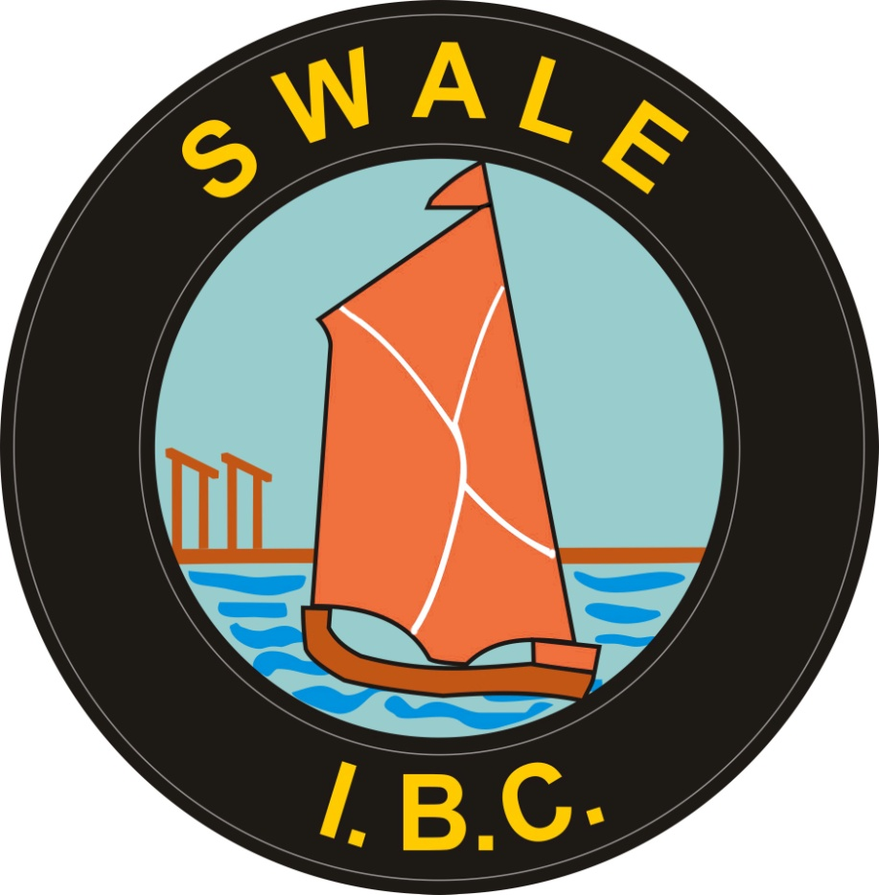SWALE INDOOR BOWLING CENTRE

Safeguarding pOLICY DOCUMENT

# Document Version Control

**Version:**

|  |  |
| --- | --- |
| **First Approved on:** | March 2017 |
| **Last reviewed on:** | May 2018 |
| **Date of next review:** | May 2019 |

**Review History**

|  |  |
| --- | --- |
| **Date of Review** | **Comments** |
| March 2017 | Version 1 reviewed and approved for use |
| May 2019 | Club Safeguarding Officer changed to Safeguarding Officer |
|  |  |
|  |  |
|  |  |
|  |  |

**Revision History**

|  |  |  |
| --- | --- | --- |
| **Version** | **Change Log** | **Date** |
| 1 | Reviewed and updated | 16 May 2018 |
| 2 |  |  |
| 3 |  |  |
| 4 |  |  |
| 5 |  |  |

**INDEX**

**Item Page**

Key abbreviations 4

Introduction 5

Principles 6

Coaches 6

Safe Recruitment 7

Implementation of the Guidelines 7

Training 8

Dealing with Concerns and Allegations 8

Definition of Abuse (Children) 9

Definition of Abuse (Adults) 10

Responding to concerns about a child 11

Step by Step Guide 14

Flowcharts 16 - 25

Whistle-Blowing 21

Disciplinary Procedures 21

Investigating Complaints 21

Records and Information 22

Rules for Information Sharing 23

# Key abbreviations found in this document

BDA Bowls Development Alliance

BE Bowls England

CPSU Child Protection in Sport Unit

CSC Children’s Social Care (formerly known as Social Services)

CSP County Sports Partnership

DBS Disclosure & Barring Service (formally known as CRB)

EBF English Bowls Federation

EIBA English Indoor Bowling Association Ltd

LSCB Local Safeguarding Children’s Board

NGB National Governing Body

NSPCC National Society for the Prevention of Cruelty to Children

**Safeguarding Bowls**

**Introduction**

The Bowls Development Alliance is the umbrella organisation for the development of the sport of bowls, working with all the National Governing Bodies of bowls to ensure a safe environment for young people and adults at risk to enjoy playing bowls.

All partners are committed to ensuring that support is available to all clubs to assist them with ensuring policies are in place and resources are available to ensure that safe environment.

Other codes of bowls will be encouraged to follow the same processes and endorse these in all their clubs.

Everyone in bowls has a part to play in safeguarding young people and adults at risk. This policy includes guidelines for all those involved in the sport of bowls to ensure that everyone is aware of the structures and systems in place to make bowls an enjoyable and safe experience, and to respond to any concerns that may emerge.

**The Children Acts 1989 and 2004** and **Working Together to Safeguard Children** (DOH 2015) highlight the shared responsibility of organisations to promote children’s wellbeing and safeguard them from harm. This includes the entire bowls structure from clubs to National Governing Bodies.

The Government guidance **‘No Secrets’**, published in 2000, sets out a code of practice for the protection of adults at risk: The **Care Act (2014),** which came into force from April 2015, sets out for the first time a legal framework for safeguarding adults.

**Mental Health Act 1983/2007**

**Human Rights Act 1998, the Mental Capacity Act 2005/Deprivation of Liberty 2009**

**Care Standards Act 2000**

**Safeguarding Vulnerable Groups Act** **2006**

There is no one specific piece of legislation in place designed to protect adults at risk from harm (e.g. nothing comparable to the Children Act 1989)

It is not possible to eliminate all risks but it is important that those in bowls with a specific responsibility for junior players, adults at risk or members can demonstrate that they have assessed the risks and taken all steps to minimise them.

To fulfil their commitment to safeguard and promote the welfare of children and adults at risk, all organisations that provide services for, or work with, children and adults at risk must have:

* a clear line of accountability for the provision of services designed to safeguard and promote the welfare of children and adults at risk.
* a senior board level lead to take leadership responsibility for the organisation’s safeguarding arrangements;
* a culture of listening to children and adults at risk and taking account of their wishes and feelings, both in individual decisions and the development of services;
* clear whistleblowing procedures which are suitably referenced in staff training and codes of conduct, and a culture that enables issues about safeguarding and promoting the welfare of children and adults at risk to be addressed.
* clear information sharing arrangements which set out the processes for sharing information, with other professionals and with the Local Safeguarding Children Board’s (LSCB);
* NGB Safeguarding Officer
* safe recruitment practices for individuals whom the organisation will permit to work regularly with children and adults at risk, including policies on when to obtain a criminal record check;
* appropriate supervision and support for staff, including undertaking safeguarding training:
* clear policies in line with those from the LSCB for dealing with allegations against people who work with children

**Principles**

A child’s welfare is paramount (a child is defined as any young person under the age of 18 years). An adult at risk is a person aged 18 or over who ‘is or may be in need of community care services by reason of mental or other disability, age or illness; and who is or may be unable to take care of him or herself, or unable to protect him or herself against significant harm or exploitation'

All young people and adults at risk regardless of age, disability, racial origin, religious belief, gender, sexual identity and social background have a right to enjoy sport free from all forms of abuse or poor practice.

The National Governing Bodies of Bowls, affiliated County Associations and bowls clubs have responsibilities for the welfare of children and adults at risk who take part in their sport.

**Coaches**

Coaches have a very important part to play in protecting children and adults at risk from potential harm and are often the first to recognise and raise concerns.

It is very important that all coaches read the “Safeguarding Bowls” Policy & the Guidelines document and are aware of the process to follow, to deal with any concerns. They should also ensure that any coaches employed or deployed by them also have knowledge of and abide by these guidelines.

**Good Coaching practice**

Joint guidance was produced by sports coach UK and the Child Protection in Sport Unit in 2010 outlining best practice guidelines for coaches coaching young people’s activities.

It stressed the need for clear ratios for appropriate staffing/supervision ratios of coaches to participants (generally 1:8). This will minimise any risks to participants and enhance the benefits they draw from the activity

Coaches should never be left alone with an individual or group and it is recommended that at least one adult present is the same gender as the bowler or group of bowlers.

The Coach should hold an appropriate qualification, comply with minimum age requirements, have relevant insurance cover, have completed a criminal records disclosure that is acceptable to the NGB (if they are coaching on a regular basis) and have signed up to the following policies:

Code of conduct for coaches

Equality Policy

Safeguarding policy

Health and Safety Policy

**Safe recruitment**

Ensuring that staff and volunteers recruited by the National Governing Bodies are safe to work with children and adults at risk includes several areas as outlined in the” Safe Recruitment Guidelines”, i.e. application process, interview, criminal records checks, references, induction process.

Criminal records checks form one part of this process. The Criminal Records Bureau (CRB) and the Independent Safeguarding Authority (ISA) merged to form the Disclosure and Barring Service (DBS) in December 2012.

The DBS was established under the Protection of Freedoms Act 2012 (‘The Act’) and carries out the functions previously undertaken by the CRB and ISA, and the CRB application form has been replaced with a new DBS application form.

Criminal records checks assist organisations in the public, private and voluntary sectors to make safer recruitment decisions by identifying candidates who may be unsuitable for certain work, especially work that involves children or vulnerable adults.

Each NGB offers a criminal records checking service for all their affiliated members.

**Implementation of the Guidelines**

* + A club pack should be made available to include: Posters to be displayed on notice boards
  + Templates to report concerns
  + Templates for clubs to complete around local contacts in the event of concerns or need for advice
  + Information about relevant procedures
  + Information that can be communicated to parents, children and all club members.

County Associations should support clubs in developing and communicating this information.

Swale Indoor Bowling Centre (SIBC) should complete the “Club Checklist” to help them identify areas of development within the club, with the support of the County and/or National Governing Body

SIBC should communicate relevant information about the Safeguarding in Bowls policy and procedures to all their members.

SIBC must appoint a Club Welfare Officer SIBC to lead on the development of safeguards within the club, respond to any concerns and ensure that their contact details are available to all members. SIBC has appointed a Safeguarding Officer and Assistant Safeguarding Officer to carry out these responsibilities as the Club Welfare Officer is responsible for other duties.

**Training**

It is important that anyone who is involved in Safeguarding should develop their awareness of the subject and it is recommended that they attend training relevant to their role.

**Sports coach UK** – *3hr course (this course is available at a local level, organised by the local County Sport Partnership). Provides a basic understanding and awareness of safeguarding and is ideal for any member including coaches, volunteers and in particular club welfare (safeguarding) officers. Contact details for your nearest County Sport Partnership can be found on* [www.safeguardingbowls.org](http://www.safeguardingbowls.org)

**Safeguarding in Bowls - “Time to Listen” –** *4hr course. This is a bowls-specific workshop designed to support club welfare/safeguarding officers. The workshop uses easy to follow, practical, bowls-related examples and case studies to enable you to fully understand your role in the club, and how you can effectively safeguard young people and adults at risk in your care. The course has been developed by the Child Protection in Sport Unit of the NSPCC but is administered by the Bowls Development Alliance. For more information go to* [www.safeguardingbowls.org](http://www.safeguardingbowls.org)

**Dealing with Concerns and Allegations**

It is not the responsibility of those working in bowls to make judgements as to whether or not abuse is occurring. It is however their responsibility to act on any concerns.

Adults within bowls have a duty of care to respond to inappropriate behaviour, abuse or bullying.

Not all concerns are about child or adults at risk relate to abuse – many relate to poor practice and can be dealt with internally, with the support of the National Governing Body if appropriate.

All information received and discussed must be treated in confidence and only shared with those individuals within the organisation with a designated safeguarding role.

On occasion, it may be necessary to seek advice or inform the statutory agencies e.g. Child/Adult Social Care or the Police.

**Definition of Abuse (Children)**

It is important to be aware of what constitutes abuse. The following definitions are adapted from Working Together to Safeguard Children (2013)

1. **Physical Abuse -** may involve hitting, shaking, throwing, poisoning, burning or scalding, drowning, suffocating or otherwise causing physical harm to a child. This definition also applies where a parent or carer fabricates the symptoms of or deliberately induces illness in a child.
2. **Emotional Abuse -** the persistent emotional maltreatment of a child such as to cause severe and persistent adverse effects on the child’s emotional development. It may involve conveying to children that they are worthless, unloved or inadequate. It may include not giving the child opportunities to express their views, deliberately silencing them or “making fun” of what they say or how they communicate. It may occur when the child is subjected to unrealistic pressure or is bullied in order to perform to high expectations.
3. **Sexual Abuse -** involves forcing or enticing a child or young person to take part in sexual physical contact including assault by penetration (e.g. rape or oral sex) or non-penetrative acts (e.g. masturbation, kissing and touching outside of clothing) They may also include non-contact activities such as involving children looking at or in production of sexual images, watching sexual activities, encouraging children to behave in sexually inappropriate ways or grooming a child in preparation for abuse (including via the internet).
4. **Neglect -** the persistent failure to meet a child’s basic physical and/or psychological needs, likely to result in the serious impairment of the child’s health or development (such as food, clothing or shelter).
5. **Bullying -** deliberately hurtful behaviour, usually repeated over a period of time, where it is difficult for those bullied to defend themselves. Bullying can take many forms but there are three main types:

* **Physical e.g.** hitting, kicking, theft
* **Verbal e.g.** racist or homophobic remarks, threats, name calling
* **Emotional e.g.** isolating an individual from the activities and social acceptanceof their peer group

There are a number of signs that may indicate that children are being abused:

* Unexplained or suspicious injuries, such as bruising, cuts or burns, particularly if situated on a part of the body not normally prone to such injuries.
* an injury for which the explanation seems inconsistent.
* the child describes what appears to be an abusive act involving him/her.
* someone else (a child or adult) expresses concern about the welfare of another child.
* unexplained changes in behavior (e.g. becoming very quiet, withdrawn or displaying sudden outbursts of temper).
* inappropriate sexual awareness.
* engaging in sexually explicit behavior.
* distrust of adults, particularly those with whom a close relationship would normally be expected.
* difficulty in making friends.
* being prevented from socialising with other children.
* displaying variations in eating patterns including overeating or loss of appetite.
* loss of weight for no apparent reason.
* the child becoming increasingly dirty or unkempt.

This list is not exhaustive and the presence of one or more of the indicators is not proof that abuse is actually taking place. Some changes in behavior can be caused by changes at home, for example, bereavement and parents are encouraged to inform the Club, Coach or Safeguarding/Welfare Officer of any such circumstances.

It is important to be aware that some children are additionally vulnerable to abuse including disabled children, those from different cultures and high performing young people.

**Definition of Abuse (Adults)**

The Department of Health in its **‘No Secrets’ 2000** report suggests the following as the main types of abuse:

* **Physical abuse** - including hitting, slapping, pushing, kicking, misuse of medication, restraint, or inappropriate sanctions.
* **Sexual abuse** - including rape and sexual assault or sexual acts to which the vulnerable adult has not consented, or could not consent or was pressured into consenting.
* **Psychological abuse** - including emotional abuse, threats of harm or abandonment, deprivation of contact, humiliation, blaming, controlling, intimidation, coercion, harassment, verbal abuse, isolation or withdrawal from services or supportive networks.
* **Financial or material abuse** - including theft, fraud, exploitation, pressure in connection with wills, property or inheritance or financial transactions, or the misuse or misappropriation of property, possessions or benefits.
* **Neglect and acts of omission** - including ignoring medical or physical care needs, failure to provide access to appropriate health, social care or educational services, the withholding of the necessities of life, such as medication, adequate nutrition and heating.
* **Discriminatory abuse** - including race, sex, culture, religion, politics, that is based on a person’s disability, age or sexuality and other forms of harassment, slurs or similar treatment, hate crime.
* **Institutional abuse** - Institutional abuse although not a separate category of abuse in itself, requires specific mention simply to highlight that adults placed in any kind of care home or day care establishment are potentially vulnerable to abuse and exploitation. This can be especially so when care standards and practices fall below an acceptable level as detailed in the contract specification.
* **Multiple forms of abuse** - Multiple forms of abuse may occur in an ongoing relationship or an abusive service setting to one person, or to more than one person at a time, making it important to look beyond single incidents or breaches in standards, to underlying dynamics and patterns of harm. Any or all of these types of abuse may be perpetrated as the result of deliberate intent and targeting of vulnerable people, negligence or ignorance.

**Responding to concerns about a child**

Abuse can and does occur in a variety of situations, which may include sport or other social activities. Most children are abused by someone known to them. This may be within or outside of the bowls context. Concerns may arise from a child or adult expressing concerns or by something observed that raise issues.

It is important that those involved in bowls are vigilant about concerns, and that all allegations are taken seriously and appropriate action taken.

There is a responsibility to inform appropriate agencies of possible abuse so that they can then make enquiries and take any action necessary to protect the child. This applies both to suspicions of abuse occurring within the context of bowling activities and to allegations that abuse is taking place elsewhere.

Examples of concerns that might arise are:

a parent who pushes too hard.

a coach who adopts a win-at-all costs philosophy.

an older player who intimidates.

an official who places unfair pressure on a person.

changes in a child’s behaviour linked to concerns about home.

**If there is cause for concern you need to:**

stay calm.

keep an open mind.

listen very carefully to what is being said and take the child seriously.

as soon as possible record in writing what was said using the child’s own words.

explain who needs to know.

keep questions to a minimum to ensure a clear and accurate understanding of what has been said.

reassure the child that they have done the right thing telling you.

report the issue in line with procedures.

All concerns about a child must be taken seriously, investigated appropriately and treated confidentially.

It is not the responsibility of the Bowls Club Safeguarding/Welfare Officer or anyone working in bowls to decide if a child has been abused. It is however their responsibility to act upon any concern and refer to the County Welfare Officer and/or NGB Safeguarding Officer (as appropriate).

The NSPCC Helpline (0800 800 5000) can be contacted to talk through any concerns that arise. This can be done anonymously.

If action needs to be taken urgently, contact the Police by dialling 999. If concerns are identified out of hours the Police and CSC provide an out of hours’ service.

When concerns are reported to the statutory authorities they will investigate to establish whether a child is at risk of “significant harm”. If a criminal offence is suspected the CSC will always work in partnership with the police. Their primary duty is to safeguard and ensure the welfare of the child and to work within LSCB procedures.

If concerns relate to an individual within bowls, the following will apply:

The relevant disciplinary procedures will be implemented following the advice of the statutory authorities if they are involved.

The individual may be asked to stop working with the child (children) immediately whilst a full investigation is carried out. This is to protect all parties involved.

Alongside the disciplinary procedures, and informed by any statutory enquiries, the National Governing Body Case Management Group will assess whether it is appropriate for the person to return to work with children and how this will be managed.

The National Governing Body Case Management Group will assess on a case by case basis any support needed for the person about whom the allegations have been made.

An independent person may be appointed to give this support.

There are appropriate procedures to manage reported concerns or allegations which have been complied in accordance with Government guidelines and legislation.

To retain bowls integrity it is important that all organisations apply the same procedures.

**Step by Step Guide**

**Reporting and Managing concerns within the sport of Bowls**

If concerns are raised about possible abuse or poor practice within bowls the process would be as follows:

The SIBC Safeguarding Officer or Assistant Safeguarding Officer should be notified.

The SIBC Safeguarding Officer or Assistant Safeguarding Officer must notify either the County Welfare Officer or NGB Safeguarding Officer (as appropriate) using the template form provided (Template 15)

The County Welfare Officer or NGB Safeguarding Officer (as appropriate) will report any concerns about abuse to the statutory authorities

The NGB Safeguarding Officer will notify the National Governing Body Case Management Group as required.

The NGB Safeguarding Officer will report concerns to the Local Authority Designated Officer if they relate to a person in a position of trust, for example a coach.

Advice from CSC and/or Police should direct the timing of any investigation which may be being considered under the NGB Disciplinary Procedures.

If the SIBC Safeguarding Officer, the Assistant Safeguarding Officer or County Welfare Officer or the NGB Safeguarding Officer is not available there must be no delay. Advice should be sought from CSC, the Police or the NSPCC.

**All concerns or allegations must be treated with the utmost confidentiality.**

Until the allegations are substantiated only those directly involved in investigating the case should be informed.

If the allegation is found to be unfounded, confidentiality must be maintained.

In line with all data protection procedures, all confidential records kept by the NGB must be kept securely in a locked cabinet or a computer with password access, stored for a minimum period of 7 years, with limited access to authorised people only.

**FLOWCHART (Within Bowls)**

The Safeguarding Officer will complete an Incident Report Form (Template

15).

Report to the

appointed Safeguarding Officer or

person in

charge.

National

Governing Body

Safeguarding

Officer

*……………………*

*……………………*

*……………………*

Report Incident to the

National Governing Body Lead Safeguarding

Officer

with a copy of the Incident Report Form.

He/she w

ill then make a decision on how the case is to be dealt with and

whether or not further action should be taken against the individual(s).

You are concerned about a child inside bowls.

Do you need

advice

?

**Always:**

•

stay calm

-

ensure the child is safe and feels safe;

•

show and tell the child that you are taking what s/he says seriously;

•

reassure the child and stress that s/he is not to blame

•

be honest, explain you will have to tell someone else to help stop the

alleged abuse;

•

make a note of what the child has said as soon as possible after the

event and prepare incident report;

•

maintain confidentiality

-

only tell others if it will help protect the child

**Never:**

•

rush into actions that may be inappropriate;

•

make promises you cannot keep;

•

ask inappropriate questions, which may jeopardise any impending

police

investigation

;

•

take sole responsibility

-

consult someone else (the person in charge

or someone you can trust) so you can begin to protect the child and

gain support for yourself

ChildLine

*0800 1111*

NSPCC

Helpline

0808 800 5000

If the Child concerned requires medical attention, contact the

medical services and inform them of your concerns.

Yes

No

**Reporting and Managing concerns outside of Bowls**

There may be occasions when a concern is raised regarding poor practice or alleged abuse outside of bowls.

The process would be as follows:

* If there are immediate concerns, refer to statutory authorities and inform SIBC Safeguarding Officer or County Welfare Officer or National Governing Body Safeguarding Officer (as appropriate).
* SIBC Safeguarding Officer should be informed.
* SIBC Safeguarding Officer would report the concern to the County Welfare Officer or NGB Safeguarding Officer (as appropriate)
* The County Welfare Officer or NGB Safeguarding Officer as appropriate) would report to the statutory authorities – CSC/ police if appropriate.
* The County Welfare Officer or NGB Safeguarding Officer (as appropriate) would advise on further action required at club level including support for the child and person making the referral.

**Working in a school**:

* Inform the designated teacher who will follow the school’s child protection procedures and contact the statutory services – CSC/police as appropriate.
* Inform the NGB Safeguarding Officer for consideration of the implications within bowls.

**Working on a local authority programme:**

* Inform the Sports Development Officer or nominated person who will follow the local authority child protection procedures.
* Inform the NGB Safeguarding Officer for consideration of the implications within bowls.

**FLOWCHART (outside Bowls)**

What to do if you are worried that a child is being abused outside the bowls environment (the concern is identified through the child’s involvement in bowls).



**FLOWCHART – A Parent/Carer’s concerns regarding a child**

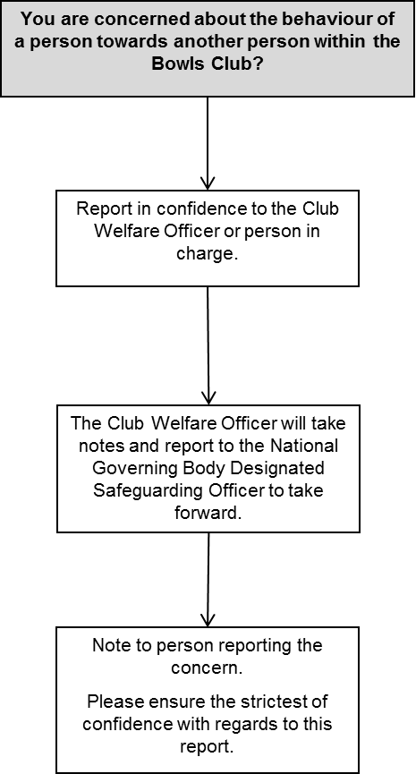

**Flowchart dealing with the behaviour of a club member**

Is the allegation or complaint about

the Safeguarding Officer?

Do you need

advice

?

Sexual/Physical

allegation

Refer to the Safeguarding Officer

Yes

No

National

Governing

Body

Safeguarding

Officer

ChildLine

*0800 1111*

NSPCC

Helpline

0808 800 5000

No

Yes

Go to the next person in

charge at the Club

Report allegation to

Police and Local Social

Services

Allegation of bullying,

emotional abuse or neglect

Possible

abuse

e?

Misconduct

Disciplinary

procedure by

the Club

Report concerns to

the

National

Governing Body

Lead Safeguarding

Officer supported by

the completed

Incident Report

Form (Template

13),

NGB to monitor

number of incidents.

**Allegations of Previous Abuse**

An adult who was abused as a child by a person, who is still working with children, may make allegations of abuse, sometime after the incident. Where such an allegation is made, you should follow the same procedures.

This is because other children either within the sport or outside it may be at risk from this person.

It is important to remember that anyone who has had a previous criminal conviction for offences related to abuse is legally prohibited from working with children.

**Codes of Conduct**

The Bowls Development Alliance has developed codes of conduct that it is recommended that all participants within bowls sign up to. These are available in the “Guidelines” document.

The Child Protection in Sport Unit developed specific guidance around physical contact and young people in sport. These are available on the CPSU website – [www.thecpsu.org.uk](http://www.thecpsu.org.uk) and outline a number of principles that should be followed when the activity involves physical contact.

Physical contact during sport should always be intended to meet the child’s needs, NOT the adult’s. Any person should only use physical contact if their aim is to:

* develop sports skills or techniques.
* treat an injury.
* prevent an injury or accident from occurring.
* meet the requirements of the sport.

The person should seek to explain to the child the nature and reason for the physical contact reinforcing the teaching or coaching skill. Unless the situation is an emergency, the person should ask the child for permission.

Any form of physical punishment of children is unlawful, as is any form of physical response to misbehaviour unless it is by way of restraint. It is particularly important that persons understand this, both to protect the child, their own position as well as the overall reputation of the sport.

There may be occasions where a distressed child needs comfort and reassurance, which may include physical comforting, such as a caring parent would give. Physical contact may also be required to prevent an accident or injury and this would be wholly appropriate. A child or coach may also want to mark a success or achievement with a hug or other gesture. A person should use their discretion in such cases to ensure that what is (and what is seen by others present) normal and natural does not become unnecessary and unjustified contact, particularly with the same child over a period of time.

Whistle-Blowing

The NGB’s are committed to creating and maintaining the safest possible environment for young people (U18) and adults at risk to participate in bowls and recognise their responsibility to promote a safe environment for any concerns to be reported without fear of reprisal.

Whistle-Blowing is an early warning system. It is about revealing and raising concerns over misconduct or malpractice within an organisation or within an independent structure associated with it.

**The Public Interest Disclosure Act 1998** protects those who raise legitimate concerns about specified matters. It makes provision about the kinds of disclosure that may be protected and the circumstances in which disclosures are protected. This policy is therefore intended to comply with the Act by encouraging everyone in bowls to make disclosures about fraud, misconduct or wrongdoing in the sport of bowls and anyone within it, without fear of reprisal, so that problems can be identified, dealt with and resolved quickly.

See Guideline 3 Whistle-Blowing Policy.

Disciplinary Procedures

Each Club/County Association is encouraged to follow the relevant disciplinary procedures.

Investigating Complaints

Where there is a complaint of abuse, there may be three types of investigation, each of which may have some level of NGB involvement:

Disciplinary or misconduct – the NGB will be involved, informed by statutory services where applicable.

Criminal – the Police are involved.

Child protection – CSC are involved (possibly involving the Police).

If after consideration and investigation by the CSC or the Police, the incident is deemed to be poor practice, bullying or harassment, the Bowls Club, County or National Governing Body are empowered to deal with this as misconduct, and each organisation is recommended to adopt and apply the NGB Disciplinary Policy and Procedures.

**Records and Information**

Information passed to the CSC or the Police must be as helpful as possible - hence the necessity for making a detailed record at the time of the disclosure or concern will help you to ensure that all relevant details can be reported.

Reporting the matter to the Police or CSC should not be delayed by attempts to obtain more information.

Wherever possible, referrals telephoned to CSC must be confirmed in writing within 24 hours.

A record must also be made of the name and designation of the CSC officer or Police Officer to whom the concerns were passed, together with the time and date of the call, in case any follow-up is needed. Use the template form provided in Template 15.

A copy of this information should be sent to the NGB Safeguarding Officer.

If advice is required on any aspect of the contents of these Guidelines, your NGB Safeguarding Officer should be available for advice, and useful contact details are as follows.

Additional Information

NPSCC 24 hour freephone helpline 0808 800 5000; Website [www.nspcc.org.uk](http://www.nspcc.org.uk)

Child Protection in Sport Unit – advice around safeguarding developments, [www.thecpsu.org.uk](http://www.thecpsu.org.uk); [cpsu@nspcc.org.uk](mailto:cpsu@nspcc.org.uk); 0116 234 7278

You can access any of the information through your NGB website:-

BCGBA – [www.crowngreenbowlsharepoint.com](http://www.crowngreenbowlsharepoint.com)  
BE – [www.bowlsengland.com](http://www.bowlsengland.com)   
Bowls Development Alliance – [www.safeguardingbowls.org](http://www.safeguardingbowls.org)  
EBF – [www.edbowls.co.uk](http://www.edbowls.co.uk)  
EIBA – [www.eiba.co.uk](http://www.eiba.co.uk)   
ESMBA – [www.esmba.co.uk](http://www.esmba.co.uk)

**Rules for information sharing**

Remember that the Data Protection Act is not a barrier to sharing information but provides a framework to ensure that personal information about living persons is shared appropriately.

Be open and honest with the person (and/or their family where appropriate) from the outset about why, what, how and with whom information will, or could be shared, and seek their agreement, unless it is unsafe or inappropriate to do so.

Seek advice if you are in any doubt, without disclosing the identity of the person where possible.

Share with consent where appropriate and, where possible, respect the wishes of those who do not consent to share confidential information. You may still share information without consent if, in your judgement, that lack of consent can be overridden in the public interest. You will need to base your judgement on the facts of the case.

Consider safety and well-being: Base your information sharing decisions on considerations of the safety and well-being of the person and others who may be affected by their actions.

Necessary, proportionate, relevant, accurate, timely and secure: Ensure that the information you share is necessary for the purpose for which you are sharing it, is shared only with those people who need to have it, is accurate and up-to-date, is shared in a timely fashion, and is shared securely.

Keep a record of your decision and the reasons for it – whether it is to share information or not. If you decide to share, then record what you have shared, with whom and for what purpose.

For more information or to discuss specific queries about information sharing, contact your NGB Safeguarding Officer.

**Flowchart of key questions for information sharing**



If there are concerns that a child or adult may be at risk of significant harm, then follow the relevant procedures without delay.

Seek advice if you are not sure what to do at any stage and ensure that the outcome of the discussion is recorded.