Deloris Coleman
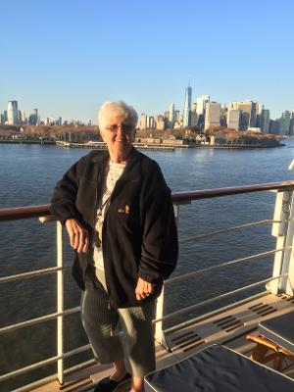
Friendship Force Florida Suncoast has many well-traveled members, but probably none with as many stamps on their passports as our new member Deloris Coleman. As a former travel agency owner who still keeps her hand in with a little consulting, she has taken 199 cruises and an equal number of land trips from Europe to the Pacific Rim. She and Linda Maksel, a 30-year friend who gets kudos for introducing her to FFFS, actually have cruise number 200 booked for April on the Queen Mary. The cruises are her travel favorites. "I love being at sea and going to sleep and waking up in the next country," she says. Lucky for her it has been pretty much all "smooth sailing." During a second career as a high school teacher, Deloris used her travel experience to escort groups of students on 10-day European adventures during Easter breaks.

After years of residing in Palm Harbor and summering at Belleair Beach, Deloris is relocating to Pinecrest of Largo this week. She is originally from Lavallette on the Barnegat Peninsula in New Jersey. She and her late husband Thomas got to know this part of Florida largely thanks to a brother-in-law who was a Pinellas County sheriff. They raised three sons: Shawn, who is a Navy veteran and retired police office in New Jersey; Jonathan, a retired attorney living in Sarasota; and Brian, who lives in Pasadena, California and is a fellow traveler with three million airline miles. (As an aside, Deloris noted that currently Brian and Linda are on safari in South Africa.)

Deloris says she is happy to be part of Friendship Force and is looking forward to getting to know club members here and from around the world. "Staying in the homes of new friends and hosting them in ours is an excellent way to do that."

Welcome, Deloris.

