MAC FAMILY CHIROPRACTIC

Chiropractic is not just for Pain Relief but for Better Health
Welcome to our Practice!
CONFIDENTIAL HEALTH FORM.

To ensure your visit with us is a pleasant one, here’s what to expect on your first visit:
CONSULTATION: You will meet the Doctor and he will review your history and determine if yours is a Chiropractic case. You will be informed of the cost of any office procedures before they are performed.
EXAMINATION: Standard physical, orthopaedic, neurological, muscle, postural and Chiropractic tests will be performed to determine the cause(s) of your subluxations (problems)
SPINAL IMAGES: A referral for the necessary views may be given to take the appropriate films to visualize the location of any spinal problems, neurological interferences, reveal any pathology, and make your chiropractic care more specific.
CORRELATION: Before proper care can be rendered, the Doctor will study your examination findings. Later, you will see your x-rays, review your findings by comparing them to normal films, and receive specific care and recommendations.

NAME: DATE:

ADDRESS: HOME PHONE: MOBILE:

EMAIL (for appointment reminders only):
BIRTH DATE: / / AGE: SEX: M F

MARITAL STATUS: M W D S SPOUSE’S NAME: # OF CHILDREN:
EMPLOYED BY: OCCUPATION: WORK PHONE:

HEALTH FUND NAME? (If you have one):
________________________________________________________________________
CONCESSION NO. AND EXPIRY:
HOW DID YOU FIND US?:
Emergency Contact (NAME AND PHONE):
- Have you ever had chiropractic care before? Yes O No O
- How often did you go? Often O Only when I felt pain O Hardly ever O

HOW DID YOU HEAR ABOUT US?
O SIGNAGE/ WALK BY/ DRIVE BY
O RECOMMENDATION BY A FRIEND
O BY THE CHIROPRACTOR
O INTERNET SEARCH / GOOGLE
O OTHER...

WHAT BRINGS YOU IN?
Reasons for consulting our office in order of severity:

1.________________________________________For how long?__________________

2.________________________________________For how long?__________________

3.________________________________________For how long?__________________
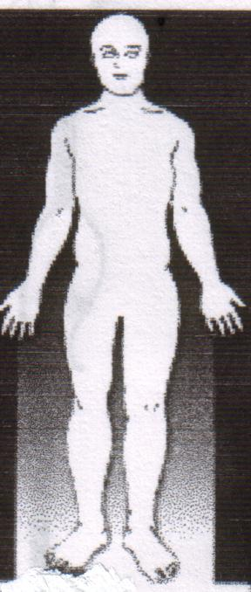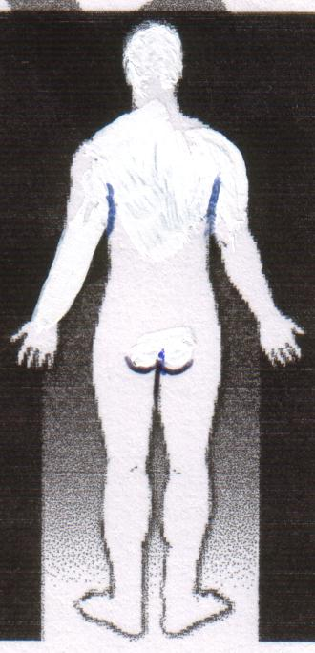
Do you have? pain O Numbness O tingling O aches O

Is your pain? sharp O dull O throbbing O constant O intermittent O

Are your symptoms affected by? sitting O standing O walking O
bending O lying down O weather O

Do your symptoms interfere with? work O sleep O day –to-day activities O

RATE YOUR PAIN (0=I feel perfect, 100= This is the worst pain ever)
0 10 20 30 40 50 60 70 80 90 100

What Do You Know About Chiropractic?

In your own words, what do chiropractors do?

1. Do you know what spinal nerve stress / SUBLUXATIONS are? Yes O No O
2. Do any family or friends see chiropractors? Yes O No O
3. Are you seeking chiropractic for : Health maintenance / optimisation O
pain relief O both O
4. What would you like to gain from chiropractic care?
O Relief of pain only
O Finding out where the restrictions/subluxations are in my Nervous system that are preventing it from working properly and removing them so that my body and health can work at it's ABSOLUTE POTENTIAL?
5. Are there other health concerns or anything else you’d like us to know about you?
Yes O No O Please tell us : _______________________________________________________________________________________________________________________________________________________________________________________________________________________________________________________________________________________

About Your Health…
The Human body is designed to be healthy. If your NERVOUS SYSTEM is working at it’s best, then your body is working in peak potential. However, throughout life, events occur which can damage your body’s internal strength.

Present Health: Are you affected by any of the following? (within the last 6 months)

PLEASE PLACE A TICK NEXT TO THE RELEVANT SYMPTOMS BELOW:

Muscle & Joint General Symptoms Gastrointestinal Cardiovascular
O Backache O Fever/Chills/Sweat O Difficult Digestion O Rapid heart beat
O Neck pain O Fainting O Belching or gas O Slow heart beat
O Painful tailbone O Convulsions O Nausea or vomiting O High blood pressure
O Foot Pain O Allergy O Pain over stomach O Low blood pressure
O Shoulder Pain O Skin problems O Constipation O Pain over heart
O Hernia O Colds O Colon trouble O Swelling of ankles
O Spinal Curvature O Tremors O Liver trouble O Previous heat attack
O Faulty Posture O Loss of balance O Gall bladder trouble O Poor circulation
O Arthritic Pain O Heartburn O Stroke
RESPIRATORY O Diarrhea
STRESS SYMPTOMS O Chronic cough O Bloody stools
O Headaches O Difficult breathing
O Tension O Spitting up blood EYES, EAR, NOSE THROAT FEMALES ONLY
O Dizziness O Chest pain O Deafness O Painful menstruation
O Ringing in ears O Ear ache O Excessive flow
O Blurred vision URINARY O Sore throat O Irregular
O Loss of sleep O Painful urination O Asthma O Cramps or back pain
O Loss of concentration O Increased urination O Tonsillitis O Abnormal discharge
O Irritable/nervousness O Blood in urine O Sinus trouble O Passed menopause
O Depression O Getting up at night to urinate O Are you pregnant?
O Decreased energy O Birth control pill
O Fatigue
O Numbness/Tingling O Anything else! (TELL US!)

PAST HEALTH: Have you ever suffered from any of the following conditions?

O Allergies O Back pain O Emotional problems O Headaches O Polio O Thyroid trouble
O Arthritis O Cancer O Epileptic seizures O Heart disease O Psoriasis O Tuberculosis
O Asthma O Diabetes O High blood pressure O Pneumonia O Stomach Ulcers

Please List Any Significant Illnesses

Date / Illness:
1. /
2. /
3. /
4. /
5. /

MAC FAMILY CHIROPRACTIC
94 KIRBY ROAD, ASPLEY QLD 4034
07 3863 2661
Mob. 04185 777 22
Email: matt@yourchiro.us
Dr. Matthew MacGregor, Chiropractor Provider #: 222650

PATIENT INFORMATION / CONSENT FORM

Changes to the law now require all practitioners who manipulate the spine to warn patients of the material risks, no matter how slight. In extremely rare circumstances, some treatments of the neck may damage a blood vessel and give rise to stroke or stroke-like symptoms (approximately 1 in 5.85 million neck manipulations, Haldeman, et al. Spine vol 24-8 1999). This has never occurred in this practice or with the Chiropractors at this office, but we are still required to warn you. Prior to any adjustments (manipulations) you will be tested beforehand by a professional Chiropractor, as has always been our practice.

Other very slight risks include strain/ injury to a ligament or disk in the neck (less than 1 in 139,000) or the low back (1 in 62,000), (Dvorak study in Principles and Practice of chiropractic, Haldeman. 2nd edition).

Chiropractic adjustments of the spine are internationally recognized as being far safer in dealing with neck and low back pain than medication and many other alternatives, (A Risk Assessment of Cervical manipulation, JMPT, 1995, Manga Report, Ontario Ministry of Health, 1993). If you have any questions related to the above or to Chiropractic treatment, please speak to Dr. Matt MacGregor.

I ________________have read and understand the above information and give consent to both an examination and treatment

Patient Signature________________________Date_______________
*I have no further question regarding the above information (initial here)___

THANK YOU!
THINK POSITIVE AND EXPECT MIRACLES!!!

