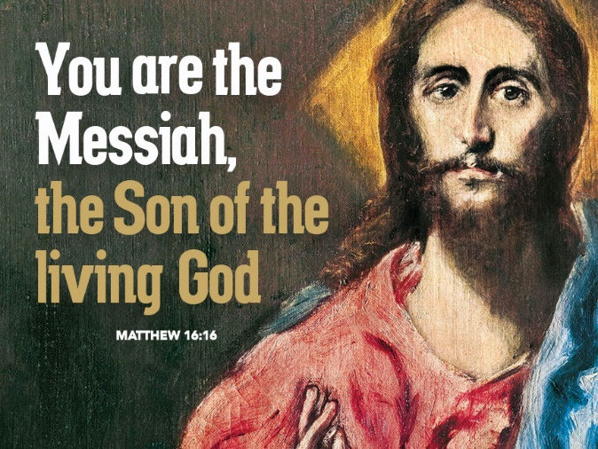
Who Do You Say Jesus Is?
August 27, 2017
Matthew 16:13-20
Grace and peace to you from God, Our Father and from Jesus Christ, the Son of the Living God, amen.
One of my favorite ways of learning is by asking questions. Some say curiosity killed the cat and that may be true, but nobody ever learned anything new without first being curious first. For those who are attending my Sunday school classes or those who have gone through my Catechism you know I always ask lots of questions and then we spend the rest of our time discussing them. We almost always go into areas I would never have thought of on my own. That’s the fun of learning through questions, you explore areas you never thought you would get to.
Martin Luther used the same approach to teaching. His most famous question is, “What does this mean?” I use this approach when I take on a story from the Bible. I read it over always asking myself, what does this mean? Sometimes the Holy Spirit leads me into discussions that I never thought I would end up in and to conclusions my simple mind could never think up on its own. That’s how God works. God is revealed through His Word and the Holy Spirit.
(Slide 1, Map) Jesus asked his disciples a question when they were at Caesarea Philippi. This city was newly renovated at this time by the ruler of the territory Phillip and was the farthest point north from Jerusalem where you were still be in Israel. It was the place were several contrasting religions all existed side by side. The Canaanite god Baal (Slide 2 first image) was a half man half bull who was very ancient dating back to at least 300 years BC. (Slide 2, image 2) The Egyptian god Ra was often depicted as a man with a falcon’s head and the disk of the sun on top of his head. (Slide 2, image 3) The Greek god Pan was a sinister half man, half goat who required sacrifices at this location. The sacrifice would be thrown into the deep waters in the cave known as Hades and if blood appeared in the spring outside the cave the sacrifice was rejected. If no blood appeared the sacrifice was accepted. (Slide 2, image 4) The Roman god Zeus was known as the King of the Gods. Imagine a melting pot of every religion known to mankind and all the associated gods and that’s Caesarea Philippi. As Jesus led His disciples into that environment of pure pagan debauchery, can you imagine how outnumbered they must have felt? These gods that I’ve shown here are just a few of the gods available for worship during the Greek, Roman, and Egyptian empires.
(Slide 3) This slide shows what one artist believes this site might have looked like during Jesus’ day. It was quite a lively religious center. Right there at the site of the largest temple where the sacrifices to Pan were taking place, that’s the place Jesus pointed to and declared that even these gates of Hades would not prevail against His Church. (Slide 4) Just to show you Jesus was correct, here’s a couple of pictures showing the site as it is today. It’s quite beautiful to visit, but the gods are no longer worshipped there. Instead this place is visited by millions of Christians every year on pilgrimages as they walk the paths of Jesus. (Slide 5-You can leave this one up for the rest of the sermon)
Although Christianity today isn’t outnumbered by active cults worshiping Zeus or Pan or one of the other gods today, don’t ever think for a minute we have any shortage of false gods or idols. Martin Luther said anything that comes between you and the One Living God is your god. So, in that light, Jesus’ question to his disciples at the Pagan Capital of the known world still applies to us today here in the United States of America where we are free to worship any god we choose or no god at all. Among all the false gods, idols, and temptations that call us away from following Jesus and that litter our lives today, who do you say that Jesus is? This is the most burning question of our lives. It’s the main question I ask the graduating Confirmands when they meet with me before I’ll confirm them in their faith. Who is Jesus to you now, today?
Jesus first asks who the people think he may be. The disciples answer that the people are speculating Jesus might be the reincarnation of John the Baptist, Elijah, who was prophesized to precede the Messiah, or one of Israel’s great prophet. No one had figured out Jesus might be the Messiah, because Jesus was so different from the Messiah that they were expecting. Today, who do the people of our time say Jesus is? Most would probably say he was a good man and a pretty good teacher, if, that is, they acknowledge he ever really existed at all.
After listening to what the people around the countryside thought of him, Jesus asks his disciples, “And who do you say that I am?” They are silent except for Peter who says, “You are the Christ the Son of the Living God.” Peter had been walking with Jesus for three years, and inspired by the Holy Spirit, it is finally revealed to Peter who Jesus really is—the Messiah for whom Israel had been waiting.
There’s a huge difference between Peter’s confession and the general populous who merely conjured up speculation about who they thought Jesus was. Along with Peter’s proclamation that Jesus was the Christ came the commitment to follow Jesus through thick and thin. The speculation of the people cost them nothing and affected their lives very little. Peter’s confession (and the confession of the church that followed) cost him everything and changed his life completely. Peter wasn’t perfect. He had his bad moments, like denying he even knew the man, Jesus, but in the end Peter followed Jesus even to the cross. Peter ended his days at the heart of the empire, with all their false gods, and was so certain Jesus was his Lord and Savior he was willing to literally take up his cross. He was crucified upside down on a hill in Rome called the Vatican. That’s how much his confession changed his life!
Today we can follow the example of the people and only speculate about who Jesus might be—keeping an open mind for other possibilities. We can worship God, sing songs of praise, and listen to sermons and even say prayers, while hesitating to make a commitment. Without the confession that Jesus Christ is Lord, there’s little or no motivation to commit our lives to his service.
If we are brothers and sisters of Peter, though, we have received the revelation that Jesus Christ is the Son of the Living God; that Jesus Christ is our Lord and Savior. We also open ourselves to the life changing possibilities that such a confession frees us from all those other gods to commit ourselves to live in this reality by pledging our lives—time, talents, and treasures to loving God, and loving and serving our neighbor, all the while experiencing the abundant, joyful life that is ours in Christ Jesus. Who we say that Jesus is, makes a huge difference in how we live out our lives in our words and actions.
Peter experienced Jesus as the Christ, the Son of the Living God. Throughout the Scriptures God has revealed himself to people differently, and touched their lives in a variety of ways. For the Psalmist of Psalm 23, God was a good shepherd who led him to green pastures, cool streams and walked with him through the valley of the shadow of death. In Psalm 46, the writer sees God as his refuge and strength, always ready to help in times of trouble. Several times in the Old Testament the Lord is referred to as God Almighty, Creator of Heaven and Earth. The prophet Isaiah writes the Messiah will be titled, “Wonderful Counselor, Mighty God, Everlasting Father, and Prince of Peace.” The name Jesus or Joshua can be translated, “God saves.” Jesus is called Emmanuel, or “God with us.” Each of us has experienced God in our lives in different ways. For me, God is my provider giving me my daily bread. Jesus is my comfort, surrounding me with his love in times of grief. He is my peace, calming the storms of my life and walking with me through troubled times. Jesus gives me strength to persevere and overcome. He’s the one I pray to when I can’t do it, whatever it is, anymore.
Who do you say that Jesus is? If he is your Lord and Savior, then commit your life to him and offer your life, your time, talents and treasures as your living sacrifice. If God is your provider, comfort, or peace, than give of your time, talents and treasures so that you can be like a desert stream to someone else who is parched and dried up by life’s troubles. Participate in the ministries of the Church so that Jesus can still be The Christ, The Messiah, the Son of the Living God to all those around us.
No one can answer this question for you. You can’t poll the crowd and go with the majority. This question you must answer yourself and allow your confession to direct the path of your life. May you take Jesus’ question seriously for your life today and for all your tomorrows. May God’s Holy Spirit reveal to you anew who Jesus is for you and give you fresh vision for how you can be his disciple, following Him when ever and where ever He leads. May God bless each of you as you consider your response to who Jesus Christ is to you. Amen

