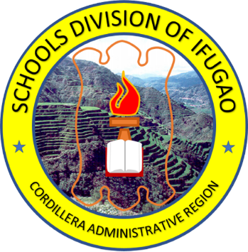
Republika ng Pilipinas
Republic of the Philippines
Kagawaran ng Edukasyon
Department of Education
REHIYON NG CORDILLERA
CORDILLERA ADMINISTRATIVE REGION

SANGAY NG IFUGAO
SCHOOLS DIVISION OF IFUGAO

XXXXXX HIGH SCHOOL

Pinatunayan nito na si
This certifies that

JUAN A. DELA CRUZ
Learner Reference Number (LRN): xxxxxxxxx

ay kasiya-siyang nakatupad sa mga kinakailangan sa Kurikulum ng Junior High School na itinakda
has satisfactorily completed the requirements of the Junior High School Curriculum prescribed

para sa Mataas na Paaralan ng Kagawaran ng Edukasyon, kaya pinagkalooban siya nitong
for Secondary Schools of the Department of Education and is therefore awarded this

KATUNAYAN
CERTIFICATE

Nilagdaan sa xxxxxx, Pilipinas nitong ika-______ ng ______ 2020.
Signed in xxxx, Philippines on the ______ day of _________________ 2020.

XXXXXXXXXXXXXXXXXXXXXXXX
Punongguro
Principal

BENEDICTA B. GAMATERO
Pansangay na Tagapamanihala ng mga Paaralan
Schools Division Superintendent

