Parallel Park

The three main points of this manoeuvres is control, accuracy and steering. The pace you will perform the manoeuvre is a crawling pace. You must take in information about the gradient of the road and how this would affect the control of the car. As you pull up alongside the parked car aim for a metre clearance. Check that it is safe for you to stop and decide if a signal is required.
- Stop when your passenger door mirror meets the bumper of the parked car. (if the car is longer than your car you may need to stop at the parked cars wheel arch)
- Prepare yourself into reverse and make all round observations.
- Steer half a turn to the left (or 45 minutes if you want to come in sharper) this will guide your rear wheels towards the kerb.
- Observing as you are reversing.
- Look in your passenger exterior mirror, when the kerb disappears in the mirror (stretch up till cant see kerb no more) steer a full lock to the right to take the front end of the car in towards the kerb.
- When the car is parallel to the kerb straighten the wheel, half a turn followed by a whole turn.
- Stop the car half to one car length from the parked car.

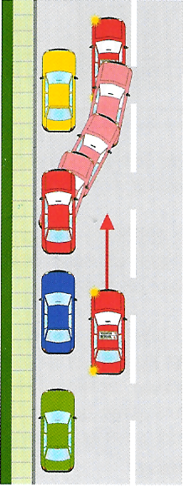
What can go wrong?
Pace too fast, lack of observations, not signalling to other road users, Steering while not moving, steering too slowly, missing reference points and not taking into account the gradient of the road.

