Angels & Alcohol 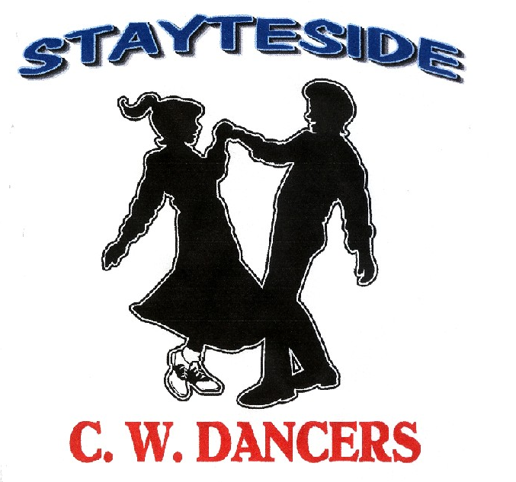

Description: Partner Dance. (64 Counts) Opposite Footwork Throughout
Start: Facing LOD. Right sweetheart position. Lady slightly forward from Gent..
Choreographer: Carol* & George Stayte. (UK) * Fully Qualified D & G Instructor. 02392 423925. carol.stayte@ntlworld.com
Music: “Angels & Alcohol” by Alan Jackson. CD. Angels and Alcohol. (Near the end of the music there is a pause, just dance
through it) (104 Bpm - Intro 16 Counts)
Alternative: “Lay Low” by Josh Turner. Single CD “Lay Low. Josh Turner (109 Bpm – Intro After main intro, 32 Counts)

GENT: LADY:

1 BOTH: CROSS ROCK. SIDE SHUFFLE (CHANGING SIDES) (X2)
1 – 2 Rock right over left, recover on left, Rock left over right, recover on right.
3 & 4 Right side shuffle RLR. (Changing sides, travelling behind lady) Left side shuffle LRL (Left sweetheart position)
5 – 6 Rock left over right, recover on right. Rock Right over left, recover on left.
7 & 8 Left side shuffle LRL. (Changing sides, travelling behind lady) Right side shuffle RLR (Right sweetheart position)

2 BOTH: PIVOT 1/2 TURN, SHUFFLE 1/2 TURN, BACK ROCK, 1/4 TURN SHUFFLE.
1 – 2 Step fwd on right pivot 1/2 Turn left. (Release Hands) Step fwd on left, pivot 1/2 Turn right..
3 & 4 Shuffle 1/2 Turn left on RLR Shuffle 1/2 Turn right, on LRL
5 – 6 Rock back on left, recover on right. (Rejoin Inside Hand Hold). Rock back on right, recover on left.
7 & 8 Shuffle 1/4 Turn right on LRL. (Double hand hold). OLOD Shuffle 1/4 Turn left on RLR. ILOD

3 GENT: WEAVE. POINT. STEP FORWARD.POINT. STEP BACK. KICK FORWARD.
LADY: WEAVE. POINT. STEP BACK. POINT. STEP FORWARD. KICK TO RIGHT DIAGONAL.
1 – 2 Cross right behind left, step to side on left, Cross left over right, step to side on right.
3 & 4 Cross right over left, point left to left side. Cross left behind right, point right to right side.
5 – 6 Step fwd on left point right to right side. Step back on right, point left to left side.
7 & 8 Step back on right, small kick left between ladies legs. Step fwd on left, small kick right to gents left side.

4 GENT: STEP FORWARD. TOUCH. SIDE SHUFFLE. BACK ROCK. 1/2 TURN (CHANGING SIDES)

LADY: STEP BACK. TOUCH. SIDE SHUFFLE. BACK ROCK. 1/2 TURN.

1 – 2 Step fwd on left, touch right next to left. Step back on right, touch left next to right.

3 & 4 Right side shuffle RLR. Left side shuffle LRL

5 – 6 Rock back on left recover on right. Rock back on right, recover on left.
7 – 8 1/2 Turn left on left, right. (To Face ILOD) 1/2 Turn right on right, left. (To Face OLOD)
Note: Count: 7 - 8 (Changing sides Gent passing in front of Lady) Release Gent’s right hand. Gent’s turning under his left hand.
Rejoin into double hand hold.

5 BOTH: TRIPLE IN PLACE. SIDE TOGETHER SIDE SHUFFLE, BACK ROCK.
1 & 2 Triple step in place LRL. Triple step in place RLR. (Face To Face)
3 – 4 Step to side on right, together on left. Step to side on left, together on right.
5 & 6 Right side shuffle RLR. Left side shuffle LRL.
7 – 8 Rock back on left recover on right. Rock back on right, recover on left.

6 BOTH: 1/4 TURN (CHANGING SIDES) SHUFFLE FORWARD, FULL TURN. SHUFFLE FORWARD.
1 – 2 1/4 Turn right on left, right (Changing Sides, Gent behind lady) 1/4 Turn left walking diagonally fwd on right, left.
3 & 4 Shuffle fwd LRL Shuffle fwd RLR
5 – 6 Full Turn Left on right, left. Full turn right on left, right.
7 & 8 Right shuffle fwd RLR to LOD Left shuffle fwd LRL to LOD
Note: Count: 1 – 2 Release Gent’s left hand, Lady turning under Gent’s right hand.
Count: 5 – 6 Release hands. Count: 7 & 8 Rejoin Lady’s right hand to Gent’s right hand.

7 GENT: WALK, WALK, SHUFFLE FORWARD. STEP FORWARD TOUCH. SHUFFLE BACK.
LADY: 1/2 TURN SHUFFLE BACK. STEP BACK TAP ACROSS.SHUFFLE FORWARD..
1 – 2 Walk fwd on left right. 1/4 Turn right on right. 1/4 Turn right stepping back on left.
3 & 4 Left shuffle fwd LRL. Right shuffle back RLR RLOD
5 – 6 Step fwd on right, touch left next to right. Step back on left, tap right across left.
7 & 8 Left shuffle back .LRL Right shuffle fwd RLR
Note: Count: 1 & 2 Right hands over Lady’s head, right shoulder to right shoulder.

8 GENT: BACK ROCK. SHUFFLE FORWARD. WALK, WALK, SHUFFLE FORWARD.
LADY: FORWARD ROCK. SHUFFLE 1/2 TURN. WALK, WALK SHUFFLE FORWARD.
1 – 2 Rock back on right, recover on left. Rock fwd on left recover on right.
3 & 4 Right shuffle fwd RLR. Shuffle 1/2Turn left on LRL LOD.
5 – 6 Walk fwd on Left, right. Walk fwd on right, left.
7 & 8 Left shuffle fwd. LRL Right shuffle fwd.LOD
Note: Count: 3 & 4. Rejoin left hands into sweetheart position.
START AGAIN

