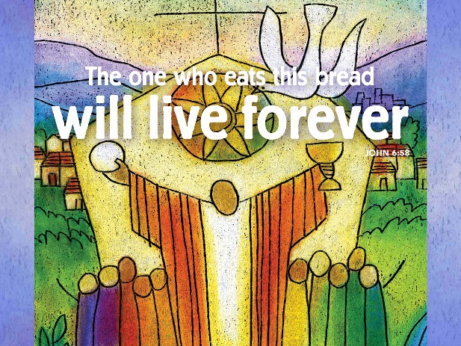
Cooking With Jesus
August 19, 2018
John 6:51-58
Grace and peace to you from God Our Father and from the Bread that came down from Heaven, Jesus Christ Our Lord, amen.
If you can't stand the heat, get out of the kitchen… Apparently, a lot of people are doing just that. This week I read an article about cooking, or I should say the lack of cooking in our society today by Megan McArdle, published in the Atlantic, but available on line, just a Google search away. "The Joy of Not Cooking," reports that the average woman in the 1920s spent about 30 hours a week preparing food and cleaning up. By the 1950s, she was doing this just 20 hours a week. Now, women average about five hours a week in the kitchen. We may have some exceptions here in our congregation because of all the farmers’ wives who still cook and bring meals out to the fields during planting and harvesting times. Even including you farmers’ spouses, I’m willing to bet you spend less time in the kitchen today than you did say, 20 or 30 years ago… And that's not because men are stepping in to help -- guys give only about 15 minutes a day to kitchen work!
Oddly enough, gourmet kitchens are on the rise at the very same time people are fleeing the heat. Men and women are spending a ton of money on kitchen equipment they rarely use. I know we do at our house. We don’t own a Viking stove, but I hear they go for about $10,000. A KitchenAid toaster runs $320 on Amazon Prime. A Margaritaville Frozen Concoction Maker which sits on a shelf in our pantry, retails for $349. And a Shun chef's knife, with its own wooden display stand? $199. This is expensive kitchen equipment, being purchased at a time when more than a quarter of all meals and snacks are being consumed outside the home. What's going on here? McArdle believes each expensive kitchen gadget comes with a vision of doing something warm and inviting such as baking bread, rolling your own pasta, or slow-cooking a pot roast. Gourmet kitchen equipment promises a warm and wonderful feeling, even if you rarely touch it.
Cooking has become a leisure activity for many Americans, instead of a daily job. Some chefs have noted an increase in the number of males entering the cooking industry. They call it the dudification of cooking. Even outside of the professional Chef business guys are getting into cooking as a leisure pursuit. As with most things guys get into, we tend to buy a lot of high-end toys even for the relatively small amount of time we spend using them and dude cookery, according to experts, is all “fire, blood and knives.”
In the gospel of John, Jesus uses a number of kitchen-based images to describe himself and his mission from God. “I am the living bread that came down from heaven,” he says, offering a warm, inviting and nourishing image of himself as the bread of life. Very soon his language changes: “Whoever eats of this bread will live forever; and the bread that I will give for the life of the world is my flesh.”
In a flash, the pleasant image of enjoying fresh-baked bread takes a turn toward the eating of human flesh. We're suddenly in the world of fire, blood and knives. John has already told us Jesus is the Word of God in human form, having said “the Word became flesh and lived among us.” (John 1:14) We know this Word made flesh was not destined to live a long, happy, earthly life. Jesus is going to be lifted up on the cross, sacrificing his own flesh to bring us forgiveness and everlasting life.
Let’s recap… Living bread. Word made flesh. Lifted on the bloody cross. Given for the life of the world. In Jesus' kitchen we find God's recipe for everlasting life, but this kitchen gets hot. So hot in fact, the people in our text begin to dispute among themselves, saying, “How can this man give us his flesh to eat?” When Jesus spoke to them about “living bread,” they had a sense of what he was talking about because they remembered the bread from God -- the manna -- their ancestors ate in the wilderness. But his flesh? That didn't make any sense.
“Very truly, I tell you,” says Jesus, “unless you eat the flesh of the Son of Man and drink his blood, you have no life in you.” (Repeat…) His images have shifted from warm bread to something much more urgent and dire. There is no longer any doubt Jesus is going to have to give his flesh and shed his blood, and that his followers will need to eat and drink of his sacrifice. Jesus is giving his whole self to us, and inviting us to eat him up. Just reading or saying that is enough to make one's skin crawl. Now, obviously, Jesus doesn’t mean this in any literal sense of the words. There’s no cannibalistic Jewish tradition his listeners would have understood. Thus, their confusion. They weren’t positioned spiritually to understand Jesus' word on any metaphorical level either. As a direct result of these sayings from Jesus, many people, even some of those who were disciples, left Jesus at this point thinking, this teaching is too difficult; who can accept it? This guy is nuts! They left the kitchen.
Clearly, cooking with Jesus is not easy. This is understandable since kitchens have not always been pleasant places to be. Back in my younger days I worked for the Green Giant Company in Belvidere Ill. I was the head sauce maker for all the boil in the bag vegetables. We made corn in butter sauce, all the sauces for things like rice medley and even creamed spinach and cream style corn. I can tell you first hand large scale cooking is hot and hard labor. I did it for 5 years before I wised up and joined the Air Force. I’m not sure if conditions have improved at Green Giant, but I will tell you I thought the Green Giant kitchen was pure hell. It was a hot, dirty, smelly, dangerous place, and the work done there seemed endless. Not just kitchens, but sometimes life in general can be hell on Earth. That's why Jesus entered the kitchen and baked the bread of life. Out of such a hell comes the promise of eternal life.
Unlike modern cooking, consuming Jesus isn’t a leisure pursuit. It’s not something we do when we feel like it or when it’s convenient. Taking Jesus into ourselves is a full-time challenge, one that transforms us from the inside out. After all, you are what you eat. Jesus said, “Those who eat my flesh and drink my blood have eternal life and I will raise them up on the last day; for my flesh is true food and my blood is true drink. Those who eat my flesh and drink my blood abide in me, and I in them. Just as the living Father sent me, and I live because of the Father, so whoever eats me will live because of me.” If we take Jesus into ourselves, we have eternal life. Don't expect to understand it, just be grateful for it.
After so much talk of flesh and blood, Jesus returns to the image of bread. He says about himself, “This is the bread that came down from heaven, not like that which your ancestors ate, and they died. But the one who eats this bread will live forever.” In the kitchen of Jesus, the ingredients of bread, flesh and blood all mix together. They form an unexpected meal, one that nourishes us spiritually and fills us with everlasting life.
The challenge for us is to stay close to Jesus, receive his nourishment and do his work in the world. This isn’t a leisure pursuit, one that can be done off and on. Jesus wants us to remain in the kitchen with him, even when it gets hot. Consuming Jesus isn’t about a special time with your lord. It’s about saving your life and giving you life in abundance. I know the frequency of Communion is still an issue of contention around here just as it was for the original disciples. When Jesus finally, out of frustration, asks His closest disciples if they wish to go away too, Peter answers by saying, “Lord, to whom can we go? You have the words of eternal life.”. The words of Jesus remain a source of solid spiritual food for us, whether Jesus is describing himself as "the resurrection and the life" (John 11:25), telling us to "love one another" (John 13:34), or commanding us to eat of his flesh and drink of his blood as often as we think of it. Jesus instructs us to eat and drink of the bread and the wine to remember him and to honor him. Receiving communion is an important way of living in Christ, and allowing him to live in us. None of this requires a gourmet kitchen, filled with expensive gadgets. All we need to do is keep cooking with Jesus, even when things get hot.
May we love Jesus enough to follow him into the heat of the kitchen. May we partake of his body and blood even when it doesn’t feel special because we know we are the ones who need his life-giving forgiveness and salvation. May we be strengthened by this meal Jesus hosts so we can be “little Christs” when we leave this place and go back out there into the real heat of the kitchen. Amen.

