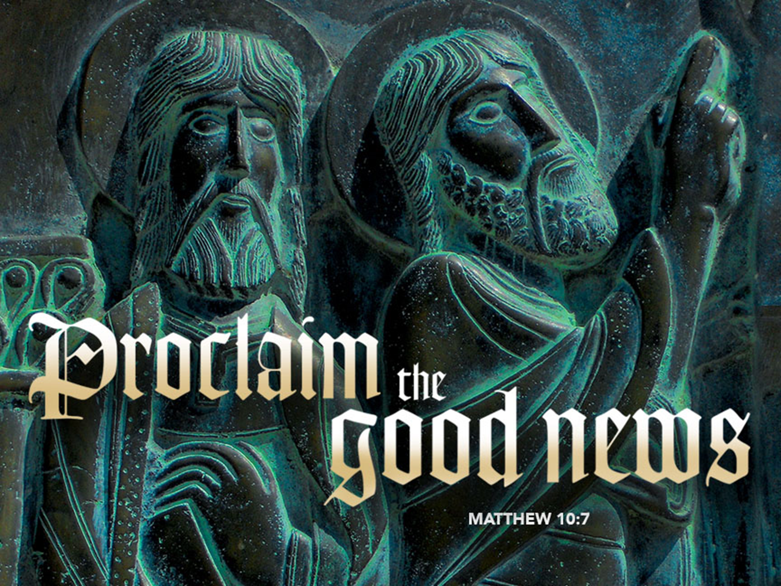

Same Old Story
June 18, 2017
Happy Father’s Day
Matthew 9:35-10:23

Grace and peace to you from God Our Father and from the One who brought us the Good News that the Kingdom of God is Near, Jesus Christ, Our Lord, amen.
When I was a kid I remember attending Messiah Lutheran Church in Ashtabula Ohio with my parents. I guess I was fortunate in that I was dragged to Church by both parents. I remember sitting in the pew watching my dad. He always paid close attention to the sermon. I couldn’t understand back then why he thought it was so important. To me, it just seemed like it was the same old story, week after week…
Today’s lessons, all of them, are wonderful resources for the telling of the love of God. Paul, in his letter to the Romans sums up the depth of God’s love for us in these words; “While we were still sinners, Christ died for us.” I could literally stand here for hours and talk about just this one sentence. These words remove any doubt about who does the work of salvation. God didn’t look down at us and say, “once you’ve changed your ways, once you’ve made up your mind, once you’ve decided to follow me, then I’ll do something about it.” Quite the contrary! God loved us enough that through His grace and mercy He was willing to become one of us and die for us on the cross while we were still mired in our own sin. These words contain God’s Grace in a nutshell.
That’s one of the reasons we gather together for worship. So we can hear God’s Word spoken to us and have it imbedded in our hearts and minds. For the next few minutes, we are going to look at the Old Testament lesson and the Gospel appointed for this day. These two stories are literally the same story, told to different people at different times, but with the same meaning.
Our Old Testament lesson takes place at the foot of Mt. Sinai. The Israelites had been on the march for about 3 months since their deliverance from Pharaoh. Now they have gathered at the foot of the mountain of God. Moses ascends the mountain to speak with God and comes back with a wonderful message. God tells Moses to remind the people He brought them to where they are. God is telling the people to take a new look at themselves. They’re no longer a lost wandering mass of humanity. They’re no longer slaves subject to the whims of Pharaoh. They’re no longer subjected to the worship of false gods. They’re no longer victims of their circumstances. It’s as if the Israelites had been, for the past 400+ years, walking around in one of those fun houses they used to have at amusement parks. You know the ones where you walk in front of the mirrors and in one you look wide and short, and in the next one you would be skinny and tall. Well, that’s the image the Israelites had been seeing for years and years. They had not seen the true picture of who they were.
They had not been seeing themselves as children of God, chosen people, of the Heavenly Father. God wants them to have a new view of who they are. He wants them to have a view of themselves through the eyes of God. They’re no longer distorted. They’re no longer slaves. They are now free because of what God has done. He has brought them on “eagle’s wings” to be with Him. Just so they don’t misunderstand, God also tells Moses to remind them of something else. God wants them to remember that He is the creator of the world. How often do we forget who the actual owner of everything is? The problem is, we claim ownership. Despite this huge sin, God tells the Israelites something even more stunning. He says, “Even though I own everything, even though I created the heavens and the earth and everything in them, I choose you.” God wanted the people He had established a covenant with to know He was still their God and they were still His people.
The Hebrew word used to describe these people is SEG U LA. Our NRSV translation has “niced” it up to read “you will be my treasured possession.” The actual translation means “peculiar.” Peculiar can have different meanings depending on the ear of the hearer. It’s kind of like beauty is in the eye of the beholder. What is beautiful to one person is nothing of the sort to others. Peculiar to some people means strange or bizarre, curious, eccentric, odd, or maybe just a bit weird. To others it means distinctive, unique, one of a kind. I think God meant both.
God was identifying the Israelites as His one and only. His priceless possession. That doesn’t mean they wouldn’t be looked at by some as bizarre and curious or odd or maybe just a little weird. (Just as we, as Christians are sometimes looked at as being a little peculiar.) But to God, they were His priceless possession.
Let me put that in a little perspective. My brother-in-law, Laszlo had a dog named Buddy. Buddy was a scruffy, mean old mutt. Buddy was nothing to look at. He had long curly hair that covered his eyes and if you tried to pet him, you were just as likely to get nipped as to receive any returned affection. To be honest, I never knew what Laszlo saw in that dog. Yet, to Laszlo, Buddy was his pride and joy and Buddy treated Laszlo unlike anyone else. He never left Laszlo’s side and the two were true “Buddies.” The “pricelessness” of a possession is often times determined by its ownership. God wanted the people of Israel to know in His eyes, because He chose them, they were priceless. They were peculiar to Him.
So, God gives Moses all this Good News, reconveying, renewing, reiterating the covenant made between God and Abraham and Isaac and Jacob and Moses goes down to tell the people. The people listen and they respond, “We will do everything the Lord has said.” Here’s the rub. The people of Israel, and many people to this day, think they understood what God said. They think He said obey all of my commandments. They think God said, “Do this, don’t do that, do this.” That is not what God said. First of all, He hadn’t even given them the commandments yet, but most importantly, God wasn’t laying down the LAW, He was giving the Israelites something to have faith in. God gave himself to them so they would have hope for the future. To put their trust in Him. To honor Him. To fear Him. To worship Him. To believe in Him. To let God be God. To trust in Him for salvation.
Now, fast forward to our Gospel text. Jesus had been traveling throughout the region of Galilee, teaching in the Synagogues, healing the sick and curing the diseased. Crowds had gathered and we are told that when Jesus saw these people he felt compassion for them. My friends, Jesus saw in those crowds the same thing God the Father had seen in the people of Israel in the Sinai desert. Lost wandering sheep with no Shepherd to lead them. They are harassed and helpless and in Christ they find compassion. Just as God had come down to the people on Mt. Sinai, Jesus has come down to dwell among them. His message is that the kingdom of God is near. His message is the same message his Father gave to Moses on the mountain top. It’s Sinai all over again. God is making for himself a new people in Jesus, His Son.
And now, the Good News for us. Yes, it’s the same old story. You see, today, we are the peculiar people. We have been chosen by God to be God’s children. We are God’s priceless possessions. When God came down from heaven to be with the people of Israel at Mt. Sinai, He came down, but He did not go back up. He “tabernaceled” with them there in the desert and went with them during their journey to the promised land. When Jesus Christ was born to the Blessed Virgin Mary, the Word was made flesh and dwelt among us. They even called him “Emanuel” which means “God With Us!” Today, Christ is here. God is in our midst. Today we share the body and blood of Christ Jesus and in the reception of that gift we receive the forgiveness of our sins and the continuing promise of everlasting life. When we hear the words, this is the Body and Blood broken and shed “FOR YOU” we are reminded God has once again chosen you to be God’s treasured possession.
So today, as we celebrate Father’s Day and remember fondly our earthly fathers, we also remember and celebrate our Heavenly Father. He has given to us a gift that can’t be taken away. God asks nothing in return, no neckties, no after shave, no good works…. just faith in Him. May you be blessed this day with the gift of faith, trusting in the old, old story of the mighty acts of God and in the promises yet to be fulfilled for you in eternity, amen.

