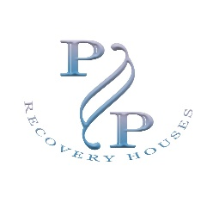
P & P Recovery Houses
P.O. Box 4084, Virginia Beach, VA 23454
Ph. 757-752-2070 ceo@pprecovery.org
Application for Residency
Full Name__________________________Phone#________________Date_________
Current/Former address________________________ City/State_________________
DOB___________ SSN#______________________ Highest Grade _____________
Driver’s License State/or State ID #______________________________
Employer/Source of income___________________ Weekly/Monthly income $________
Address ____________________________________ How long employed________
Phone _____________________________________________
Supervisor _________________________ any other skills_______________________
History of alcohol/drug abuse yes/no_______ past treatment yes/no_______
Emergency Contact Person/Address/Phone number:
Prescription medications:
I authorize Clay Property Management and Consulting, LLC and P & P Recovery Houses to perform a criminal background check by using the above identification information for the sole purpose of screening for housing. This executed application also gives my permission to coordinate with Federal, State, Local agencies, non-profits, social service agencies to assist in securing housing for me. I further authorize a urinalysis and drug screening. This authorization will remain in effect from the date of this signature until residency is terminated in the premises. I fully understand that if I violate the House Rules or Lease that I will have a limited time (30 minutes) to vacate the premises and will do so when directed by management.
Printed Name____________________ Signature___________________

