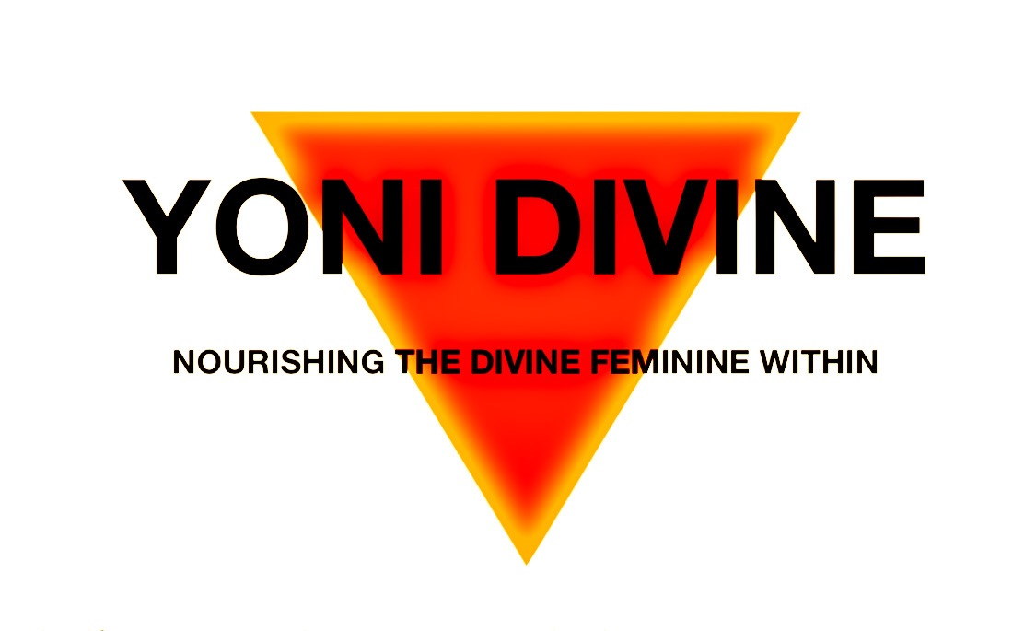

HERBAL YONI WANDS
Regain the natural, healthy balance of the vagina

Yoni Divine herbal yoni wands naturally harmonize and revitalize the yoni. The combinations of healing herbs helps balance pH levels while aiding in cell renewal of vaginal skin. The benefits start immediate as you will feel a sense of renewal and restoration of health and wellness.

Sustainably harvested according to natural cycles and passed down through generations of women who have kept this secret alive in Asia, Herbal Yoni Wands are now being made available globally for all women to adopt the practices of these wise women of the past and treat the most delicate part of their bodies with the highest quality of standards and care it deserves.

The ingredients have powerful antifungal and antibacterial properties that provide natural solutions for vaginal issues – like fungal infections (vaginal candidiasis, candida, or thrush), vaginal dryness, inflammation of the vagina (vaginitis), unpleasant odor (vaginosis), or discharge (leucorrhoea) – and natural exfoliation of the vaginal skin. It works to sensitize, cleanse, and regenerate the vagina to improve the consistency and aroma of its secretion and ward off the return of any unpleasant smelling discharge while also tightening and bringing it back to a youthful state.

Herbal Yoni Wand Efficacy:
- Harmonize Yoni balance + pH, relieve itching, prevent infection, eliminate peculiar smell, remove undesirable secretions, and reduce the incidence of gynecological disease.
- Expel harmful substance, repair wound, accelerate postpartum locia excretion, promote recovery of uterus.
- Tightens the yoni & revives youthfulness.

Herbal Yoni Wand Method of Application:
- First rinse vulva and lubricate vagina with yoni oil. Secondly, humidify the wand by warm water, gently insert the wand into the yoni slowly and softly, rotate the wand clockwise at the same time. About 30-50 seconds. No more than one minute. Remove wand. If there is flocculent or granulate excretion adhere to the wand, you should wash yoni before using the wand. In acute situations it is recommended to use wand according to personal circumstances, the usage should be adjusted.

There are no know Side effects for using an Herbal Yoni Wand.

CONTRAINDICATIONS:
- DO NOT use while menstruating, pregnant, or nursing.
- DO NOT use daily as vaginal dryness may occur (use once per week or as needed)
- DO NOT use a tampon at the same time as using the wand.
- DO NOT get in contact with eyes. If residue gets in your eyes, rinse with water.
- DO NOT ingest. For vaginal use only.
- DO NOT keep wand longer than 9 months after first use.
- DO NOT drop wand. It is fragile and will break if dropped.
- DO NOT Keep in reach of children.

CAUTION:
In cases where an imbalance is present, a noticeable burning feeling may be felt, which will go away with continued use. Discontinue use if the burning is too uncomfortable or does not decrease after the third or fourth application.

Herbal Yoni Wand Ingredients:
Madura, Fructose cnidii (She- Chuang-Zi), Sophora flavescens (Ku Shen), Schizonepetae, Pearl Powder, Dried Alum (Ming Fan)

- Madura: Madura is the most rapid acting medicinal herb found in the Island of Madura, in Indonesia, it is a traditional herb, well-known to Madurese women for hundreds of years, that has been passed on for generations. It has a unique and unusual vaginal muscle contraction, a rapid anti-inflammatory effect and that helps eliminate vaginal odor.

- Pearl Powder: The practice of powdering pearls for use in cosmetics started in China centuries ago and continues today. Pearls contain a unique combination of amino acids, peptides, vitamins & trace minerals that nourish & strengthens the skin, encourages cell renewal & helps to keep the skin soft, supple, and retain its moisture. It contains 10 amino acids which help maintain cell nutrition & are essential building blocks for cell generation.

- Fructose cnidii (She- Chuang-Zi): a traditional herb that has been claimed to have kidney warming effects that invigorate Yang. Known to enhance sexual performance and sex drive. Also used for fertility enhancement as well as for fungal and bacterial infections. Some people also take it to increase energy.

- Sophora flavescens (Ku Shen): is a medicinal herb from China that appears to possess mostly anti-cancer properties

- Dried Alum (Ming Fan): prevents the propagation of bacteria and reduce perspiration by keeping the skin pH low. Similarly, it also works for fungal infection. clinically it is widely used for the treatment of a variety of diseases, such as hemorrhoids, rectal prolapse, uterine prolapse, chronic otitis media, tinea capitis, hydrocele, infectious hepatitis, chronic dysentery, hemoptysis of pulmonary tuberculosis, the ulcer of stomach and duodenum, manic psychosis, infection in burn wounds, epilepsy, canker sores, acne, cold sores, etc.

- Schizonepeta: has warm and pungent properties, Its functions are to expel wind and stop bleeding. It helps to treat bloody stools and uterine bleeding; studies of schizonepeta extract suggest it can speed up the time it takes for blood to clot. Schizonepeta can also reduce inflammation and swelling.

