programme beginning in 2014 for “Remembering the First World War” by supporting the work of the Imperial War Museum for cultural commemorative programmes – funding for which is likely to be available from early 2013. We will be working with Stockport Heritage Trust to ensure the best joint use of the space available to them (and us) in the north aisle – best use of the shop area etc. We will be working with Stockport Deanery, to look towards future requirements and sharing of resources. There is a lot to look forward to as we enter 2013, but we need your help and support, your prayers and encouragement, and for us to work together.

With Best Wishes
For a Happy, Peaceful and Prosperous New Year

31ST December 2012 11.30pm
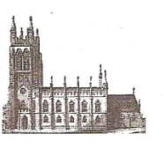
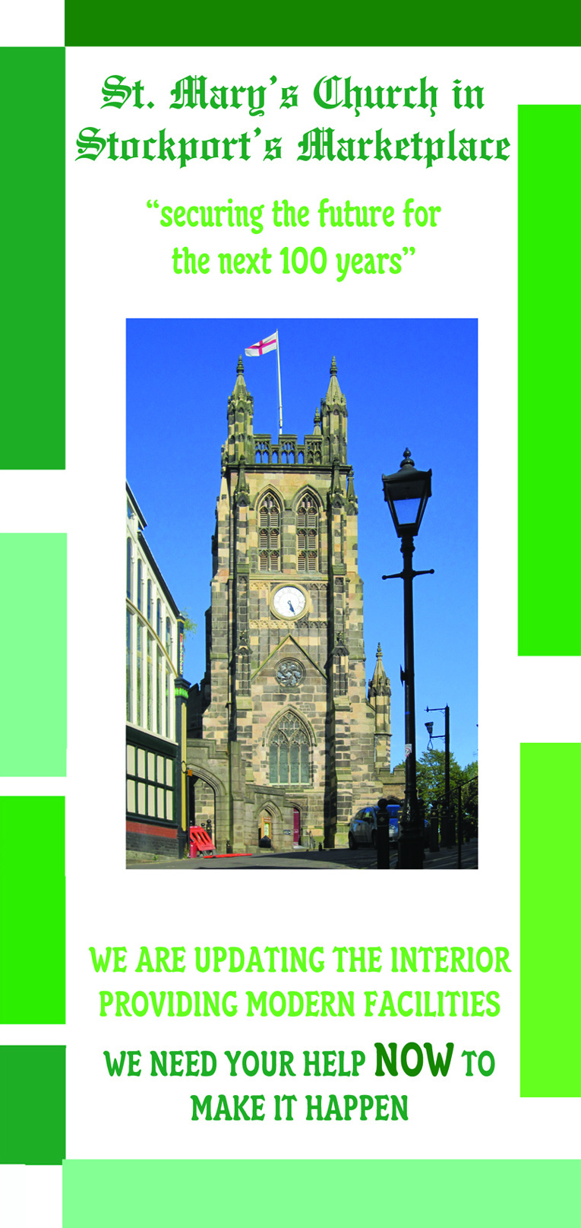
St Mary’s in the Marketplace.

Issue No 24 (30th December 2012)
“Securing the future for the next 100 years”
The drills and hammers remain silent as Lambert Walker take a break, and other than for our Sunday service (and special News Year Eve service on Monday, 31st December) St Mary’s remains closed until Saturday, 5th January 2013.
We have welcomed to services and concerts around two and a half thousand adults and children during December, as well as many other visitors just calling into Church to look round, light a candle, or enjoy our hospitality and fellowship. December was an exceptionally busy month, but a most enjoyable one.
We wish to extend our thanks to everyone who supported our “Christmas Programme” of events and to give a very “BIG” thank you to the “St Mary’s team” of volunteers – everyone who has assisted us, from serving tea/coffee and mince pies to acting as “loo” attendant in the pouring rain – from making the Advent candle-ring and putting up the decorations, to cleaning and mopping – your help is most valuable to us – and will continue to be, as we move into 2013, with new facilities, new opportunities and new “ways of working”.
Our contractors will be back shortly when we will discuss with them the time-frame for completion of works within the North aisle, work that we are able to complete within the main body of the church (as well as the memorial chapel) and of course the completion of works on the tower roof, east elevation of the tower (including return of the clock face) and installation of new flag pole. We remain on target for a mid-February hand-over.
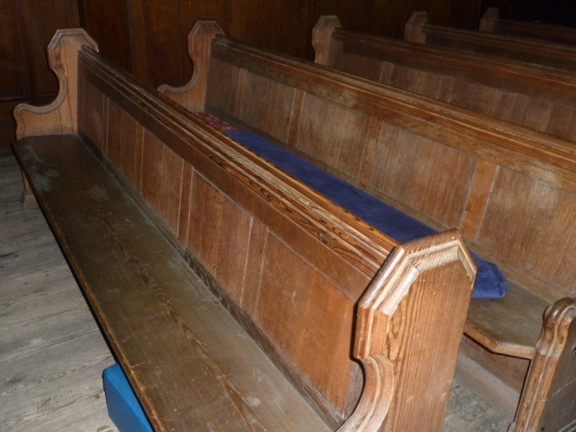
We now have authority to finally sell the pews (both presently in storage and those remaining at St Mary’s). This could be your last change to show an “expression of interest” if you wish to buy one – as we continue to talk to prospective purchasers (trade and otherwise) and will shortly be placing an advert in the local press as well as looking at selling via “EBay”, “Gumtree” or other similar internet outlet.

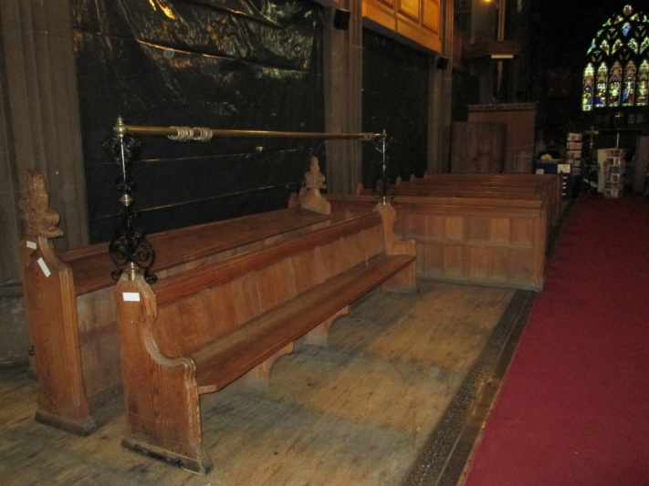

We still have a lot of work to do before “hand-over” day, we would still like to generate more funds to the Interior Appeal Account, we still have applications for funding pending and we still have faculty paperwork to complete. We have deadlines of our own to observe for having storage premises cleared, furniture moved and orders put in place for delivery of our new chairs, cushions, etc.
New “ways of working” will need to be planned and implemented – we will have three toilets to keep spotlessly clean, a semi-professional kitchen to keep to the highest of standards, food hygiene regulations to observe and registration with Stockport Council to operate the “Nave Café”. We will need to continue to ensure that the church is cleaned, brasses are polished, and most of all, to make sure that everyone entering St Mary’s is made welcome.
We will arrange a meeting of our “volunteers” shortly and hope that everyone will continue to contribute towards the work of St Mary’s in one way or another. We will welcome others to join the team and support our efforts – we will look at “partnership working” with other organisations and church groups; at opportunities open to us within the community – either voluntary or business sectors. We will re-visit our “Business Plan” reviewing our aims and objectives for the short, medium and long term. Exciting and challenging times are ahead as we move forward “securing the future for the next 100 years”.
The work on continued restoration will not end in February, we will be seeking grant funding for the vestry areas to be properly re-roofed and repaired during 2013/14. We will be reviewing the historic interest of this medieval part of the Church. We will be working with English Heritage, Stockport Council and other interested parties and towards restoration of the archway at the west end of the church yard and paying special attention to the various war memorials within St Mary’s as we join in the

