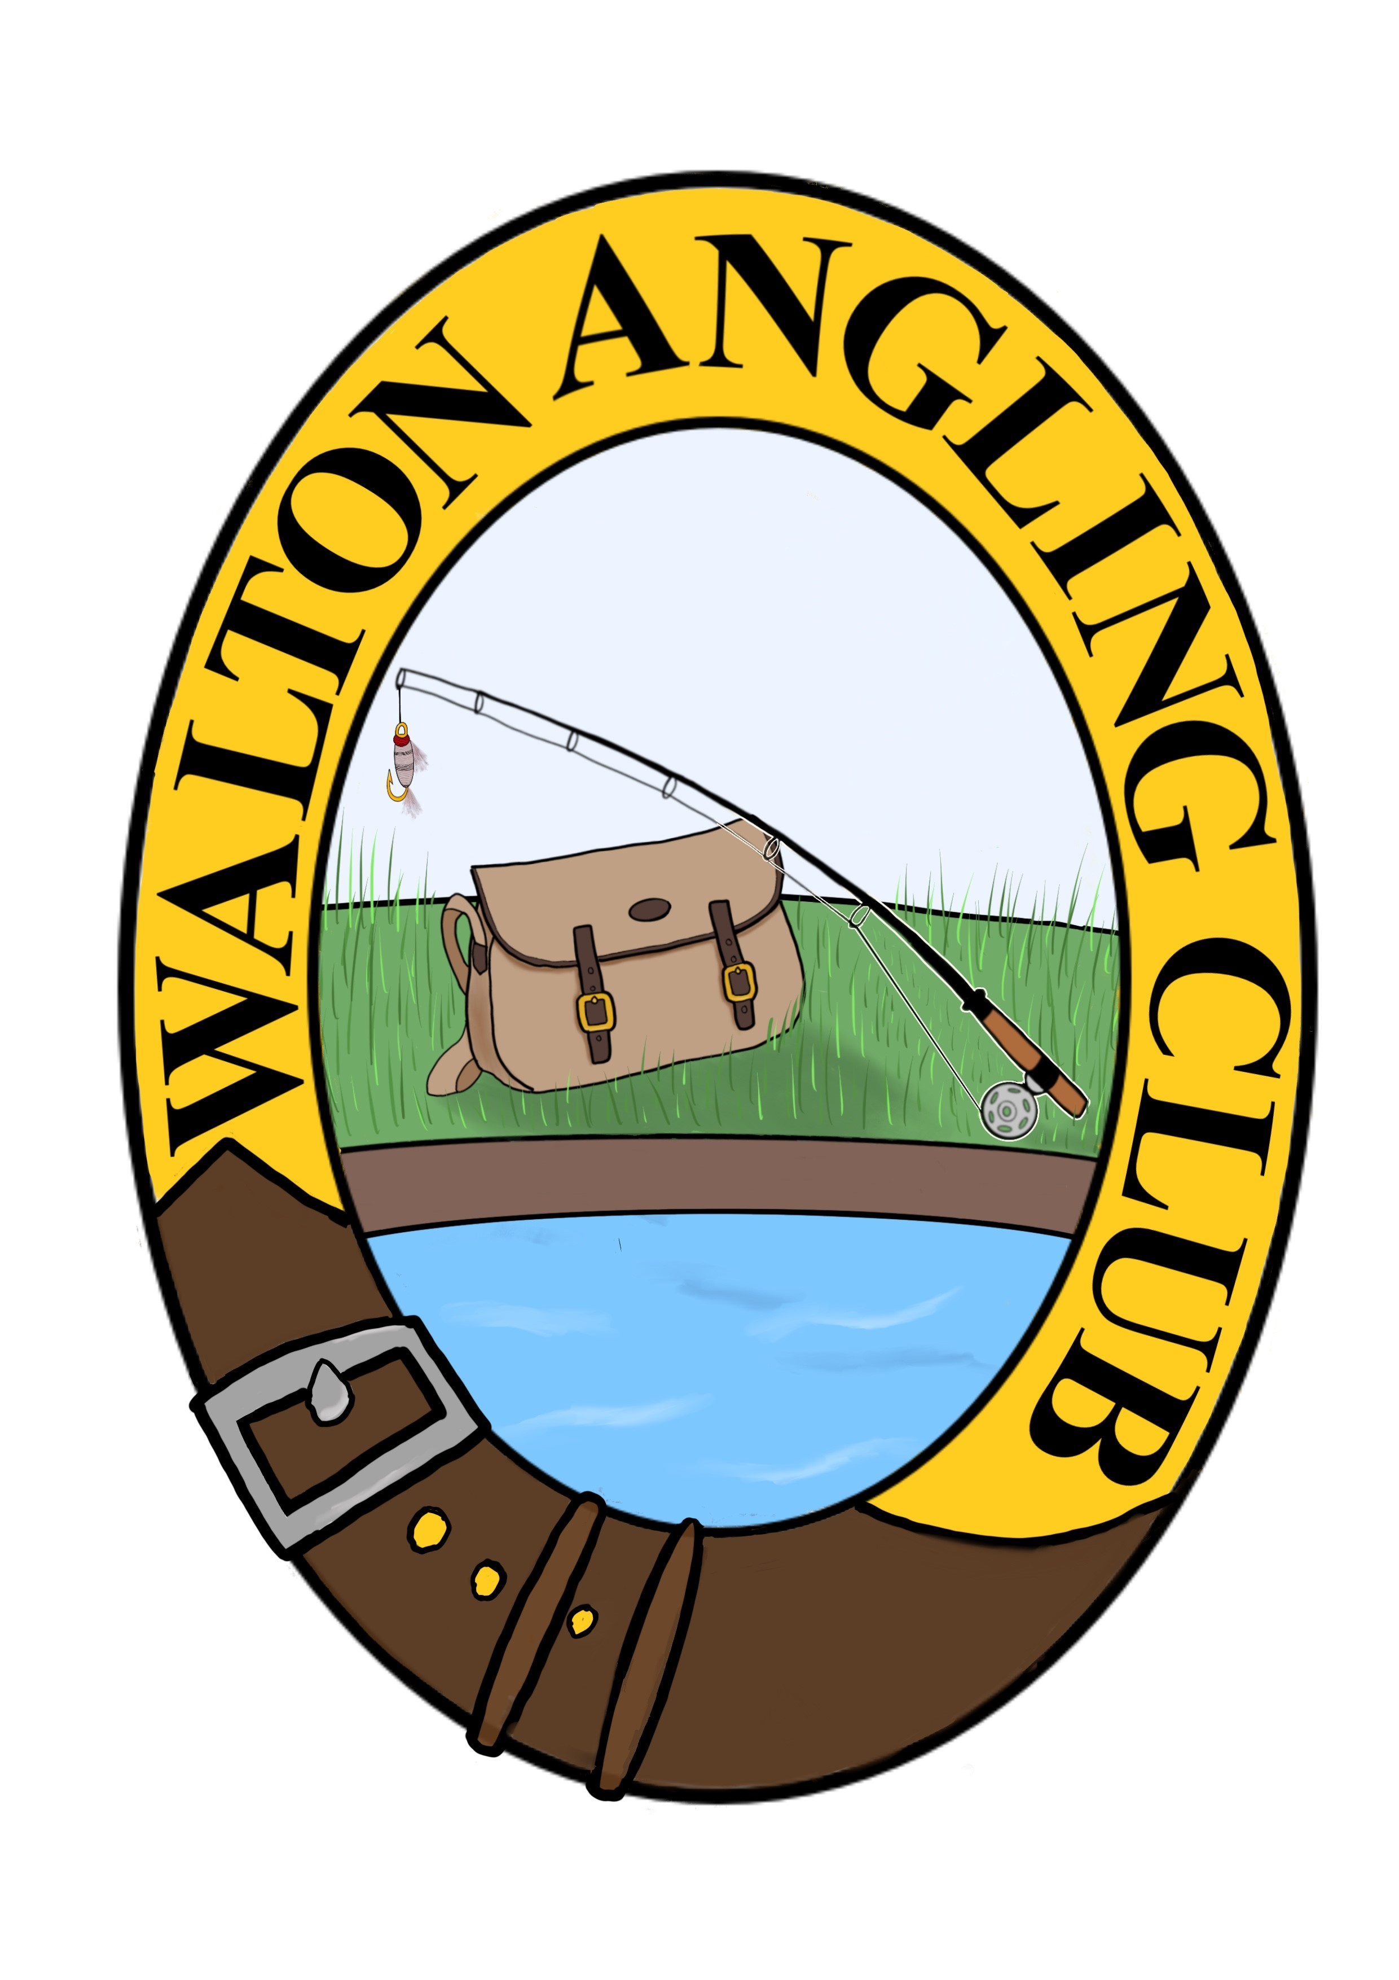
Walton Angling Club

APPLICATION FOR MEMBERSHIP SEASON 2023

COMPULSORY FEES

JOINING FEE: £10.00 £
If you are a new/lapsed member

ADULT: £35.00 £

CONCESSIONARY:
(Under 16 and over 65 by 15th March 2022)

If you are over 65 and new/lapsed or dropping down
from Adult then the fee for season 2022 is £21.00 £
(If your existing concessionary fee is £21 it remains so)

(If your existing concessionary fee is £15 it remains so) £15.00 £

OPTIONAL FEES

To be added to COMPULSORY FEES

Pilmuir Reservoir Section: £105.00 £

TOTAL FEE PAYABLE £

I wish to apply for ADULT/CONCESSIONARY* membership of the Walton Angling Club.
*Delete as appropriate

NAME ……………………………………………………………………………………………………………

ADDRESS ……………………………………………………………………………………………………………

…………………………………… POST CODE ………………………………………………

TEL. NO. ……………………………….. E-MAIL ADDRESS ………………………………………………

Please tick box showing your payment option:

Cheque payable to “Walton Angling Club”

bank transfer (You MUST ensure your name is in the reference section)

Sort Code: 80-12-88 Account Number: 00129274

Please either return this form along with the appropriate fee, if paying by cheque, to the Membership Secretary whose address is at the top of this form. A stamped addressed envelope is always appreciated.

Or complete the form and email it to waltonac@waltonac.com stating the your date of payment.
If you can’t email the form back then please include all the appropriate details on your email so we know what you are paying for.

