A Civil War treasure returned
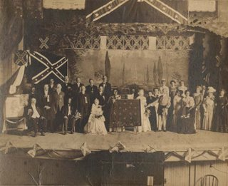
Confederate Memorial Day is May 10. On May 12, 1909 the 4th Ohio Cavalry Association returned the Rifle Scouts' Civil War battle flag to the state of Alabama at the Elk's Theater in Huntsville. Note the presence of Tallulah B. Bankhead --not the famous actress, who was 7 years old at the time, but rather her mother.
Captain John R. Pitts of the 4th Ohio Cavalry Association presented the flag to Mrs. Charles G. Brown of the United Daughters of the Confederacy. The following individuals are pictured: Mayor T. W. Smith of Huntsville; James Quinton (4th Ohio); Mrs. Virginia Clay-Clopton (UDC); Mrs. Helen Plaine (UDC); Joseph H. Goddard (4th Ohio); L. C. Bramkamp (4th Ohio); T. C. Lindsey (4th Ohio); W. W. Shoemaker (4th Ohio); William H. Henry (4th Ohio); Mrs. A. W. Newsom (UDC); Mrs. Charles G. Brown (UDC); Mrs. Cornelia Branch Stone (UDC); Mrs. Andrew J. Dowdell (UDC); Captain John R. Pitts (4th Ohio); Mrs. Thomas W. Palmer (UDC); Mrs. Bennett B. Ross (UDC); Mrs. Leopold Bashinski (UDC); Mrs. Tallulah B. Bankhead (UDC); Mrs. Clarence M. Tardy (UDC); Thomas Osborn (4th Ohio); M. H. Richardson (4th Ohio); C. N. Vaught (UCV); James R. Johnson; Mrs. Ellen P. Bryce (UDC); Mrs. Asa S. Rountree (UDC); Mrs. L. T. Pride (UDC).

