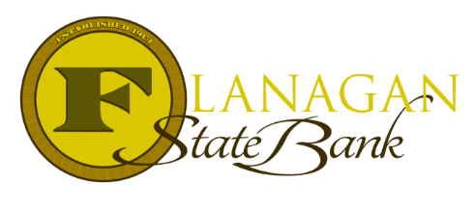
Mortgage Tidbits

Keeping you informed and in the know….

VA Seller Concessions

VA seller concessions work a bit differently than the other programs. It is very helpful to understand the details of what VA allows to negotiate the contract correctly. VA will allow up to 6% concessions, but they specifically break them up into categories. Of the 6%, 4% are allowed to be used toward closing costs. The other 2% is allowed for discount points.

The 4% can be used towards:
- Payment of the buyers Funding fee
- Prepaid taxes and insurance
- Title Fees
- Origination Fees/Lender Fees
- Closing costs that are normal for the area
- Recording Fees

When writing the contract, it is important to break the % up to match what VA will allow, or the concession may not be utilized correctly and to the max allowed for the benefit of the Veteran. In addition, a purchase contract that will be using VA financing MUST state specifically that VA is the loan type or underwriting will request a correction later in the process for the purchase contract.

Knowing the best way to structure a VA loan is an advantage that will be beneficial to the Veteran’s. Being knowledgeable about VA loans will help you win the client and the negotiation!

Call us today for the best answers to the mortgage questions!
Insert photo here or delete box when ready to use
~ Provided to you by ~
Name: Phone:
Title: Email:
Address: City, State, Zip
Apply Now Link:

