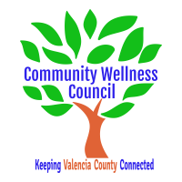
Board Meeting
November 6, 2019
1:00pm-3:00pm Wellness Center

1:00PM-1:15PM

- Call Meeting to Order
- Welcome Guests
- Agenda
- Consent Agenda
  - Minutes of 10/2/19
  - Treasurer Report
  - Coalition Reports
- Social Media/Website Report
- Consent Exemptions
Business
- Coordinator’s Report/Grant Deliverable Activities Update (Noelle) 1:15PM-1:30PM
- Financial Management Update/Monthly Match (Noelle) 1:30PM-1:40PM
- Anna Age 8 Update 1:40PM-1:55PM
- KAH update 1:55pm-2:05PM
- Behavioral Health CRUNCH Debrief 2:05-2:15PM
- CWC Retreat Planning 2:15PM-2:30PM
- OSAP/Strategic Plan and Core Team Planning Update (Linda) 2:30-2:45PM
- MRGDA Update (Noelle/Diana) 2:45pm-2:50pm
- Review of Activities/Time Line/Action Items 2:45 PM-3:00PM

Additional Items of Discussion
- Adjourn

