Indigestion ... Acid Reflux ... Heartburn ... GERD

Literally millions of North Americans take Tums, Rolaids, Prevacid, Nexium, Prilosec, etc. on a DAILY for indigestion, acid reflux, heartburn/GERD.

However, when you look up the side effects of some of these products, the short list can include: headaches, abdominal or stomach pain, diarrhea or constipation, dizziness or vertigo, back pain, malabsorption, depression, muscle cramps, insomnia, etc.

We recommend that you reach for one or both of the following Shaklee products ... Nature provides amazing answers (with NO SIDE EFFECTS)!
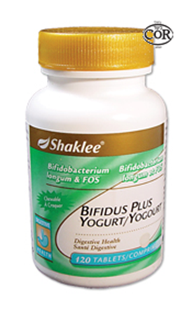
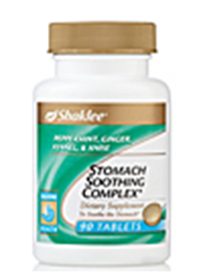

Chewable Bifidus Plus Yogurt ... a “tasty” digestive aid ...
- gentle enough to give to an infant, but powerful enough to make a difference for a grown man
- each tablet supplies 250 million live probiotics in a chewable form, that many brag have brought almost instant relief to upper indigestive problems
- each tablet also contains 100 mg of fructooligosaccharides (FOS), complex carbohydrates that have been clinically proven to multiply bifidobacteria in the intestinal tract
- ingredients supports lactose digestion, and help absorb minerals

Stomach Soothing Complex ... an herbal combo made from peppermint leaf & oil, ginger root, fennel seed and anise seed
- Peppermint has been known for centuries to effectively treat indigestion, gas & abdominal pain. Its essential oil stimulates the flow of bile which helps to make fat more readily digestible
- Ginger root helps in preventing gas, abdominal cramping, and heartburn. It also helps break down proteins, and increases bile production which aids in fat digestion.
- Fennel Seed reduces gas and upset stomach. It also stimulates the pancreas to increase its enzyme secretions which results in better and quicker digestion of food.
- Anise Seed settles the stomach, and reduces indigestion and burping. It also reduces discomfort of colic-type pains.

