Use of School Premises Policy
2016+

Board of Management Scoil Bhríde Nurney
2016+
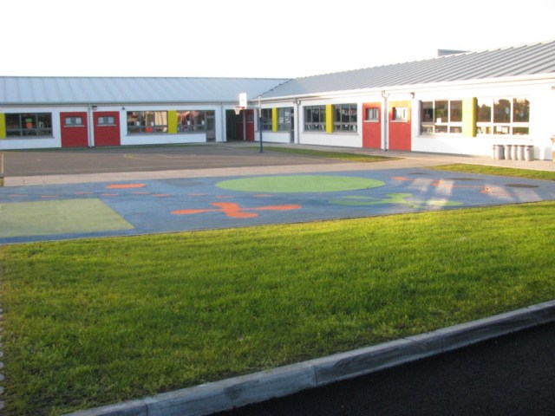

Scoil Bhríde

Use of School Premises Policy

External group use of the school premises for whatever purpose is dependent on compliance with the following directions:

- Application in writing of proposed events to Principal/Chairperson of BOM with all details e.g. Proposed activity, number of people/children involved, duration of hire etc.
- Evidence of appropriate insurance including public liability is provided in writing to the Board of Management (unless the BOM agrees alternative arrangements).
- The nature of the activities for which the school is hired is in keeping with the general educational aims and/or ethos of the school.
- The standard and quality re-organisation, discipline and instruction (where it applies) is in keeping with the professional standard of the school.
- Where it applies, the quality of care towards and responsibility shown to children involved in specific activities is in keeping with that of the school.
- The supervision of children attending extracurricular activities is the responsibility of the teacher/instructor present on behalf of the group/individual hiring the school. This includes the supervision and care of the pupils waiting beforehand and waiting to be collected afterwards.
- Responsibility rests with the group/individual who is hiring the school for communicating with participants about:
- Starting/finishing dates and times
- Cancellations, re-scheduling etc
- All other course information
- A contact phone number should be provided to parents through which all questions are directed. The school phone number is not to be provided as a contact number.

- The teacher/organiser present on behalf of the group/individual hiring the school is responsible for:
- Health and Safety of participants
- Ensuring that the school’s no smoking status is upheld
- Providing evidence of their Garda Vetting to the school
- Providing their Child Protection Policy to the school
- Turning off lights and closing all windows
- Turning off heat and ensuring excessive heat is not used.
- Returning equipment and furniture to proper storage point
- Re-arranging classroom furniture
- All cleaning up afterwards
- Setting the alarm system, locking up the school building and grounds
- The agreed school hire charges are paid by cash or cheque to ‘Board of Management of Scoil Bhríde Nurney’.
- The school reserves the right to use the room for its own purposes.
- The BOM will periodically review the hire of the school premises and should the need arise, to suspend the hire should they deem it necessary. The school reserves the right to discontinue the use of the hall/room at any time for any specific reason.
- The rate will be decided on a case by case basis.
- The Board of Management will periodically review the hire of the school premises.
- There shall be no disruption to any teacher, child or staff member. The group shall use their own resources unless specifically requested otherwise e.g. computers. They will have the use of the specific room which approval has been requested and granted only.
- All course activity organisers shall be responsible for their own tax liabilities. They will provide a tax clearance certificate with their application for use of the school premises.
- The organisers are responsible for familiarising themselves with all Health and Safety Procedures.
- All course organisers shall receive this policy and shall sign it thus agreeing to the aforementioned.
- All course organisers shall receive, read and sign the attached contract (which forms part of this policy) for the rental/leasing of premises for Scoil Bhríde Nurney
- This agreement will be valid, subject the above conditions, for one year.

I _____________________________________ agree to these rules and procedures for my

___________________________________running on_____________________________.

I have provided:
- Evidence of appropriate insurance including public liability is provided in writing to the Board of Management.
- Evidence of Garda Vetting to the school.
- A Child Protection Policy to the school.
- A tax clearance certificate.
- The signed contract below agreeing to all the above terms and conditions

CONTRACT

For the rental/leasing of premises for Scoil Bhríde Nurney

Name of organisation

Address

Phone | Mobile |  | Landline
Email

Purpose for which the premises will be used

Number of participants

Period of rental | From |  | To
Insurance company
(please enclose copy of policy)

Contact person

Phone

- I will pay the Board of Management of Scoil Bhríde Nurney the agreed rate of €________per week/day (delete as appropriate) for the duration of the rental period.
Cheques only and payable in advance to “Board of Management of Scoil Bhríde Nurney”
- I undertake to repair any damage to the premises and equipment and return it to its former state.
- I will ensure that all school equipment is kept safely and properly stored.
- I agree to use only the room(s) agreed in advance
- I agree that the school premises will only be used for the activities agreed in advance.

Any changes in these activities should be agreed in writing with the Board of Management.

Signed by renter: _________________________________ Date: _________________

Signed on behalf of the BOM: ________________________ Date: __________________

Ratification of Use of School Premises Policy

This policy was adopted by the Board of Management on _________________

Signed: _________________________ Signed: __________________________
Chairperson of Board of Management Principal

Date: __________________________ Date: __________________________

Date of next review: __________________

