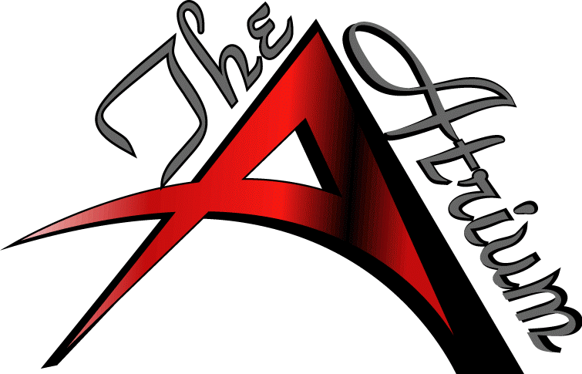
Diamond Room Floor Plan
Bar: Yes/No
Projector: Yes/No
Speaker: Yes/No
Client Name:_______________________Date of Event:_________ Arrival Time____________ Event Type:________________
02

