RESTLESS LEG SYNDROME
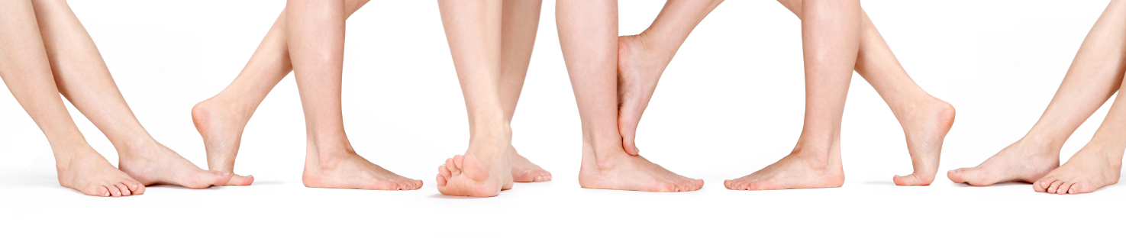

Millions of people have trouble getting to sleep due to a condition commonly known as restless leg syndrome.

Symptoms:
Legs jerk, twitch and kick involuntarily. It can also involve painful nighttime leg muscle cramps.

Causes:
Restless leg syndrome can result from a wide variety of causes including the following:
- Nutritional deficiencies: particularly Calcium/Magnesium, B Complex and Lecithin
  - Calcium/Magnesium is essential for muscle health and relaxation (Extra VitalMag is valuable)
  - B Complex is essential for a healthy, balanced central nervous system
  - Lecithin is a fatty acid essential for insulating the myelin sheath on the central nervous system.
- Lack of Amino Acids: “Quantity” and “Quality” are both essential with regard to Protein.
  - Quantity: Restless leg syndrome can be the result of lack of adequate protein (1/2 to 3/4 gm per pound of body weight is a minimum formula)
  - Quality: Many people get adequate protein from a quantity perspective, but the protein they are eating may be lacking in specific amino acids. Therefore, Shaklee’s raw soy protein powder is recommended to guarantee ALL nine of the essential amino acids daily.
- Toxicity: The accumulation of toxins in cellular tissue is causing a variety of unusual responses in the cellular tissue. A daily detoxification program including an herbal detoxifier for cellular tissue and the liver are highly recommended in a polluted environment. Shaklee DTX is a great choice. A Hair Analysis is a wise choice … it will show if accumulated heavy metals may be a problem. To order your test kit, contact 905-871-4281.
- Poor Circulation: The legs are the farthest from the heart. Aging can cause poorer circulation which can lead to increased symptoms of restless leg syndrome. CoEnzymeQ10, Vitamin E and Ginkgo Biloba are recommended.

Suggestions:
- Avoid caffeine-containing beverages – they are stimulatory and will make matters worse.
- Take a hot bath before bedtime.
- Use Valerian at bedtime (Gentle Sleep Complex is an herbal muscle relaxant from Shaklee, with no side effects)
- Use Ginkgo Biloba to increase blood circulation and increase cellular communication (Shaklee Mental Acuity)
- Use CoenzymeQ10 to powerup the circulation
- The “CHI Machine” is VERY helpful to enhance circulation (use once or twice a day). To order your machine, contact Martha Willmore 905-871-4281.
- Supplement your diet to provide the nutrients necessary: We suggest the use of Shaklee Supplements:
STEP 1: a) Multiple Vitamin/Mineral (Vita Lea)
b) Raw Soy Protein Powder: the 9 essential amino acids (Shaklee Soy Protein)
c) Herbal Detoxifier (Herb-Lax)
STEP 2: a) Additional B Complex
b) Chew Calcium tablets about 30 minutes before bedtime
STEP 3: a) 400 to 800 I.U. of Vitamin E with the evening meal
b) l500 mg of cold-processed Lecithin from soy bean daily (3 Shaklee Lecithin daily)
STEP 4: Take a detoxification bath one a week (using lemons and baking soda)

