Nutrition Plus, Inc.

121 Mays Rd., Winfield, KS. 67156
www.nutritionplusinc.com

Executive Director: Emily Roark (620) 221-2777 roark2@cox.net
Administrative Supervisor: Patti Brenn (620) 218-1811 pattibrenn@cox.net
Topeka Area Coordinator: Susan Morrell
(785) 230-7441 smorrell12@gmail.com
Menu Advisor: Jacque Zimmerman (620) 660-0236 jacque.nutritionplus@gmail.com

June is:
National Country Cooking Month
National Dairy Month
National Fresh Fruit and Vegetables Month
National Papaya Month
National Turkey Lovers Month

Important Dates:
June 5th – Claims Due (This is one of the months where our deadline is so early that if we receive your claim after the 5th, we can’t guarantee payment at the end of June. It might be July before your May claim is paid)

June 17th – Checks/Direct Deposits go out

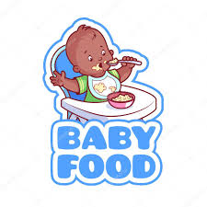
How to make homemade baby food!
The National CACFP Association has a great option for those of you that feed infants. There are many advantages to making your own baby food. Most importantly for you, is that it will save you money and time by using some foods you are already serving the older kids. You can prepare homemade baby food by steaming, boiling, baking, roasting, microwaving, pressure cooking, grilling or sautéing.
This will help you decide which method to use for the different food components in the CACFP infant meal pattern.
Fruits: Soft fruits require no cooking. Just mash and serve.
Harder fruits such as apples and pears need to cook
before puréeing.
Vegetables: Cook by desired method. Steaming or
baking works best. Drain and mash. Then purée.
JUNE 2022

Meats: Cook the meat until well done. Use your blender
or food processor and purée!

Preparation is important. When making food for baby, it is especially important to follow food safety. Wash
your hands, clean the produce, clean your work area, and cook foods to recommended temperatures.
For babies just starting solid foods, you will need to prepare the purées with a thinner texture. As they advance and show readiness signs, you can begin making a thicker texture of baby food for them to enjoy. If you are serving only 1 infant, you can use their breast milk or formula to change the consistency of the food. If preparing for multiples, use the food’s own cooking liquid or water to thin it down.

After cooking homemade baby food: Refrigerate your homemade baby food within 2 hours. It can be stored in the refrigerator for up to 72 hours or in the freezer for up to three months. Be sure to label and date bags to ensure freshness. To freeze, use clean ice cube trays, spooning the mixture into separate cubes (each section of the tray holds about 2 tablespoons of food). You can thaw the baby food when ready by simply moving a cube or the desired amount to the refrigerator where it can stay for up to 48 hours. You can also submerge by placing the cube in a separate container and then putting the container in warm water for about 10 – 20 minutes or microwave on 50% power for 15 second increments. It is suggested not to reheat the food more than once. Thoroughly reheat refrigerated of frozen baby foods to 165° F to kill any bacteria. Allow to cool and test before feeding to baby.
Caution: All foods are subject to the individual infant and their own developmental readiness to consume that food item. It is extremely important to check with the baby’s parents before starting the process of preparing and serving homemade baby food. They may prefer commercially prepared food, which is ok. Also, a warning from the American Academy of Pediatrics: homegrown spinach, beets, turnips, carrots, and collard greens made at home, should not be fed to infants less than 6 months of age because they may contain nitrates. This can cause a condition which can make it harder for a baby’s blood to carry oxygen. You can find more excellent info on homemade baby food on pages 97-108 of your USDA “Feeding Infants in the CACFP” book.
Superhero Toss

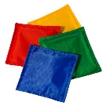

Create two lines parallel to each other, an appropriate
distance apart. Place buckets labeled with exercises on
one of the lines. The children will stand on the other
line. They will take turns throwing bean bags into the buckets. If they land a bean bag, everyone freezes and does that exercise! Labels might include: 10 superhero leaps, 5 spins, 3 Superman punch in the air jumps, Stomp like the Hulk for 10 seconds, throw webs in the air like Spider-Man, etc.

Superhero Capes

Using old t-shirts, cut the front and sleeves off the shirt leaving only the neck and back. Allow the children to decorate with fabric paint, felt and glue stick, any crafty do-dads you can find! Once they are dry, they are ready to fly wearing their individual capes!

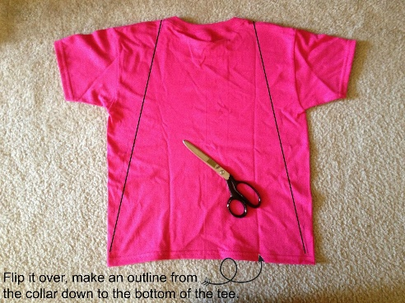

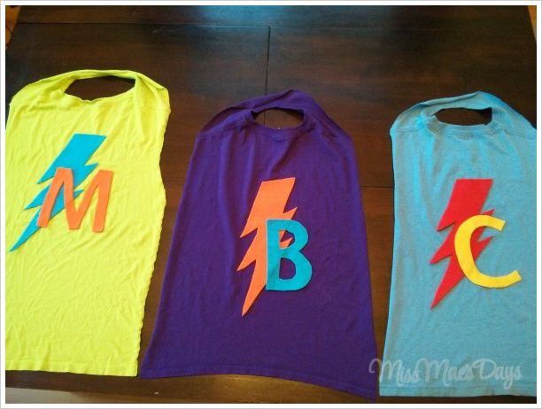
Corn Pudding
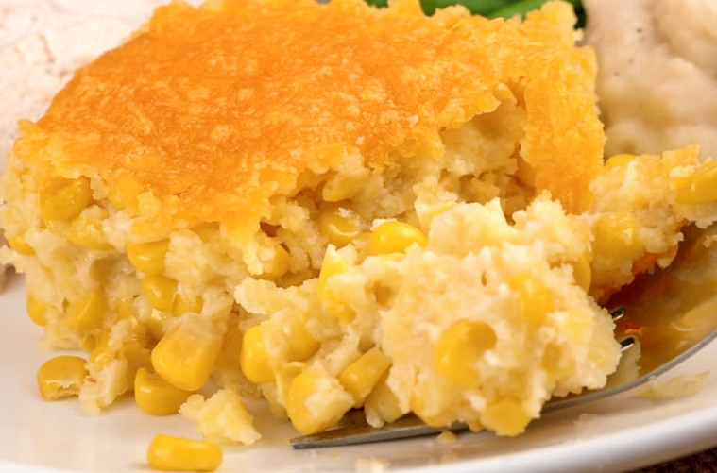
(Corn Pudding is a southern classic that combines frozen corn with canned cream style corn in a luscious batter made of whole wheat flour, whole-grain cornmeal, eggs, and sour cream. It is a delicious country dish!)
Serves 6. Double for 12 kiddos and use a 9” x 13” pan.

Ingredients:
½ cup + 2 Tbsp or 3 oz Whole-wheat flour
¼ cup + 2 Tbsp or 2 oz White whole-grain cornmeal
⅛ cup or 2 Tbsp Sugar
1 tsp baking powder
⅛ tsp Salt
⅛ tsp Ground black or white pepper
1 medium Egg or 1 oz liquid egg
¼ cup or 2 oz Low-fat sour cream
1 Tbsp Canola oil
1 cup or 5 ½ oz Frozen corn, thawed, drained
½ cup or 5 ½ oz Canned cream style corn, unsalted
¼ cup or 1 oz Fresh onions, chopped

Instructions:
1. Preheat oven:
Conventional oven: 375 °F. Convection oven: 325 °F.
2. Combine flour, cornmeal, sugar, baking powder, salt, and pepper in a large bowl. Stir well.
Set aside for step 4.
3. Combine eggs, sour cream, oil, corn, cream style corn, and onions in a large bowl. Stir well.
4. Pour egg mixture over flour mixture. Stir well.
5. Transfer corn pudding mixture to a (8” x 8” x 2”) baking dish lightly sprayed with pan release spray.
6. Bake until golden brown. Conventional oven: 375 °F for 45-50 minutes. Convection oven: 325 °F for 30-40 minutes.
7. Cut into six even portions. Serve hot.
Serve 1 piece (about 2 ½” x 4” square).
CACFP Home Childcare Crediting Information
One piece (2 ½" x 4") provides ¼ cup vegetable, and 1.25 oz equivalent grains.
(I personally make a version of this for every single family get-together because it’s always requested.)

You are all amazing and we are so happy you are helping your kids learn about health and nutrition. Keep doing what you’re doing!
Emily, Patti, Susan & Jacque!

