MILLMERRAN
PONY CLUB
INC.

WORKING HORSE DRAFT
UNOFFICIAL DRESSAGE
GYMKHANA
27th & 28th June 2015
MILLMERRAN SHOWGROUNDS
MILLMERRAN CECIL PLAINS ROAD
FREE CAMPING, POWER, SHOWERS, STABLING.
NO STABLING RESERVATIONS ACCEPTED.
STABLING & CAMPING AREAS TO BE LEFT CLEAN OF MANURE AND RUBBISH.
DOGS NOT ALLOWED IN COMPETITION AREAS AND TO BE ON LEASH AT ALL TIMES.
WILSON’S FIRST AID BOTH DAYS
CANTEEN OPERATING, BBQ LUNCHES AVAILABLE
MULTI-DRAW RAFFLE DRAWN AT COMPLETION OF COMPETITION SUNDAY
Millmerran Pony Club would like to thank all sponsors, helpers and donors that make this weekend possible.
PCAQ HORSE HEALTH DECLARATION MUST ACCOMPANY ARRIVAL.

CHIEF STEWARD: PATRICK LUNNEY
PH: 0447952126
lunneys@virginbroadband.com.au
Working Horse Draft
Saturday 27th June 2015
Starting time: 8.30AM Enquiries: Patrick Lunney(pres): 0447952126 Nominations: $25.00 Carol Christensen(sec): 4695189 12 and under have 1 beast in cut-out Vanessa Lunney(tres):0427952126
Age Groups: 8-10 years 15 & 16 years
11 & 12 years 17 & under 26 years
13 & 14 years 26 years & over
Trophies: 1st to 4th in each age group. Sponsored by C&K Electrical and VacX.
Highest cut-out first round < 15 years sponsored by Club President, Patrick Lunney.
Highest cut-out first round 15 to 25 years sponsored by, the Reid Family.
Rules: To be run in accordance with the” Camp Draft Competition rules” in the PCAQ Camp Draft Rule Book as at March 2015.
HC Horses (i.e.: horses that have NOT had a camp draft start that day) may be accepted if numbers allow at committee’s discretion.
Entries Close: Friday 19th June 2015 (NO PHONE OR LATE ENTRIES ACCEPTED, MONEY MUST ACCOMPANY NOMINATION FORM)
Unofficial Dressage
Saturday 27th June 2015
Starting Time: 9.00AM
Nominations: $5.00 per test HC horses accepted
Age Groups: 8 years & under, 9 – 12 years, 13 – 16 years, 17 years & over
Dressage Tests: a) Walk Trot A b) Unofficial Preliminary 1.1 (iii)
As per PCAQ Dressage Test Book April 2014
Sashes: 1st – 4th place. Sponsored by Mill Inn Tavern.
Highest overall %: Garland donated by County Downs Arabians.
Entries Close: Friday 19th June 2015. (NO PHONE OR LATE ENTRIES ACCEPTED, MONEY MUST ACCOMPANY NOMINATION FORM).
DRAW WILL BE POSTED ON THE DAY; RIDERS COMPETING IN THE CAMP DRAFT AS WELL WILL BE ACCOMODATED.
WILL BE RUN AS A SEPARATE EVENT TO THE CAMP DRAFT i.e. RIDERS MAY COMPETE ON A DIFFERENT HORSE IN EACH DISCIPLINE OF SATURDAY’S COMPETITIONS.
PLEASE FORWARD ENTRIES PAID IN FULL TO: VANESSA LUNNEY: PO BOX 311 MILLMERRAN Q 4357
PH: 0427952126 lunneys@virginbroadband.com.au

Club :________________________________ Contact Name :_______________________________________
Contact Ph :____________________________ Email :______________________________________________

WORKING HORSE DRAFT NOMINATION
Age  Group | Name | Horse | PCAQ  # | PIC  # | Entry  Fee
 |  |  |  |  | 25
 |  |  |  |  | 50
 |  |  |  |  | 75
 |  |  |  |  | 100
 |  |  |  |  | 125
 |  |  |  |  | 150
 |  |  |  |  | 175
 |  |  |  |  | 200
 |  |  |  |  | 225
 |  |  |  |  | 250
 |  |  |  |  | 275
 |  |  |  |  | 300
 |  |  |  |  | 325
 |  |  |  |  | 350
 |  |  |  |  | 375
 |  |  |  |  | 400
 |  |  |  | TOTAL

UNOFFICIAL DRESSAGE NOMINATIONS
Age  Group | Name | Horse | TEST | PCAQ  # | PIC  # | Entry  Fee
 |  |  |  |  |  | 5
 |  |  |  |  |  | 10
 |  |  |  |  |  | 15
 |  |  |  |  |  | 20
 |  |  |  |  |  | 25
 |  |  |  |  |  | 30
 |  |  |  |  |  | 35
 |  |  |  |  |  | 40
 |  |  |  |  |  | 45
 |  |  |  |  |  | 50
 |  |  |  |  |  | 55
 |  |  |  |  |  | 60
 |  |  |  |  |  | 65
 |  |  |  |  |  | 70
 |  |  |  |  |  | 75
 |  |  |  |  |  | 80
 |  |  |  |  | TOTAL

GYMKHANA
SUNDAY 28TH JUNE 2015
EACH CLUB RESPONSIBLE FOR THEIR OWN GEAR CHECK
Starting Time : 8.30 am Nominations : $15.00 All nominations to be paid by 1 club official and all names on official entry form. Horse Health Declarations to accompany nominations for every competitor.
Age Groups : Events:
A Assisted any age 1.March Past (all ages eligible)
B 6 years & under 2.Presentation A – N 11.Sporting Figure 8 A - N
C 7 years 3.Rider Class A – N
D 8 years 4.Barrel Race A – N 12.Mug Race A - N
E 9 years 5.Bending Race A – N 13.Ben-Bar-Aft A - N
F 10 years 6.Flag Race A – N 14.Millmerran Challenge C - N
G 11 years 7.Wagon Wheel A – N 2 rings, no gate < 13 yrs
H 12 years 8.Bondfield Bend D – N 15a.AM7 Showjump I - N
I 13 years 9.Cambooya Classic A – N 15b.A2 Showjump D - H
J 14 years 10.Scudda Ho A - N 16.Lolly Race A - C
K 15 years
L 16 years
M 17 – U 26 years
N 26 + years
Ribbons: 1st – 4th each event
Trophies: 1st – 4th each age group plus medallions for all unplaced in assisted group. Sponsored by Downer
Sashes & Trophies: Champion boy & girl 7 -16 years gaining highest points. Donated by Ergon Energy
Millmerran Pony Club Patrons Shield: Club with 3 or more competitors with highest average points (seniors & assisted not eligible)
Gwen Houston Memorial Trophy: For Millmerran junior rider under 17 gaining highest points in a group of 4 or more. Donated by Gwen’s Family
Current Patron’s Trophy: For Millmerran junior rider under 17 gaining highest points not receiving a trophy. Donated by Club Patron, Mr. John Moffatt
Trophy: For fastest barrel race 12 years & under. Donated by Millmerran Bakery
Trophy: For fastest barrel race 13 – 16 years. Donated by Millmerran Rural Agencies

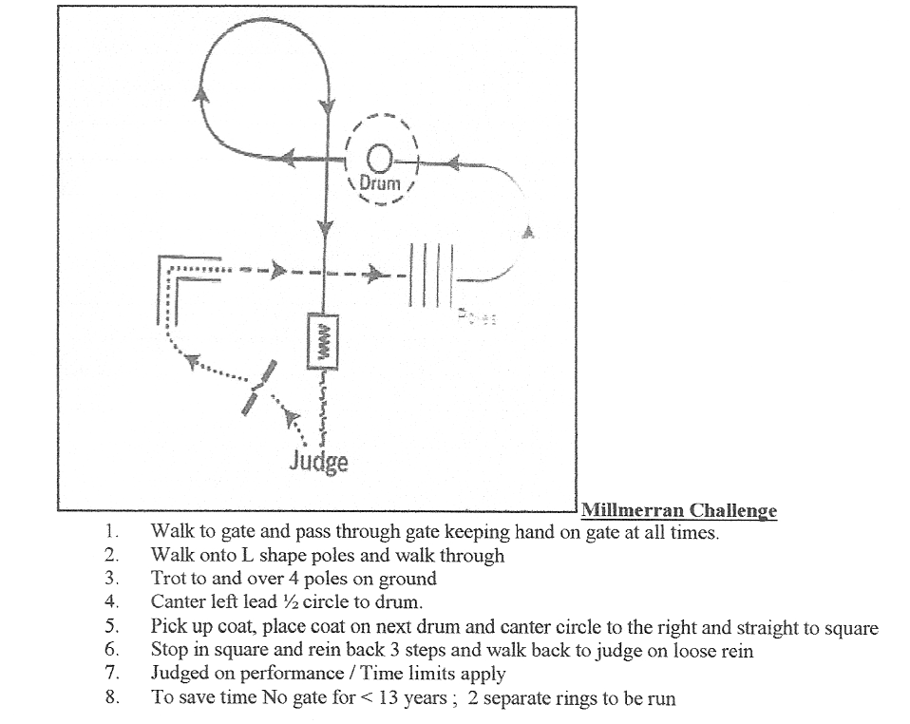
CONDITIONS
- Disclaimer: Neither the organizing committee nor the PCAQ Inc., nor the Millmerran Showgrounds Committee accepts any liability for any damages, illness, accident or injury to horse, owners, riders, spectators or any other persons whatsoever.
- For Pony Clubs affiliated with PCAQ and all events according to PCAQ rule & gear check book 2015.
- Competitors leaving their group without permission of the steward or riding in a dangerous manner anywhere on the ground will be disqualified for the day.
- No outside assistance to be given to unaided competitors. Led horses to be led from the shoulder.
- Senior and aided classes’ points do not count toward the club scores.
- One senior member from each club will form the disputes committee and its decision will be final. A fee of $30.00 is to be lodged with the protest within 30 minutes of the conclusion of the event.
- The organizing club reserves the right to alter, restrict, omit or add to the events or conditions if deemed necessary.
- Judges decision is final
- Member must wear full uniform and helmets – equestrian helmet AS/NZ 3838, EN 1384 or ASTM F1163 with an effective chin strap and boots as per rule book March 2015.
- Pony Club uniform strictly adhered to (NO BLUE JEANS ALLOWED)
- Dressage & Campdraft events are run separately i.e. riders may compete on different horses for each event.
- Callers allowed for dressage tests.
13 Dogs must be kept restrained on a leash at all times.
14. Full pony club uniform to be worn for presentations. Riders must be present to accept the award otherwise it will be forfeited. Organizers, at their discretion have the right to waive this requirement.
- Stables & camping areas must be left free of rubbish and manure.
- ONLY COMPETITORS AND OFFICIALS TO BE IN COMPETITION ARENA.

MILLMERRAN PONY CLUB GYMKHANA NOMINATIONS
CLUB: _______________________________________
Age  Group | Name | HHD  Y/N | Entry  fee
 |  |  | 15
 |  |  | 30
 |  |  | 45
 |  |  | 60
 |  |  | 75
 |  |  | 90
 |  |  | 105
 |  |  | 120
 |  |  | 135
 |  |  | 150
 |  |  | 165
 |  |  | 180
 |  |  | 195
 |  |  | 210
 |  |  | 225
 |  |  | 240
 |  |  | 255
 |  |  | 270
 |  |  | 285
 |  |  | 300
 |  |  | 315
 |  |  | 330
 |  |  | 345
 |  |  | 360
 |  | TOTAL

