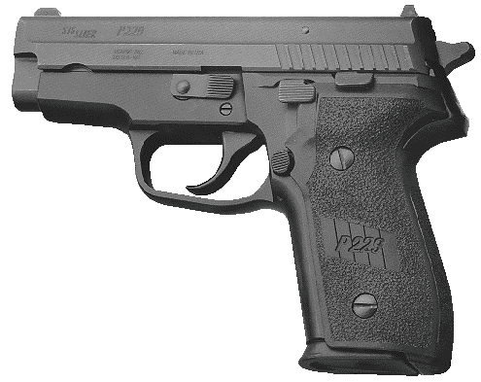

**SIG P-229 .40 S&W**

**The 229, like all SIG pistols, utilizes an automatic firing pin safety. This means the SIG operates without need of traditional safety control levers. It is a double action/single action semi-automatic and the first shot when the hammer is down requires a double action trigger pull.**

**SIG presently has a safety bulletin out advising shooters against lowering the hammer on their pistols with any method other than the decocking lever. When the shooter stops shooting, or if the threat is no longer present, the shooter should take his finger off the trigger and with a simple down-stroke of the decocking lever, lower the hammer on the handgun. The pistol is still instantly ready for action with a double action trigger pull. It is a simple and easy system to teach those shooters who formerly carried revolvers. There is no confusing abundance of safety levers or complicated sequences.**

**The third lever on the left side is the slide release. It is used to release the slide after it locks open, either for the reload or for inspection. The slide release's position relative to the decocking lever requires some training because a common error for new SIG shooters is to hit the decocking lever when they really want to release the slide after the reload.**

**Shooting the .40 SIG reveals a pistol with some recoil, but because the grip is so well designed the rearward push is more straight to the rear than that felt on competing designs. One of my complaints about the .40 S&W cartridge has been the fact that production .40 caliber pistols have seldom demonstrated what I would classify as "good" accuracy. Adequate is an accurate description for most of the past .40 S&W service pistols I have tested, but I was duly impressed with the accuracy of the test P-229. In short, it shot and shot well, even if the recoil proved tiresome and induced fatigue over a three hour test session.**

**At the distance of 50 feet it was not uncommon to keep 12 rounds within a 3 1/2" circle in continuous firing strings that offered no pause for rest. If I concentrated on my best five-shot slow-fire strings, I could easily tighten these groups by an inch or better.**

**The P-229 is a successful pistol. It combines high round capacity (12+1) together with a serious big bore cartridge, and it does it in a package that is both light to carry and easy to shoot. The feel of a SIG is legendary, but the most sterling quality of the P-229 is its reliability. These guns work!**

**It may have taken SIG a little longer to introduce and produce their .40 S&W pistols, but believe me the wait was worth it. The P-229 is a serious self-defense/law enforcement handgun.**