In the summer of 1608, some children tending sheep reported seeing a beautiful lady holding a baby on the spot where a church had stood, and she was weeping. The children returned the next day with some villagers, including a Calvinist minister. They all saw the lady as well.
A new Catholic church was built on the site of the old one, and eventually replaced by a much larger one to accommodate the multitudes of pilgrims – now the Basilic of the Nativity of Mary. The Chapel of the Apparition, built over the rock where the Virgin appeared, has the tallest steeple in Lithuania. Pilgrims kiss the rock itself, which is accessible under the chapel's altar.
For its devotion to the Virgin, Pope Pius XI entitled Lithuania as Terra Mariana ('Maryland'). Until World War II, processions of pilgrimage to Šiluva would start in towns all over Lithuania. Our Lady of Šiluva is the patroness of those who have lapsed from the Catholic faith, and of those who pray on their behalf.

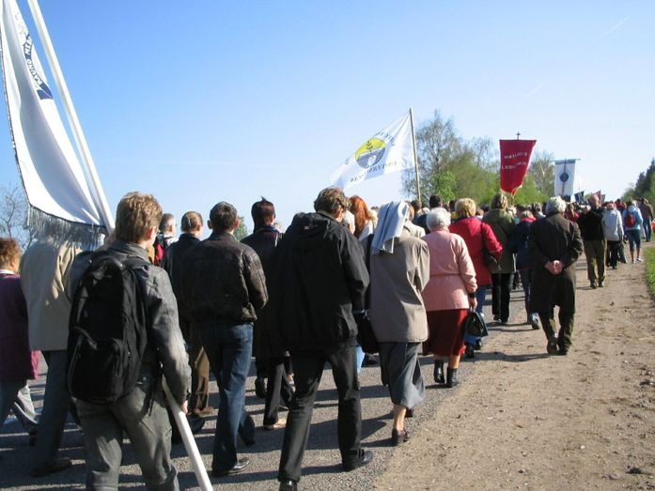

Lithuanian pilgrims on the way to Šiluva.
Image: CD, CC BY-SA 3.0

