PROJECT FUNDING APPLICATION FORM

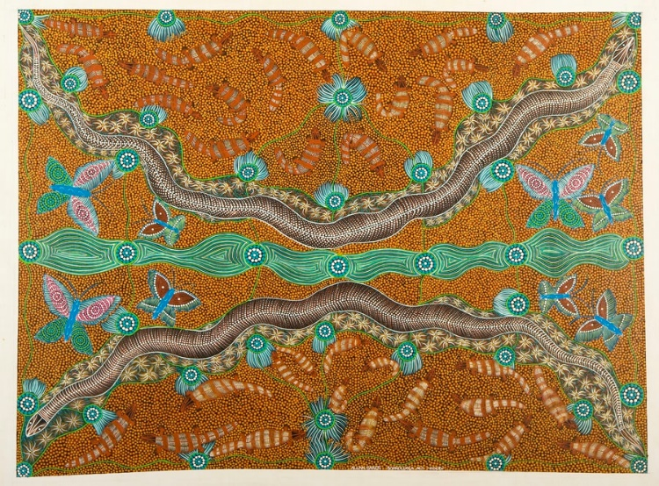
The McArthur River Mine Community Benefits Trust supports the social and economic development of the Gulf region.

This form can be used to apply for grant funding for programs or projects to be implemented for the benefit of this regional community. Please refer to the Project Funding Guidelines in preparing your application.

Additional pages can be attached.

Project Name ____________________________________________________________

Organisation ____________________________________________________________

Grant value ____________________________________________________________
ORGANISATION DETAILS
The organisation is the body applying for the grant and undertaking the proposed project or activity.
Legal Entity | Click here to enter the exact name of the incorporated organisation.

Trading Name | Click here to enter text.

ACN | Click here to enter text.

ABN | Click here to enter text.

Are you currently registered for Goods and Services Tax (GST)? YES NO
Postal Address | Click here to enter text.
 | Click here to enter text.

Telephone | Click here to enter text. | Facsimile | Click here to enter text.

Email address | Click here to enter text.

- CONTACT PERSON DETAILS
For inquiries regarding the application
Name | Click here to enter text.

Position | Click here to enter text.

Telephone | Click here to enter text. | Facsimile | Click here to enter text.

Email address | Click here to enter text.

- ACCOUNTABLE PERSON DETAILS
Name | Click here to enter text.

Position | Click here to enter text.

Telephone | Click here to enter text. | Facsimile | Click here to enter text.

Email address | Click here to enter text.

- ELIGIBILITY STATUS OF INCORPORATED ORGANISATION

Please confirm that the organisation is eligible to apply for a grant by ticking the relevant box below.
Incorporated under the Associations Incorporation Act 1981
Incorporated with non-profit objectives under the Corporations Law
Incorporated under the Co-operatives Act 1997
Incorporated under the Aboriginal Councils and Associations Act 1976 (Commonwealth)
Incorporated under the Community Services (Aborigines) Act 1984
Incorporated under the Community Services (Torres Strait) Act 1984
An organisation with non-profit objectives incorporated by an Act of Parliament and which is approved by the Treasurer
Other (please specify)
Click here to enter text.

- ORGANISATIONAL CAPACITY

Provide a brief overview of your organisation including its purpose and operations.

Click here to enter text.

Detail your organisation’s experience in successfully undertaking projects including:
- Previous project/program delivery
- Working with strategic partnerships
- Reporting, management and technical capacity.

Click here to enter text.

Is a Business Plan or Feasibility Study available in relation to this project? (Please include a copy with your application)

YES NO

- PROJECT DETAILS

Project Name

Click here to enter text.

Project Overview
Provide an overview description of the project including its current status.
Click here to enter text.
How does this project coordinate or support your organisation’s other initiatives?
Click here to enter text.
What are the key outcomes this project will achieve? (please be as specific as possible)
Click here to enter text.
Who will directly benefit from this project? (include numbers of people if known)
Click here to enter text.
How many local people will be employed with this project?
(Please include number of people to be employed, type of employment [fulltime, part-time, casual, contract] and period of employment.)
Click here to enter text.
How will this project assist the Borroloola community to achieve its vision as described in the Project Funding Guidelines?
Click here to enter text.

Of the Trust focus areas below, to which one category does your project best relate?
Enterprise and job creation
Education
Social and community development
Environment
Health
Culture and Art

How will the community be involved in or contribute to the project? (Please note if consultation has already been conducted within the gulf regional community in support of your project.)
Click here to enter text.

Does the organisation have the support of key community stakeholders to implement this project?

Yes No
Please provide proof of this support for relevant projects:
- Local Elders support for Aboriginal culture, arts and/or storytelling projects
- School Council support (in writing) for education, sport and young people’s programs

- PROJECT MANAGEMENT

List the members of your organisation’s executive management and Board and provide a brief summary of their relevant experience.

Click here to enter text.

How will the project and its finances be managed?

Click here to enter text.

Provide details of the implementation schedule for this project including the start date.

Click here to enter text.

- EVALUATION AND REPORTING

Please nominate 3-4 key performance indicators or targeted outcomes that will determine the success of the program. (e.g. participation in sport in Borroloola increases by 5% by 2020)

Click here to enter text.

Please indicate the length of your project.
These periods will be included in Funding Agreements for projects approved by the Trust in line with the stated reporting periods in the Guidelines.
Project < 12 months duration
Project > 12 months duration

- FINANCIAL MANAGEMENT

Please attach as supporting documentation:
- information about your organisation’s financial status
- a specific budget for this project including projection of revenue from all sources and expenditure.

Please note: Grants are expressed in GST exclusive terms.
For more information on the Trust’s treatment of GST, please refer to the Project Funding Guidelines available at:
http://www.mcarthurrivermine.com.au/EN/Publications/Pages/CommunityInformation.aspx

Budget summary
What is the total budget for the project? | $Click here to enter text.
What is the total funding being sought (GST exclusive) from the MRM Community Benefits Trust? | Click here to enter text. $A
How much equity is your organisation putting into the project? | $Click here to enter text.
How much is sought from other sources of funding?* | $Click here to enter text.
How much funding is for this financial year (year ending 30 June)? | $Click here to enter text.
What is the period the funding is being sought for? | Click here to enter text.
What is the anticipated commencement date? | Click here to enter text.

*Is funding available through any other sources eg. Territory, Federal, Philanthropic trusts or any other sources?
Yes No
Please indicate what other sources have been considered and the status of these approaches. Please specify the program name, source and level of funding.
Click here to enter text.
If your organisation is registered, required to be registered or become registered for GST, do you agree to issue valid tax invoices prior to payments being made by the Trust?
YES NO N/A

Recurrent implications of project
Will the project require funding support in subsequent years?
Yes No
Please indicate how the organisation will meet resulting recurrent commitments, aside of any grant support from the Trust.
Click here to enter text.
NOTE: Where alternative funding has not been considered, Trust’s Project Officer may assist in identifying opportunities.

- PROJECT PROMOTION

How will the MRM Community Benefits Trust be recognised for its contribution to your project?
Click here to enter text.

- CERTIFICATION

This application should be signed by the Accountable Officer named in Question 3 and by another office bearer in the incorporated organisation, e.g. Secretary or Treasurer.

We certify:

- The information given in this application is true and correct and that all the conditions of the grant will be complied with should support be approved.

- The application is consistent with the aims and objectives of the incorporated body as set out in its Constitution.

- There will be appropriate insurance coverage for the project.

- Reporting requirements of the Trust will be met.

We authorise McArthur River Mine Community Benefits Limited to confirm details of information provided in this application form with relevant government department and/or non-government sources. We understand these inquiries would be for the sole purpose of assessing the eligibility of a project to be funded by McArthur River Mine Community Benefits Limited.

Click here to enter text. |  | Click here to enter text.
Full Name of Accountable Officer |  | Position in organisation
 |  | Click here to enter text.
Signature |  | Date
Click here to enter text. |  | Click here to enter text.
Full Name of Accountable Officer |  | Position in organisation
 |  | Click here to enter text.
Signature |  | Date

- SUBMIT APPLICATION
Applications should be submitted by email to the following address. For further information, please contact the Trust Project Officers at the email/phone number provided below.
Project Officer
Plan C
Jim Gleeson
0422 794 072
email: cbt@planc.com.au

Checklist - I have attached the following:

Copy of Incorporation document

Information on organisation’s financial status

Completed Project Funding Application

Completed Project Budget

Other: ............................................................

