Nutrition Plus, Inc.
121 Mays Rd., Winfield, KS. 67156
Emily Roark Patti Brenn Susan Morrell
(620) 221-2777 (620) 218-1811 (785) 230-7441
roark2@cox.net pattibrenn@cox.net smorrell12@gmail.com
www.nutritionplusinc.com
February is:
Canned Food Month
National Bake for Family Fun Month
National Cherry Month
National Grapefruit Month
National Hot Breakfast Month
National Snack Food Month

Important dates:

February 26th – Checks/Direct Deposits go out

Whole Grains made easier!

Children need whole grains every day. They contain key vitamins, minerals, and fiber to keep their bodies healthy and strong. Get children in the habit of eating and enjoying whole grains, by introducing them when they are young and continuously including a whole grain at meals or a snack at least once a day.
You probably won’t win them all but if you do, congratulations, Rockstar!

Here are some options to consider for variety:
- Whole-wheat bread, rolls & bagels
- Whole-wheat waffles & pancakes
- White whole-wheat bread
- Whole-wheat crackers
- Whole-grain cereal
- Brown rice
- Whole-wheat pasta
- Oatmeal
- Whole-grain tortillas
February 2021

Let’s test your whole grain skills!

Try this out!
Which of the following foods is a whole grain?
A. Bread ingredients: whole wheat flour, niacin, iron, riboflavin, folic acid…
B. Tortilla ingredients: wheat flour, soybean oil, salt, corn, starch, wheat starch…
C. Roll ingredients: unbleached enriched wheat flour, sugar, salt, soybean oil, and yellow corn meal…
Circle your answer.
Answer: A. Bread. First ingredient is whole-wheat flour

Try again!
Which of the following foods is a whole grain?
A. Bread ingredients: unbleached enriched wheat flour, malted barley flour, riboflavin, honey, yeast, other preservatives…
B. Cracker ingredients: whole wheat flour, unbleached enriched wheat flour, cheddar cheese, vegetable oil & 2% or less of other irrelevant ingredients.
C. waffle ingredients: water, whole wheat flour, enriched wheat flour, canola oil, whey powder, sugar, leavening, egg whites, oat bran…
Circle your answer.
Answer: B & C. Crackers and waffles. Crackers first two ingredients of whole wheat flour and unbleached enriched wheat flour follow the “rule of 3” and qualify them as whole grain-rich. The waffle’s first two ingredients, after water, of whole wheat flour, enriched wheat flour follow the “rule of 3” and qualify them as whole grain-rich.

You Make My Heart Flutter Craft
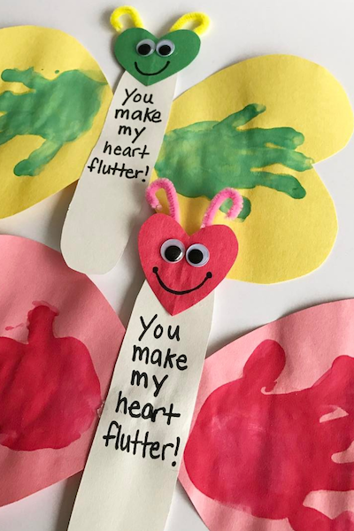

Supplies needed:
Washable paint
construction paper
googly eyes
pipe cleaners
glue (stick works best)
marker

First: Cut two large hearts for wings and one small heart for the head out of construction paper. Also cut out a long oval for the butterfly’s body. Cut the pipe cleaners to 3 inches and curl the ends.
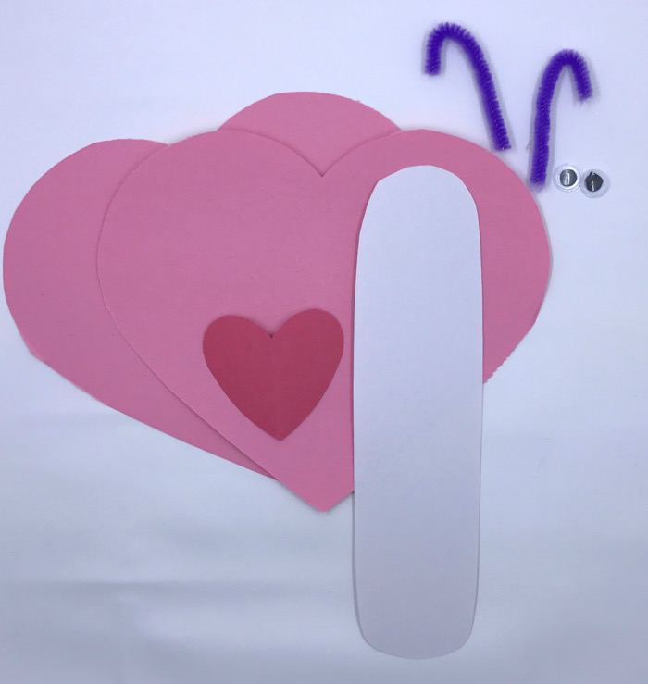
Dip your child’s hand into washable paint and stamp it onto both hearts. Let the paint dry.

After it’s dry, attach the two hearts to the back of the body. (If you can, use a hot glue gun or glue stick. Elmer’s glue made the marker bleed through the paper.) Then write the words “You make my heart flutter” on the body. (Moms will eat this up and they’re stress out to the max right now!!) Glue on the googly eyes, pipe cleaners, and draw a smile.
Open-Faced Pizza Burgers
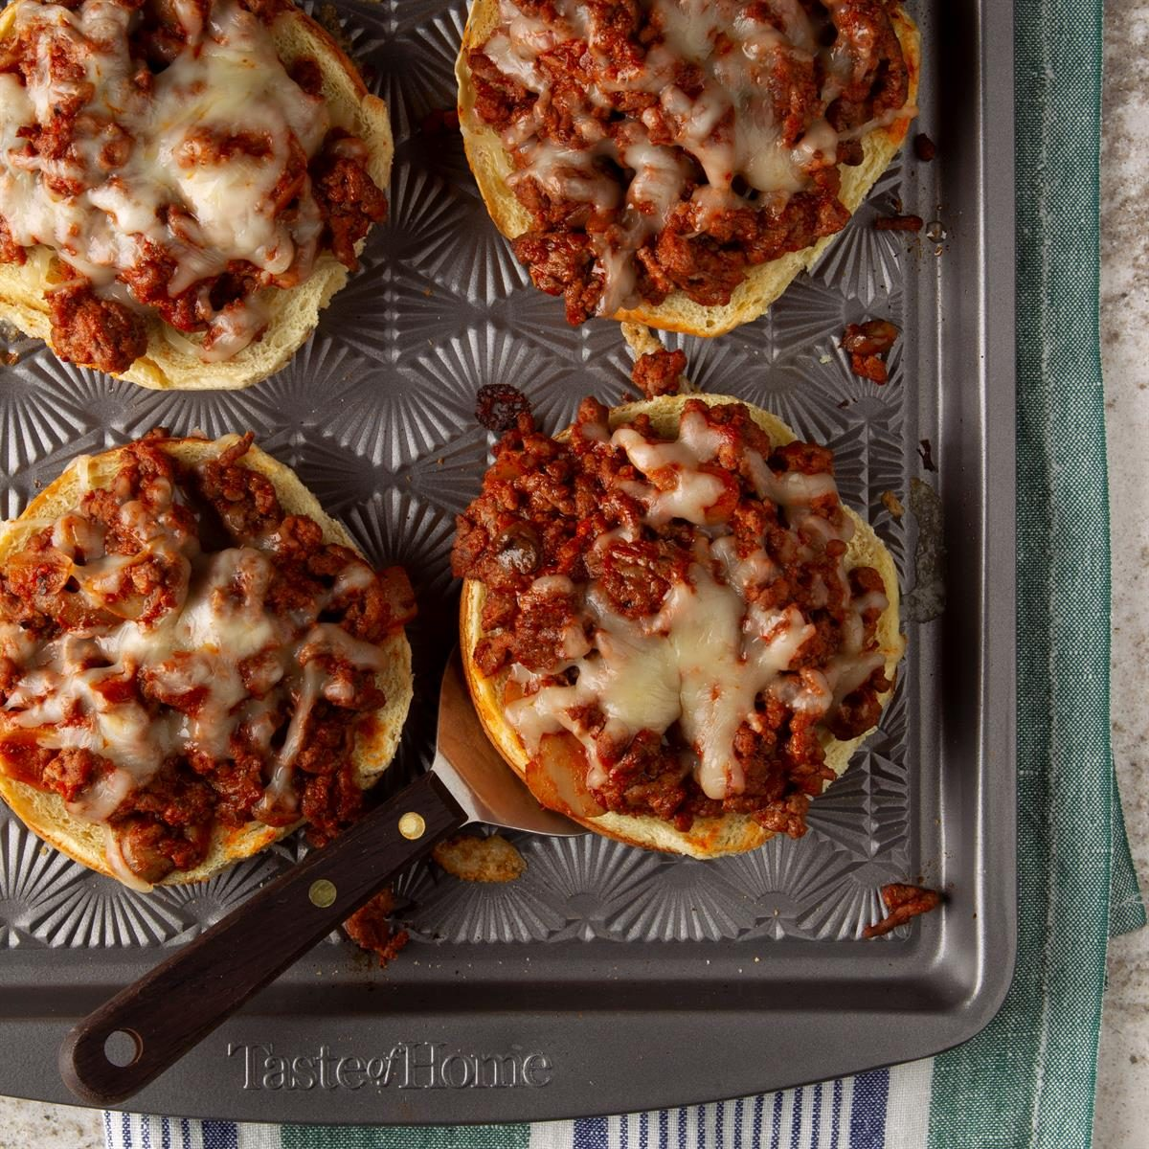

Ingredients needed:
1-1/2 pounds ground beef
1/4 cup chopped onion
1 can (15 ounces) pizza sauce
1 can (4 ounces) mushroom stems and pieces, drained
1 tablespoon sugar
1/2 teaspoon dried oregano
6 hamburger buns, split and toasted
1-1/2 cups shredded part-skim mozzarella cheese

1. In a large skillet, cook beef and onion over medium heat until the meat is no longer pink, 3-5 minutes, breaking into crumbles. Drain. Stir in the pizza sauce, mushrooms, sugar and oregano; mix well. Spoon onto buns; sprinkle with mozzarella cheese.
2. Place on ungreased baking sheets. Broil 4 in. from the heat until cheese is melted, 2 minutes.
Serves 12
3. To freeze for quick lunches later, place the split and toasted buns on a baking sheet. Spoon the meat mixture onto buns; freeze for 1 hour. Transfer to freezer-safe airtight containers.
4. To use frozen burgers: Thaw completely in the refrigerator. Sprinkle with cheese. Broil 4 in. from the heat until heated through and cheese is melted, 2 minutes.

You all are doing an amazing job. Give yourself a break once in a while. Thank you for being the best of Nutrition Plus. Emily, Patti & Susan

