Ackworth & District Riding Club
Annual Presentation Night
17/02/2022
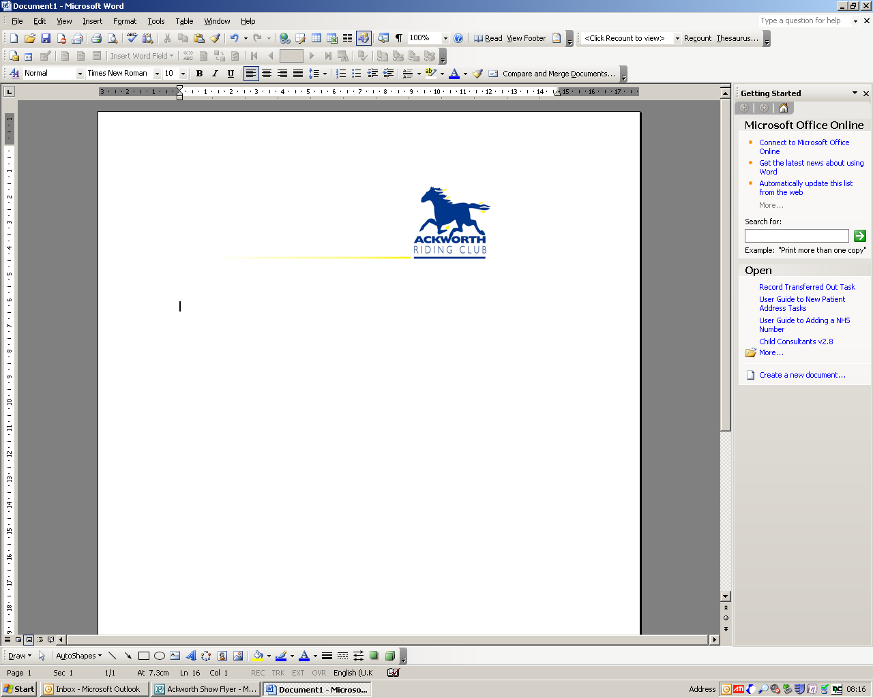
MEMBERS NOMINATION FORM
2021 YEAR

9 Services to the Club
This person was chair then treasurer and has spent many an hour trying to sort out payments to the club whilst learning all the different activities that can take place within a year from training, membership, camp, area and members’ competitions. She has been trying to step down from this role for about 3 years and stayed whilst the search was on.
We are not letting her go completely as she does like to sort us out (well she tries) and so many thanks to Linda Binns.

1. JUNIOR (UP TO 18YRS) RIDER AND THEIR HORSE OR PONY OF THE YEAR
Name & Reason
For someone who has joined in and had a good year with the club.
Evie Edwards
After a full year of not being able to compete when she had only just really started jumping, Evie became the new jockey of the famous Crackerjack and they qualified for the Naff National Championships in the 70 showjumping. Evie was gutted though when Cracker went lame and thought she wouldn’t be able to go. A wonderful offer came in from Ella & Louise Kett for Evie to ride the equally amazing Willpower and after sitting on him only twice before off they went to the champs. Evie rode brilliantly and William looked after her so well. 2 fabulous clear rounds earned them a fantastic 5th Place in Evie’s first ever championship

2. SENIOR (18 AND OVER) RIDER AND THEIR PONY OR HORSE OF THE YEAR
Name & Reason
For someone who has joined in- be it training, members’ competitions, helping, fund raising, sporting, supportive etc You decide.
Moulin Rouge and Margaret Smith:
They have had a very rewarding 2021 season. Apart from organising training events, including camp, being Chair of Area 4 she has ridden at riding club qualifiers, qualifying for both Novice & Intermediate Virtual Dressage Championships, DTM National Championships at Bury Farm and she competed in both Novice & Intermediate Summer Area. In the autumn Margaret was part of the Jorvik team with a respectable Elementary Test with 70%+ and then qualified for the Winter Intermediate Championships.

3. BEST PAIR OF VOLUNTEERS
Name & Reason
We often see people helping but who have you noticed? Where and what were they doing? Junior or Senior? Nominate as many as you wish.
Sheila Rogerson and Margaret Smith :Two golden oldies who both put in time for the members and running/organising the activities and area events
4. UNSUNG HERO
Name & Reason
Who is that non-member of the club who seems to help a lot?
Val Hobson
Always there cool as you like! Spends hours of her time helping at the members SJ and keeps us all on the straight and narrow. - for the commentary and scoring

5. RIDING CLUB MEMBER OF YEAR
Name & Reason
For someone who has joined in- be it training, members’ competitions, helping, fund raising, sporting, supportive etc Has the club helped this person to progress? Have they done something new? You decide.

Alex Mounsey
Has supported the Club at numerous training events, helped out at the Show Cross at Epworth, pole picked at jumping. Alex has progressed and now is jumping 90 cm comfortably and this has been great to see. Even though Ozzy her horse looks like an angel he has been difficult, esp. at Epworth Camp lol, when seen to move so fast….and leap in the air, and he is a big lad too. Qualifying for the championships from a strong class was topped by 3rd place at Lincoln.

6. NEWCOMER OF THE YEAR
Name & Reason
Who has joined recently and made an impact and why?
Emma Haigh,
Since joining the club she has had a go at everything she can fit in. Has been to training, members’ competitions and has helped at dressage. Then she went to the dressage qualifier and has qualified for the Novice Winter Championships in March. Emma Haigh burst onto the scene and very quickly became a familiar face at training and then as a competitor at dressage and jumping.
7. OUTSTANDING ACHIEVEMENTS (BRC EVENTS)
Name & Reason
Who took part and was successful in 2020/21 in area competitions or championships? Was it a step up for them? Let us know.

Lorraine Holmes.
This is in recognition of now seeing the results of perseverance in building her partnership with Millie. 2021 saw Lorraine riding at many of the club and area competitions and then qualifying for the riding club championship in style jumping. She was also in the winning team at the combined challenge, waiting for an invite to the champs.

8 Improver of the Year
This has been discussed by trainers and organisers of members’ competitions and although many names came up the recipient of this trophy was unanimously agreed. She has normally acted as groom, driver and supporter but now is taking the opportunity of having a go herself and is coming to the members’ dressage on William.
The winner is Louise Kett.

MEMBERS LEAGUE RESULTS:
DRESSAGE: SENIOR
6th Sally Ramskill
5th Lorraine Holmes
4th Emma Haigh
3rd Dave Rogerson
Res Champion Alex Mounsey
Champion Louise Hobson
SHOW JUMPING: SENIOR
6th Emma Love
5th Emma Martin
4th Lorraine Holmes
3rd Alex Mounsey
Res Champion Sheila Rogerson
Champion Geraldine Gundill
JUNIOR
Res Champion Gabriella Musgrave
Champion Evie Edwards

