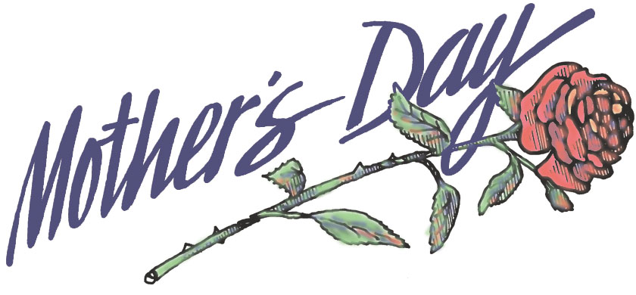
Mother’s Day Litany

Pastor: For those women who have joined God in Heaven
and whom we miss dearly here on earth.
All: Thank God for the mothers of the past.

Pastor: For every woman who is working day and night
to raise her children right now.
All: Thank God for the mothers of today.

Pastor: For all the women who are expecting, but aren't
quite mothers yet!
All: Thank God for the soon-to-be-mothers.

Pastor: For the women who took in others' children through
adoption and foster care.
All: Thank God for the mothers with hearts so big.

Pastor: For those women who have lost a child to death and
must carry on.
All: Thank God for the mothers who are so strong.

Pastor: For all the women who have desperately wanted to
have children of their own, but chose instead to mother
everyone else.
All: Thank God for the mothers in spirit.

All: We thank you, Lord, for the women who have
influenced our lives in so many ways. We pray that we
will honor them in everything we do. Amen.

