Episcopal Formation Chapters 11 and 12
Exodus 39:27-31

Week 11 Continues Symbols of the Episcopacy
First, we recap the last lesson and continue discussing the symbols and appointments of the episcopacy and their importance to the ministry of the bishops and how to correctly used them. We look at what the bishop should and should not wear.
Secondly, we look at the coat of arms of the bishops and what they should or should not look like. And we will discuss other appointments of the office of bishop.

Choir Dress/Ceremonial Dress
Simplicity is at the heart of all we do. We try to direct all back to Jerusalem. Though much of we have developed from Roman everyday dress in the First Century in the West and The Court Dress in the 3th and 4th century in the East.
The guiding principle among us is that All Bishops are Sacramentally Equal.

Use of the Crozier
The pastoral staff of the bishop is called a crozier. It is carried in the left hand of the bishop as he walks in procession while the right hand is left free to bless the people. If an assistant is carrying the crozier than they carry it with both hands.
The crozier before Vatican II denoted the rank of ministry of the person who used it. With certain metals being reserved for higher ranking bishops and others and wood for lower ranks of the prelacy. Today, that practice has been discontinued across the board in all traditions of western Christianity.
The main practice today is that ordinaries carry a crozier. While Metropolitan-Archbishop may make use of the crozier or the pastoral staff (crozier top with a Latin Cross). The primate of a communion has the option of a crozier or an archiepiscopal staff with two bar cross if they are also of the rank or equal to the rank of archbishop.
Bishops whether in their jurisdiction or not walk in processional with the crook facing outward. There is supposedly a tradition of walking with the crook facing the user if they were outside of their jurisdiction. I can find no record in law of this tradition. However, bishops, who are outside of their diocese and pontificating in another’s diocese should asked for permission or should be automatically granted the right to use the crozier. Primates do not have to ask for permission because their jurisdiction extends over the entire communion.

Coat of Arms
For a Bishop personal coat of arms, unless the bishop has a family coat of arms, he typically adopts within his shield symbols that indicate his interests or past service.
Normally multiple colors and metals are not used though this is broken from time to time.
When the Bishop is a diocesan Bishop, he may marshal his arms with that of the diocese. Note – no diocesan or auxiliary bishop should marshal their coat of arms with that of another bishop. This combining is called marshalling, and is done by impalement, placing the arms of the diocese to the viewer's left (dexter in heraldry) and the personal arms to the viewer's right (sinister in heraldry).
Cardinals and prelates that Work as part of the Papal Household may marshal their coat of arms with the pope that first appointed them or with each pope that they served while they served them.
Many have gone with these massive “supports” on their arms on both sides and the foundation which tend to take away from the meanings of the arms. Ecclesiastical arms are not to be gaudy as the secular coats of arms. They are meant to be simple and embody the ministry or reflect the character of the person to whom the arms belong.
The simpler the coat of arms the better so that it can translate into a wax or ink stamp for the user of such arms.
Coats of Arms usually contain the following basic elements: shield, ecclesiastical hat, cross, mitre and pallium, crozier, and motto.
Shield – The basic element is the shield. The shield is used because we are all call to contend for the faith once delivered unto the saints. We are defenders of truth and righteousness. The shield contains elements that speaks to the ministry and life of the person to whom the arms belong.
The Ecclesiastical Hat – This hat can be a galero in the Roman Tradition with the appropriate amount of tassels that tell the rank of the person using it. Or it could be a mitre which all who are entitled to wear one may make use of on their coat of arms. It is usually place on top of the shield or above the shield.
When using the galero to crown your coats of arms, the Cross is place behind the shield to denotes that the ministry of the person using the arms is a bishop or archbishop. The archbishop makes use of the two bar cross (archiepiscopal cross). Persons who are not bishops do not display the cross being their shield. The cross used is normally the Latin Cross.
The Miter or mitre is placed above the shield of all persons who were entitled to wear the mitre. If the ecclesiastical hat is used, then the mitre is not used. In the Anglican Churches, the mitre is still placed above the arms of bishops and not an ecclesiastical hat. The seal of diocese and communions may have the mitre place on top of the shield as a sign that they are led by episcopal ministry.
No bishop should have a crown or coronet on their coat of arms because no bishop is considered to be prince-bishops except about a handful of bishops in Europe.
The Pallium is a distinctive vestment of metropolitan archbishops, and may be found on their arms as well as the arms of archdioceses, displayed either above or below the shield. The pallium is sometimes seen within the shield itself.
The crozier is a symbol of pastoral jurisdiction by bishops, abbots, abbesses, and cardinals even if they were not bishops and is used as part of their coat of arms. The crozier of abbots and abbesses had a veil below the crook. One or two croziers are place behind the shield. Normally the crook always faces outward from the shield no matter what side it is on. Some place a crozier and cross behind the shield of the coat of arms.
The motto is a short statement that appears at the bottom of the shield that is usually the motto or focal of the bishop’s ministry. Anglican Bishops rarely have a motto at the bottom of their shields.
2. The Vesica Piscis or Fish Bladder
In the shape of a vertically oriented vesica piscis, the seal of bishops and the seals of ecclesiastical organizations can be enclosed within (instead of the more circular enclosure). Also, the icthys (fish symbol) symbol incorporates the vesica piscis shape.
The followings are examples of seals and crests of bishops. (templates)
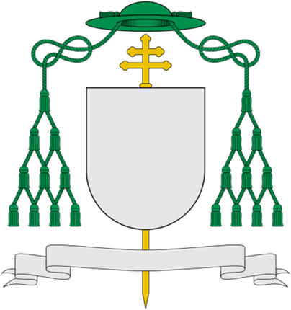

Pictured to the left is the Roman Coat of Arms for an Archbishop. Note the Green Galero which means the Archbishop isn’t a cardinal. Note the number of tassels which is 10 on both sides which denotes the person is an archbishop. Also note the two bar Latin archiepiscopal cross that speaks to the archiepiscopal ministry of the archbishop.
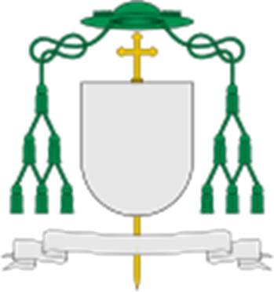

The coat of arms of a bishop. The galero is green and it has 6 tassels hanging on both sides. Not the single bar Latin cross which tells you the person is an ordinary or auxiliary bishop.

This symbol to the Above is called the vesica piscis or fish bladder. In traditions who do not make use of the ecclesiastical hat/galero, the vesica piscis can be used to enclose the arms of the bishop, diocese or communion of churches.

Homework
What is the guiding principle for vestments and protocol in the Congress?

Who can or cannot have Coat of Arms?

How does the Arms of a bishop differ from that of an archbishop?

What appointments can a bishop use that other clerics cannot?

Episcopal Protocol
We will close out this week examining the Episcopal Protocols of the Office and those who serve the office of Bishop. Finally, we will address the protocol around the bishop’s visit and episcopal courtesy.

The Use of Honorific
Reverend Dr. N.N.
It is never Apostle Dr or Bishop Dr
MOST, RIGHT AND VERY REVEREND usage

The Bishop’s Chaplain
What is bishop’s chaplaincy? (answer this for Homework)

What does a Chaplain do? (Homework)

Protocol around the Bishops visit and Episcopal Courtesy

Preparing for the Visit of the Bishop things to do
Episcopal Courtesy
- Announcing your coming to another diocese
- Wearing the Episcopal Colors
- Use of certain Episcopal Appointments

Other Homework questions
Does the Bishop have to dress down while in the jurisdiction of another?

What can a bishop do while in the jurisdiction of another?

Is purple an exclusive color of the episcopacy?

According to the Book, what can a cleric wear once they have received and acknowledge their appointments?

Is the cope an episcopal garment or can all clerics wear it?

