Reverend Dr. Sheryl T. Martin
Cell: 559-779-5510 or Email: weddingsbyrevmartin@gmail.com

Wedding Prices:

Wedding Ceremony or Vow Renewal Fee: $250.00
- Minister travel to your Venue location (50 miles included; additional miles are .62 cents per mile from 78676 zip code) Or You come to my FREE Venue location in Wimberley, Texas
- Consultation by phone, email, or in person + ongoing communication throughout
- Self-written vows or Minister’s choice
- Wedding day Officiant and signing of the marriage license
- Photography for ceremony - optional free service (if photographer is available on your date this includes disk/flash drive of all photos)

Additional Services Available for Both Packages:
- Premarital Counseling - $75.00 an hour
- Rehearsal attendance - $100.00 plus mileage fee
- Crystal Grid Ceremony - $75.00 (includes a keepsake crystal)
- Herb Ceremony - $75.00 (includes herbs and keepsake jar)
- Jumping Broom Ceremony - $60.00 (includes keepsake broom)
- Handfasting ceremony - $60.00 (includes keepsake cord)
- Unity candle ceremony - $60.00 (includes keepsake candles)
- Unity sand ceremony - $60.00 (includes sand and keepsake container)
- Breaking Glass Ceremony - $60.00 (includes glass)
- Las Arras Ceremony (Modern Version) - $60.00 (includes keepsake coin)
- Lasso Ceremony - $60.00 (includes keepsake lasso)
- Garland Exchange Ceremony - $60.00 (includes keepsake satin ribbon and beads garland haar)

Additional Information:
- 50% non-refundable deposit is required to secure your date
- 10% discount off the base ceremony cost (value $25.00) for students and Veterans with current ID
- Payment can be made through PayPal to heaven_pathways_earth@yahoo.com (ensure to include underscores), through Venmo @heavenpathwaysearth, or you can call (559) 779-5510 to pay by credit/debit card

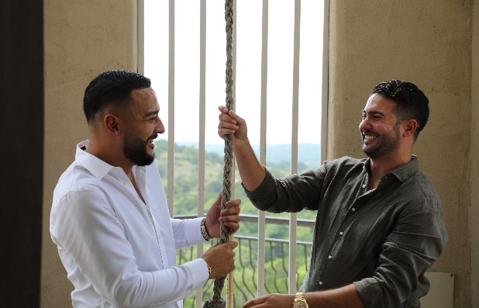
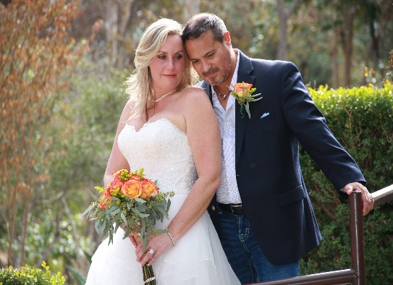
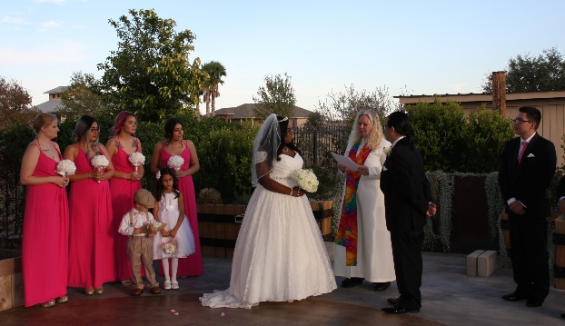
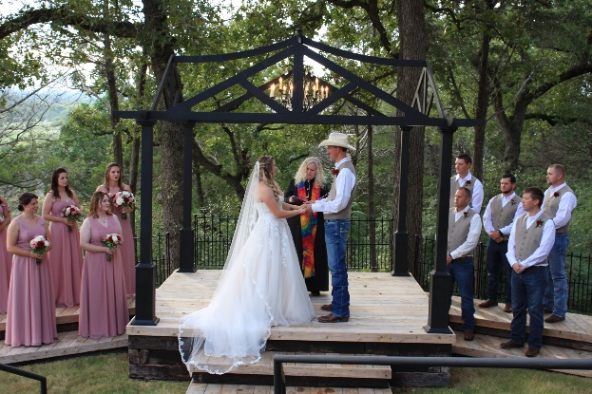
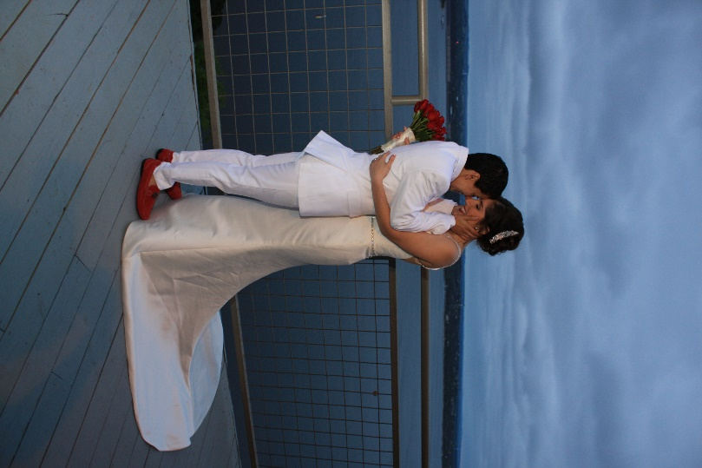

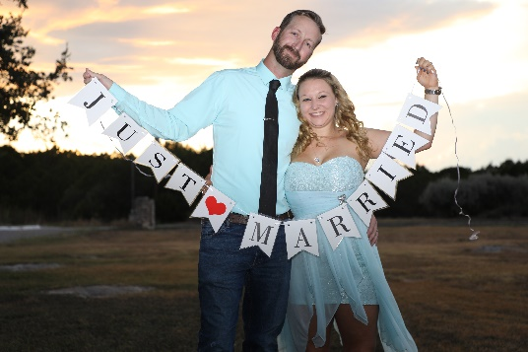
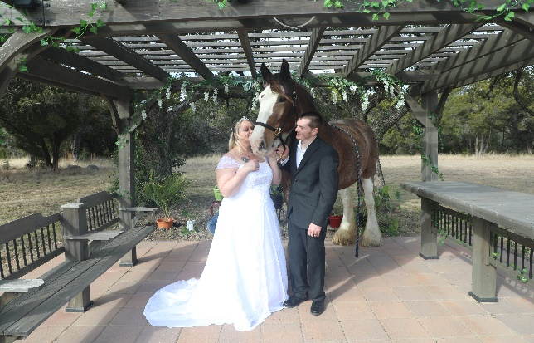

Do you need a Venue? OPTIONAL Venue available

A Hill Country Wedding - Wimberley, TX
Home to towering trees, wildflowers, and gorgeous views; Wimberley is located where Cypress Creek and Blanco River meet. This beautiful Hill country town is nestled in the middle of Austin and San Antonio, TX.

Wimberley has much to offer as you explore the Square, check out local artists, and take a dip in the river or one of the swimming holes. A perfect destination getaway as you tie the knot. Check out more at texashillcountry.com

Your Wedding - Located on 5 Acres in Wimberley, TX
Option 1 - The Wishing Well Wedding
For the small and intimate wedding in mind, this Hill Country Wedding is designed for the couple and up to 2 guests. Standing only.

Option 2 - The Pergola Wedding
This gorgeous pergola is designed to accommodate up to 30 guests during the ceremony as you tie the knot. Chairs are available to rent 1-30 for $25.00, guest can stand or bring their own chairs.

Note: The is no charge for using either of these venue locations.

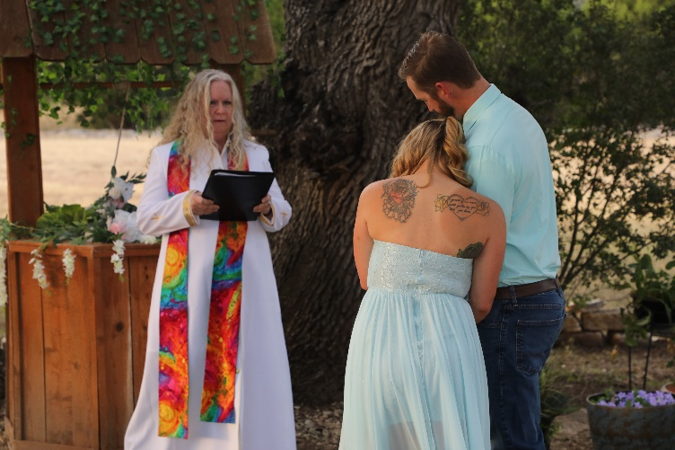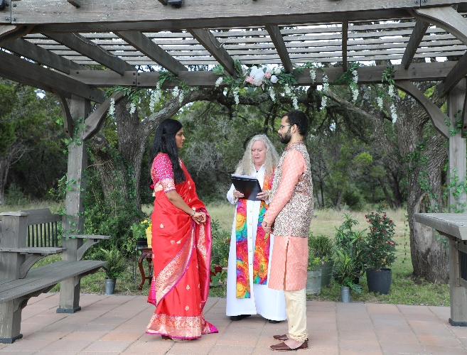

Wedding Ceremony Information Form - PLEASE PRINT CLEARLY
How did you find me? (ex. Wedding Wire, Instagram, Google, etc.): ________________________

Please select your package:
[] Wedding Ceremony $250 [] Renewal $250

Wedding Details:
[] Indoor Wedding [] Outdoor Wedding
Requested Wedding Date[s]: __________________________________________________________
Requested Time: ___________________________________________________________________
Doors Open: ______________________________

About the Venue:
[] Wishing Well Wedding, Wimberley, TX (Free Venue – up to 2 guest)
[] Pergola Wedding, Wimberley, TX (Free Venue – up to 30 guest)
[] Would like to rent chairs 1-30 available for $25.00 How Many ___________
[] Other Venue:
Venue Name: ______________________________________________________________________
Venue Address: ____________________________________________________________________
__________________________________________________________________________________
Mileage fee of $0.62 per mile will be charged after the first 50 miles, measured from 78676.

Rehearsal Information ($100.00 optional service):
Rehearsal Date: __________________________________ & Time: ____________________
(Mileage fee of $0.62 per mile will be charged after the first 50 miles, measured from 78676)

License Information:
Do you have your License? YES_____ NO_____ (You MUST have it prior to the ceremony)
Note: In Texas there is a 72-hour waiting period after receiving your license. The license is valid for 90 days. You will have 30 days to return the signed license to the county clerk office after the ceremony. Witnesses are not required in Texas.

Optional FREE Photographer: (if photographer is available on your date)
Signed and submitted Photo release form: YES_____ NO____ (both people need to sign)
Photographer (non-professional) is provided FREE of charge for the ceremony. Tips are highly encouraged and appreciated for their services. This is in addition to any wedding photographer you may/or may not hire. A disk or flash drive of the pictures will be mailed to you and can be used as you wish. You may edit and/or print any of the photos as you please.

If you are comfortable, it would be wonderful if you sent me a picture(s) or tagged me in any post. Thank you!
Instragram @ weddingsbyrevmartin
Facebook @ weddingsbyrevmartin

About the Couple:
Person 1:
Legal Name: _______________________________________________________________________
Preferred Name: _____________________________________________________________________
Address: __________________________________________________________________________
City: _______________________________ State: ___________________ Zip: _________________
Phone: _____________________________________________________________ Cell/Home/Work
Email Address: _____________________________________________________________________
What are your preferred pronouns? He/Him, She/Her, They/Them, Other: ______________________
Do you wish to be referred to as Bride, Groom, or Other? ___________________________________
Do you wish to be referred to as Husband, Wife, Spouse, or Other? ___________________________

Person 2:
Legal Name: _______________________________________________________________________
Preferred Name: _____________________________________________________________________
Address: __________________________________________________________________________
City: _______________________________ State: ___________________ Zip: _________________
Phone: _____________________________________________________________ Cell/Home/Work
Email Address: _____________________________________________________________________
What are your preferred pronouns? He/Him, She/Her, They/Them, Other: ______________________
Do you wish to be referred to as Bride, Groom, or Other? ___________________________________
Do you wish to be referred to as Husband, Wife, Spouse, or Other? ___________________________

Ceremony Planning Information (Please check all that apply):

Usage of the word God: YES_____ NO____

Estimated Number of Guest Attending: ________________________________________

Civil Ceremony _____ Non-Denomination Ceremony _____
Religious Ceremony ______ Religion: _____________________________________

Procession _____ (when the wedding party [all or part] will be walking down the aisle)
Ritual _____ please specify: ________________________________________________________ (this is intended if you have a family, spiritual, or religious ritual that you wish to include)

Opening Words _____
(intended for when the couple wishes to address their guest and want time to speak)

Reading(s) _____ (this is when a family member or friend will be reading at the ceremony)
What is the name/relationship of the person reading? ________________________________________
What will they be reading? ____________________________________________________________

Minister’s Choice (check if you wish to have included):
Reads a Scripture ______ Reads a Poem _____ Reads a Prayer _____

Honoring of Family members _____
(this is when you wish to honor family who have passed away and cannot be physically present)

What is the name/relationship of the family members that you wish to honor?
____________________________________________________________________________________________________________________________________________________________________
__________________________________________________________________________________

Unity Candle Ceremony (additional $60.00, includes keepsake candles) _____
Will Person 1 yes/no, or Name of person to light their candle? __________________________
Will Person 1 yes/no, or Name of person to light their candle? __________________________

Unity Sand Ceremony (additional $60.00, includes sand and heart keepsake) _____
Sand Color for Person 1? ____________ Sand Color for Person 2? ____________
Do you want additional people other than Person 1 and 2 to participate (example: children)? _______
Name and sand color: ________________________________________________________________
__________________________________________________________________________________

Handfasting Ceremony (additional $60.00, includes keepsake cord) _____

Crystal Grid Ceremony (additional $75.00, includes a keepsake crystal) _____

Breaking Glass Ceremony (additional $60.00, includes glass) _____

Jumping Broom Ceremony (additional $60.00, includes keepsake broom) _____

Circle of Herbs Ceremony (additional $75.00, includes herbs and keepsake jar) _____
_____ Red Roses to symbolize love, passion, and luck in your commitment to each other.
_____Calendula for health and joy in your future.
_____ Fennel to bring strength and unity.
_____ Vitex Berries to enhance future fertility and building of a new family.

Las Arras (Modern Version where the Bride and Groom give coin to each other) Ceremony (additional $60.00, includes keepsake coin) _____
Minister give coin to Person 1 yes/no, or Name of person to give coin? _______________
Minister give coin to Person 2 yes/no, or Name of person to give coin? _______________

Lasso Ceremony (additional $60.00, includes keepsake lasso) _____
Minister places lasso on Person 1 yes/no, or Name of person to place lasso? _______________
Minister places lasso on Person 2 yes/no, or Name of person to place lasso? _______________

Garland Exchange Ceremony - $60.00 (includes keepsake satin ribbon and beads garland haar) _____

Minister hands Garland to Person 1 yes/no, or Name of person who will hand Garland to Person 1? _______________
Minister hands Garland to Person 2 yes/no, or Name of person who will hand Garland to Person 1? _______________

Do You Have an Alternative Preferred Unity Ceremony: YES____ NO____?
If so, what is it? _____________________________________________________________________

Vows: Minister Choice _____ Self Written _____ Other: ____________________________________

Exchanging of rings_____ Will each party be getting a ring? YES____ NO____
Blessing of the rings_____

Pronouncement _____
Do you want to be announced as Husband and Wife, as Married, Wife and Wife, Husband and Husband, Spiritually and Legally Bound, or Other_________________________________________?

Kiss _____ Closing Blessing _____

Ritual _____ please specify: ___________________________________________________________ (this is intended if you have a family, spiritual, or religious ritual that you wish to include)

Recession _____ (this is when the couple walk out back through the aisle to leave)

Wedding Party, complete all that applies:
Will Person 1 be given away? YES_____ NO_____
Name/Relationship of Individual Giving Person 1 Away? ___________________________________

Will Person 2 be given away? YES_____ NO_____
Name/Relationship of Individual Giving Person 2 Away? ___________________________________

Do you want to include Children in the ceremony? YES_____ NO_____
If yes, what role would you like them to be included in? _____________________________________
__________________________________________________________________________________
Children names and ages? _____________________________________________________________
__________________________________________________________________________________

Do you want to include animals in the ceremony? YES_____ NO_____
If yes, what role would you like them to be included in? _____________________________________
__________________________________________________________________________________
Animal names and type of animals? _____________________________________________________
__________________________________________________________________________________

Premarital Counseling Requested? YES_____ NO_____ ($75.00 per hour)
If yes: Would you like counseling as a couple _____ or in individual sessions______ or both______
Would you like counseling by phone_______ or in person________ (at my location)
How many sessions would you like as a couple____ as an individual: Person 1____ Person 2____

Are there certain topics or concerns you would like to discuss, if yes what are they? _______________
__________________________________________________________________________________
________________________________________________________________________________________________________________________________________________________________________________________________________________________________________________________________________________________________________________________________________
What does marriage mean to Person 1? __________________________________________________
__________________________________________________________________________________________________________________________________________________________________________________________________________________________________________________________________________________________________________________________________________________________________________________________________________________________________________________________________________________________________________________________________________________________________________________________________________________________________________________________________________________________________________________________________________________________________
What does marriage mean to Person 2? __________________________________________________
__________________________________________________________________________________________________________________________________________________________________________________________________________________________________________________________________________________________________________________________________________________________________________________________________________________________________________________________________________________________________________________________________________________________________________________________________________________________________________________________________________________________________________________________________________________________________

Please provide a short story of when and how the couple met and the story of their journey until now __________________________________________________________________________________
__________________________________________________________________________________
____________________________________________________________________________________________________________________________________________________________________________________________________________________________________________________________________________________________________________________________________________________________________________________________________________________________________________________________________________________________________________
________________________________________________________________________________________________________________________________________________________________________________________________________________________________________________________________________________________________________________________________________________________________________________________________________________________________________________________________________________________________________________________________________________________________________________________________________________________________________________________________________________________________________________________________________________________________________________________________________________________________________________________________________________________________________________________________________________________________________________________________________________________

Cost Based on Your Selections:
Wedding Ceremony or Vow Renewal Base Price $250.00 ____________
Chair Rental if using the Free Wimberley Venue $25.00 (optional) ____________
Wedding Mileage Fee of $0.62 per mile after the first 50 miles ____________
Rehearsal Attendance $100.00 (optional) ____________
Rehearsal Mileage Fee of $0.62 per mile after the first 50 miles ____________
Unity Candle Ceremony $60.00 (optional) ____________
Unity Sand Ceremony $60.00 (optional) ____________
Handfasting Ceremony $60.00 (optional) ____________
Circle of Herbs Ceremony $75.00 (optional) ____________
Crystal Grid Ceremony $75.00 (optional) ____________
Breaking Glass Ceremony $60.00 (optional) ____________
Jumping of the Broom Ceremony $60.00 (optional) ____________
Las Arras Ceremony $60.00 (optional) ____________
Lasso Ceremony $60.00 (optional) ____________
Garland Exchange Ceremony $60.00 (optional) ____________
Premarital Counseling $75.00 x ______ session(s) (optional) _____________
Photographer for ceremony and disk of pictures $0.00 FREE (tips appreciated)

Sub Total Cost of Service _____________
-10% Discount for Veteran or Student (off Base fee with current ID) _____________

Total Cost of Service _____________
50% non-refundable deposit to secure your date, paid on ________ _____________
Remaining Balance (due before wedding date/rehearsal date) _____________
Balance Paid on ________________ _____________

Payment Options:
- PayPal to: heaven_pathways_earth@yahoo.com (ensure to include underscores)
- Credit Card or Debit Card: Call 559-779-5510
- Venmo @heavenpathwaysearth
Following the ceremony:
- Directly following the ceremony, we will need a few minutes for the signing of the marriage license and for taking photos.
- You will be mailed a disk or flash drive of all photos taken.
- I strive to provide you with FIVE STAR service. You will receive a review request from Wedding Wire. Please take a few moments to provide a review of the services that you received. Thank you.
Reverend Dr. Sheryl T. Martin
PHOTO RELEASE FORM

I hereby grant Reverend Dr. Sheryl T. Martin permission to use my likeness in a photograph, video, or other digital media (“photo”) in any and all of its publications, including web-based publications, without payment or other consideration.

I understand and agree that all photos will become the property of Reverend Dr. Sheryl T. Martin and will not be returned.

I hereby irrevocably authorize Reverend Dr. Sheryl T. Martin to edit, alter, copy, exhibit, publish, or distribute these photos for any lawful purpose. In addition, I waive any right to inspect or approve the finished product wherein my likeness appears. Additionally, I waive any right to royalties or other compensation arising or related to the use of the photo.

I hereby hold harmless, release, and forever discharge Reverend Dr. Sheryl T. Martin from all claims, demands, and causes of action which I, my heirs, representatives, executors, administrators, or any other persons acting on my behalf or on behalf of my estate have or may have by reason of this authorization.

I HAVE READ AND UNDERSTAND THE ABOVE PHIOTO RELEASE. I AFFIRM THAT I AM AT LEAST 18 YEARS OF AGE. I ACCEPT:

_____________________________ _______________________________
Print Name Print Name

_____________________________ _______________________________
Signature Signature

_________________ _________________
Date Date

