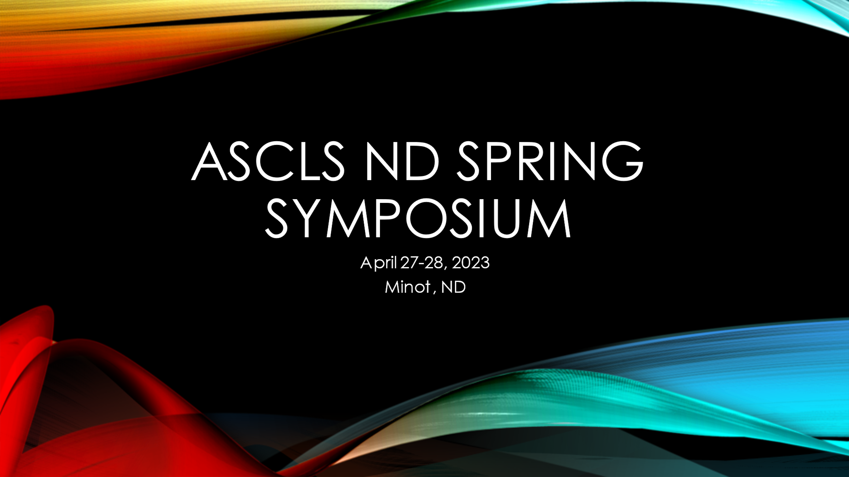
“Spring Symposium” - April 27-28, 2023
Hot Topic Education, Professional Updates, Networking & FUN
American Society for Clinical Laboratory Science - North Dakota

Supporting Sponsors:
Sleep Inn & Suites
2400 10th Street SW
Minot, North Dakota 58701
(701) 502-0028

Room Special Rate*: $99.00 + tax
(traditional Double Queen or King)

*To receive special rate, guests must call and provide group ID: ASCLS
Rooms can be reserved at this rate for Wednesday, Thursday and Friday nights – APRIL 26-28, 2023
Reserved room block will only be available until April 7, 2023 - make your reservations early!

SPRING SYMPOSIUM VALUE, BENEFITS & HIGHLIGHTS
- Up to 13 CE hours in one meeting
- Meeting together and touching base with all our fellow laboratorians
- Great speakers, great vendor opportunities and networking
- ASCLS-ND is approved as a provider of continuing education programs in the clinical laboratory sciences through the ASCLS P.A.C.E. program. P.A.C.E credits will be awarded for sessions attended. Session descriptions and handouts will be found on the ASCLSND website when available

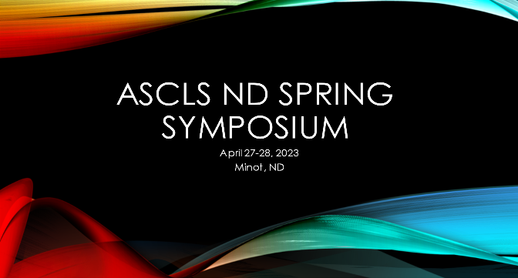

REGISTRATION INFORMATION
Complete & submit registration form and payment by mail or website.

Pre-registration is required.
Registrations must be postmarked by April 15, 2023
Late fee of $20 applies after April 15, 2023.

Registration Fees: | 2-Day  4-27  4-28 | 1-Day  4-27 | AM  4-27 | PM  4-27 | 1-Day  4-28 | AM  4-28 | PM  4-28
ASCLS Member | $200 | $130 | $55+ | $60+ | $85  + | $45+ | $45+
Non-member | $215 | $135 | $70+ | $75+ | $100+ | $60+ | $60+
ASCLS Student member | $120 | $75 | * | * | $50 | * | *
Student Non-member | $135 | $90 | * | * | $65 | * | *
Late Fee – post 4/15 | $20 | $20 | $20 | $20 | $20 | $20 | $20

+Exhibit/Social not included
*This option not available for student attendees

How to register and submit payment:
- Complete form  - Email completed form to:  - sreistad@srt.com  - Payment via check (payable to ASCLS-ND)  - OR  - Register at the ASLCS-ND website  - Select attendance option  - Complete payment electronically | Mail check to:  Sharon Reistad  7340 37th Ave SE  Minot, ND 58701  Electronic: jessicarosin.fry@gmail.com

Meeting Questions: | Sharon Reistad (E) sreistad@srt.comC) 701-240-7219

2023 ASCLS-ND SPRING SYMPOSIUM REGISTRATION FORM
Name: |  |  |  |  |  |  | Member #:
Street Address: |  |  |  |  |  |  |  |  |  | (required for member registration fee)
City: |  |  |  |  | State: |  |  |  | Zip:
Facility: |  |  |  |  |  |  |  | Phone:
Email:
 |  |  | (required for registration invoice & confirmation and/or follow up communication if needed)
I would love to be a moderator – Yes/No:

Registration Fee: | $ | Late Fee (after 4/15): | $ | Total Fee Submitted: | $

