Doc Holley’s Advanced Placement World History FLASH CARD Master List

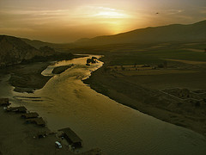
Mesopotamia
A region between the Tigris and Euphrates rivers that developed the first urban societies. In the Bronze Age this area included Sumer and the Akkadian, Babylonian and Assyrian empires, In the Iron Age, it was ruled by the Neo-Assyrian and Neo-Babylonian empires.
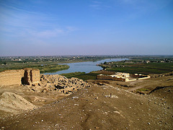
Fertile Crescent
The Tigris and Euphrates Rivers gave life to the first known agricultural villages in this area about 10,000 years ago and the first known cities about 5,000 years ago. Includes Mesopotamia, Palestine, and the Nile.

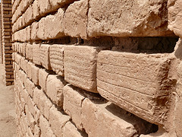
ziggurat
A temple tower of ancient Mesopotamia, constructed of square or rectangular terraces of diminishing size, usually with a shrine made of blue enamel bricks on the top
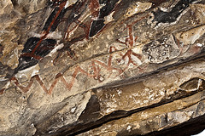
pictograms
A pictorial symbol or sign representing an object or concept. Used by many non-alphabetic written scripts.

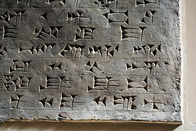
cuneiform
The earliest known form of writing, which was used by the Sumerians. The name derives from the wedge shaped marks made with a stylus into soft clay. Used from the 3000s BCE to the 100s BCE.
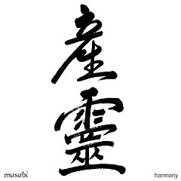
ideograms
A character or figure in a writing system in which the idea of a thing is represented rather than it's name (example: Chinese)
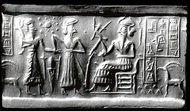
Sumer
The world's first civilization, founded in Mesopotamia, which existed for over 3,000 years.

Xia
A legendary Chinese dynasty that was not believed to exist until relatively recently. Walled towns ruled by area-specific kings assembled armies, built cities, and worked bronze. Created pictograms which would evolve in to the first Chinese script.

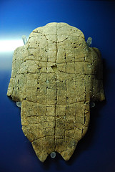
Shang
An early Chinese dynasty. Not a unified Chinese state. Instead rulers and their relatives gave orders through a network of cities. Earliest evidence of Chinese writing comes from this period.

Zhou
Succeeded the Shang dynasty. Similar to the Shang And Xia dynastic periods in that China was fragmented politically. Yet, despite the lack of true centralization, this was one of the longest Chinese dynasties, lasting about 600 years. It left substantial written records, unlike the preceding dynasties.

Yellow River
Also known as the Huang-He. The second longest river in China. The majority of ancient Chinese civilizations originated in its valley.

Oracle Bones
The earliest known Chinese writing is found on these from ritual activity of the Shang period.
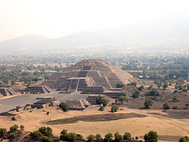
Teotihuacan
A large central city in the Mesoamerican region. Located about 25 miles Northeast of present day Mexico City. Exhibited city planning and unprecedented size for its time. Reached its peak around the year 450.

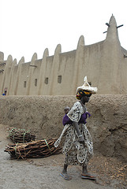
Jenne-Jeno
One of the first urbanized centers in western Africa. A walled community home to approximately 50,000 people at its height. Evidence suggests domestication of agriculture and trade with nearby regions.

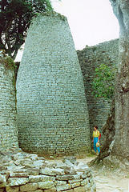
Great Zimbabwe
A stone-walled enclosure found in Southeast Africa. Have been associated with trade, farming, and mining.

Code of Hammurabi
A collection of 282 laws. One of the first (but not THE first) examples of written law in the ancient world.

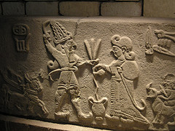
Hittites
An ancient Anatolian group whose empire at largest extent consisted of most of the Middle East. Some of the first two-wheeled chariots and iron.

Zoroastrianism
One of the first monotheistic religions, particularly one with a wide following. It was central to the political and religious culture of ancient Persia.
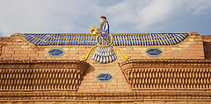
Zoroaster
The founder of Persia's classical pre-Islamic religion, Zoroastrianism.

Hellenistic
Of or influenced by the Greek Empire. A type of culture typically referred to after the conquests of Alexander the Great.

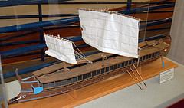
Trireme
Greek ships built specifically for ramming enemy ships.

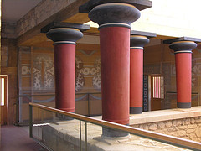
Minoans
One of the early proto-Greek peoples from 2600 BCE to 1500 BCE. Inhabitants of the island of Crete. Their site of Knossos is pictured above.

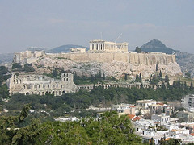
Acropolis
Greek for "high city". The chief temples of the city were located here.

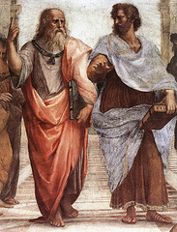
Plato
Socrates' most well known pupil. Founded an academy in Athens.

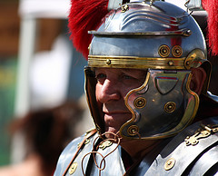
Pax Romana
The "Roman Peace", that is, the state of comparative concord prevailing within the boundaries of the Roman Empire from the reign of Augustus (27 B.C.E.-14 C.E.) to that of Marcus Aurelius (161-180 C.E.)
Republic
A state that is not ruled by a hereditary leader (a monarchy) but by a person or persons appointed under a constitution and in some way claims to be "of the people."

Century
The smallest unit of the Roman army, each composed of some 100 foot soldiers and commanded by a centurion. A legion was made up of 60 of these. They also formed political divisions of Roman citizens.

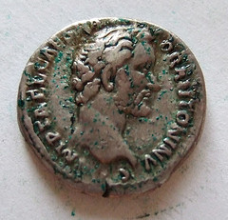
Consul
Under the Roman Republic, one of the two magistrates holding supreme civil and military authority. Nominated by the Senate and elected by citizens in the Comitia Centuriata, the consuls held office for one year and each had power of veto over the other.

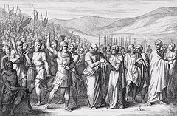
Patricians
The land-owning noblemen in Ancient Rome

Plebeians
All non-land-owning, free men in Ancient Rome

Paterfamilias
the head of the family or household in Roman law -always male- and the only member to have full legal rights. This person had absolute power over his family, which extended to life and death.

Twelve Tables
Completed in 449 BCE, these civil laws developed by the Roman Republic following demands by plebeians.

Triumvirate
An unofficial coalition between Julius Caesar, Pompey, and Crassus was formed in 60 B.C.E. Eventually results in civil war that brings down the republic and results in the Roman Empire.

Monophysites
The supporters of a doctrine in the early Christian Church that held that the incarnate Christ possessed a single, wholly divine nature. they opposed the orthodox view that Christ had a double nature, one divine and one human, and emphasized his divinity at the expense of his capacity to experience real human suffering.

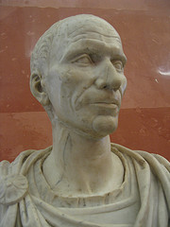
Julius Caesar
Part of the first triumvirate who eventually became "emperor for life". Chose not to conquer Germany. Was assassinated by fellow senators in 44 B.C.E.
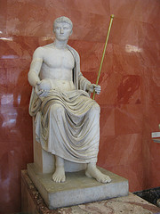
Octavian
Part of the second triumvirate whom the power eventually shifted to. Assumed the name Augustus Caesar, and became emperor. Was the end of the Roman Republic and the start of the Pax Romana.

Diocletian
Roman emperor of 284 C.E. Attempted to deal with fall of Roman Empire by splitting the empire into two regions run by co-emperors. Also brought armies back under imperial control, and attempted to deal with the economic problems by strengthening the imperial currency, forcing a budget on the government, and capping prices to deal with inflation. Civil war erupted upon his retirement.

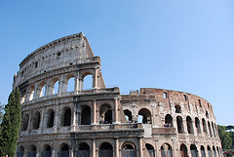
Bread and Circuses
A Roman bribery method of coping with class difference. Entertainment and food was offered to keep plebeians quiet without actually solving unemployment problems.

Goths
An array of Germanic peoples, pushed further westward by nomads from central Asia. They in turn migrated west into Rome, upsetting the rough balance of power that existed between Rome and these people.
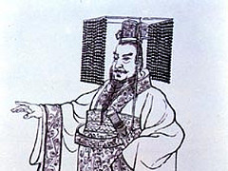
legalism
A school of Chinese philosophy. Prominent during Warring States Period. Had great influence on the policies of the Qin dynasty. Based on a pessimistic view of human nature. Social harmony could only be attained through strong government control and the imposition of strict laws, enforced absolutely.

assimilation
The process by which people are gradually absorbed and integrated into another culture.

Huns
large nomadic group from northern Asia who invaded territories extending from China to Eastern Europe. They virtually lived on their horses, herding cattle, sheep, and horses as well as hunting.

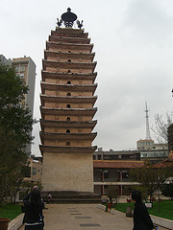
Tang
Continuing the imperial revival started by the Sui Dynasty this dynasty that followed restored the Chinese imperial impulse four centuries after the decline of the Han, extending control along the silk route. Trade flourished and China finally reached its western limits when its forces were defeated by the imperial armies of the Muslim Abbasid Empire at the Talas River--which stopped future expansion by both empires.
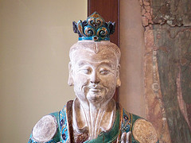
Yellow Turban Revolt
A 184 C.E. peasant revolt against emperor Ling of Han. Led by Daoists who proclaimed that a new era would be3ing with the fall of the Han. Although this specific revolt was suppressed, it triggered a continuous string of additional outbreaks.

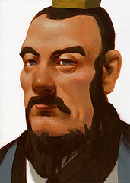
Liu Bang
First emperor of the Han dynasty under which a new social and political hierarchy emerged. Scholars were on top, followed by farmers, artisans, and merchants. He chose his ministers from educated men with Confucian principals.

Aryans
immigrants who arrived at the Ganges river valley by the year 1000 BC
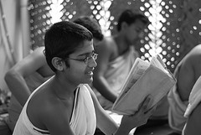
Vedas
compilations of hymns, religious reflections, and Aryan conquests

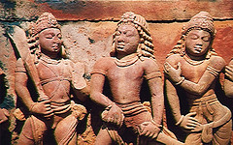
Mahabharata
the longest single poem in the world, about a war fought between two branches of the same family. One of India's greatest epics written between 1000 and 700 BC

Janapadas
Political units in India in the years 700-600 BC. They are the major realms or kingdoms of Vedic (Iron Age) India. They are the earliest kingdoms set up by the Indo-Aryans migrants to India.

Guilds
Pre-industiral associations of businessmen and producers two work for their collective interest.

Dharma
the fulfillment of one's social and religious duties in Hinduism

Arthashastra
The famous ancient Indian book on statecraft, economic policy, and military strategy. Written by Kautilya.

Siddhartha Gautama
The prince who is said to have founded Buddhism.

Rigveda
One of the worlds oldest religious texts. It is a book composed by Vedic Brahman priests that contains hymns and Sanskrit poetry.

Caste system
India's traditional social hierarchy.

Samsara
the cycle of life and rebirth in Hinduism

Nirvana
Within several Indian religious this is the peace of mind that comes from ending the cycle of rebirth. For some it is from overcoming suffering while for others it comes from joining with Brahman.

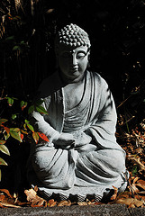

Four Noble Truths
- Suffering is always present in life
2. Desire is the cause of suffering
3. Freedom from suffering can be achieved in nirvana
4. The Eightfold Path leads to nirvana

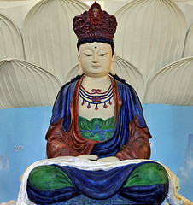

Mahayana
The name of the more mystical and larger of the two main Buddhist sects. This one originated in India in the 400s CE and gradually found its way north to the Silk road and into Central and East Asia.
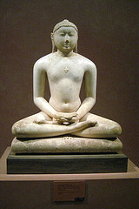
Jainism
An ancient religion of India with a small following today of only about 10 million followers. Originated in the 800s BCE. They prescribes a path of non-violence towards all living beings. Its philosophy and practice rely mainly on self-effort to progress the soul up the spiritual ladder to divine consciousness. Any soul that has conquered its own inner enemies and achieved the state of supreme being is called jina (Conqueror or Victor).

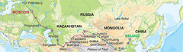
Silk Road
Connected China, India, and the Middle East. Traded goods and helped to spread culture.

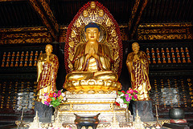

Empress Wu
the only woman to rule China in her own name, expanded the empire and supported Buddhism during the Tang Dynasty.

mantra
The repetition of mystic incantations in Hinduism and Buddhism.

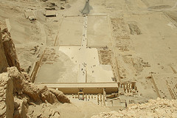
Mentuhotep I
Egyptian pharaoh who founded the Middle Kingdom by REUNITING Upper and Lower Egypt in 2134 BCE.

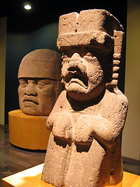
Olmec
Mesoamerican civilization in lower Mexico around 1500 BCE to about 400 BCE focused. Most remembered for their large stone heads.

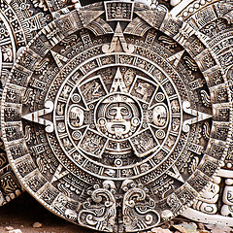
Maya
Never an empire but an extensive and culturally advanced Mesoamerican society with many cities in the Yucatan.

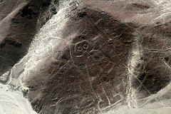
Nazca
South American civilization famous for its massive aerial-viewable formations

Neo-Assyrian
The agressive Mesopotamian empire created after an Assyrian resurgence, which initiated a series of conquests until a combined attack by Medes and Babylon defeated them resulting in the Persian Empire.
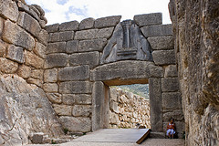
Mycenae
Sea-faring Greek kingdom. A major center of Greek Civilization in the 1000s BCE, centuries before Greek's "Golden Age" of Athenian influence. It's center was located about 90 km southwest of Athens.

Persian Empire
Mesopotamian empire that conquered the existing Median, Lydian, and Babylonian empires, as well as Egypt and many others. Also known as the Achaemenid Empire.

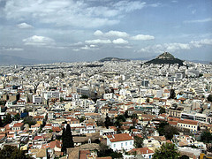
Polis
Form of government in which power is centralized into a local city-state.

Solon
Early Greek leader who brought democratic reforms such as his formation of the Council of Four Hundred

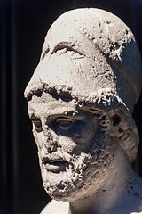
Pericles
Ruler of Athens who zealously sought to spread Athenian democracy through imperial force

Peloponnesian War
Conflict between Athens and Sparta

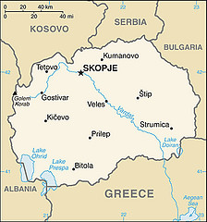
Macedonia
Area between the Greek and Slavic regions; conquered Greece and Mesopotamia under the leadership of Philip II and Alexander the Great

Philip II
Macedonian king who sought to unite Greece under his banner until his death or murder. He was succeeded by his son Alexander.
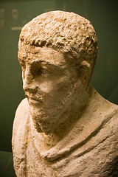
Ptolemy
His ideas on science influenced Muslim and European scholars from Roman times until the Scientific Revolution. He was a Greco-Roman writer famous as a mathematician, astronomer, geographer, astrologer, and poet. He lived in the city of Alexandria in the Roman province of Egypt, wrote in Greek, and held Roman citizenship.

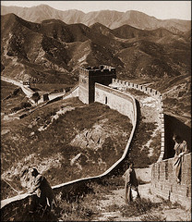
Qin
1st unified imperial Chinese dynasty

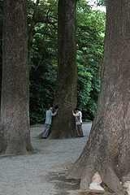
Shinto
"Way of the Kami"; Japanese worship of nature spirits

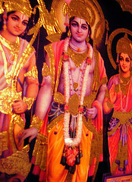
Rama
Incarnation of Hindu god Vishnu made famous in the Ramayana

Buddha
Means "Enlightened One." He is said to have renounced his worldly possessions and taught of a way to overcome suffering.

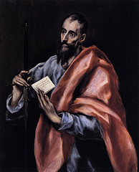
Apostle Paul
The man who was instrumental in its spreading Christianity beyond its early Jewish roots, particularly to the Greeks.

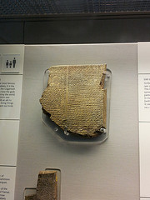
Epic of Gilgamesh
An epic poem from Mesopotamia, and among the earliest known works of literary writing.

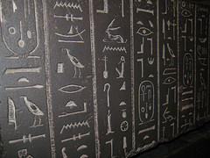
Hieroglyphics
designating or pertaining to a pictographic script, particularly that of the ancient Egyptians, in which many of the symbols are conventionalized, recognizable pictures of the things represented

Hegemony
leadership or predominant influence exercised by one nation over others, as in a confederation.

Hoplite
A citizen-soldier of the Ancient Greek City-states. They were primarily armed as spear-men.

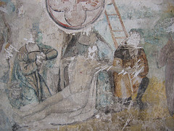
Iconoclasm
Opposing or even destroying images, especially those set up for religious veneration in the belief that such images represent idol worship.

Diaspora
any group migration or flight from a country or region; dispersion. Particularly used in relation to Jews scattered by Romans in 70 CE or to Africans spread to new places during the Atlantic Slave Trade.

Realpolitik
Political realism or practical politics, especially policy based on power rather than on ideals.
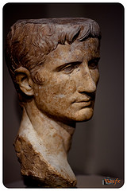
Stoicism
An ancient Greek philosophy that became popular amongst many notable Romans. Emphasis on ethics. They considered destructive emotions to be the result of errors in judgment, and that a wise person would repress emotions, especially negative ones and that "virtue is sufficient for happiness." They were also concerned with the conflict between free will and determinism. They were also non-dualists and naturalists.

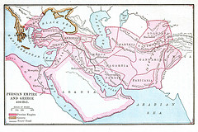
Satrapy
A province and/or the title of a client kings of the Persian Empire. Based on the system where conquered territory would maintain much of their identity and sovereignty within the Persian Empire.

Buddhism
a religion, originated in India by Buddha (Gautama) and later spreading to China, Burma, Japan, Tibet, and parts of southeast Asia, holding that life is full of suffering caused by desire and that the way to end this suffering is through enlightenment that enables one to halt the endless sequence of births and deaths to which one is otherwise subject.

Mandate of Heaven
A political theory developed during the Zhou Dynasty of ancient China in which those in power were believed to have the the right to rule from divine authority.

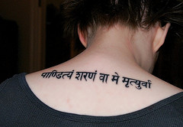
Sanskrit
an Indo-European, Indic language, in use since c1200 b.c. as the religious and classical literary language of India.

Diffusion
The spread of ideas, objects, or traits from one culture to another

Imperialism
The extension of political rule by one people over other, different peoples. First done by Sargon of Akkad to the Sumerian city states.

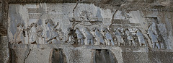
Cyrus
Created the Persian Empire by defeating the Medes, Lydians, and Babylonians; was known for his allowance of existing governments to continue governing under his name

Darius
The third king of the Persian Achaemenid Empire. He ruled the empire at its peak. He organized the empire by dividing it into provinces and placing satraps to govern it. He organized a new uniform money system, along with making Aramaic the official language of the empire. He also worked on construction projects throughout the empire.

Alexander the Great
King of Macedonia who conquered Greece, Egypt, and Persia

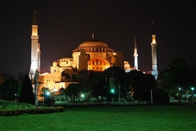
Constantinople
City founded as the second capital of the Roman Empire; later became the capital of the Byzantine Empire

Confucianism
Chinese ethical and philosophical teachings of Confucius which emphasized education, family, peace, and justice

Daoism
Philosophy that teaches that everything should be left to the natural order; rejects many of the Confucian ideas but coexisted with Confucianism in China

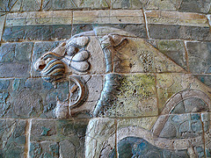
Babylonian Empire
Empire in Mesopotamia which was formed by Hammurabi, the sixth ruler of the invading Amorites

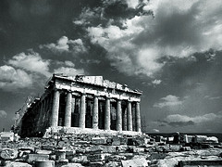
Delian League
Alliance between Athens and many of its allied cities following the first attempted invasion of Perisa into Greece. Caused a lot of wealth to flow into Athens and thus contributed to the Athenian "golden age."

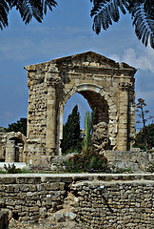
Carthage
This city has existed for nearly 3,000 years, developing from a Phoenician colony of the 1st millennium BC into the capital of the Carthaginian Empire. The expanding Roman Republic took control of many of its outposts after the two Punic Wars.

Constantine
Roman emperor who adopted Christianity for the Roman Empire and who founded Constantinople as a second capital

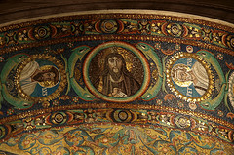
Byzantine Empire
Eastern half of the Roman Empire that survived the fall of the Western half.

Talmud
The collection of Jewish rabbinic discussion pertaining to law, ethics, and tradition consisting of the Mishnah and the Gemara.

Warring States Period
the period from 475 BC until the unification of China under the Qin dynasty, characterized by lack of centralized government in China. It followed the Zhou dynasty.

Theodosius
Emperor of the Roman Empire who made Christianity the official religion of the empire.

urbanization
the movement of people to Urban areas in search of work.

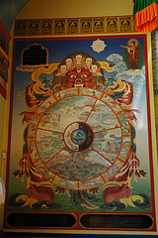
Wheel of Life
An important symbol of Buddhism. It represents the endless cycle of life through reincarnation.

Tao-te Ching
the central text of Daoism.

Zhou dynasty
the longest lasting Chinese dynasty, during which the use of iron was introduced.
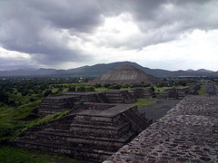
Teotihuacan
The most significant pre-Columbian Mesoamerican city.

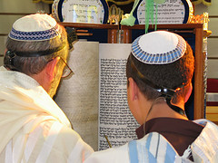
Tanakh
a term for the books of the Bible that make up the Hebrew canon.

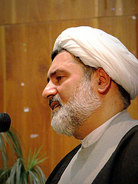
ulama
The theologians and legal experts of Islam. Best known as the arbiters of sharia law.

ummah
The collective community of Islamic peoples, which is thought to transcend ethnic and political boundaries.

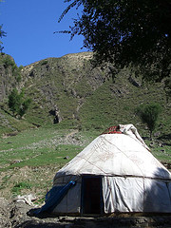
Yurt
a portable dwelling used by the nomadic people of Centa Asia such as Mongols, consisting of a tentlike structure of skin, felt or hand-woven textiles arranged over wooden poles.

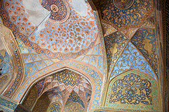
Akbar
The greatest of the Mughald Emperors. Second half of 1500s. Descendant of Timur. Consolidated power over northern India. Religiously tolerant. Patron of arts, including large mural paintings.
Safavid
The _________ Empire that ruled Persia (Iran) between 1502-1736.

Jizya
Poll tax that non-Muslims had to pay when living within a Muslim empire

syncretism
The unification or blending of opposing people, ideas, or practices, frequently in the realm of religion. For example, when Christianity was adopted by people in a new land, they often incorporate it into their existing culture and traditions.

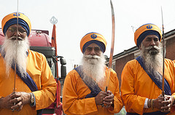
Sikh
A member of a religious community founded in the Punjab region of India. Developed in the 15th century. They believe in One Immortal Being and the teachings of ten Gurus, starting with Guru Nanak.

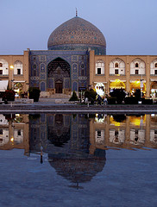
Isfahan
Persian capital from the 16th to 18th centuries under the Safavid Empire. Still a major cultural center of Iran today.
Constantinople
A large and wealthy city that was the imperial capital of the Byzantine empire and later the Ottoman empire, now known as Istanbul

Mestizo
A new racial concept that develops in Latin America following the intermixing that occurred between European colonists and the native American population.

Divine Right of Kings
Doctrine that states that the right of ruling comes from God and not people's consent

Glorious Revolution
Following the English Civil War, this event involve the British Parliament once again overthrowing their monarch in 1688-1689. James II was expelled and William and Mary were made king and queen. Marks the point at which Parliament made the monarchy powerless, gave themselves all the power, and wrote a bill of Rights. The whole thing was relatively peaceful and thus glorious.

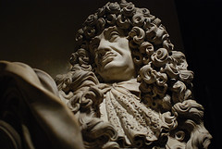
King Charles I
The English monarch who was beheaded by Puritans (see English Civil War) who then established their own short-lived government ruled by Oliver Cromwell (1650s).

Tennis Court Oath
A pledge signed by all but one of the members of the Third Estate in France. Marks the first time the French formally opposed Louis XVI.
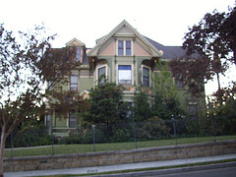
Bourgeoisie
A social class that derives social and economic power from employment, education, and wealth, as opposed to the inherited power of aristocratic family of titled land owners or feudal privileges. It's a term for the middle class common in the 19th century. It's characterized by their ownership of property and their related culture.

Kepler
German astronomer and mathematician of the late 16th and early 17th centuries, known as the founder of celestial mechanics

John Locke
17th century English philosopher who opposed the Divine Right of Kings and who asserted that people have a natural right to life, liberty, and property.

Shakespeare
A popular English playwright and poet in the 16th century.

Deism
A popular Enlightenment era belief that there is a God, but that God isn't involved in people's lives or in revealing truths to prophets.
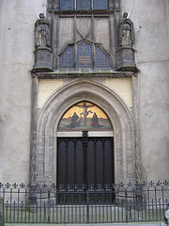
95 Theses
It was nailed to a church door in Wittenberg, Germany in 1517 and is widely seen as being the catalyst that started the Protestant Reformation. It contained Luther's list of accusations against the Roman Catholic Church.

Indulgence
Within the Catholic Church, this is the remission punishment for ones sins. Such as for a sin that has already been forgiven by God but which still carries with it some kind of punishment. Centuries ago the Church would sell certificates that would get a person out of purgatory. This practice contributed to the Protestant reformation.

Bartholomew Dias
Portuguese navigator that discovered the Cape of Good Hope in Southern Africa.

Cortes
The Spanish conqueror of Mexico.

Enconmienda
A labor system set up by the Spanish government where Spanish colonists could work the native Americans on their land while compensating them and agreeing to educate some of them and teach them about Christianity. The system was meant to curb exploitation but actually made the exploitation of Native Americans worse.

Mita
When colonists were allowed to use Indians for forced labor in colonial South America as a form of taxation. The Inca had previously used a similar practice.

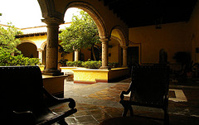
Hacienda
Spanish estates in the Americas that were often plantations. They often represent the gradual removal of land from peasant ownership and a type of feudalistic order where the owners of Haciendas would have agreements of loyalty to the capital but would retain control over the actual land. This continued even into the 20th century.

Mercantilism
Economic policy common to many absolute monarchies. Government control of foreign trade is of paramount importance for ensuring the military security of the country. In particular, it demands a positive balance of trade and desires new sources of gold and silver bullion, thus fueling more colonialism.

Laissez Faire
The belief that the government shouldn't intervene much in the economy and should instead let the people do what they want with their property.

Capitalism
Economic system with private and corporate ownership of property and competitive markets. However, since its origins in the 18th and 19th century it was also often correlated to large-scale collusion between governments and private industries such as through establishing royal charters, copyrights and patents, corporate law, and eventually even subsidies of taxpayer money to private industries.

Nation-State
A modern concept of a government that controls an area and represents the people of that area, often idealized as a homogeneous people that share a common language and feeling of nationality.

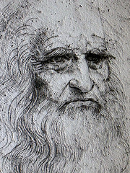
Leonardo da Vinci
A well known Italian Renaissance artist, architect, musician, mathemetician, engineer, and scientist. Known for the Mona Lisa.

Huguenot
A French Protestant

Shogun
In feudal Japan, a noble similar to a duke. They were the military commanders and the actual rulers of Japan for many centuries while the Emperor was a powerless spiritual figure.

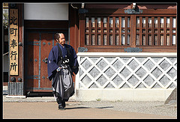
Samurai
A member of the warrior class in pre-modern feudal Japan

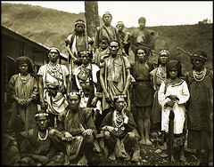
Aborigine
The general named often used to describe the original inhabitants of Australia.

Janissary
A slave soldier of the Ottoman Army

Dar al-Islam
a term used by Muslims to refer to those countries where Muslims can practice their religion freely.
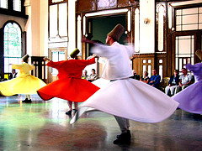
Sufi
A member of the more mystical third sect of Islam famous for their dance and their poetry.

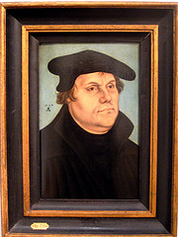
Martin Luther
The German monk widely regarded as the leader of the Protestant Reformation. He was excommunicated by the Catholic Church due to his opposition to certain practices and he began his own sect of Christianity in the 16th century.

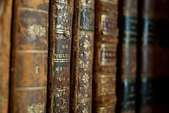
Enlightenment
A popular philosophical movement of the 1700s that focused on human reasoning, natural science, political and ethical philosophy.
Jamestown
The first permanent English settlement in North America, found in East Virginia
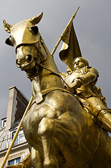
Hundred Years War
War between France and Britain, lasted 116 years, mostly a time of peace, but it was punctuated by times of brutal violence (1337 to 1453)

Colombian Exchange
The trading of various animals, diseases, and crops between the Eastern and Western hemispheres

triangle
From the 16th to 19th centuries, the flow of goods between the Americas, Europe in Africa is often described with what geometric shape?

Colonization
The expansion of countries into other countries where they establish settlements and control the people

Scientific Revolution
period in the 16th and 17th centuries where many thinkers rejected doctrines of the past dealing with the natural world in favor of new scientific ideas.
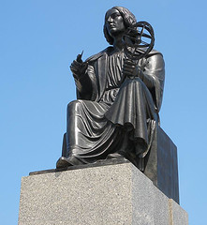
Copernicus
Devised a model of the universe with the Sun at the center, and not earth.

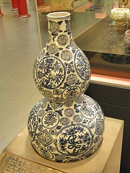
Ming
Chinese dynasty between 1368-1644. Economy flourished and the government even explored the Indian Ocean through many expeditions led by Zheng He. Ultimately they were taken over by the Manchurians from the North in 1644.

Gunpowder
Invented within China during the 9th century, this substance was became the dominant military technology used to expand European and Asian empires by the 15th century.

Christopher Columbus
He mistakenly discovered the Americas in 1492 while searching for a faster route to India.

Empiricism
theory that all knowledge originates from experience. It emphasizes experimentation and observation in order to truly know things.

Philosophes
Writers during the Enlightenment and who popularized the new ideas of the time.

Concordat
the peace agreement made between Napoleon and the Pope following the chaos of the French Revolution.
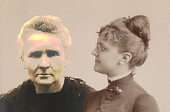
Marie Curie
Notable female Polish/French chemist and physicist around the turn of the 20th century. Won two nobel prizes. Did pioneering work in radioactivity.

Albert Einstein
German physicist, father of modern quantum physics.

Sigmund Freud
Austrian neurologist known for his work on the unconscious mind. Father of psychoanalysis.
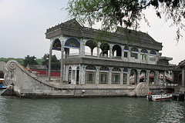
Cixi
Ultraconservative empress in Qing (Manchu) dynasty China. Ruled china in the turbulent late 19th century, not as a true Empress but as an Empress Dowager.

Guomindang
Political party that ruled China from 1911 to 1949; enemy of the Communists. Often abbreviated at GMD.

creole
Descendants of the Europeans in Latin America, usually implies an upper class status.
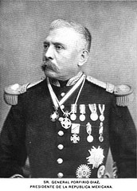
Porfirio Diaz
Dictator in Mexico from 1876 to 1911. Overthrown by the Mexican Revolution of 1910.
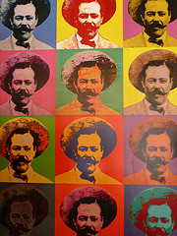
Pancho Villa
This military leader dominated Northern Mexico during the Mexican Revolution between 1910 and 1915. His supporters seized hacienda land for distribution to peasants and soldiers. He robbed and commandeered trains. Allied with Zapata. He was eventually defeated though before the revolution ended in 1920.
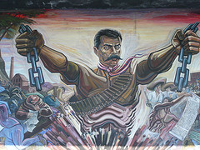
Zapata
Revolutionary Leader in Mexico during the Mexican Revolution who originated from the lower classes and was especially appealing to the peasants because he wanted to take land from the haciendas and return it to them.

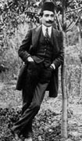
Young Turks
A coalition starting in the late 1870s of various groups favoring modernist liberal reform of the Ottoman Empire. It was against monarchy of Ottoman Sultan and instead favored a constitution. In 1908 they succeed in establishing a new constitutional era.

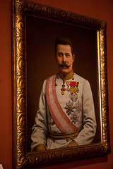
Franz Ferdinand
Archduke of Austria-Hungary assassinated by a Serbian nationalist. A major catalyst for WWI.

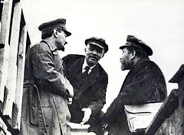
Bolsheviks
The Marxist revolutionaries who eventually gain control of Russia in 1917.

Vladimir Lenin
Leader Russia's Bolshevik movement.

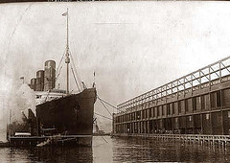
Lusitania
British passenger ship holding Americans that sunk off the coast of Ireland in 1915 by German U-Boats killing 1,198 people. It was decisive in turning public favor against Germany and bringing America into WWI.

Zimmerman telegram
This was sent by Germans to encourage a Mexican attack against the United States. Intercepted by the US in 1917.

Fourteen Points
Woodrow Wilson's post WWI plan, most of which was rejected by European leaders following the war.

Treaty of Versailles
Treaty particularly known for its harsh reparations towards the Germans after World War I.
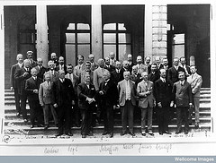
League of Nations
Diplomatic organization created after World War I. Proposed by Wilson but the US did not join. The organization is widely regarded as a huge failure.

Joseph Stalin
Leader of the Soviet Union after the death of Vladimir Lenin.

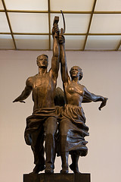
Collectivization
The process seen in the Soviet Union and Communist China to form communal work units for agriculture and manufacturing--from private hands to large, collective, government operations.

Franklin D. Roosevelt
President of the United States during most of the Depression and most of World War II.

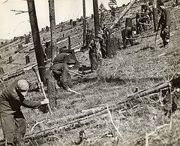
Civilian Conservation Corps
A major public works program in the United States during the Great Depression.

Fascism
A political theory advocating an authoritarian hierarchical ultra-nationalist government. Favors nationalizing economic elites rather than promoting egalitarian socialist collectivization.

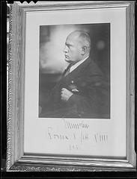
Benito Mussolini
Italian politician who led the National Fascist Party and created Fascism

Adolf Hitler
German leader of the Nazi Party.

Nazism
National socialism. In practice a far-right wing ideology (with some left-wing influences) that was based largely on racism and ultra-nationalism.

Weimar Republic
German republic founded after the WWI and the downfall of the German Empire's monarchy.

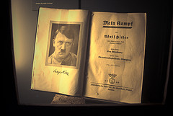
Mein Kampf
Influential book Written by Adolf Hitler describing his life and ideology.

Totalitarianism
Government ruled by a single party and/or person that exerts unlimited control over its citizen's lives.

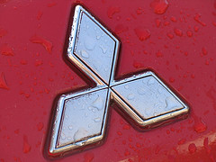
Zaibatsu
Large conglomerate corporations through which key elite families exerted a great deal of political and economic power in Imperial Japan. By WWII, four of them controlled most of the economy of Japan.
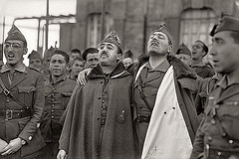
Francisco Franco
Spanish general whose armies took control of Spain in 1939 and who ruled as a dictator until his death

Sudetenland
Land that Germany thought was rightfully theirs due to the large German speaking population

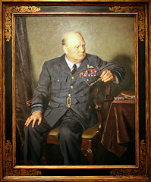
Winston Churchill
British statesman and leader during World War II; received Nobel prize for literature in 1953

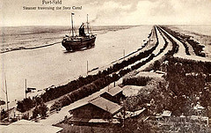
Suez Canal
A ship canal in northeastern Egypt linking the Red Sea with the Mediterranean Sea
Tito
Yugoslav statesman who led the resistance to German occupation during World War II and established a communist state after the war

Holocaust
Mass murder of Jews under the Nazi Regime

Comfort girls
Women forced into prostitution by the Japanese during WWII. The women came from countries in East and Southeast Asia as Japan's empire expanded.

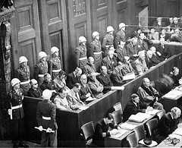
Nuremberg Trials
One key set of trials held for certain Germans accused of war crimes.

Berlin Blockade
Soviet blocking of Berlin from allies; Causing the Berlin Airlift

NATO
Alliance of the allied powers against the Soviets
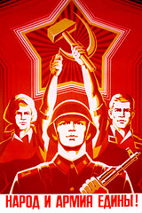
Warsaw Pact
Alliance against democracy, supporting communism

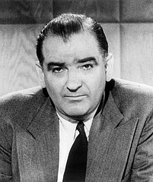
McCarthyism
The act of accusing people of disloyalty and communism

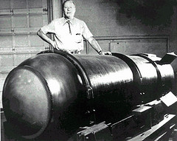
Hydrogen bomb
A thermonuclear bomb which uses the fusion of isotopes of hydrogen

Nikita Khrushchev
A Soviet leader during the Cuban Missile Crisis. Also famous for denouncing Stalin and allowed criticism of Stalin within Russia.

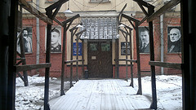
gulag
Russian prison camp for political prisoners

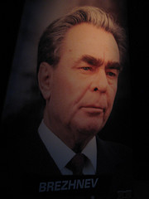
Leonid Brezhnev
Soviet leader from 1962 to 1984 who is most known internationally for actions such as his hard-line stance against the pro-democracy Prague Spring protesters in 1968 and well as overseeing Russia's long, costly, and futile war in Afghanistan.
Proxy war
A war instigated by a major power that does not itself participate
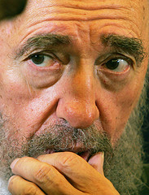
Fidel Castro
Cuban socialist leader who overthrew a dictator in 1959 and established a Marxist socialist state in Cuba

John F. Kennedy
President of the US during the Bay of Pigs Invasion and the Cuban Missile Crisis

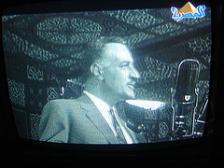
Gamal Abdel Nasser
He led the coup which toppled the monarchy of King Farouk and started a new period of modernization and socialist reform in Egypt
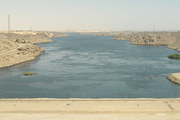
Aswan High Dam
One of the world's largest dams on the Nile River in southern Egypt. A key project under Gama Abdel Nasser.

Charles de Gaulle
French General who founded the French Fifth Republicn in 1958 and served as its first President from 1959 to 1969

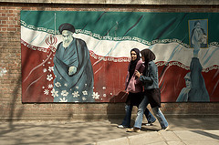
Khomeini
leader of the 1979 Iranian Revolution

OPEC
An international oil cartel originally formed in 1960. Represents the majority of all oil produced in the world. Attempts to limit production to raise prices. It's long name is the Organization of Petroleum Exporting Countries.
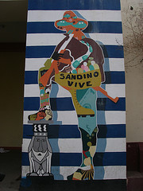
Sandinista
Rebel forces in Nicaragua who struggled against what they saw as US occupation of their nation and US backed puppet rulers in their nation's government. Particularly active in the 1970s and 1980s. The US frequently arranged groups to fight against these rebels, sometimes covertly as in the case of the Iran-Contra Affair.

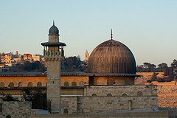
Zionism
A Jewish movement starting in the 1800s that resulted in the migration of Jews to Palestine and the establishment of the state of Israel in 1948.

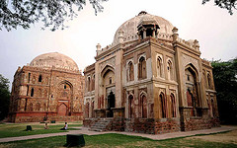
Delhi Sultanate
The first Islamic government established within India from 1206-1520. Controled a small area of northern India and was centered in Delhi.
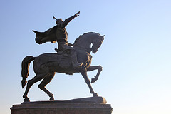
Timur
Sometimes known as Tamerlane, this was the Central Asian leader of a Mongol tribe who attempted to re-establish the Mongol Empire in the late 1300's. His empire included Persia (Iran) and many surrounding lands. He is the great great grandfather of Babur. who later founds the Mughal Empire in India.

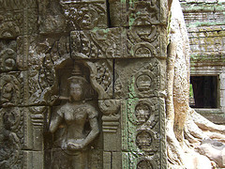
Khmer Empire
Aggressive empire in Cambodia and Laos that collapsed in the 1400's when Thailand conquered Cambodia

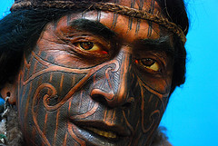
Maori
New Zealand indigenous culture established around 800 CE

Pax Mongolica
The period of approximately 150 years of relative peace and stability created by the Mongol Empire.

Ghana
West African state that supplied the majority of the world's gold from 500 CE-1400's
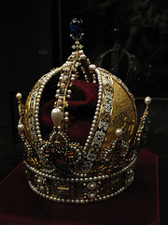
Habsburg
German princely family who ruled in alliance with the Holy Roman Empire and controlled most of Central Europe

Witchcraft
Many people (mostly women) were accused of this and burned at the stake in medieval and early modern Europe.
Humanism
Philosophy that celebrates human cultural achievements and emphasizes human reason and ethics.

Hadith
Traditional records of the deeds of Muhammad, and his quotations

Marco Polo
Italian explorer who wrote about his travels to Central Asia and China.

Mongol Empire
Largest land empire in the history of the world, spanning from Eastern Europe across Asia.

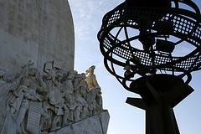
Henry The Navigator
This Portuguese prince who lead an extensive effort to promote seafaring expertise in the 14th century. Sent many expedition to the coast of West Africa in the 15th century, leading Portugal to discover a route around Africa, ultimately to India.

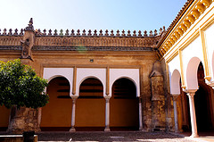
Abbasid Caliphate
Descendants of the Prophet Muhammad's uncle, al-Abbas, they overthrew the Umayyad Caliphate and ruled an Islamic empire from their capital in Baghdad (founded 762) from 750 to 1258.
Adolf Hitler
Born in Austria, became a radical German nationalist during World War I. He became dictator of Germany in 1933. He led Europe into World War II.
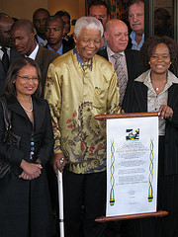
African National Congress
An organization dedicated to obtaining equal voting and civil rights for black inhabitants of South Africa. Founded in 1912 as the South African Native National Congress, it changed its name in 1923. Eventually brought greater equality.

Afrikaners
South Africans descended from Dutch and French settlers of the seventeenth century. Their Great Trek founded new settler colonies in the nineteenth century. Though a minority among South Africans, they held political power after 1910.

Agricultural Revolution
The change from food gathering to food production that occurred between around 8000 and 2000 B.C.E. Also known as the Neolithic Revolution.

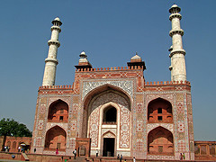
Akbar
Most illustrious sultan of the Mughal Empire in India (r. 1556-1605). He expanded the empire and pursued a policy of conciliation with Hindus.

Akhenaten
Egyptian pharaoh (r. 1353-1335 B.C.E.). He built a new capital at Amarna, fostered a new style of naturalistic art, and created a religious revolution by imposing worship of the sun-disk.

Albert Einstein
German physicist who developed the theory of relativity, which states that time, space, and mass are relative to each other and not fixed.

Alexandria
City on the Mediterranean coast of Egypt founded by Alexander. It became the capital of the Hellenistic kingdom of Ptolemy. It contained the famous Library and the Museum and was a center for leading scientific and literary figures in the classical and postclassical eras.

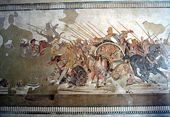
Alexander the Great
Between 334 and 323 B.C.E. he conquered the Persian Empire, reached the Indus Valley, founded many Greek-style cities, and spread Greek culture across the Middle East.
All-India Muslim League
Political organization founded in India in 1906 to defend the interests of India's Muslim minority. Led by Muhammad Ali Jinnah, it attempted to negotiate with the Indian National Congress. Demanded the partition of a Muslim Pakistan.

Enclosure Movement
The 18th century privatization of common lands in England, which contributed to the increase in population and the rise of industrialization.

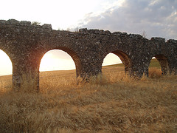
aqueduct
A conduit, either elevated or underground, using gravity to carry water from a source to a location-usually a city-that needed it. The Romans built many of these in a period of substantial urbanization.

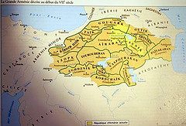
Armenia
One of the earliest Christian kingdoms, situated in eastern Anatolia (east of Turkey today) and the western Caucasus and occupied by speakers of the Armenian language. The Ottoman Empire is accused of systematic mass killings of Armenians in the early 20th century.

Asante
African kingdom on the Gold Coast that expanded rapidly after 1680. A major participant in the Atlantic economy, trading gold, slaves, and ivory. It resisted British imperial ambitions for a quarter century before being absorbed into Britain.
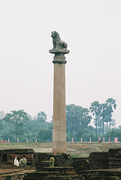
Asoka
Third ruler of the Mauryan Empire in India (r. 270-232 B.C.E.). He converted to Buddhism and broadcast his precepts on inscribed stones and pillars, the earliest surviving Indian writing.

Asian Tigers
Collective name for South Korea, Taiwan, Hong Kong, and Singapore-nations that became economic powers in the 1970s and 1980s.
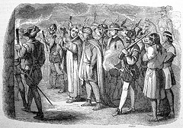
Atahualpa
Last ruling Inca emperor of Peru. He was executed by the Spanish.

Atlantic
After 1500, world economic activity gradually began to shift toward this body of water, noncontributing to the rise of Western European colonialism and economic dominance in the world.

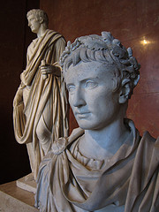
Caesar Augustus
He established his rule after the death of Julius Caesar and he is considered the first Roman Emperor.

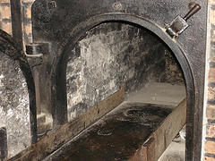
Auschwitz
Nazi extermination camp in Poland, the largest center of mass murder during the Holocaust. Close to a million Jews, Gypsies, Communists, and others were killed there. (p. 800)

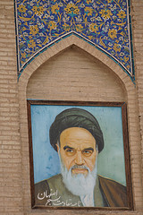
Ayatollah Khomeini
Shi'ite philosopher and cleric who led the overthrow of the shah of Iran in 1979 and created an Islamic Republic of Iran.

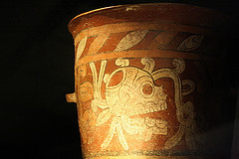
Aztecs
Also known as Mexica, they created a powerful empire in central Mexico (1325-1521 C.E.). They forced defeated peoples to provide goods and labor as a tax.

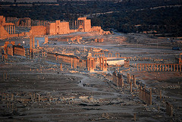
Babylon
The largest and most important city in Mesopotamia. It achieved particular eminence as the capital of the king Hammurabi in the eighteenth century B.C.E. and the Neo-Babylonian king Nebuchadnezzar in the sixth century B.C.E. (p. 29)

Balfour Declaration
Statement issued by Britain's Foreign Secretary Arthur Balfour in 1917 favoring the establishment of a Jewish national homeland in Palestine.
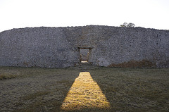
Bantu
A major African language family. Collective name of a large group of sub-Saharan African languages and of the peoples speaking these languages. Famous for migrations throughout central and southern Africa.

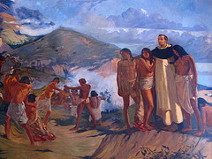
Bartolome de Las Casas
First bishop of Chiapas, in southern Mexico. He devoted most of his life to protecting Amerindian peoples from exploitation. His major achievement was the New Laws of 1542, which limited the ability of Spanish settlers to compel Amerindians to labor.

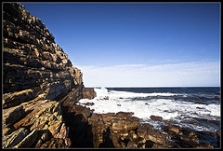
Bartolomeu Dias
Portuguese explorer who in 1488 led the first expedition to sail around the southern tip of Africa from the Atlantic and sight the Indian Ocean.
Battle of Midway
U.S. naval victory over the Japanese fleet in June 1942, in which the Japanese lost four of their best aircraft carriers. It marked a turning point in the pacific theater of World War II.

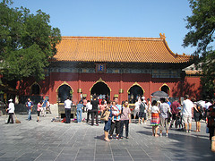
Beijing
China's northern capital, first used as an imperial capital in 906 and now the capital of the People's Republic of China.
Bengal
Region of northeastern India. It was the first part of India to be conquered by the British in the eighteenth century and remained the political and economic center of British India throughout the nineteenth century. Today this region includes part of Eastern India and all of Bangladesh.
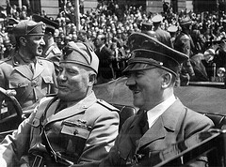
Benito Mussolini
Fascist dictator of Italy (1922-1943). He led Italy to conquer Ethiopia (1935), joined Germany in the Axis pact (1936), and allied Italy with Germany in World War II. He was overthrown in 1943 when the Allies invaded Italy.

Benjamin Franklin
American intellectual, inventor, and politician He helped to negotiate French support for the American Revolution.

Berlin Conference
Conference that German chancellor Otto von Bismarck called to set rules for the partition of Africa. It led to the creation of the Congo Free State under King Leopold II of Belgium.

Bhagavad-Gita
The most important work of Indian sacred literature, a dialogue between the great warrior Arjuna and the god Krishna on duty and the fate of the spirit.

Black Death
The common name for a major outbreak of plague that spread across Asia, North Africa, and Europe in the mid-fourteenth century, carrying off vast numbers of persons.

Bolsheviks
Radical Marxist political party founded by Vladimir Lenin in 1903. They eventually seized power in Russia in 1917.

bourgeoisie
In early modern Europe, the class of well-off town dwellers whose wealth came from manufacturing, finance, commerce, and allied professions.
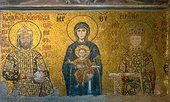
Byzantine Empire
Historians' name for the eastern portion of the Roman Empire from the fourth century until its downfall to the Ottomans in 1453. Famous for being a center of Orthodox Christianity and Greek-based culture.
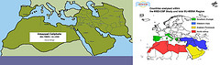
caliphate
Islamic empire ruled by those believed to be the successors to the Prophet Muhammad.

capitalism
The economic system of large financial institutions-banks, stock exchanges, investment companies-that first developed in early modern Europe. The belief that all people should seek their own profit gain and that doing so is beneficial to society. See Adam Smith, Wealth of Nations (1776).
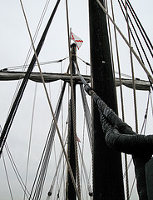
caravel
A small, highly maneuverable three-masted ship used by the Portuguese and Spanish in the exploration of the Atlantic.

Carthage
City located in present-day Tunisia, founded by Phoenicians ca. 800 B.C.E. It became a major commercial center and naval power in the western Mediterranean until defeated by the expanding Roman Republic in the third century B.C.E.

Catholic Reformation
Religious reform movement within the Latin Christian Church, begun in response to the Protestant Reformation. It clarified Catholic theology and reformed clerical training and discipline.
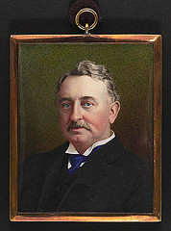
Cecil Rhodes
British entrepreneur and politician involved in the expansion of the British Empire from South Africa into Central Africa. The colonies of Southern Rhodesia (now Zimbabwe) and Northern Rhodesia (now Zambia) were named after him. (p. 736)

Celts
Peoples sharing a common language and culture that originated in Central Europe in the first half of the first millennium B.C.E.. After 500 B.C.E. they spread as far as Anatolia in the east, Spain and the British Isles in the west. Conquered by Romans and displaced by Germans and other groups, today they are found in some corners of the British Isles.

Champa Rice
Quick-maturing rice that can allow two harvests in one growing season. Originally introduced into Champa from India, it was later sent to China as a tribute gift by the Champa state (as part of the tributary system.)

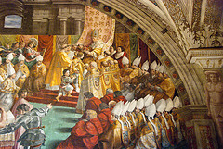
Charlemagne
King of the Franks (r. 768-814); emperor (r. 800-814). Through a series of military conquests he established the Carolingian Empire, which encompassed all of Gaul and parts of Germany and Italy. Illiterate, though started an intellectual revival.
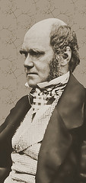
Charles Darwin
English naturalist. He studied the plants and animals of South America and the Pacific islands, and in his book On the Origin of Species by Means of Natural Selection (1859) set forth his theory of evolution.

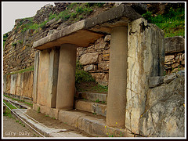
Chavin
The first major urban civilization in South America (900-250 B.C.E.). Its capital was located high in the Andes Mountains of Peru. Chavin became politically and economically dominant in a densely populated region.
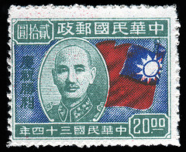
Chiang Kai-Shek
General and leader of Nationalist China after 1925. Although he succeeded Sun Yat-sen as head of the Guomindang, he became a military dictator whose major goal was to crush the communist movement led by Mao Zedong. In 1949 the Guomingdang was defeated by the CCP and transplanted to Taiwan.

chiefdom
Form of political organization with rule by a hereditary leader who held power over a collection of villages and towns. Less powerful than kingdoms and empires, they were based on gift giving and commercial links.
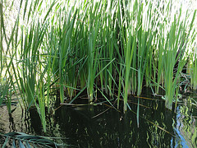
chinampas
Raised fields constructed along lake shores in Mesoamerica to increase agricultural yields.

Christopher Columbus
Genoese mariner who in the service of Spain led expeditions across the Atlantic, reestablishing contact between the peoples of the Americas and the Old World and opening the way to Spanish conquest and colonization.

city state
A small independent state consisting of an urban center and the surrounding agricultural territory. A characteristic political form in early Mesopotamia, Archaic and Classical Greece, Phoenicia, and early Italy.

Cold War
The ideological struggle between communism (Soviet Union) and capitalism (United States) for world influence. The Soviet Union and the United States came to the brink of actual war during the Cuban missile crisis but never attacked one another.

colonialism
Policy by which a nation administers a foreign territory and develops its resources for the benefit of the colonial power.
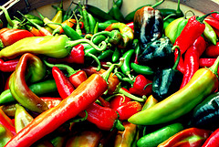
Columbian Exchange
The exchange of plants, animals, diseases, and technologies between the Americas and the rest of the world following Columbus's voyages.

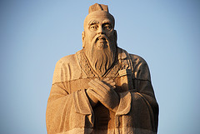
Confucius
His doctrine of duty and public service had a great influence on subsequent Chinese thought and served as a code of conduct for government officials. Although his real name was Kongzi (551-479 B.C.E.).

Congress of Vienna
Meeting of representatives of European monarchs called to reestablish the old order and establish a plan for a new balance of power after the defeat of Napoleon.

conquistadors
Early-sixteenth-century Spanish adventurers who conquered Mexico, Central America, and Peru. (Examples Cortez, Pizarro, Francisco.)

Constantine
Roman emperor (r. 312-337). After reuniting the Roman Empire, he moved the capital to Constantinople and made Christianity a tolerated/favored religion.
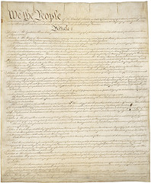
Constitutional Convention
Meeting in 1787 of the elected representatives of the thirteen original states to write the Constitution of the United States.

constitutionalism
The theory developed in early modern England and spread elsewhere that royal power should be subject to legal and legislative checks.
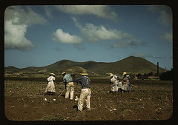
Indentured servitude
A worker bound by a voluntary agreement to work for a specified period of years often in return for free passage to an overseas destination. Before 1800 most were Europeans; after 1800 most indentured laborers were Asians.

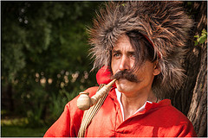
Cossacks
Peoples of the Russian Empire who lived outside the farming villages, often as herders, mercenaries, or outlaws. Cossacks led the conquest of Siberia in the sixteenth and seventeenth centuries.

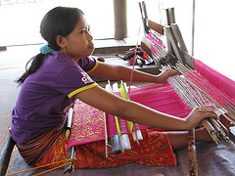
cottage industry
Weaving, sewing, carving, and other small-scale industries that can be done in the home. The laborers, frequently women, are usually independent. Most manufacturing was done this way before the industrial revolution.

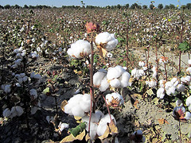
cotton
The plant that produces fibers from which many textiles are woven. Native to India, it spread throughout Asia and then to the New World. It has been a major cash crop in various places, including early Islamic Iran, Yi Korea, Egypt, and the US

creoles
In colonial Spanish America, term used to describe someone of European descent born in the New World. Elsewhere in the Americas, the term is used to describe all nonnative peoples.
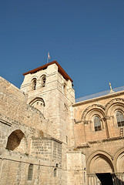
Crusades
Armed pilgrimages to the Holy Land by Christians determined to recover Jerusalem from Muslim rule. The Crusades brought an end to western Europe's centuries of intellectual and cultural isolation.
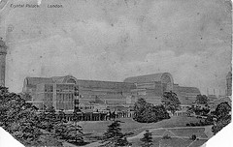
Crystal Palace
Building erected in London, for the Great Exhibition of 1851. Made of iron and glass, like a gigantic greenhouse, it was a symbol of the industrial age.
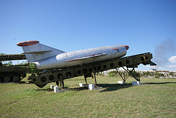
Cuban Missile Crisis
Brink-of-war confrontation between the United States and the Soviet Union over the latter's placement of nuclear-armed missiles in Cuba.

cultural imperialism
Domination of one culture over another by a deliberate policy that encourages cultural assimilation of neighboring foreign peoples or by economic or technological superiority.
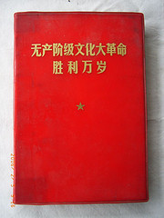
Cultural Revolution
Campaign in China ordered by Mao Zedong to purge the Communist Party of his opponents and instill revolutionary values in the younger generation.
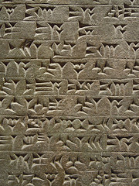
cuneiform
A system of writing in which wedge-shaped symbols represented words or syllables. It originated in Mesopotamia and was used initially for Sumerian and Akkadian but later was adapted to represent other languages of western Asia.

Cyrus
Founder of the Achaemenid Persian Empire. Between 550 and 530 B.C.E. he conquered Media, Lydia, and Babylon. Revered in the traditions of both Iran and the subject peoples.

dalai lama
Originally, a title meaning 'universal priest' that the Mongol khans invented and bestowed on a Tibetan lama (priest) in the late 1500s to legitimate their power in Tibet. Subsequently, the title of the religious and political leader of Tibet.

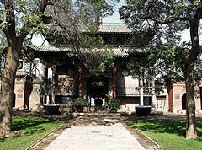
Daoism
Chinese religion that believes the world is always changing and is devoid of absolute morality or meaning. They accept the world as they find it, avoid futile struggles, and deviate as little as possible from 'the way' or 'path' of nature.

Darius I
Third ruler of the Persian Empire (r. 521-486 B.C.E.). He crushed the widespread initial resistance to his rule and gave all major government posts to Persians rather than to Medes.

Declaration of the Rights of Man
Statement of fundamental political rights adopted by the French National Assembly at the beginning of the French Revolution.
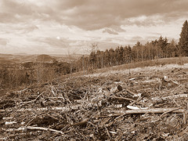
deforestation
The removal of trees faster than forests can replace themselves.

democracy
system of government in which all 'citizens' (however defined) have equal political and legal rights, privileges, and protections, as in the Greek city-state of Athens in the fifth and fourth centuries B.C.E. Demographic Transition,A change in the rates of population growth. Before the transition, both birth and death rates are high, resulting in a slowly growing population; then the death rate drops but the birth rate remains high, causing a population explosion. (867)

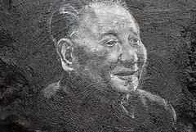
Deng Xiaoping
Communist Party leader who seen as responsible for Chinese economic reforms after the death of Mao Zedong in 1976.

devshirme
'Selection' in Turkish. The system by which boys from Christian communities were taken by the Ottoman state to serve as Janissaries.

diaspora
A Greek word meaning 'dispersal,' used to describe the communities of a given ethnic group living outside their homeland. Jews, for example, were spread from Israel to western Asia and Mediterranean lands in by the Romans.

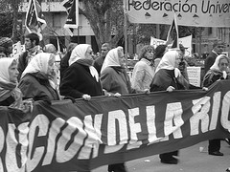
Dirty War
War waged by the Argentine military (1976-1982) against leftist groups. Characterized by the use of illegal imprisonment, torture, and executions by the military.

driver
A privileged male slave whose job was to ensure that a slave gang did its work on a plantation.

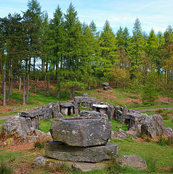
Druids
The class of religious experts who conducted rituals and preserved sacred lore among some ancient Celtic peoples. They provided education, mediated disputes between kinship groups, and were suppressed by the Romans as potential resistance.

economic sanctions
Boycotts, embargoes, and other economic measures that one country uses to pressure another country into changing its policies.

telegraph
A device for rapid, long-distance transmission of information over an electric wire. It was introduced in England and North America in the 1830s and 1840s.

electricity
A form of energy used in telegraphy from the 1840s on and for lighting, industrial motors, and railroads beginning in the 1880s.

Emilano Zapata
Revolutionary and leader of peasants in the Mexican Revolution. He mobilized landless peasants in south-central Mexico in an attempt to seize and divide the lands of the wealthy landowners. Though successful for a time, he was ultimately assassinated.

Emilio Aguinaldo
Leader of the Filipino independence movement against Spain (1895-1898). He proclaimed the independence of the Philippines in 1899, but his movement was crushed and he was captured by the United States Army in 1901.

Emperor Menelik
Emperor of Ethiopia (r. 1889-1911). He enlarged Ethiopia to its present dimensions and defeated an Italian invasion at Adowa (1896).

Empress Dowager Cixi
Empress of China and mother of Emperor Guangxi. She put her son under house arrest, supported anti-foreign movements like the so-called Boxers, and resisted reforms of the Chinese government and armed forces.
encomienda
A grant of authority over a population of Amerindians in the Spanish colonies. It provided the grant holder with a supply of cheap labor and periodic payments of goods by the Amerindians. It obliged the grant holder to Christianize the native Americans.

Enlightenment
A philosophical movement in eighteenth-century Europe that fostered the belief that one could reform society by discovering rational laws that governed social behavior and were just as scientific as the laws of physics.
Estates General
The traditional group of representatives from the three Estates of French society: the clergy, nobility, and commoners. Louis XVI assembled this group to deal with the financial crisis in France at the time, but the 3rd estate demanded more rights and representation.

Ethiopia
East African highland nation lying east of the Nile River.

ethnic cleansing
Effort to eradicate a people and its culture by means of mass killing and the destruction of historical buildings and cultural materials. It was used for example by both sides in the conflicts that accompanied the disintegration of Yugoslavia.

European Community
An organization promoting economic unity in Europe formed in 1967 by consolidation of earlier, more limited, agreements. Replaced by the European Union (EU) in 1993.

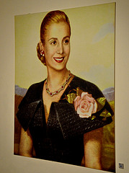
Eva Peron
Wife of Juan Peron and champion of the poor in Argentina. She was a gifted speaker and popular political leader who campaigned to improve the life of the urban poor by founding schools and hospitals and providing other social benefits.

extraterritoriality
Foreign residents in a country living under the laws of their native country, disregarding the laws of the host country. 19th/Early 20th Centuries: European and US nationals in certain areas of Chinese and Ottoman cities were granted this right.

Fascist Party
Italian political party created by Benito Mussolini during World War I. It emphasized aggressive nationalism and was Mussolini's instrument for the creation of a dictatorship in Italy from 1922 to 1943.

Ferdinand Magellan
Portuguese navigator who led the Spanish expedition of 1519-1522 that was the first to sail around the world.

Solomon's Temple
A monumental sanctuary built in Jerusalem by King Solomon in the tenth century B.C.E. to be the religious center for the Israelite god Yahweh. The Temple priesthood conducted sacrifices, received a tithe or percentage of agricultural revenues.
Five Year Plans
Plans that Joseph Stalin introduced to industrialize the Soviet Union rapidly, beginning in 1928. They set goals for the output of steel, electricity, machinery, and most other products and were enforced by the police powers of the state.
Forbidden City
The walled section of Beijing where emperors lived between 1121 and 1924. A portion is now a residence for leaders of the People's Republic of China.

Pancho Villa
A popular leader during the Mexican Revolution of 1910. An outlaw in his youth, when the revolution started, he formed a cavalry army in the north of Mexico and fought for the rights of the landless in collaboration with Emiliano Zapata.

Toussaint L'Ouverture
Leader of the Haitian Revolution. He freed the slaves and gained effective independence for Haiti despite military interventions by the British and French.
Fransisco Pizarro
Spanish explorer who led the conquest of the Inca Empire of Peru in 1531-1533.

neocolonialism
Economic dominance of a weaker country by a more powerful one, while maintaining the legal independence of the weaker state. In the late nineteenth century, this new form of economic imperialism characterized the relations between the Latin American republics.

fresco
A technique of painting on walls covered with moist plaster. It was used to decorate Minoan and Mycenaean palaces and Roman villas, and became an important medium during the Italian Renaissance.

gentry
A general term for a class of prosperous families, sometimes including but often ranked below the rural aristocrats.

George Washington
Military commander of the American Revolution. He was the first elected president of the United States (1789-1799).

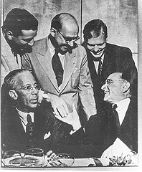
Getulio Vargas
Dictator of Brazil from 1930 to 1945 and from 1951 to 1954. Defeated in the presidential election of 1930, he overthrew the government and created Estado Novo ('New State'), a dictatorship that emphasized industrialization.

Ghana
First known kingdom in sub-Saharan West Africa between the sixth and thirteenth centuries C.E.
Gold Coast
Region of the Atlantic coast of West Africa occupied by modern Ghana; named for its gold exports to Europe from the 1470s onward.

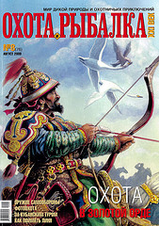
Golden Horde
Mongol khanate founded by Genghis Khan's. It was based in southern Russia and quickly adopted both the Turkic language and Islam. Also known as the Kipchak Horde.
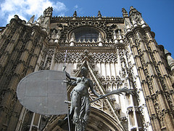
Gothic Cathedrals
Large churches originating in twelfth-century France; built in an architectural style featuring pointed arches, tall vaults and spires, flying buttresses, and large stained-glass windows.

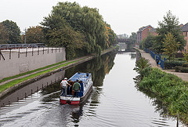
Grand Canal
The 1,100-mile (1,700-kilometer) waterway linking the Yellow and the Yangzi Rivers. It was begun in the Han period and completed during the Sui Empire.
Great Circuit
The network of Atlantic Ocean trade routes between Europe, Africa, and the Americas that underlay the Atlantic system.

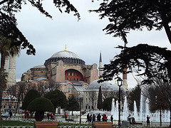
Great Schism
A division in the Latin (Western) Christian Church between 1378 and 1417, when rival claimants to the papacy existed in Rome and Avignon. (p. 411)

Great Zimbabwe
City, now in ruins (in the modern African country of Zimbabwe), whose many stone structures were built between about 1250 and 1450, when it was a trading center and the capital of a large state.
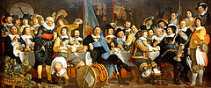
guild
In medieval Europe, an association of men (rarely women), such as merchants, artisans, or professors, who worked in a particular trade and created an organized institution to promote their economic and political interests.

gunpowder
The formula, brought to China in the 400s or 500s, was first used to make fumigators to keep away insect pests and evil spirits. In later centuries it was used to make explosives and grenades and to propel cannonballs, shot, and bullets.

Guomindang
Nationalist political party founded on democratic principles by Sun Yat-sen in 1912. After 1925, the party was headed by Chiang Kai-shek, who turned it into an increasingly authoritarian movement.

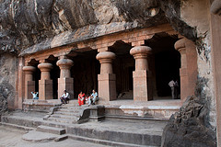
Gupta Empire
Powerful Indian state based in the Ganges Valley. It controlled most of the Indian subcontinent through a combination of military force and its prestige as a center of sophisticated culture. Often associated with a Golden Age of classical India.
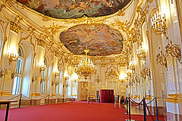
Habsburg
A powerful European family that provided many Holy Roman Emperors, founded the Austrian (later Austro-Hungarian) Empire, and ruled sixteenth- and seventeenth-century Spain.

hadith
A tradition relating the words or deeds of the Prophet Muhammad; next to the Quran, the most important basis for Islamic law.

Hammurabi
Amorite ruler of Babylon (r. 1792-1750 B.C.E.). He conquered many city-states in southern and northern Mesopotamia and is best known for a code of laws, inscribed on a black stone pillar, illustrating the principles to be used in legal cases.
Hanseatic League
An economic and defensive alliance of the free towns in northern Germany, founded about 1241 and most powerful in the fourteenth century.
Harappa
Site of one of the great cities of the Indus Valley civilization of the third millennium B.C.E. It was located on the northwest frontier of the zone of cultivation, and may have been a center for the acquisition of raw materials.

Hatshepsut
Queen of Egypt (1473-1458 B.C.E.). Dispatched a naval expedition down the Red Sea to Punt (possibly Somalia), the faraway source of myrrh. There is evidence of opposition to a woman as ruler, and after her death her name was frequently expunged.

Hebrew Bible
A collection of sacred books containing diverse materials concerning the origins, experiences, beliefs, and practices of the early Hebrew people. Most of the extant text was compiled by members of the priestly class in the fifth century B.C.E.

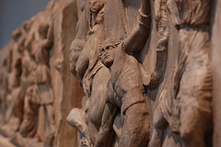
Hellenism
Greek culture spread across western Asia and northeastern Africa after the conquests of Alexander the Great. The period ended with the fall of the last major Hellenistic kingdom to Rome, but Greek cultural influence persisted until the spread of Islam.

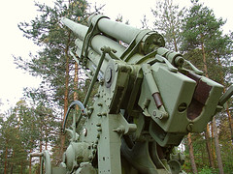
Helsinki Accords
Political and human rights agreement signed in Helsinki, Finland in 1975 by the Soviet Union and western European countries.

Herodotus
Greek Historian, considered the father of History. He came from a Greek community in Anatolia and traveled extensively, collecting information in western Asia and the Mediterranean lands.

The Mahdi
Last imam in a series of twelve descendants of Muhammad's son-in-law Ali, whom Shi'ites consider divinely appointed leaders of the Muslim community. In occlusion since ca. 873, he is expected to return as an apocolyptic messiah at the end of time.

hieroglyphics
System of writing in which pictorial symbols represented sounds, syllables, or concepts. Used for official and monumental inscriptions in ancient Egypt.

Hinduism
Term for a wide variety of beliefs and ritual practices that have developed in the Indian subcontinent since antiquity. It has roots in ancient Vedic, Buddhist, and south Indian religious concepts and practices.

Hiroshima
City in Japan, the first to be destroyed by an atomic bomb, on August 6, 1945. The bombing hastened the end of World War II.

Hittites
A people from central Anatolia who established an empire in Anatolia and Syria in the Late Bronze Age. With wealth from the trade in metals and military power based on chariot forces, they vied with New Kingdom Egypt over Syria.
Holocaust
Nazis' program during World War II to kill people they considered undesirable. Some 6 million Jews perished during the Holocaust, along with millions of Poles, Gypsies, Communists, Socialists, and others.

Holy Roman Empire
Loose federation of mostly German states and principalities, headed by an emperor who had little control over the hundreds of princes who elected him. It lasted from 962 to 1806.

hoplite
Heavily armored Greek infantryman of the Archaic and Classical periods who fought in the close-packed phalanx formation. Hoplite armies-militias composed of middle- and upper-class citizens supplying their own equipment. Famously defeated superior numbers of opponents by fighting as a unit.

horse collar
Harnessing method that increased the efficiency of horses by shifting the point of traction from the animal's neck to the shoulders; its adoption favors the spread of horse-drawn plows and vehicles.

House of Burgesses
Elected assembly in colonial Virginia, created in 1618.

Humanists
European scholars, writers, and teachers associated with the study of the humanities (grammar, rhetoric, poetry, history, languages, and moral philosophy), influential in the fifteenth century and later.

Humanism
a worldview and a moral philosophy that considers humans to be of primary importance. It is a perspective common to a wide range of ethical stances that attaches importance to human dignity, concerns, and capabilities, particularly rationality. A major component of the Italian Renaissance.

Hundred Years War
Series of campaigns over control of the throne of France, involving English and French royal families and French noble families.

Ibn Battuta
Moroccan Muslim scholar, the most widely traveled individual of his time. He wrote a detailed account of his visits to Islamic lands from China to Spain and the western Sudan.

Ibn Khaldun
Arab historian. He developed an influential theory on the rise and fall of states. Born in Tunis, he spent his later years in Cairo as a teacher and judge. In 1400 he was sent to Damascus to negotiate the surrender of the city.

Inca
Largest and most powerful Andean empire. Controlled the Pacific coast of South America from Ecuador to Chile from its capital of Cuzco.

Indian Civil Service
The elite professional class of officials who administered the government of British India. Originally composed exclusively of well-educated British men, it gradually added qualified Indians.

Indian National Congress
A movement and political party founded in 1885 to demand greater Indian participation in government. Its membership was middle class, and its demands were modest until World War I. Led after 1920 by Mohandas K. Gandhi, appealing to the poor.

Indian Ocean
This area possessed the biggest network of sea-based trade in the postclassical period prior to the rise of Atlantic-based trade.

indulgence
The forgiveness of the punishment due for past sins, granted by the Catholic Church authorities as a reward for a pious act. Martin Luther's protest against the sale of these is often seen as touching off the Protestant Reformation.

Industrial Revolution
The transformation of the economy, the environment, and living conditions, occurring first in England in the eighteenth century, that resulted from the use of steam engines, the mechanization of manufacturing in factories, transit, and communications

investiture
controversy Dispute between the popes and the Holy Roman Emperors over who held ultimate authority over bishops in imperial lands.

iron curtain
Winston Churchill's term for the Cold War division between the Soviet-dominated East and the U.S.-dominated West.

Iroquois Confederacy
An alliance of five northeastern Amerindian peoples (after 1722 six) that made decisions on military and diplomatic issues through a council of representatives. Allied first with the Dutch and later with the English, it dominated W. New England.

Islam
Religion expounded by the Prophet Muhammad (570-632 C.E.) on the basis of his reception of divine revelations, which were collected after his death into the Quran.

Israel
A Jewish state on the eastern shore of the Mediterranean, both in antiquity and again founded in 1948 after centuries of Jewish diaspora.

Jacobins
Radical republicans during the French Revolution. They were led by Maximilien Robespierre from 1793 to 1794.

James Watt
invented the condenser and other improvements that made the steam engine a practical source of power for industry and transportation. The watt, an electrical measurement, is named after him.

Janissaries
Infantry, originally of slave origin, armed with firearms and constituting the elite of the Ottoman army from the fifteenth century until the corps was abolished in 1826.

Nehru
Indian statesman. He succeeded Mohandas K. Gandhi as leader of the Indian National Congress. He negotiated the end of British colonial rule in India and became India's first prime minister (1947-1964).

Jesuits
Members of the Society of Jesus, a Roman Catholic order founded by Ignatius Loyola in 1534. They played an important part in the Catholic Reformation and helped create conduits of trade and knowledge between Asia and Europe.

Jesus
A Jew from Galilee in northern Israel who sought to reform Jewish beliefs and practices. He was executed as a revolutionary by the Romans. He is the basis of the world's largest religion.

Joesph Stalin
Ruled the Soviet Union from 1924 to 1953. Ruled with an iron fist, using Five-Year Plans to increase industrial production and terror to crush opposition.

joint-stock company
A business, often backed by a government charter, that sold shares to individuals to raise money for its trading enterprises and to spread the risks (and profits) among many investors.

Jose Morelos
Mexican priest and former student of Miguel Hidalgo y Costilla, he led the forces fighting for Mexican independence until he was captured and executed in 1814.

Josiah Wedgwood
English industrialist whose pottery works were the first to produce fine-quality pottery by industrial methods.

Juan Peron
President of Argentina (1946-1955, 1973-1974). As a military officer, he championed the rights of labor. Aided by his wife Eva Duarte Peron, he was elected president in 1946. He built up Argentinean industry, became very popular among the urban poor.

junk
A very large flatbottom sailing ship produced in the Tang and Song Empires, specially designed for long-distance commercial travel.

kamikaze
The 'divine wind,' which the Japanese credited with blowing Mongol invaders away from their shores in 1281.

Karl Marx
German journalist and philosopher, founder of the Marxist branch of socialism. He is known for two books: The Communist Manifesto (1848) and Das Kapital (Vols. I-III, 1867-1894).

karma
In Indian tradition, the residue of deeds performed in past and present lives that adheres to a 'spirit' and determines what form it will assume in its next life cycle. Used in India to make people happy with their lot in life.

keiretsu
Japanese business groups after the post-WWII dismantling of the zaibatsu. They are Alliances of corporations each often centered around a bank. They dominate the post-WWII Japanese economy.

khipu
System of knotted colored cords used by preliterate Andean peoples to transmit information. These knots are interesting because the Inca are notable for being a relatively sophisticated empire and civilization, but they had no written language (very unusual). Some have gone so far as to suggest that these knots were themselves a language, but this probably isn't true.

Khubilai Khan
Last of the Mongol Great Khans (r. 1260-1294). Ruled the Mongol Empire from China and was the founder of the Yuan Empire in China after defeating what was left of the Song Dynasty.

Kievan Russia
Government established at Kiev in Ukraine around 879 CE by Scandinavian adventurers asserting authority over a mostly Slavic farming population.

King Leopold II
King of Belgium (r. 1865-1909). He was active in encouraging the exploration of Central Africa and became the infamous ruler of the Congo Free State (to 1908).
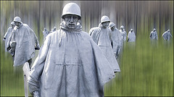
Korean War
Conflict that began with North Korea's invasion of South Korea and came to involve the United Nations (primarily the United States) allying with South Korea and the People's Republic of China allying with North Korea.

labor union
An organization of workers in a particular industry or trade, created to defend the interests of members through strikes or negotiations with employers.

laissez faire
The idea that government should refrain from interfering in economic affairs. The classic exposition of laissez-faire principles is Adam Smith's Wealth of Nations (1776).

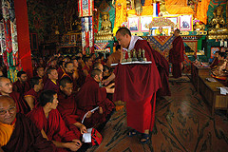
lama
In Tibetan Buddhism, a teacher.

League of Nations
International organization founded in 1919 to promote world peace and cooperation but greatly weakened by the refusal of the United States to join. It proved ineffectual in stopping aggression by Italy, Japan, and Germany in the 1930s.
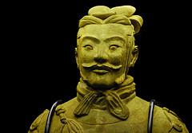
Legalism
In China, a political philosophy that emphasized the unruliness of human nature and justified state coercion and control. The Qin ruling class invoked it to validate the authoritarian nature of their regime.

liberalism
A political ideology that emphasizes rule of law, representative democracy, rights of citizens, and the protection of private property. This ideology, derived from the Enlightenment, was especially popular among the property-owning middle classes.

Little Ice Age
A century-long period of cool climate that began in the 1590s. Its ill effects on agriculture in northern Europe were notable.

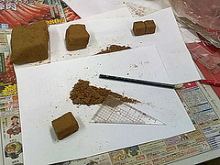
loess
Fine yellowish light silt deposited by wind and water. It constitutes the fertile soil of the Yellow River Valley in northern China. Because of the tiny needle-like shape of its particles, it can be easily shaped and used for underground structures (but vulnerable to earthquake)

Long March
The 6,000-mile (9,600-kilometer) flight of Chinese Communists from southeastern to northwestern China. The Communists, led by Mao Zedong, were pursued by the Chinese army under orders from Chiang Kai-shek.

ma'at
Egyptian term for the concept of divinely created and maintained order in the universe. Reflecting the ancient Egyptians' belief in an essentially beneficent world, the divine ruler was the earthly guarantor of this order.

Macartney Mission
The unsuccessful attempt by the British Empire to establish diplomatic relations with the Qing Empire in 1793.

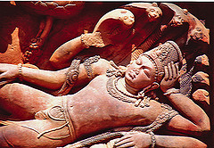
Mahabharata
A vast epic chronicling the events leading up to a cataclysmic battle between related kinship groups in early India. It includes the Bhagavad-Gita, the most important work of Indian sacred literature. Mahayana Buddhism,Branch of Buddhism followed in China, Japan, and Central Asia. The focus is on reverence for Buddha and for bodhisattvas, enlightened persons who have postponed nirvana to help others attain enlightenment.

Malay
A designation for peoples originating in south China and Southeast Asia who settled the Malaysian Peninsula, Indonesia, and the Philippines, then spread eastward across the islands of the Pacific Ocean and west to Madagascar. (p. 190)

Mali
Empire created by indigenous Muslims in western Sudan of West Africa from the thirteenth to fifteenth century. It was famous for its role in the trans-Saharan gold trade.

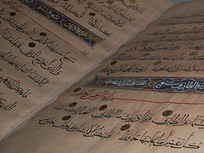
Mamluks
Under the Islamic system of military slavery, Turkic military slaves who formed an important part of the armed forces of the Abbasid Caliphate of the ninth and tenth centuries. Mamluks eventually founded their own state, ruling Egypt and Syria (1250-1517)

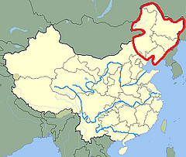
Manchuria
Region of Northeast Asia North of Korea.

Manchus
Northeast Asian peoples who defeated the Ming Dynasty and founded the Qing Dynasty in 1644, which was the last of China's imperial dynasties.

Mandate of Heaven
Chinese religious and political ideology developed by the Zhou, was the prerogative of Heaven, the chief deity, to grant power to the ruler of China.

Mandate System
Allocation of former German colonies and Ottoman possessions to the victorious powers after World War I, to be administered under League of Nations supervision. Used especially in reference to the Western European possession of the Middle East after WWI.
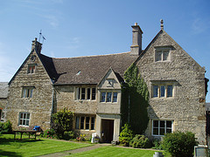
manor
In medieval Europe, a large, self-sufficient landholding consisting of the lord's residence (manor house), outbuildings, peasant village, and surrounding land.

Mansa Musa
Ruler of Mali (r. 1312-1337). His extravagant pilgrimage through Egypt to Mecca in 1324-1325 established the empire's reputation for wealth in the Mediterranean world.

manumission
A grant of legal freedom to an individual slave.

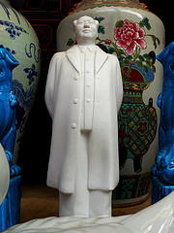
Mao Zedong
Leader of the Chinese Communist Party (1927-1976). He led the Communists on the Long March (1934-1935) and rebuilt the Communist Party and Red Army during the Japanese occupation of China (1937-1945).

mass deportation
Removal of entire peoples used as terror tactic by Assyrian and Persian Empires.

mass production
The manufacture of many identical products by the division of labor into many small
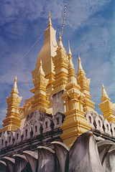
Mauryan Empire
The first state to unify most of the Indian subcontinent. It was founded by Chandragupta Maurya in 324 B.C.E. and survived until 184 B.C.E. From its capital at Pataliputra in the Ganges Valley it grew wealthy from taxes.

Max Planck
German physicist who developed quantum theory and was awarded the Nobel Prize for physics in 1918.

Maximillien Robespierre
Young provincial lawyer who led the most radical phases of the French Revolution. His execution ended the Reign of Terror. See Jacobins.
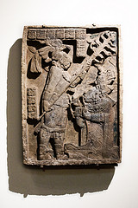
Maya
Mesoamerican civilization concentrated in Mexico's Yucatan Peninsula and in Guatemala and Honduras but never unified into a single empire. Major contributions were in mathematics, astronomy, and development of the calendar.

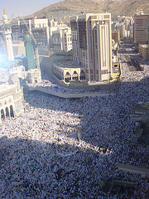
Mecca
City in western Arabia; birthplace of the Prophet Muhammad, and ritual center of the Islamic religion.
mechanization
The application of machinery to manufacturing and other activities. Among the first processes to be mechanized were the spinning of cotton thread and the weaving of cloth in late-eighteenth- and early-nineteenth-century England. (p. 603)

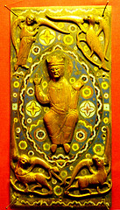
medieval
Literally 'middle age,' a term that historians of Europe use for the period between roughly 500 and 1400, signifying the period between Greco-Roman antiquity and the Renaissance.

Medina
City in western Arabia to which the Prophet Muhammad and his followers emigrated in 622 to escape persecution in Mecca.

Memphis
The capital of Old Kingdom Egypt, near the head of the Nile Delta. Early rulers were interred in the nearby pyramids.

mercantilism
European government policies of the sixteenth, seventeenth, and eighteenth centuries designed to promote overseas trade between a country and its colonies and accumulate precious metals by requiring colonies to trade only with their motherland country
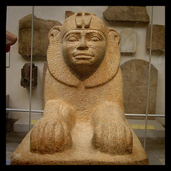
Nubians
The people in Eastern Africa south of Egypt who were rivals of the ancient Egyptians and known for their flourishing kingdom between the 400s BC and the 400s CE. They speak their own language and were known by the Egyptians for their darker skin.

mestizo
The term used by Spanish authorities to describe someone of mixed native American and European descent.

Middle Passage
The part of the Great Circuit involving the transportation of enslaved Africans across the Atlantic to the Americas.

Miguel Hidalgo y Costilla
Mexican priest who led the first stage of the Mexican independence war in 1810. He was captured and executed in 1811.

Mikhail Gorbachev
Head of the Soviet Union from 1985 to 1991. His liberalization effort improved relations with the West, but he lost power after his reforms led to the collapse of Communist governments in Eastern Europe.
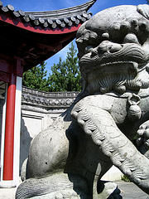
Ming
Chinese dynasty that followed the overthrow of the Yuan (Mongol) Dynasty in China. Among other things, the emperor Yongle sponsored the building of the Forbidden City and the voyages of Zheng He. It was mostly a time of vibrant economic productivity. It is regarded as the last great Chinese dynasty (1368-1644). In 1644 they fall to Manchurian (Qing Dynasty) from the North who who rule China until the Nationalist revolution in 1911.

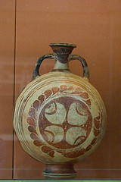
Minoan
Prosperous civilization on the Aegean island of Crete in the second millennium B.C.E. Exerted powerful cultural influences on the early Greeks.

mita
Andean labor system based on shared obligations to help kinsmen and work on behalf of the ruler and religious organizations.

Montezuma II
The last Aztec emperor. Here he is on vacation at the beach, just days before being captured and killed by Cortés in 1520.

modernization
The process of reforming political, military, economic, social, and cultural traditions in imitation of the early success of Western societies, often with regard for accommodating local traditions in non-Western societies.
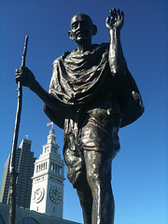
Mohandas Gandhi
Leader of the Indian independence movement and advocate of nonviolent resistance. After being educated as a lawyer in England, he returned to India and became leader of the Indian National Congress in 1920.

Mohenjo-Daro
Largest city of the Indus Valley civilization. It was centrally located in the extensive floodplain of the Indus River. Little is known about the political institutions of Indus Valley communities, but the large-scale implies central planning.

moksha
The Hindu concept of the spirit's 'liberation' from the endless cycle of rebirths.

monasticism
Living in a religious community apart from secular society and adhering to a rule stipulating chastity, obedience, and poverty. (Primary Centers of Learning in Medieval Europe)

Mongols
A people of this name is mentioned as early as the records of the Tang Empire, living as nomads in northern Eurasia. After 1206 they established an enormous empire under Genghis Khan, linking western and eastern Eurasia.

monotheism
Belief in a single divine entity. The Israelite worship of Yahweh developed into an exclusive belief in one god, and this concept passed into Christianity and Islam.

monsoon
These strong and predictable winds have long been ridden across the open sea by sailors, and the large amounts of rainfall that they deposit on parts of India, Southeast Asia, and China allow for the cultivation of several crops a year.

movable type
Type in which each individual character is cast on a separate piece of metal. It replaced woodblock printing, allowing for the arrangement of individual letters and other characters on a page. Invented in Korea 13th Century.
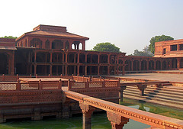
Mughal Empire
Muslim state (1526-1857) exercising dominion over most of India in the sixteenth and seventeenth centuries.
Muhammad
Arab prophet; founder of religion of Islam.

Muhammad Ali
Leader of Egyptian modernization in the early nineteenth century. He ruled Egypt as an Ottoman governor, but had imperial ambitions. His descendants ruled Egypt until overthrown in 1952.

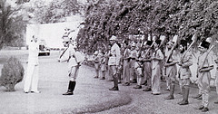
Muhammad Ali Jinnah
Indian Muslim politician who founded the state of Pakistan. A lawyer by training, he joined the All-India Muslim League in 1913. As leader of the League from the 1920s on, he negotiated with the British/INC for Muslim Political Rights

mulatto
The term used in Spanish and Portuguese colonies to describe someone of mixed African and European descent.

Muscovy
The Russian feudal duchy that emerged as a local power gradually during the era of Mongol domination. The Muscovite princes convinced their Mongol Tatar overlords to let them collect all the tribute gold from the other Russian princes on behalf of the Mongols. This caused Moscow to become the power center of Russian society and eventually they rebelled against Mongol domination.The Muscovite dynasty ruled without interruption from 1276 to 1598.

Muslim
An adherent of the Islamic religion.
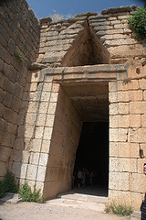
Mycenae
Site of a fortified palace complex in southern Greece that controlled a Late Bronze Age kingdom. In Homer's epic poems Mycenae was the base of King Agamemnon, who commanded the Greeks besieging Troy.

Napoleon Bonaparte
Overthrew the French revolutionary government (The Directory) in 1799 and became emperor of France in 1804. Failed to defeat Great Britain and abdicated in 1814. Returned to power briefly in 1815 but was defeated and died in exile.

Nasir al-Din Tusi
Persian mathematician and cosmologist whose academy near Tabriz provided the model for the movement of the planets that helped to inspire the Copernican model of the solar system.

National Assembly
French Revolutionary assembly (1789-1791). Called first as the Estates General, the three estates came together and demanded radical change. It passed the Declaration of the Rights of Man in 1789. nationalism,Political ideology that stresses people's membership in a nation-a community defined by a common culture and history as well as by territory. In the late eighteenth and early nineteenth centuries, nationalism was a force for unity in western Europe
NATO
Organization formed in 1949 as a military alliance of western European and North American states against the Soviet Union and its east European allies. (See also Warsaw Pact.)

Neo-Assyrian Empire
A major Mesopotamian empire between 934-608 BCE. They used force and terror and exploited the wealth and labor of their subjects. They were an iron-age resurgence of a previous bronze age empire.
Neolithic
The period of the Stone Age associated with the ancient Agricultural Revolution. It follows the Paleolithic period.

New Economic Policy
Policy proclaimed by Vladimir Lenin in 1924 to encourage the revival of the Soviet economy by allowing small private business and farming using markets instead of communist state ownership. His idea was that the Soviet state would just control "the commanding heights" of the economy like major industry, while allowing ordinary citizens to operate business and property ownership as normal. Joseph Stalin ended this in 1928 and replaced it with greater state ownership, collectivization, and a series of Five-Year Plans.

New Imperialism
Historians' term for the late-nineteenth- and early-twentieth-century wave of conquests by European powers, the United States, and Japan, which were followed by the development and exploitation of the newly conquered territories.

nomad
A person who lives a way of life, forced by a scarcity of resources, in which groups of people continually migrate to find pastures and water.

nonaligned
During the Cold War, countries who did not want to support either side sometimes declared themselves to be.
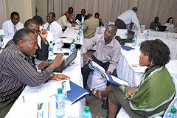
Nongovernmental Organizations
Nonprofit international organizations devoted to investigating human rights abuses and providing humanitarian relief. Two NGOs won the Nobel Peace Prize in the 1990s: International Campaign to Ban Landmines (1997) and Doctors Without Borders (1999).

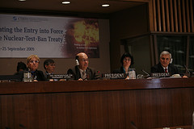
nuclear nonproliferation
Goal of international efforts to prevent countries other than the five declared nuclear powers (United States, Russia, Britain, France, and China) from obtaining nuclear weapons. The first Nuclear Non-Proliferation Treaty was signed in 1968.

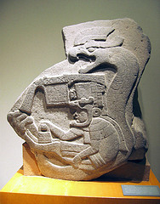
Olmec
The first Mesoamerican civilization. Between ca. 1200 and 400 B.C.E., these people of central Mexico created a vibrant civilization that included intensive agriculture, wide-ranging trade, ceremonial centers, and monumental construction.

Opium Wars
Wars between Britain and the Qing Empire (mind 1800s), caused by the Qing government's refusal to let Britain import Opium. China lost and Britain and most other European powers were able to develop a strong trade presence throughout China against their wishes.

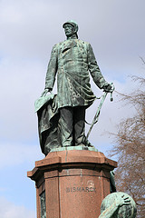
Otto von Bismarck
Chancellor of Prussia from 1862 until 1871, when he became chancellor of Germany. A conservative nationalist, he led Prussia to victory against Austria (1866) and France (1870) and was responsible for the creation of the German Empire

Ottomans
Turkish empire based in Anatolia. Arrived in the same wave of Turkish migrations as the Seljuks.

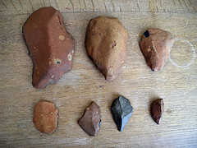
Paleolithic
The period of the Stone Age associated with the evolution of humans. It predates the Neolithic period.
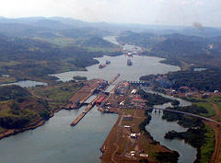
Panama Canal
Ship canal cut across the isthmus of Panama by United States, it opened in 1915.

papacy
The central administration of the Roman Catholic Church, of which the pope is the head. (pp. 258, 445)

papyrus
A reed that grows along the banks of the Nile River in Egypt. From it was produced a coarse, paperlike writing medium used by the Egyptians and many other peoples in the ancient Mediterranean and Middle East.

Parthians
Iranian ruling dynasty between ca. 250 B.C.E. and 226 C.E.

Apostle Paul
A Jew from the Greek city of Tarsus in Anatolia, he initially persecuted the followers of Jesus but, according to Christian belief, after receiving a revelation on the road to Syrian Damascus, he became arguably the most significant figure in the spread of Christianity and the shaping of its doctrine.

pax romana
The period of stability and prosperity that Roman rule brought to the lands of the Roman Empire in the first two centuries C.E. The movement of people and trade goods along Roman roads and safe seas allowed for the spread of cuture/ideas.

Pearl Harbor
Naval base in Hawaii attacked by Japanese aircraft on December 7, 1941. The sinking of much of the U.S. Pacific Fleet brought the United States into World War II.

Peloponnesian War
War between Athens and Spartan Alliances. The war was largely a consequence of Athenian imperialism in the Aegean region. It went on for over 20 years. Ultimately, Sparta prevailed but both were weakened sufficient to be soon conquered by Macedonians, later leading to the Hellenistic Empire and Alexander the Great.

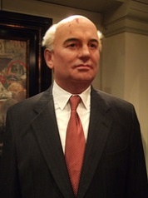
Perestroika
Russian term for the political and economic reforms introduced in June 1987 by the Soviet leader Mikhail Gorbachev. Its literal meaning is "restructuring", referring to the restructuring of the Soviet political and economic system.
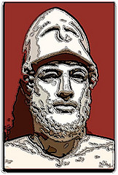
Pericles
Aristocratic leader who guided the Athenian state through the transformation to full participatory democracy for all male citizens.
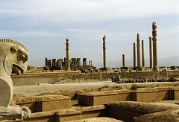
Persepolis
A complex of palaces, reception halls, and treasury buildings erected by the Persian kings Darius I and Xerxes in the Persian homeland

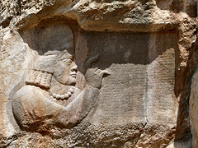
Persian Wars
Conflicts between Greek city-states and the Persian Empire in the 400s BCE. Essentially Perisa--biggest empire in the world at the time--invaded Greece twice with an overwhelming force and lost both times. It contributed heavily to the rise of Athens as a mini-empire and the "golden age" of Athenian culture.

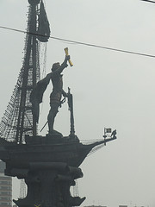
Peter the Great
(1672-1725) Russian tsar (r. 1689-1725). He enthusiastically introduced Western languages and technologies to the Russian elite, moving the capital from Moscow to his new city of St. Petersburg.

pilgrimage
Journey to a sacred shrine by Christians seeking to show their piety, fulfill vows, or gain absolution for sins. Other religions also have pilgrimage traditions, such as the Muslim journey to Mecca.

Pilgrims
Group of English Protestant dissenters who established Plymouth Colony in Massachusetts in 1620 to seek religious freedom after having lived briefly in the Netherlands.

postmodernism
Post-World War II intellectual movement and cultural attitude focusing on cultural pluralism and release from the confines and ideology of Western high culture.
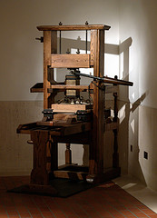
printing press
A mechanical device for transferring text or graphics from a woodblock or type to paper using ink. Presses using movable type first appeared in Europe in about 1450.

Protestant Reformation
Religious reform movement within the Latin Christian Church beginning in 1519. It spit the Roman Catholic Church and resulted in the 'protesters' forming several new Christian denominations, including the Lutheran, Calvinist, and Anglican Churches, among many others.

proxy wars
During the Cold War, local or regional wars in which the superpowers armed, trained, and financed the combatants.

Puritans
English Protestant dissenters who believed that God predestined souls to heaven or hell before birth. They founded Massachusetts Bay Colony in 1629.

Qin
A people and state in the Wei Valley of eastern China that conquered rival states and created the first short-lived Chinese empire (221-206 B.C.E.). Their ruler, Shi Huangdi, standardized many features of Chinese society and enslaved his subjects.

Qing Empire
Empire established in China by Manchus who overthrew the Ming Empire in 1644. At various times they also controlled Manchuria, Mongolia, Turkestan, and Tibet. The last emperor of this dynasty was overthrown in 1911 by nationalists.

Quran
Book composed of divine revelations made to the Prophet Muhammad between ca. 610 and his death in 632; the sacred text of the religion of Islam.

railroads
Networks of iron (later steel) rails on which steam (later electric or diesel) locomotives pulled long trains at high speeds. The first were built in England in the 1830s. Success caused the construction of these to boom lasting into the 20th Century

Kshatriya
The Hindu warrior caste.

Ramesses II
A long-lived ruler of New Kingdom Egypt (r. 1290-1224 B.C.E.). He reached an accommodation with the Hittites of Anatolia after a military standoff. He built on a grand scale throughout Egypt.

Reconquista
Beginning in the eleventh century, military campaigns by various Iberian Christian states to recapture territory taken by Muslims. In 1492 the last Muslim ruler was defeated, and Spain and Portugal emerged as united kingdoms.

Italian Renaissance
A period of intense artistic and intellectual activity, said to be a 'rebirth' of Greco-Roman culture. From roughly the mid-fourteenth to mid-fifteenth century followed by this movement spreading into the Northern Europe during 1400-1600

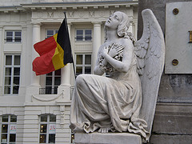
Revolutions of 1848
Democratic and nationalist revolutions that swept across Europe during a time after the Congress of Vienna when conservative monarchs were trying to maintain their power. The monarchy in France was overthrown. In Germany, Austria, Italy, and Hungary the revolutions failed.

Richard Arkwright
English inventor and entrepreneur who became the wealthiest and most successful textile manufacturer of the first Industrial Revolution. He invented the water frame, a machine that, with minimal human supervision, could spin several threads at once.
Roman Principate
A term used to characterize Roman government in the first three centuries C.E., based on the ambiguous title princeps ('first citizen') adopted by Augustus to conceal his military dictatorship.

Roman Republic
The period from 507 to 31 B.C.E., during which Rome was largely governed by the aristocratic Roman Senate. (p. 148)

Roman Senate
A council whose members were the heads of wealthy, landowning families. Originally an advisory body to the early kings, in the era of the Roman Republic the Senate effectively governed the Roman state and the growing empire.

Romanization
The process by which the Latin language and Roman culture became dominant in the western provinces of the Roman Empire. Romans did not seek to Romanize them, but the subjugated people pursued it.

Royal African Company
A trading company chartered by the English government in 1672 to conduct its merchants' trade on the Atlantic coast of Africa. (p. 507)

Saddam Hussein
President of Iraq from 1979 to 2003. Waged war on Iran in 1980-1988. In 1990 he ordered an invasion of Kuwait but was defeated by United States and its allies in the Gulf War (1991). Defeated by US led invasion in 2003.
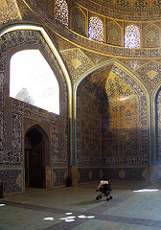
Safavid Empire
Turkish-ruled Iranian kingdom (1502-1722) established by Ismail Safavi, who declared Iran a Shi'ite state.

Sahel
Belt south of the Sahara where it transitions into savanna across central Africa. It means literally 'coastland' in Arabic.
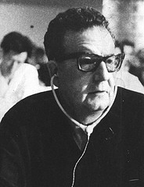
Salvador Allende
The first Marxist politician elected president in the Americas. He was elected president of Chile in 1970 and overthrown by a US-backed military coup in 1973.

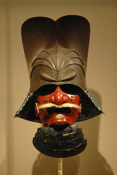
samurai
Literally 'those who serve,' the hereditary military elite in Feudal Japan as well as during the Tokugawa Shogunate.

Sandinistas
Members of a leftist coalition that overthrew the Nicaraguan dictatorship of Anastasia Somoza in 1979 and attempted to install a socialist economy. The United States financed armed opposition by the Contras. They lost national elections in 1990.

Sasanid Empire
The last of pre-Islamic Persian Empire, from 224 to 651 CE. One of the two main powers in Western Asia and Europe alongside the Roman Empire and later the Byzantine Empire for a period of more than 400 years

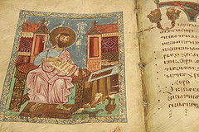
scholasticism
A philosophical and theological system, associated with Thomas Aquinas, devised to reconcile Aristotelian philosophy and Roman Catholic theology in the thirteenth century.
Scientific Revolution
The intellectual movement in Europe, initially associated with planetary motion and other aspects of physics, that by the seventeenth century had laid the groundwork for modern science.

scramble for Africa
Sudden wave of conquests in Africa by European powers in the 1880s and 1890s. Britain obtained most of eastern Africa, France most of northwestern Africa. Other countries (Germany, Belgium, Portugal, Italy, and Spain) acquired lesser amounts.

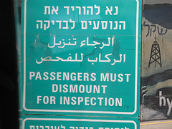
Semitic
Family of related languages long spoken across parts of western Asia and northern Africa. In antiquity these languages included Hebrew, Aramaic, and Phoenician. The most widespread modern member of the this language family is Arabic.

Separate Spheres
Nineteenth-century idea in Western societies that men and women, especially of the middle class, should have different roles in society: women as wives, mothers, and homemakers; men as breadwinners and participants in business and politics

sepoy
A soldier in South Asia, especially in the service of the British.
Sepoy Mutiny
The revolt against the British by many different groups across India 1857 but led particularly by some of the disgruntled Indian soldiers working for the British. It caused the British government to take over more direct control of India from the British East India Company.
Serbia
The Ottoman province in the Balkans that rose up against Janissary control in the early 1800s. Terrorists from here triggered WWI. After World War II it became the central province of Yugoslavia.
serf
In medieval Europe, an agricultural laborer legally bound to a lord's property and obligated to perform set services for the lord. In Russia some of them worked as artisans and in factories; in Russia it was not abolished until 1861.

Shah Abbas I
Shah of Iran (r. 1587-1629). The most illustrious ruler of the Safavid Empire, he moved the imperial capital to Isfahan in 1598, where he erected many palaces, mosques, and public buildings. (p. 533)

shamanism
The practice of identifying special individuals (shamans) who will interact with spirits for the benefit of the community. Characteristic of the Korean kingdoms of the early medieval period and of early societies of Central Asia. (p. 292)

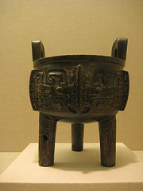
Shang
The dominant people in the earliest Chinese dynasty for which we have written records (ca. 1750-1027 B.C.E.). Ancestor worship, divination by means of oracle bones, and the use of bronze vessels for ritual purposes were major elements of this culture.

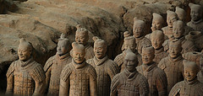
Shi Huangdi
Founder of the short-lived Qin dynasty and creator of the Chinese Empire (r. 221-210 B.C.E.). He is remembered for his ruthless conquests of rival states and standardization.

Shi'a
Branch of Islam believing that God vests leadership of the community in a descendant of Muhammad's son-in-law Ali. Mainly found in Iran and a small part of Iraq. It is the state religion of Iran. A member of this group is called a Shi'ite.

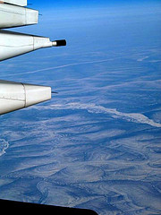
Siberia
The northeastern sector of Asia or the Eastern half of Russia.

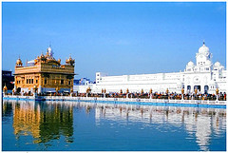
Sikhism
Indian religion founded by the guru Nanak (1469-1539) in the Punjab region of northwest India. After the Mughal emperor ordered the beheading of the ninth guru in 1675, warriors from this group mounted armed resistance to Mughal rule.

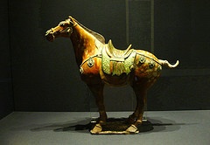
Silk Road
Caravan routes connecting China and the Middle East across Central Asia and Iran.

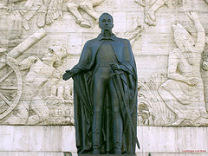
Simon Bolivar
The most important military leader in the struggle for independence in South America. Born in Venezuela, he led military forces there and in Colombia, Ecuador, Peru, and Bolivia.
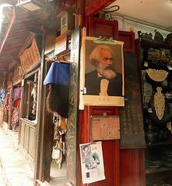
socialists
An umbrella term for people of diverse perspectives but many of whom typically advocate equality, protection of workers from exploitation by property owners and state ownership of major industries. This ideology led to the founding of certain labor parties in the late 1800s.

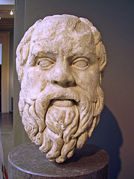
Socrates
Athenian philosopher (ca. 470-399 B.C.E.) who shifted the emphasis of philosophical investigation from questions of natural science to ethics and human behavior.

Sokoto Caliphate
large Muslim state founded in 1809 in what is now northern Nigeria.
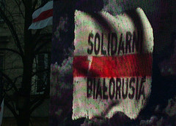
Solidarity
Polish trade union created in 1980 to protest working conditions and political repression. It began the nationalist opposition to communist rule that led in 1989 to the fall of communism in eastern Europe.

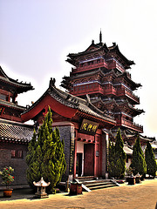
Song Dynasty
Empire in southern China (1127-1279) while the Jin people controlled the north. Distinguished for its advances in technology, medicine, astronomy, and mathematics.

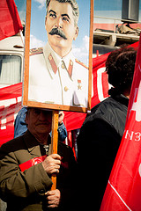
Stalingrad
City in Russia, site of a Red Army victory over the Germany army in 1942-1943. The Battle of Stalingrad was the turning point in the war between Germany and the Soviet Union. Today Volgograd.

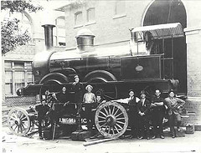
steam engine
A machine that turns the energy released by burning fuel into motion. Thomas Newcomen built the first crude but workable one in 1712. James Watt vastly improved his device in the 1760s and 1770s. It was then applied to machinery.

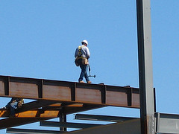
steel
A form of iron that is both durable and flexible. It was first mass-produced in the 1860s and quickly became the most widely used metal in construction, machinery, and railroad equipment.

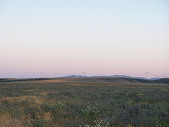
steppes
Treeless plains, especially the high, flat expanses of northern Eurasia, which usually have little rain and are covered with coarse grass. They are good lands for nomads and their herds. Good for breeding horses: essential to Mongol military.
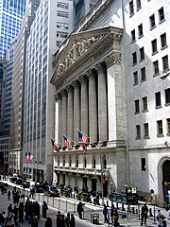
stock exchange
A place where shares in a company or business enterprise are bought and sold.

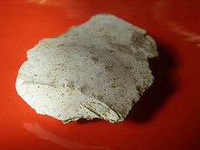
Stone Age
The historical period characterized by the production of tools from stone and other nonmetallic substances. It was followed in some places by the Bronze Age

submarine telegraph cables
Insulated copper cables laid along the bottom of a sea or ocean for telegraphic communication. The first short cable was laid across the English Channel in 1851; the first successful transatlantic cable was laid in 1866. In the late 1980s this technology was replaced with large submarine fiber optic cables that still today form the basis of most global communication.

sub-Saharan Africa
Portion of the African continent lying south of the Sahara.

Suez Canal
Ship canal dug across the isthmus of Suez in Egypt, designed by Ferdinand de Lesseps. It opened to shipping in 1869 and shortened the sea voyage between Europe and Asia. Its strategic importance led to the British conquest of Egypt in 1882.

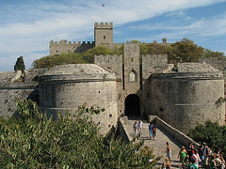

Suleiman the Magnificent
The most illustrious sultan of the Ottoman Empire (r. 1520-1566); also known as 'The Lawgiver.' He significantly expanded the empire in the Balkans and eastern Mediterranean.

Sumerians
The people who dominated southern Mesopotamia through the end of the third millennium B.C.E. They were responsible for the creation of many fundamental elements of Mesopotamian culture-such as irrigation technology, cuneiform, and religious conceptions.

Sun Yat-Sen
Chinese nationalist revolutionary, founder and leader of the Guomindang until his death. He attempted to create a liberal democratic political movement in China but was thwarted by military leaders.

Sunnis
Muslims belonging to branch of Islam believing that the community should select its own leadership. The majority religion in most Islamic countries.

Swahili
Bantu language with Arabic loanwords spoken in coastal regions of East Africa.

Taiping Rebellion
The most destructive civil war in China before the twentieth century. A Christian-inspired rural rebellion threatened to topple the Qing Empire. Leader claimed to be the brother of Jesus.

Tamil Kingdoms
The kingdoms of southern India, inhabited primarily by speakers of Dravidian languages, which developed in partial isolation, and somewhat differently, from the Aryan north.

Tang Empire
Empire unifying China and part of Central Asia, founded 618 and ended 907. The Tang emperors presided over a magnificent court at their capital, Chang'an.

Tanzimat
'Restructuring' reforms by the nineteenth-century Ottoman rulers, intended to move civil law away from the control of religious elites and make the military and the bureacracy more efficient.

Tenochtitlan
Capital of the Aztec Empire, located on an island in Lake Texcoco. Its population was about 150,000 on the eve of Spanish conquest. Mexico City was constructed on its ruins.

Teotihuacan
A powerful city-state in central Mexico (100-75 C.E.). Its population was about 150,000 at its peak in 600.

terrorism
targeting random people who are usually civilians with violence for a political purpose.

Thebes
Capital city of Egypt and home of the ruling dynasties during the Middle and New Kingdoms. Amon, patron deity of Thebes, became one of the chief gods of Egypt. Monarchs were buried across the river in the Valley of the Kings. (p. 43)

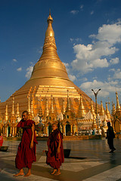
Theravada
'Way of the Elders' branch of Buddhism followed in Sri Lanka and much of Southeast Asia. It remains close to the original principles set forth by the Buddha; it downplays the importance of gods

Third World
Term applied to a group of "developing" or "underdeveloped" countries who professed nonalignment during the Cold War.

Thomas Edison
American inventor best known for inventing the electric light bulb, acoustic recording on wax cylinders, and motion pictures.

Thomas Malthus
Eighteenth-century English intellectual who warned that population growth threatened future generations because, in his view, population growth would always outstrip increases in agricultural production.

three-field system
A rotational system for agriculture in which one field grows grain, one grows legumes, and one lies fallow. It gradually replaced two-field system in medieval Europe.

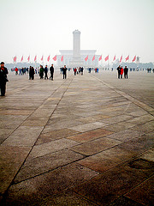
Tiananmen Square
Site in Beijing where Chinese students and workers gathered to demand greater political openness in 1989. The demonstration was crushed by Chinese military with many deaths.

Timur
Member of a prominent family of the Mongols' Jagadai Khanate, Timur through conquest gained control over much of Central Asia and Iran. He consolidated the status of Sunni Islam as orthodox, and his descendants, the Timurids, maintained his empire.

Tokugawa Shogunate
was a semi-feudal government of Japan in which one of the shoguns unified the country under his family's rule. They moved the capital to Edo, which now is called Tokyo. This family ruled from Edo 1868, when it was abolished during the Meiji Restoration.
Treaty of Nanking
Treaty that concluded the Opium War. It awarded Britain a large indemnity from the Qing Empire, denied the Qing government tariff control over some of its own borders, opened additional ports of residence to Britons, and ceded Hong Kong to Britain.
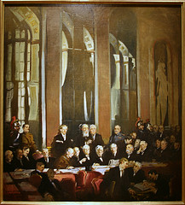
Treaty of Versailles
The treaty imposed on Germany by France, Great Britain, the United States, and other Allied Powers after World War I. It demanded that Germany dismantle its military and give up some lands to Poland. It was resented by many Germans.

Treaty Ports
Cities opened to foreign residents as a result of the forced treaties between the Qing Empire and foreign signatories. In the in these cities, foreigners enjoyed extraterritoriality.

tributary system
A system in which, from the time of the Han Empire, countries in East and Southeast Asia not under the direct control of empires based in China nevertheless enrolled as tributary states, acknowledging the superiority of the emperors in China.

tribute system
A system in which defeated peoples were forced to pay a tax in the form of goods and labor. This forced transfer of food, cloth, and other goods subsidized the development of large cities. An important component of the Aztec and Inca economies.

trireme
Greek and Phoenician warship of the fifth and fourth centuries B.C.E. It was sleek and light, powered by 170 oars arranged in three vertical tiers. Manned by skilled sailors, it was capable of short bursts of speed and complex maneuvers.
czar
From Latin caesar, this Russian title for a monarch was first used in reference to a Russian ruler by Ivan III (r. 1462-1505).
Uigurs
A group of Turkic-speakers who controlled their own centralized empire from 744 to 840 in Mongolia and Central Asia. (p. 284)
ulama
Muslim religious scholars. From the ninth century onward, the primary interpreters of Islamic law and the social core of Muslim urban societies. (p. 238)
Umayyad Caliphate
First hereditary dynasty of Muslim caliphs (661 to 750). From their capital at Damascus, the Umayyads ruled one of the largest empires in history that extended from Spain to India. Overthrown by the Abbasid Caliphate.
umma
The community of all Muslims. A major innovation against the background of seventh-century Arabia, where traditionally kinship rather than faith had determined membership in a community.

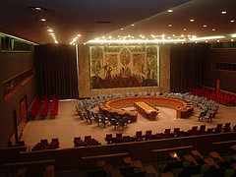
United Nations
International organization founded in 1945 to promote world peace and cooperation. It replaced the League of Nations.

Universal Declaration of Human Rights
A 1946 United Nations covenant binding signatory nations to the observance of specified rights.

Varna
The four major social divisions in India's caste system: the Brahmin priest class, the Kshatriya warrior/administrator class, the Vaishya merchant/farmer class, and the Shudra laborer class.

Vasco da Gama
Portuguese explorer. In 1497-1498 he led the first naval expedition from Europe to sail to India, opening an important commercial sea route.

vassal
In medieval Europe, a sworn supporter of a king or lord committed to rendering specified military service to that king or lord, usually in exchange for the use of land.

Vedas
Early Indian sacred 'knowledge'-the literal meaning of the term-long preserved and communicated orally by Brahmin priests and eventually written down.

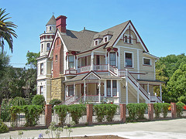
Victorian Age
Reign of Queen Victoria of Great Britain (1837-1901). The term is also used to describe late-nineteenth-century society, with its rigid moral standards and sharply differentiated roles for men and women and for middle-class and working-class people
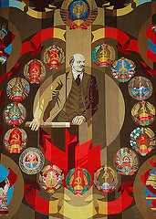
Vladimir Lenin
Leader of the Bolshevik (later Communist) Party. He lived in exile in Switzerland until 1917, then returned to Russia to lead the Bolsheviks to victory during the Russian Revolution and the civil war that followed.

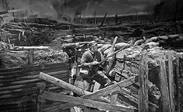
Western Front
A line of trenches and fortifications in World War I that stretched without a break from Switzerland to the North Sea. Scene of most of the fighting between Germany, on the one hand, and France and Britain, on the other.

witch-hunt
The pursuit of people suspected of witchcraft, especially in northern Europe in the late sixteenth and seventeenth centuries.
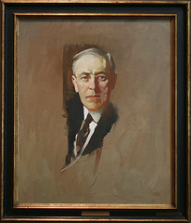
Woodrow Wilson
President of the United States (1913-1921) and the leading figure at the Paris Peace Conference of 1919. He was unable to persuade the U.S. Congress to ratify the Treaty of Versailles or join the League of Nations.

World Bank
A specialized agency of the United Nations that makes loans to countries for economic development, trade promotion, and debt consolidation. Its formal name is the International Bank for Reconstruction and Development.

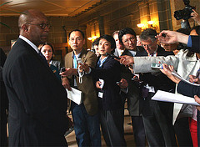
WTO
The initials of the international body established in 1995 to foster and bring order to international trade.
Yin and yang
In Daoist belief, complementary factors that help to maintain the equilibrium of the world. One is associated with masculine, light, and active qualities while the other with feminine, dark, and passive qualities.

Yongle
Reign period of Zhu Di (1360-1424), the third emperor of the Ming Empire (r. 1403-1424).Sponsored the building of the Forbidden City, a huge encyclopedia project, the expeditions of Zheng He, and the reopening of China's borders to trade and travel

Yuan Empire
He created this dynasty in China and Siberia. Khubilai Khan was head of the Mongol Empire and grandson of Genghis Khan.

Zen
The Japanese word for a branch of Mahayana Buddhism based on highly disciplined meditation.

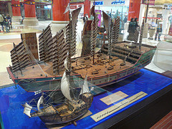
Zheng He
An imperial eunuch and Muslim, entrusted by the Ming emperor Yongle with a series of state voyages that took his gigantic ships through the Indian Ocean, from Southeast Asia to Africa.

Zhou
The people and dynasty that took over the dominant position in north China from the Shang and created the concept of the Mandate of Heaven to justify their rule. Remembered as prosperous era in Chinese History.

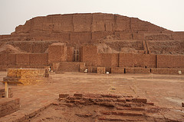
ziggurat
massive pyramidal stepped tower made of mud bricks. It is associated with religious complexes in ancient Mesopotamian cities, but its function is unknown.

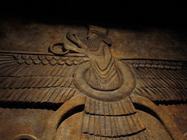
Zoroastrianism
A religion originating in ancient Iran. It centered on a single benevolent deity-Ahuramazda, Emphasizing truth-telling, purity, and reverence for nature, the religion demanded that humans choose sides between good and evil

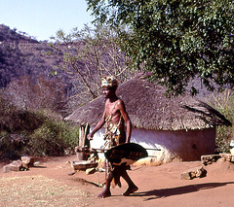
Zulu
A people of modern South Africa whom King Shaka united beginning in 1818.

10000 BCE
Date: Beginnings of Agriculture

3000s BCE
Date: Beginning of Bronze Age and river valley civilizations (Hint: _000s BCE)

1300 BCE
Date: Iron Age
(Hint: 1_00 BCE)

6th century BCE
Date: Origin of Buddhism, Confucianism, Taoism
(Hint ___ century BCE)

5th century BCE
Date: Greek Golden Age - Philosophers
(Hint "___ century BCE")

323 BCE
Date: Alexander the Great dies
(Hint: "_23 BCE")

221 BCE
Date: Qin Unified China
(Hint: _21 BCE)

32 CE
Date: Beginnings of Christianity
(Hint: _2 CE)

180 CE
Date: End of Pax Romana
(Hint: _80 CE)

220 CE
Date: End of Han Dynasty
(Hint: _20 CE)

333 CE
Date: Roman Capital moved to Constantinople
(Hint: _33 CE)

4th century CE
Date: Beginning of Trans-Saharan Trade Routes
(Hint: ___ century CE)

476 CE
Date: Fall of Rome
(Hint: _76 CE)

527 CE
Date: Justinian rule of Byzantine Empire
(Hint: _27 CE)

632 CE
Date: Rise of Islam
(Hint: __2 CE)

732 CE
Date: Battle of Tours
(Hint: _32 CE)

1054 CE
Date: East-West Great Schism in Christian Church (Hint: __54 CE)

1066 CE
Date: Norman Conquest of England
(Hint: __66 CE)

1071 CE
Date: Battle of Manzikert
(Hint: __71 CE)

1095 CE
Date: First Crusade
(Hint: ___5 CE)

1258 CE
Date: Mongols sack Baghdad
(Hint: __58 CE)

1271-1295 CE
Date: Marco Polo Travels
(Hint: "__71-__95 CE")

1324 CE
Date: Mansa Musa's Pilgrimage
(Hint: __24 CE)

1325 CE
Date: Travels of Ibn Battuta begin
(Hint: __25 CE)

1347 CE
Date: Black Death hits Europe
(Hint: ___7 CE)

1433 CE
Date: End of Zheng He's Voyages/Rise of Ottomans (Hint: __33 CE)

1453 CE
Date: Ottomans capture Constantinople (Hint: __53 CE)

1488
Date: Dias rounded Cape of Good Hope
(Hint: 1__8)

1492
Date: Columbus "Sailed the Ocean Blue" / Reconquista of Spain (Hint: 1__2)

1502
Date: Slaves begin moving to Americas (Hint: 1__2)

1517
Date: Martin Luther and 95 Theses (Hint: 1__7)

1521
Date: Cortez conquered the Aztecs (Hint: 1__1)

1533
Date: Pizarro Toppled the Incas (Hint: 1__3)

1571
Date: Battle of Lepanto (Hint: 1__1)

1588
Date: Defeat of the Spanish Armada by the British (Hint: 1__8)

1600
Date: Battle of Sekigahara - Beginning of Tokugawa (Hint: 1__0)

1607
Date: Founding of Jamestown (Hint: 1__7)

1618
Date: Thirty Years War begins (Hint: 1__8)

1683
Date: unsuccessful Ottoman seige of Vienna (Hint: 1_83)

1689
Date: Glorious Revolution / English Bill of Rights (Hint: 1__9)

1756
Date: 7 years war between France and Britain begins (Hint: 1__6)

1776
Date: American Revolution/Smith writes Wealth of Nations (Hint: 1__6)

1789
Date: French Revolution begins

1804
Date: Haitian Independence (Hint: 1__4)

1815
Date: Congress of Vienna (Hint: 1__5)

1810s
Date: Decade when Independence in mainland Latin America began (Hint: 1__0s)

1839
Date: First Opium War in China (Hint: 1__9)

1848
Date: Many European Revolutions / Marx and Engles write Communist Manifesto (Hint: 1__8)

1853
Date: Commodore Perry opens Japan to trade (Hint: 1__3)

1857
Date: Sepoy Mutiny or failed Indian revolution against British East India Company colonial rule (Hint: 1__7)

1861
Date: End of Russian Serfdom/Italian Unification (Hint: 1__1)

1863
Date: Emancipation Proclamation in US (Hint: 1__3)

1871
Date: German Unification (Hint: 1__1)

1885
Date: Berlin Conference - Division of Africa (Hint: 1__5)

1898
Date: Spanish-American War - US acquires Philippines,Cuba, Guam, and Puerto Rico (Hint: 1__8)

1899
Date: Boer War - British in control of South Africa (Hint: 1__9)

1905
Date: Russo-Japanese War (Hint: 1__5)

1910
Date: Start of the ten year long Mexican Revolution. Not to be confused with Mexican war of Independence (1810-1821) (Hint: 1__0)

1911
Date: Chinese Revolution against traditional Chinese Imperial system. (Hint: 1__1)
1914-1918
Date: WWI (from start to finish)
(Hint: "19__-19__")
1917
Date: Year of successful Russian Revolution(s)
1919
Date: Treaty of Versailles - End of WWI
1929
Date: Stock Market Crash
1931
Date: Japanese invasion of Manchuria (Hint: 1__1)
1935
Date: Italian invasion of Ethiopia (Hint: 1__5)
1939
Date: German blitzkrieg in Poland starting WWII in Europe.
1941
Date: Pearl Harbor, entry of US into WWII
1945
Date: end of WWII
1947
Date: independence & partition of India
1948
Date: declaration of of Israeli statehood
1949
Date: Chinese Communist Revolution
1950
Date: Korean War starts
1954
Date: Vietnamese defeat French at Dien Bien Phu (Hint: 1__4)

1956
Date: de-Stalinization in Russia; Egyptian nationalization of Suez Canal (Hint: 1__6)
1959
Date: Cuban Revolution (Hint: 1__9)
1962
Date: Cuban Missile Crisis
1967
Date: Six-day war in Israel; Chinese Cultural Revolution (Hint: 1__7)
1979
Date: Iranian Revolution (Hint: 1__9)
1987
Date: 1st Palestinian Intifada (Hint: 1__7)
1989
Date: Tiananmen Square protest in China; Fall of Berlin Wall in Germany
1991
Date: fall of USSR; 1st Gulf war near Iraq (Hint: 1__1)
1994
Date: genocide in Rwanda/1st all race elections in S. Africa (Hint: 1__4)
2001
Date: 9/11 Attacks
Abbasid Dynasty
From 750-1258 this was the 3rd dyansty of the Islamic Caliphate. They built their capital in Baghdad after overthrowing the Umayyad caliphate.
Abolition
The movement to make slavery and the slave trade illegal. Begun by Quakers in England in the 1780s.
Absolutism
A form of government, usually hereditary monarchy, in which the ruler has no legal limits on his or her power.
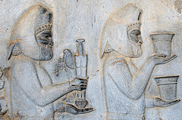
Achaemenid Empire
The name of an ancient Persian Empire (c. 550-330 BCE) which was composed of many smaller kingdoms. The realm was divided into twenty-three satrapies whose administration and taxation was managed by subordinate local rulers.

African diaspora
The separation of Africans from their homeland through centuries of forced removal to serve as slaves in the Americas and elsewhere.

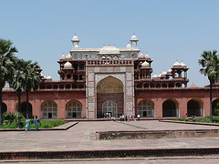
Akbar
The most famous Muslim ruler of India during the period of Mughal rule. Famous for his religious tolerance, his investment in rich cultural feats, and the creation of a centralized governmental administration, which was not typical of ancient and post-classical India.
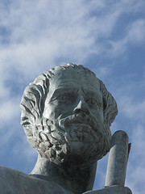
Aristotle
Greek philosopher. A pupil of Plato, the tutor of Alexander the Great, and the author of works on logic, metaphysics, ethics, natural sciences, politics, and poetics, he profoundly influenced Western thought. In his philosophical system, which led him to criticize what he saw as Plato's metaphysical excesses, theory follows empirical observation and logic, based on the syllogism, is the essential method of rational inquiry.

Aryans
nomads from Europe and Asia who migrated to India and finally settled; vedas from this time suggest beginning of caste system

Assyrian Empire
this empire covered much of what is now mesopotamia, syria, palestine, egypt, and anatolia; its height was during the seventh and eigth centuries BCE

Athens
This city was the seat of Greek art, science, and philosophy. Paul visited this city during his second missionary journey and spoke to the citizens about their altar to the unknown god.

Atlantic Slave Trade
Lasted from 16th century until the 19th century. Trade of African peoples from Western Africa to the Americas. One part of a three-part economical system known as the Middle Passage of the Triangular Trade.
Aztecs
(1200-1521) 1300, they settled in the valley of Mexico. Grew corn. Engaged in frequent warfare to conquer others of the region. Worshiped many gods (polytheistic). Believed the sun god needed human blood to continue his journeys across the sky. Practiced human sacrifices and those sacrificed were captured warriors from other tribes and those who volunteered for the honor.

Bantu migration
The movement of the Bantu peoples southward throughout Africa, spreading their language and culture, from around 500 b.c. to around A.D 1000

Bronze Age
a period of human culture between the Stone Age and the Iron Age, characterized by the use of weapons and implements made of bronze

Bubonic plague
disease brought to Europe from the Mongols during the Middle Ages. It killed 1/3 of the population and helps end Feudalism. Rats, fleas.

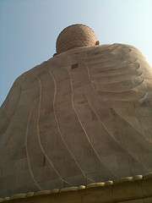
Buddhism
the teaching that life is permeated with suffering caused by desire, that suffering ceases when desire ceases, and that enlightenment obtained through right conduct and wisdom and meditation releases one from desire and suffering and rebirth

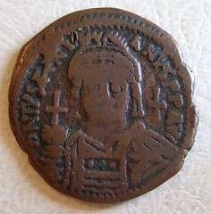
Byzantine Empire
Historians' name for the eastern portion of the Roman Empire from the fourth century onward, taken from 'Byzantion,' an early name for Constantinople, the Byzantine capital city. The empire fell to the Ottomans in 1453.
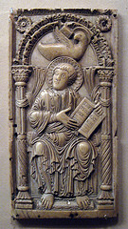
Carolingian Empire
Charlemagne's empire; covered much of western and central Europe; largest empire until Napoleon in 19th century
•

Caste System
a set of rigid social categories that determined not only a person's occupation and economic potential, but also his or her position in society
•

Catherine the Great
ruled Russia from 1762 to 1796, added new lands to Russia, encouraged science, art, lierature, Russia became one of Europe's most powerful nations
Chavin
the first major South American civilization, which flourished in the highlands of what is now Peru from about 900 to 200 B.C.
china
In the classical and postclassical era, people in this country invented the compass, the rudder, and gun powder, among other things.

Christianity
a monotheistic system of beliefs and practices based on the Old Testament and the teachings of Jesus as embodied in the New Testament and emphasizing the role of Jesus as savior

Christopher Columbus
Genoese mariner who in the service of Spain led expeditions across the Atlantic, reestablishing contact between the peoples of the Americas and the Old World and opening the way to Spanish conquest and colonization.

Commercial Revolution
the expansion of the trade and buisness that transformed European economies during the 16th and 17th centuries.

Confucianism
The system of ethics, education, and statesmanship taught by Confucius and his disciples, stressing love for humanity, ancestor worship, reverence for parents, and harmony in thought and conduct.
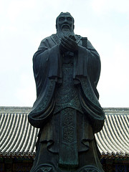
Confucius
Chinese philosopher (circa 551-478 BC)

Counter Reformation
the reaction of the Roman Catholic Church to the Reformation reaffirming the veneration of saints and the authority of the Pope (to which Protestants objected)

Crusades
a series of military expeditions in the 11th, 12th, and 13th centuries by Westrn European Christians to reclain control of the Holy Lands from the Muslims

Daoism
philosophical system developed by of Lao-tzu and Chuang-tzu advocating a simple honest life and noninterference with the course of natural events

Dar al islam
an Arabic term that means the "house of Islam" and that refers to lands under Islamic rule
Deism
The religion of the Enlightenment (1700s). Followers believed that God existed and had created the world, but that afterwards He left it to run by its own natural laws. Denied that God communicated to man or in any way influenced his life.

Wudi
emperor under the Han Dynasty that wanted to create a stronger central government by taking land from the lords, raising taxes and places the supply of grain under the government's control

Encomienda
Labor system created by Spain which allowed Spanish settlers in the Americas to control the lands AND people of a certain territory, in turn the Spanish had to pay the natives and teach them Catholicism. The system was intended to help the natives from exploitation, but the system itself turned into a coercive labor system.

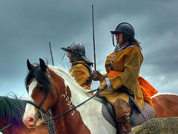
English Civil War
Conflict from 1640 to 1660; featured religious disputes mixed with constitutional issues concerning the powers of the monarchy; ended with restoration of the monarchy in 1660 following execution of previous king

Fall of the Roman Empire
The fall of this empire was precipitated by Germanic attacks and toward the mid fifth century barbarian chieftains replaced roman emperors. Rome and Western Europe was overrun by the German tribes but they respected the Roman culture and learned from their roman sunjects. Some Roman government and cultural ideas survived and blended with Germanic culture.

Ghana
First known kingdom in sub-Saharan West Africa between the sixth and thirteenth centuries C.E. Also the modern West African country once known as the Gold Coast. gold and salt trade.

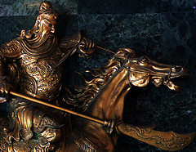
Genghis Khan
Founder of the Mongol Empire.

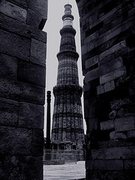
Gupta Dynasty
(ad 320-500)ruled indias golden age in science, art, and literature

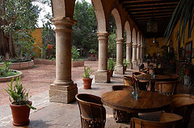
Haciendas
Large Spanish colonial estates usually owned by wealthy families but worked by many peasants
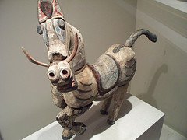
Han Dynasty
imperial dynasty that ruled China (most of the time) from 206 BC to 221 and expanded its boundaries and developed its bureaucracy

Hebrews
the ethnic group claiming descent from Abraham and Isaac (especially from Isaac's son Jacob)

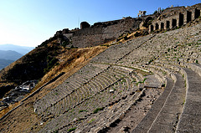
Hellenistic Empire
The name of Alexander the Great's Empire

Hinduism
A religion and philosophy developed in ancient India, characterized by a belief in reincarnation and a supreme being who takes many forms
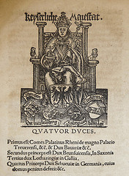
Holy Roman Empire
A medieval and early modern central European Germanic empire, which often consisted of hundreds of separate Germanic and Northern Italian states. In reality it was so decentralized that it played a role in perpetuating the fragmentation of central Europe.

Homo Sapiens
A species of the creatures Hominid who have larger brains and to which humans belong, dependent of language and usage of tools.
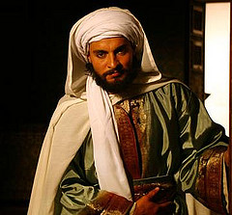
Ibn Battuta
(1304-1369) Morrocan Muslim scholar, the most widely traveled individual of his time. He wrote a detailed account of his visits to Islamic lands from China to Spain and the western Sudan. His writings gave a glimpse into the world of that time period.
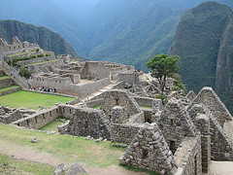
Incas
Ancient civilization (1200-1500AD) that was located in the Andes in Peru

Indentured Servitude
labor under contract to an employer for a fixed period of time, typically three to seven years, in exchange for their transportation, food, clothing, lodging and other necessities. Often used in the late 19th and early 20th century as a replacement of slave labor, but with fairly similar exploitative working conditions. Laborers were often transported thousands of miles and could not easily afford to return home.

Indian Ocean
Large amounts of rade happened in this body of water between Arab, Persian, Turkish, Indian, African, Chinese, and Europe merchants. Particularly in the postclassical period 9600-1450)

Indo-Europeans
Many people and languages of Europe, Iran, and northern India share a common linguistic traits due to being part of this ancient group.

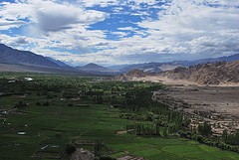
Indus
The civilization from this river's valley (3500 BC to 2500 BC) had two thriving cities which were Mohenjodaro and Harappa.

Iron metallurgy
Extraction of iron from its ores. allowed for cheaper stronger production of weapons and tools. More abundant than tin and copper

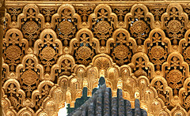
Islam
the religious faith of Muslims, based on the words and religious system founded by the prophet Muhammad and taught by the Koran, the basic principle of which is absolute submission to a unique and personal god, Allah.

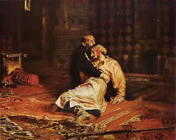
Ivan the Terrible
(1533-1584) earned his nickname for his great acts of cruelty directed toward all those with whom he disagreed, even killing his own son. He became the first ruler to assume the title Czar of all Russia.

Jainism
a religion founded in India in the sixth century BC, whose members believe that everything in the universe has a soul and therefore shouldn't be harmed. Mahavira founded this religion.

Janissaries
30,000 Infantry, originally of slave origin, armed with firearms and constituting the elite of the Ottoman army from the fifteenth century until the corps was abolished in 1826.
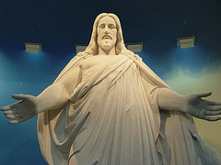
Jesus
A Jew from Galilee in northern Israel. A teacher and prophet whose life and teachings form the basis of Christianity. Christians believe Jesus to be Son of God.

John Calvin
Swiss theologian (born in France) whose tenets (predestination and the irresistibly of grace and justification by faith) defined Presbyterianism (1509-1564)

Joint Stock Company
A company made up of a group of shareholders. Each shareholder contributes some money to the company and receives some share of the company's profits and debts.

Julius Caesar
Made dictator for life in 45 BCE, after conquering Gaul, assassinated in 44 BCE by the Senate because they were afraid of his power

Justinian's Code
Laws of the byzantine empire based the twelve tables of Roman law, became a basis for laws in many European nations

King Henry VIII of England
King of England from 1509 to 1547 and founder of the Church of England; he broke with the Catholic Church because the pope would not grant him a divorce.

King Louis XIV of France
Ruled with an iron fist for 60 years, and always wanted war. Believed in Divine Right theory, in which God chose him to rule over the masses and that anyone who challenged him would be challenging God. Thought that an absolute monarchy was the best form of government, and that men couldn't be trusted to govern themselves.

Phillip II
336 BC, was an ancient Greek king of Macedon from 359 BC until his assassination in 336. He was the father of Alexander the Great.

Kingdom of Kongo
Basin of the Congo (Zaire) river, conglomeration of several village alliances, participated actively in trade networks, most centralized rule of the early Bantu kingdoms, royal currency: cowries, ruled 14th-17th century until undermined by Portuguese slave traders

Mali
Empire created by indigenous Muslims in western Sudan of West Africa from the thirteenth to fifteenth century. It was famous for its role in the trans-Saharan gold trade (see Mansa Musa)

Mandate of Heaven
a political theory of ancient China in which those in power were given the right to rule from a divine source
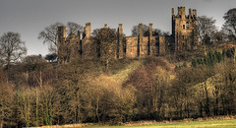
Manorialism
Economic system during the Middle Ages that revolved around self-sufficient farming estates where lords and peasants shared the land.

Marco Polo
Venetian merchant and traveler. His accounts of his travels to China offered Europeans a firsthand view of Asian lands and stimulated interest in Asian trade.

Martin Luther
a German monk who became one of the most famous critics of the Roman Catholic Chruch. In 1517, he wrote 95 theses, or statements of belief attacking the church practices.

Matteo Ricci
Portuguese Jesuit missionary who went to China, assimilated into Chinese culture and language and ran a Christian mission in China.

Alexander the Great
Chandragupta Maurya is believed to have modeled his conquest of India (forming the Mauryan Empire) off of the conquests of what other leader?

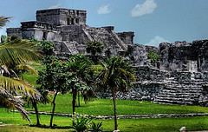
Mayans
a member of a major pre-Columbian civilization of the Yucatán Peninsula that reached its peak in the 9th century a.d. and produced magnificent ceremonial cities with pyramids, a sophisticated mathematical and calendar system, hieroglyphic writing, and fine sculpture, painting, and ceramics.

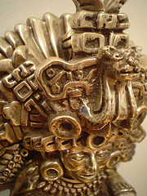
Mayans
1500 B.C. to 900 A.D. This is the most advanced civilization of the time in the Western Hempishere. Famous for its awe-inspiring temples, pyramids and cities. A complex social and political order.

Medieval Japan
1185 - 1608 a period of Japanese history when aristocratic Japanese warlords controlled land and economy.

Mercantilism
an economic system (Europe in 18th C) to increase a nation's wealth by government regulation of all of the nation's commercial interests

Mesopotamia
Birthplace of the Sumerian civilization among many others.
Millet System
Divided regions in the Ottoman Empire by religion (Orthodox Christians, Jews, Armenian Christians, Muslims). Leaders of each millet supported the Sultan in exchange for power over their millet.

Ming Dynasty
A major dynasty that ruled China from the mid-fourteenth to the mid-seventeenth century. It was marked by a great expansion of Chinese commerce into East Africa, the Middle East, and Southeast Asia

Mongol Empire
an empire founded in the 12th century by Genghis Khan, which reached its greatest territorial extent in the 13th century, encompassing the larger part of Asia and extending westward to the Dnieper River in eastern Europe.

Muhammad
the Arab prophet who founded Islam (570-632)
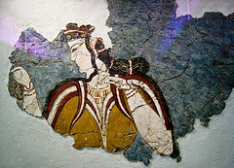

Mycenaeans
a group of people who settled on the Greek mainland around 2000 B.C.; leading city called Mycenae which could withstand any attack; nobles lived in splendor; these people invaded many surrounding kingdoms
Neo-Confucianism
term that describes the resurgence of Confucianism and the influence of Confucian scholars during the T'ang Dynasty; a unification of Daoist or Buddhist metaphysics with Confucian pragmatism

Egypt
society was ruled by a pharaoh considered the incarnation of the sun god who controled acces to the Nile; they had hieroglyphics, the 365-day calender, they were polythestic and worshipped the dead

Oceania
a large group of islands in the south Pacific including Melanesia and Micronesia and Polynesia (and sometimes Australasia and the Malay Archipelago)

Olmecs
(1400 B.C.E. to 500 B.C.E.) earliest known Mexican civilization,lived in rainforests along the Gulf of Mexico, developed calendar and constructed public buildings and temples, carried on trade with other groups.priests/aristocrats were at the top of society, built a ceremonial center, wroshiped the jaguar and werejaguar, best remains are the stone carved heads at la venta, use of calendar, spread through trade, known for art, most important legacy was priestly leadership and devotion

Olympics
Greek athletic competitions to celebrate the Gods and feed city-state rivalries

Ottoman Empire
Islamic state founded by Osman in northwestern Anatolia ca. 1300. After the fall of the Byzantine Empire.

Paleolithic Era
called the old stone age (from 10,000 to 2.5 million years ago); they were concerned with food supply; they used stone as well as bone tools; they were nomadic hunters and gatherers.

Patriarchy
a form of social organization in which the father is the supreme authority in the family, clan, or tribe and descent is reckoned in the male line, with the children belonging to the father's clan or tribe.

Persian Wars
Conflicts between Greek city-states and the Persian Empire, ranging from the Ionian Revolt (499-494 B.C.E.) through Darius's punitive expedition that failed at Marathon. Chronicled by Herodotus.
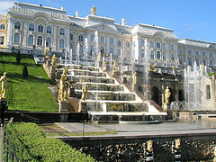
Peter the Great
(1672-1725) Russian tsar (r. 1689-1725). He enthusiastically introduced Western languages and technologies to the Russian elite, moving the capital from Moscow to the new city of St. Petersburg.

Phoenicians
located on eastern Mediterranean coast; invented the alphabet which used sounds rather than symbols like cuneiform

Polis
A city-state in ancient Greece.

Portuguese Empire
took lead in European exploration (sponsored by Prince Henry); went East and found gold in Africa (the Cape of Good hope) and India for spice trade
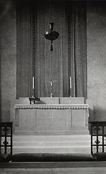
Protestant Reformation
a religious movement of the 16th century that began as an attempt to reform the Roman Catholic Church but resulted in the creation of new splinter churches who today are collectively known as Protestants
Qin Dynasty
the Chinese dynasty (from 246 BC to 206 BC) that established the first centralized imperial government and built much of the Great Wall

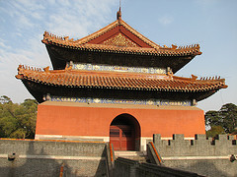
Qing Dynasty
the last imperial dynasty of China (from 1644 to 1912) which was overthrown by revolutionaries. Also known for its extreme isolationism.

Queen Elizabeth I
This "virgin" queen ruled England for 50 years and was one of the most successful monarchs in English History. She supported the arts, increased the treasury, supported the exploration of the New World, built up the military, and established the Church of England as the main religion in England

Quran
the sacred writings of Islam revealed by God to the prophet Muhammad during his life at Mecca and Medina
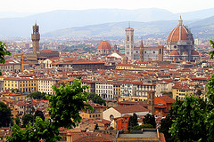
Florence
This city was once of hot spots of Renaissance culture in the 1400s,

Repartimiento system
required adult male Native Americans to devote a set number of days of labor annually to Spanish economic enterprises. PROBLEM- abused workers due to sense of urgency and exploitation

Roman Empire
Existed from 27 BCE to about 400 CE. Conquiered entire Mediterranean coast and most of Europe. Ruled by an emperor. Eventually oversaw the rise and spread of Christianity.

Roman Law
this Roman contribution delt mostly with the rights of Roman citizens; one belief was that it should be fair and equal to all people

Roman Republic
The period from 507 to 31 B.C.E., during which Rome was largely governed by the aristocratic Roman Senate.
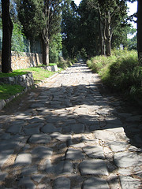
Roman roads
allowed for better military transportation and facilitated trade throughout their empire. Cities grew larger and more powerful. Appian Way, 53,000 miles make up all the Roman roads, User-contributed everyone could share supplies, 55,000miles of roads, communication, soldiers

Safavid Empire
Iranian kingdom (1502-1722) established by Ismail Safavi, who declared Iran a Shi'ite state.

Scientific Revolution
the era of scientific thought in europe during which careful observation of the natural world was made, and accepted beliefs were questioned

Serfdom
A type of labor commonly used in feudal systems in which the laborers work the land in return for protection but they are bound to the land and are not allowed to leave or to peruse their a new occupation. This was common in early Medeival Europe as well as in Russia until the mid 19th century.

Seven Years War
Fought between France/Russia and Prussia- Frederick kept fighting against heavy odds and was saved when Peter III took Russian throne and called off the war.

Shang Dynasty
Second Chinese dynasty (about 1750-1122 B.C.) which was mostly a farming society ruled by an aristocracy mostly concerned with war. They're best remembered for their art of bronze casting.

Shi Huangdi
Founder of the short-lived Qin dynasty and creator of the Chinese Empire (r. 221-210 B.C.E.). He is remembered for his ruthless conquests of rival states and standardization. (163

Silk Road
An ancient trade route between China and the Mediterranean Sea extending some 6,440 km (4,000 mi) and linking China with the Roman Empire. Marco Polo followed the route on his journey to Cathay.

Silver
Due to the changes in the growing Atlantic economy, by 1581 China was requiring that all land taxes were to be paid for with what form of currency?

Skepticism
A philosophy which suggests that nothing can ever be known for certain.

Africa
In the 16th century, warfare between states/groups in _______ for the purposes of capturing new slaves to be taken to the Atlantic market increased dramatically.

Socrates
philosopher who believed in an absolute right or wrong; asked students pointed questions to make them use their reason, later became Socratic method. condemed to death for corrupting young minds.
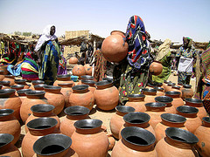
Songhay Empire
A state located in western Africa from the early 15th to the late 16th centuries following the decline of the Mali Empire.
Sparta
Greek city-state that was ruled by an oligarchy, focused on military, used slaves for agriculture, discouraged the arts

blankets
In 1763, British soldiers fighting native Americans in the Pontiac War, are famously accused of giving _______ infected with small pox to the natives. This has been suggested as an early example of germ warfare.

St. Petersburg
Built by Peter the Great of Russia to attract europeans and to get warm water ports.

Sufis
mystical Muslim group that believed they could draw closer to God through prayer, fasting, & simple life

Sui Dynasty
The short dynasty between the Han and the Tang; built the Grand Canal, strengthened the government, and introduced Buddhism to China

Suleyman the Magnificent
Ottoman Sultan (1512-20) expansion in Asia and Europe, helped Ottomans become a naval power, challegned Christian vessles througout the Mediterranian. 16th Century. The "lawgiver" who was so culturally aware yet exacted murder on two of his sons and a grandson in order to prevent civil war. Ottoman.
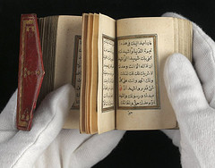
Sunni
The largest branch of Islam. After the death of Muhammad, Muslims who accepted Abu Bakr as the first Caliph became known as Ahl al-Sunnah wa al-Jama'ah or "the people of tradition and unification" in order to differentiate them from the Shia, who rejected Abu Bakr's authority in favor of Muhammad's cousin Ali as the next Caliph.
Shia
The second largest sect within Islam. It originated in the early centuries of Islam perhaps over a political dispute over who would be the next Caliph. This group believed that Muhammad's son-in-law and cousin Ali should be the Caliph. Over time this faction's religious interpretations and practices have also come to differ slightly from most Muslims.
Taj Mahal
beautiful mausoleum at Agra built by the Mogul emperor Shah Jahan (completed in 1649) in memory of his favorite wife
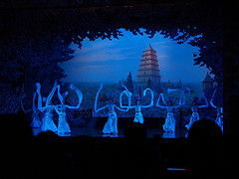
Tang Dynasty
dynasty often referred to as China's Golden age that reigned during 618 - 907 AD; China expands from Vietnam to Manchuria
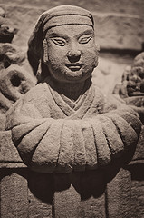
Song Dynasty
During this Chinese dynasty (960 - 1279 AD) China saw many important inventions. There was a magnetic compass; had a navy; traded with india and persia (brought pepper and cotton); paper money, gun powder; landscape black and white paintings

Teotihuacan
first major metropolis in Mesoamerica, collapsed around 800 CE. It is most remembered for the gigantic "pyramid of the sun".

The Enlightenment
A philosophical movement which started in Europe in the 1700's and spread to the colonies. It emphasized reason and the scientific method. Writers of the enlightenment tended to focus on government, ethics, and science, rather than on imagination, emotions, or religion. Many members of the Enlightenment rejected traditional religious beliefs in favor of Deism, which holds that the world is run by natural laws without the direct intervention of God.

Forbidden City
Built in the Ming Dynasty, was a stunning monument in Bejing built for Yonglo. All commoners and foreigners were forbidden to enter without special permission.
Great Wall
a vast Chinese defensive fortification begun in the 3rd century B.C. and running along the northern border of the country for 2,400 km

Romanovs
Russian family that came to power in 1613 and ruled for three centuries.

Thirty Years War
Protestant rebellion against the Holy Roman Empire ends with peace of westpahlia.1618-48) A series of European wars that were partially a Catholic-Protestant religious conflict. It was primarily a batlte between France and their rivals the Hapsburg's, rulers of the Holy Roman Empire.

Timbuktu
City on the Niger River in the modern country of Mali. It was founded by the Tuareg as a seasonal camp sometime after 1000. As part of the Mali empire, Timbuktu became a major major terminus of the trans-Saharan trade and a center of Islamic learning.

Tokugawa Shogunate
Japanese ruling dynasty that strove to isolate it from foreign influences. shogunate started by Tokugawa Ieyasu; 4 class system, warriors, farmers, artisans, merchants; Japan's ports were closed off; wanted to create their own culture; illegal to fight; merchants became rich because domestic trade flourished (because fighting was illegal); had new forms of art - kabuki and geishas

Toltecs
Nomadic peoples from beyond the northern frontier of sedentary agriculture in Mesoamerica; established capital at Tula after migration into central Mesoamerican plateau; strongly militaristic ethic, including cult of human sacrifice.

Trading Post Empires
Built initially by the portuguese, these were used to control the trade routes by forcing merchant vessels to call at fortified trading sites and pay duties there.

Trans Saharan trade
route across the sahara desert. Major trade route that traded for gold and salt, created caravan routes, economic benefit for controlling dessert, camels played a huge role in the trading

Treaty of Tordesillas
a 1494 agreement between Portugal and Spain, declaring that newly discovered lands to the west of an imaginary line in the Atlantic Ocean would belong to Spain and newly discovered lands to the east of the line would belong to Portugal.

Umayyad Dynasty
Who: Governor of Syria, Muawiya, and his successors, Shi'ites, Sunnis, Kharijites, Uthman. What: Dynasty based on succession rather than election following the first period of caliphates. Continued advances in the kingdom, venturing as far as China and deep into Asia, claiming Afghanistan for a Muslim base. Fell apart due to tension in the kingdom between the Sunnis, Shi'ites, and Kharijites, the malawis (Muslim converts) and born Muslims, and the religion and state. When: 661-750 Where: Middle East, Damascus Why: Beginning of great strife in the Muslim community

Vedas
Early Eastern sacred knowledge. by braham priests

Vedic Age
A period in the history of India; It was a period of transition from nomadic pastoralism to settled village communities, with cattle the major form of wealth.

Vikings
one of a seafaring Scandinavian people who raided the coasts of northern and western Europe from the eighth through the tenth century.

Warring States Period
time of warfare between regional lords following the decline of the Zhou dynasty in the 8th century B.C.E.

Westernization
policy of Peter the Great. Adoption of western ideas, technology, and culture

Yellow River
English name for the Huang He River in the north of China where the first Chinese civilization emerged.

Zheng He
An imperial eunuch and Muslim, entrusted by the Ming emperor Yongle with a series of state voyages that took his gigantic ships through the Indian Ocean, from Southeast Asia to Africa.

Zoroastrianism
system of religion founded in Persia in the 6th century BC by Zoroaster noun

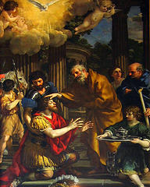
baroque
Major Western artistic style from 1500s to 1700s. Climactic, dramatic, dark vs. usage, shocking/ gruesome

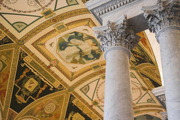

neoclassical
Major Western artistic style from 1600s to 1800s. Symmetry, Greek/ Roman influence, patterns, simple in color

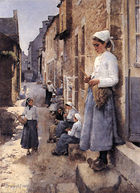

realism
Major Western artistic style of the 19th century. Against Romanticism, precise imitation w/o alteration, personal experiences, peasants/ everyday people

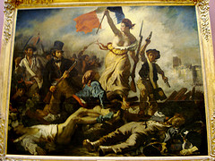
romanticism
Major Western artistic style of 1700s and 1800s.Against Neoclassicism, spontaneous, mysterious/ exotic, untamed/ powerful nature, embraces folklore and national traditions, glorification of heroes
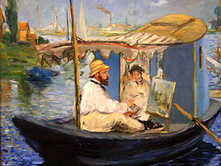
impressionism
Major Western artistic style that gained prominence in the second half of the 1800s and into the 1900s.Against Realism, visual impression of a moment, style that seeks to capture a feeling or experience, often very colorful.

Latin America
This region in the 19th century experienced a wave of independence movements following the American and French Revolutions.
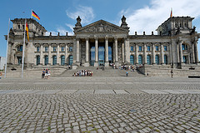
Reichstag
the parliament of Germany before 1945 (and the name of its building). Previously the general assembly of the Holy Roman Empire, and later the North German Confederation. After 1949 it was replaced with the current German parliament, the Bundestag.

Spanish-American War
conflict in 1898 between Spain and the United States. Fought mainly for the issue of Cuban independence from Spain.

Congress of Vienna
was a conference of ambassadors of European states chaired by Austrian statesman Klemens Wenzel von Metternich, and held in Vienna from November, 1814 to June, 1815. Its objective was to settle the many issues arising from the French Revolutionary Wars, the Napoleonic Wars, and the dissolution of the Holy Roman Empire.

Schlieffen Plan
German General Staff's early 20th century overall strategic plan for victory in a possible future war where it might find itself fighting on two fronts: France to the west and Russia to the east.

Iron Law of Wages
proposed principle of economics that asserts that real wages always tend, in the long run, toward the minimum wage necessary to sustain the life of the worker.

Mughal Empire
an Islamic imperial power that ruled a large portion of Indian subcontinent which began in 1526, invaded and ruled most of Hindustan (South Asia) by the late 17th and early 18th centuries, and ended in the mid-19th century.

Revolutions of 1848
a series of political upheavals throughout the European continent. Described by some historians as a revolutionary wave, the period of unrest began in France and then, soon spread to the rest of Europe.

Crimean War
war fought between the Russian Empire on one side and an alliance of the British Empire, French Empire, the Ottoman Empire, the Kingdom of Sardinia, and the Duchy of Nassau on the other.

Adam Smith
Scottish moral philosopher and a pioneer of political economics. Seen today as the father of Capitalism. Wrote On the Wealth of Nations (1776) One of the key figures of the Scottish Enlightenment.

Balkans
geopolitical and cultural region of southeastern Europe. Greece and the region North of Greece.

Tanzimat Reforms
began under Sultan Mahmud II. On November 3, 1839, Sultan Abdülmecid issued an organic statute for the general government of the empire named the Hatt-ı Şerif of Gülhane (the imperial garden where it was first proclaimed). It guarantees to ensure the Ottoman subjects perfect security for their lives, honour, and property introduction of the first Ottoman paper banknotes

Open Door Policy
Statement of U.S. foreign policy toward China. Issued by U.S. secretary of state John Hay (1899), the statement reaffirmed the principle that all countries should have equal access to any Chinese port open to trade.
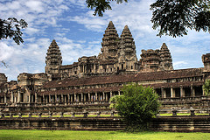
Hinduism
The architecture of this 12th century temple complex of Angkor Wat in Cambodia shows the influence of what religious culture?
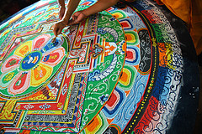
Buddhism
This artistic ritual is related to what religion?

Millennium
A historical period of 1000 years.

Century
A period of 100 years.

1800s
The 19th century includes what years?

1700s
The 18th century includes what years?

1600s
The 17th century includes what years?

1500s
The 16th century includes what years?
100s
The 2nd century BCE includes what years?

Kulak
A Russian peasant farmer who owns land. Late imperial and early Soviet eras.
Predestination
Often associated with Calvinism in the Protestant Reformation, it is the doctrine that God has already chosen who will be saved and become Christian and that people have no actual choice in the matter.
Red Guards
the Radical youth of the Cultural Revolution in China starting in 1966. Often wore red armbands and carried Mao's Little Red Book.
Phoenicians
Semitic-speaking Canaanites living on the coast of modern Lebanon and Syria in the first millennium B.C.E. Famous for developing the first alphabet, which was adopted by the Greeks. From major cities such as Tyre and Sidon, these merchants and sailors explored the Mediterranean, and engaged in widespread commerce.
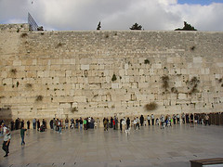
Western Wall
Sometimes called the Wailing Wall, this Sacred Jewish site is what remains of the former Israelite temple prior to the 1st century CE war with Rome and subsequent Jewish diaspora.
Ghengis Khan
The title of Temujin when he ruled the Mongols (1206-1227). It means the 'universal' leader. He was the founder of the Mongol Empire.
Jihad
A contoversial term in Islam that literally means "striving in the way of Allah"
Isolationism
the policy of separating one's country from the economic and political interactions with the rest of the world. nations
Militarism
The tendency to regard military greatness as the supreme ideal of the state and to subordinate all other interests to those of the military.
Revolution
An overthrow and replacement of an established government or political system by the people governed.
Sectarian
Devoted to a particular religious sect, particularly when referring to religious involvement in politics
Recession
A slowdown in economic activity over a period of time. During one of these periods all of the following things decline: Gross Domestic Product (GDP), employment, investment spending, capacity utilization, household incomes, business profits and inflation. Meanwhile bankruptcies and the unemployment rate rise.
Radical
Favoring drastic political, economic, or social reforms.

Nationalize
To bring under the ownership or control of a nation, such as industries and land.

United Nations
An international organization formed after WWII to promote international peace, security, and cooperation.
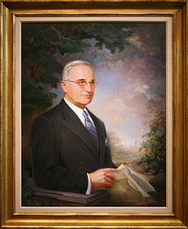
Truman Doctrine
Common name for the Cold War strategy of containment versus the Soviet Union and the expansion of communism. This doctrine was first asserted by President Truman in 1947.

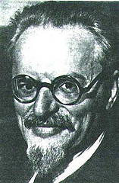
Leon Trotsky
Russian revolutionary intellectual and close adviser to Lenin. A leader of the Bolshevik Revolution (1917), he was later expelled from the Communist Party (1927) and banished (1929) for his opposition to the authoritarianism of Stalin

Abdicate
to renounce or relinquish a throne, right, power, claim, responsibility, or the like, especially in a formal manner
Armistice
A cease fire or temporary suspension of hostilities by agreement of the warring parties.
Capitalism
An economic system based on a free market, open competition, profit motive and private ownership of the means of production.

Communism
According to Karl Marx, a classless and stateless society at its ultimate peak of historical development.

Conservative
A political viewpoint disposed to preserve existing conditions, institutions, etc., or to restore traditional ones.

Containment
an act or policy of restricting the territorial growth or ideological influence of another, such as the US Cold War policy toward the USSR.

Deposed
to remove from office or position, esp. high office: The people _______ the dictator.

Egalitarian
Characterized by belief in the equality of all people, especially in political and social life.

Ethnic Cleansing
the elimination of an unwanted ethnic group or groups from a society, as by genocide or forced emigration.

Globalization
The process of the world becoming more economically interconnected and interdependent. The tendency of investment funds and businesses to move beyond domestic and national markets to other markets around the globe, thereby increasing the interconnectedness of different markets.

Guerrilla
a member of a band of irregular soldiers that uses guerrilla warfare, harassing the enemy by surprise raids, sabotaging communication and supply lines, etc.

Liberal
A political view that advocates for rule of law, representative government, and egalitarianism.

Secular
When something such as a government or cultural product is not based on religion it is said to be this.

Apartheid
A system of legal racial segregation enforced by the National Party government in South Africa between 1948 and 1994, under which the rights of the majority black inhabitants of South Africa were curtailed and minority rule by whites was maintained.

Berlin Airlift
supplied food and fuel to citizens of west Berlin when the Russians closed off land access to Berlin, which was located in the middle of Russian controlled East Germany.

Fidel Castro
Cuban revolutionary leader who overthrew the regime of the dictator Batista in 1959 and soon after established a Communist state

Che Guevara
was an Argentine Marxist revolutionary, physician, author, intellectual, guerrilla leader, diplomat, military theorist, and major figure of the Cuban Revolution. Since his death, his stylized visage has become a ubiquitous counter-cultural symbol.
Cuban Missile Crisis
A confrontation between the United States and the Soviet Union in 1962 over the presence of missile sites in Cuba
civil disobedience
Is the active refusal to obey certain laws, demands, and commands of a government, especially by people who believe the law or the government to not be legitimate or moral.
Great Leap Forward
economic and social plan used in China from 1958 to 1961 which aimed to use China's vast population to rapidly transform the country from an agrarian economy into a modern industrial society.

Mao Zedong
Chinese Communist leader from 1949 to 1976.

Marshall Plan
a plan for aiding the European nations in economic recovery after World War II in order to stabilize and rebuild their countries and prevent the spread of communism.

Rape of Nanjing
a six-week period following the Japanese capture of the Chinese city of Nanjing. During this period, hundreds of thousands of civilians were murdered and 20,000-80,000 women were raped[1] by soldiers of the Imperial Japanese Army.

European Union
an association of European nations formed in 1993 for the purpose of achieving political and economic integration.

Flu Pandemic of 1918
The deadliest natural disaster in human history. Killed between 50-100 million people following WWI.
Abbasid Caliphate
third of the Islamic Caliphates of the Islamic Empire. The rulers who built their capital in Baghdad after overthrowing the Umayyad caliphs. In started in 750 CE. It flourished for two centuries, but slowly went into decline with the rise to power of the Turkish army it had created, the Mamluks. In the 13th century the Mongols displaced them.

circa
When noting dates the letter "c." before a date represents what? (example: Jesus was born c. 5 BCE). It means approximately.

Authoritarian
A style of government characterized by submission to authority. It tends to opposed individualism and democracy. In its most extreme cases it is one in which political power is concentrated in a leader or leaders, who possess exclusive, unaccountable, and arbitrary power.

Malaria
This disease is commonly associated with poverty and is spread by mosquitos. Each year 1-3 million people mostly in sub-saharan Africa die of this diesase and hundreds of millions are infected.

Smallpox
The overall deadliest known disease in the history of the world. In the 20th century alone there were approximately 500,000,000 people who died of this disease.

Islamic Golden Age
A hypothetical period that describes the status of the Islamic world from the mid-8th to the mid-13th century CE (sack of Baghdad by Mongols). During this period, artists, engineers, scholars, poets, philosophers, geographers and traders in the Islamic world contributed to agriculture, the arts, economics, industry, law, literature, navigation, philosophy, sciences, sociology, and technology, both by preserving earlier traditions and by adding inventions and innovations of their own.

Abbasids
Abbasids or Umayyads? Were more open and integrating of non Arab peoples, and were more open to the non-Arab masses converting to Islam.

Umayyads
Abbassids or Umayyads? Non-Arab people were more ostracized from society, even if they were Muslim. They were prohibited from holding positions of influence, they paid more taxes, not wanting peasant and urban masses to convert to Islam.

Bushido
The Feudal Japanese code of honor among the warrior class.

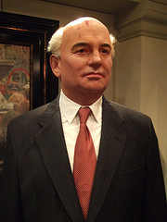
Glasnost
The policy of openness and transparency in the activities of all government institutions in the Soviet Union, together with freedom of information, introduced by Mikhail Gorbachev in the second half of the 1980s.

Gross Domestic Product (GDP)
A measurement of the total goods and services produced within a country.

Bourbon
A European Royal family that is most known for its rule of France from the 16th through the 18th centuries.

Gobi
The desert to the north of China
British Raj
The name given to the period and territory of direct British colonial rule in South Asia between 1858 and 1947--from the time of the attempted Indian Revolt (Sepoy Mutany) to the Independence of India.
Great Schism
in 1054 this severing of relations divided medieval Christianity into the already distinct Eastern (Greek) and Western (Latin) branches, which later became known as the Eastern Orthodox Church and the Roman Catholic Church, respectively. Relations between East and West had long been embittered by political and ecclesiastical differences and theological disputes.
Hammurabi
He designed a legal code in early Babylon that gave punishment based on crime and social status. Relied on the principle of lex talionis.

Sargon of Akkad
(2370-2315 BCE) He is the creator of empire in Mesopotamia.

Hebrews
Early group of people who lived in lands between Mesopotamia and Egypt. They developed the religion Judaism.

Phoenicians
A maritime people who spread their alphabet to others including the Hebrews, Romans, and Greeks.

Hittites
The group of people who toppled the Babylonian empire and were responsible for two technological innovations--the war chariots and refinement of iron metallurgy.

Bantu
The people who spread throughout Africa spreading agriculture, language, and iron.

Menes
The king who unifed Egypt.
Nile River
The river in which early kingdoms in Egypt were centered around.
Hieroglyphics
Egyptian writing that involved using pictures to represent words.

Vedas
Collections of hymns, songs, prayers, and rituals honoring the barious gods of the Aryans.

Caste System
The system in old India that seperated the people into social categories, but based mostly on color with the Aryans always on the top of the social pyramid.

Brahmins
The priest varna of the caste system.

Kshatriyas
The warrior and aristocrat varna of the caste system.

Vaishyas
The artisan and merchant varna of the caste system.

Shudras
The landless peasants and serfs of the caste system.

Jati
A sub-varna in the caste system that gave people of sense of community because they usually consisted of people working in the same occupation.
Sati
The Indian custom of a widow voluntarily throwing herself on the funeral pyre of her husband.

Upanishads
A major book in Hinduism that is often in the form of dialogues that explored the Vedas and the religious issues that they raised.

Brahman
The term for The Univeral Soul in Hinduism.

Moksha
Becoming liberated for the cycle of reincarnation in Hinduism.

Karma
The belief that actions in this life, whether good or bad, will decide your place in the next life.

Shang Dynasty
(1766-1122 BCE) The Chinese dynasty that rose to power due to bronze metalurgy, war chariots, and a vast network of walled towns whose recognized this dynasty as the superior.

Zhou Dynasty
A decentralized Chinese dynasty in China because of the massive size, and whose emperor was the first to claim to be a link between heaven and earth. Iron metallurgy increased in this dynasty.

Mandate of Heaven
The Chinese belief that the emperor claimed to be the "son of heaven" and therefore has the right to rule.
Ancestor Veneration
The practice of praying to your ancestors. Found especially in China.
Period of Warring States
The period in Chinese history (403-221 BCE) in which many different states emerged and were fighting for control of China.
Olmecs
An early peopl who settled in modern day Mexico and who traded in jade and obsidian and erected colossal heads carved from rocks.
Maya
They settled in the Yucatan Peninsula, not far from the Olmecs. A very cultural and intellectual people who used astronomy to create and very accurate calendar.

Zoroastrianism
A religion that developed in early Persia and stressed the fight between the forces of good and the forces of evil and how eventually the forces of good would prevail.

Confucius
(551-479 BCE) A Chinese philosopher known also as Kong Fuzi and created one of the most influential philosophies in Chinese history.

Analects
The book that Kong Fuzi wrote and that stresses the values and ideas of Confucianism.

Ren
An attitude of kindness and benevolence or a sense of humanity for Confucianism.

Li
Called for individuals to behave in conventionally appropriate fashion in Confucianism.
Filial Piety
Concept is stressed in Confucianism. Reflected the high significance of the family in Chinese history.

Daoism
A religion in China which emphasizes the removal from society and to become one with nature.

Legalism
A Chinese philosophy that was devoted to strengthen and expand the state through increased agricultural work and military service.
Qin Dynasty
(221-207 BCE) The first centralized dynasty of China that used Legalism as its base of belief.

Qin Shihuangdi
(r.221-210 BCE) The first emperor of the Qin Dynasty who believed strongly in Legalism and sought to strengthen the centralized China through public works.

Han Dynasty
(202 BCE-220 CE) This dynasty continued the centralization of the Qin Dynasty, but focused on Confucianism and education instead of Legalim.

Mauryan Empire
(321-185 BCE) This was the first centralized empire of India whose founder was Chandragupta Maurya.

Gupta Empire
(320-550 CE) The decentralized empire that emerged after the Mauryan Empire, and whose founder is Chandra Gupta.

Guilds
Economic groups that functioned as jati by controling prices, output, workers, and competition for a specific product.

Siddhartha
The founder of the religion Buddhism who believed that all life was suffering. Also known as the Buddha.

Four Noble Truths
All life invoves suffering; desire is the cause of suffering; elimination of desire brings an end to suffering; a disciplined life conducted life brings the elimination of desire.

Noble Eightfold Path
Calls for individuals to lead balanced and moderate lives, rejecting both the devotion to luxury and the regimes of extreme asceticism. (Buddhist Belief).

Nirvana
The state of englightenment for Buddhists.

Dharma
The basic doctrine shared by Buddhists of all sects.

Mahayana Buddhism
Also known as popular Buddhism, is allows people more ways to reach enlightenment and boddhisatvas can help you reach enlightenment.

Boddhisatva
A enlightened being who put off nirvana to come back and help others become enlightened.

Bhagavad Gita
A book in popular Hinduism that was a response to Buddhism and made reaching moksha way easier.

Minoans
The Mediterranean society that formed on the island of Crete and who were a big maritime society.
Polis
Greek word for "city-state"

Sparta
A powerful Greek miliary polis that was often at war with Athens. Used slaves known as helots to provide agricultural labor.
Athens
A democratic Greek polis who accomplished many cultural achievements, and who were constantly at war with Sparta.
Pericles
An Athenian leader who transformed Athens into a community of scientists, philosophers, poets, dramatists, artists, and architects and who was a big promoter of democracy.
Persian Wars
A series of wars between the Greeks (mainly Athens) and the Persians in which the Greeks were usually victorious.

Peloponnesian War
(431-404 BCE) The war between Athens and Sparta that in which Sparta won, but left Greece as a whole weak and ready to fall to its neighbors to the north.

Seleucid Empire
The empire in Syria, Persia, and Bactria after the breakup of Alexander's empire.

Socrates
(470-399 BCE) An Athenian philosopher who thought that human beings could lead honest lives and that honor was far more important than wealth, fame, or other superficial attributes.

Plato
(430-347 BCE) Was a disciple of Socrates whose cornerstone of thought was his theory of Forms, in which there was another world of perfection.

Aristotle
Unlike his teacher Plato, he believe that philosophers could rely on their senses to provide accurate information about the world.
Roman Republic
This establishment consisted of the Senate with two consuls who were elected by an assembly dominated by hereditary aristocrats known as patricians.

Patricians
The wealthy, hereditary aristocrats during the Roman era.

Pleibians
The common people during the Roman era.

Punic Wars
Wars between the Romans and Carthaginians that marked Rome as the preeminent power in the eastern as well as the western Mediterranean.

Trajan
Leader of the Roman Empire who disguised it as a republic, and under who the Roman Empire came to be at its greatest extent.

Pax Romana
A time in history when the Roman Empire was at peace and promoted safe trade.

Constantine
Emperor of the Roman Empire who moved the capital to Constantinople. He eventually converted to Christianity as well.
Monsoon
Major winds in the Indian Ocean that blew into India for half the year, and blew away from India for the other half. Helped facilitate trade in the Indian Ocean.
Diocletian
Roman emperor who divided the empire into a West and an East section.

The Great Schism
The separation of the Roman Catholic Church and the Eastern Orthodox Church (1054 CE)
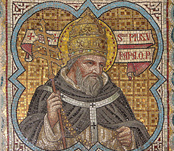
Pope
The head of the Roman Catholic Church.

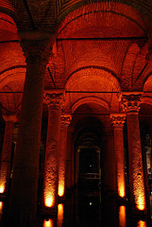
Byzantine Emperor
The head of the Eastern Orthodox Church in the Byzantine Empire.
Justinian's Code
Roman law that was modified by revising old and not needed laws. Named after the Byzantine Emperor Justinian.
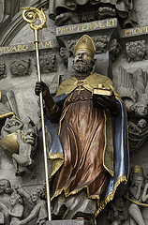
Council of Nicaea
(325 CE) A council called by Constantine to agree upon correct Christian doctrine and settle some disputes of the time.

Muhammad
The last prophet believed by Muslims who talked to the Archangel Gabriel and whose life teachings is compiled in the Hadith.

Hadith
The compiled work of the life and teachings of Muhammad.

Quran
The holy book of Muslims.

Torah
The first five books of Jewish Scripture, which they believe are by Moses, are called this

Bible
The holy book of Christians.

Umma
The term for all Muslims as a community.

Hijra
Muhammad's move to Medina. Start of the Islamic calendar (632 CE)

Five Pillars
The basic tenets of Islam: Allah is the only god and Muhammad is his prophet; pray to Allah five times a day facing Mecca; fast during the month of Ramadan; pay alms for the relief of the weak and the poor; take a hajj to Mecca

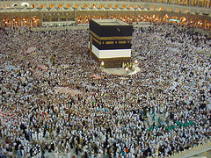
Hajj
The pilgrimage to Mecca required to take by Muslims

Jihad
The Muslim word for "struggle" especially when trying to follow the will of Allah.
Sharia
Islamic law; a combination of the Quran and the Hadith.

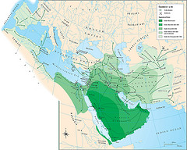
Umayyad Caliphate
(661-750 CE) The Islamic caliphate that established a capital at Damascus, conquered North Africa, the Iberian Pennisula, Southwest Asia, and Persia, and had a bureaucracy with only Arab Muslims able to be a part of it.

Jizya
The tax on people in the Umayyad Caliphate who did not convert to Islam.

Abbasid Caliphate
(750-1258 CE) The caliphate, after the Umayyads, who focused more on administration than conquering. Had a bureaucracy that any Mulim could be a part of.
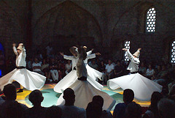
Sufi
The branch of Islam that believes in a more mystical connection with Allah.
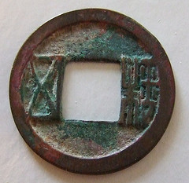
Sui Dynasty
(589-618 CE) The Chinese dynasty that was like the Qin Dynasty in imposing tight political discipline; this dynasty built the Grand Canal which helped transport the rice in the south to the north.

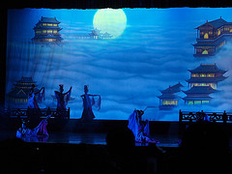
Tang Dynasty
(618-907 CE) The Chinese dynasty that was much like the Han, who used Confucianism. This dynasty had the equal-field system, a bureaucracy based on merit, and a Confucian education system.

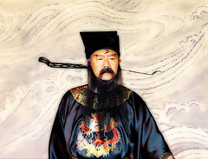
Song Dynasty
(960-1279 CE) The Chinese dynasty that placed much more emphasis on civil administration, industry, education, and arts other than military.
Neo-Confucianism
The Confucian response to Buddhism by taking Confucian and Buddhist beliefs and combining them into this. However, it is still very much Confucian in belief.

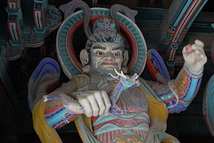
Silla Dynasty
The dynasty in Korea that rallied to prevent Chinese domination in the seventh century CE.

Harsha
(r.606-648 CE) He restored centralized rule in northern India after the collapse of the Gupta. He can be compared to Charlemagne.

Delhi Sultanate
(1206-1526 CE) The successors of Mahmud of Ghazni mounted more campaigns, but directed their goals to creating this empire.
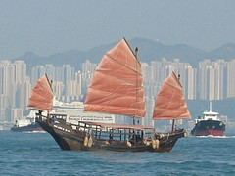
Junks
Chinese ships, particularly from the 1400s, are often called these. It was a sturdy Chinese ship design and the largest of its kind were treasures ships that could carry a thousand tons of cargo.

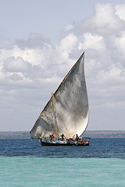
Dhows
Large ships favored by Indian, Persian, and Arab sailors that could carry up to four hundred tons of cargo.
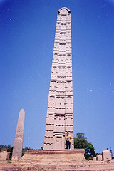
Axum
The Christian state in Africa that developed its own branch of Christianity, Coptic Christianity, because it was cut off from other Christians due to a large Muslim presence in Africa.
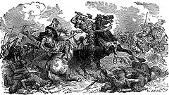
Battle of Tours
(732 CE) European victory over Muslims. It halted Muslim movement into Western Europe.

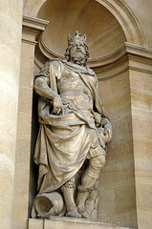
Charlemagne
(768-814 CE) Crowned king in 800 CE by the pope; can be compared to Harsha; brought back unified rule to Europe only during his life; used the missi dominici to check up on imperial officials.

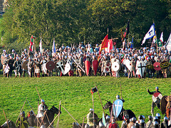
Battle of Hastings
(1066 CE) The Norman invasion of England; this was the largest battle.

Serfs
People who gave their land to a lord and offered their servitude in return for protection from the lord.

Pope Gregory I
This pope strongly emphasized the sacrament of penance and encouraged confession for the remission of sins which made people more dependent on the church for salvation.
Mongols
People from Central Asia when united ended up creating the largest single land empire in history.
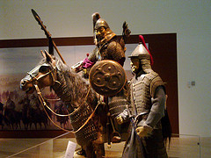
Genghis Khan
Also known as Temujin; he united the Mongol tribes into an unstoppable fighting force; created largest single land empire in history.

Khubilai Khan
Reigned in China after establishing the Yuan Dynasty; he actively promoted Buddhism; descendant of Chinggis Khan.
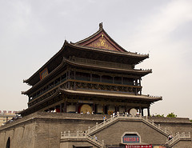
Yuan Dynasty
(1279-1368 CE) The dynasty with Mongol rule in China; centralized with bureaucracy but structure is different: Mongols on top->Persian bureaucrats->Chinese beaurocrats.
Battle of Manzikert
(1071 CE) Saljuq Turks defeat Byzantine armies in this battle in Anatolia; shows the declining power of Byzantium.

Tamerlane
He is very much like Ghengis Khan; a military leader who conquered the lands of Persia; his empire was decentralized with tribal leaders.
1453
The year that Constantinople was sacked by the Ottoman Turks and meant that Byzantium had collapsed. Hint: __53

Ghana
The kingdom in West Africa that prospered because of trans-Saharan trade especially in gold; this kingdom was around at the time of Muslim control in North Africa.

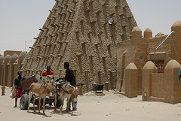
Mali
The kingdom in West Africa that followed the Kingdom of Ghana; its wealth is also based on trans-Saharan trade; this kingdom encouraged the spread of Islam.

Mansa Musa
Ruler of Mali (r.1312-1337 CE) who made a hajj to Mecca; on the way there, he spread enormous amounts of gold showing the wealth of Mali; on the way back, he brought back education and Islamic culture.

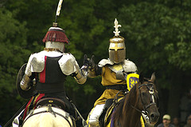
Chivalry
Code of honor and ethics taken by knights.

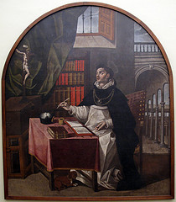
Scholasticism
This sought to synthesize the beliefs and values of Christianity with the logical rigor of Greek philosophy. Often associated with St. Thomas Aquinas.
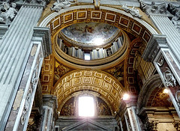
Urban II
The pope that issued the crusades in 1095 CE

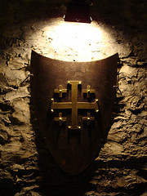
First Crusade
1099 CE, Jerusalem fell the Christian crusaders; the only successful crusade.

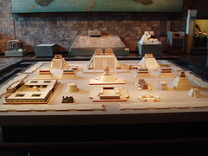
Tenochtitlan
The captial city of the Aztecs.
Marco Polo
Venetian merchant and traveler. His accounts of his travels to China offered Europeans a firsthand view of Asian lands and stimulated interest in Asian trade.
Ibn Battuta
Moroccan Muslim scholar, the most widely traveled individual of his time. He wrote a detailed account of his visits to Islamic lands from China to Spain and the western Sudan.

Little Ice Age
Temporary but significant cooling period between the fourteenth and the nineteenth centuries; accompanied by wide temperature fluctuations, droughts, and storms, causing famines and dislocation.

Bubonic Plague
Also called the Black Death; is believed to be the deadly disease that spread through Asia and Europe and killed more than a third of the people in parts of China and Europe.
Silk Road
A system of ancient caravan routes across Central Asia, along which traders carried silk and other trade goods.

MIng Dynasty
Succeeded Mongol Yuan dynasty in China in 1368; lasted until 1644; initially mounted huge trade expeditions to southern Asia and elsewhere, but later concentrated efforts on internal development within China.

Eunuchs
castrated males, originally in charge of protection of the ruler's concubines. Eventually had major roles in government, especially in China.

Hundred Years' War
Series of campaigns over control of the throne of France, involving English and French royal families and French noble families. England loses and losses half of its land but that land was in France. The negative impact- France became an absolute power. Positive impact- France formed a nation-state. Ended in 1453.

Reconquista
The retaking of the Iberian Peninsula by Spanish forces from the Moors. It was completed in 1492.

Renaissance
A period of intense artistic and intellectual activity, said to be a 'rebirth' of Greco-Roman culture. Usually divided into an Italian Renaissance, from roughly the mid-fourteenth to mid-fifteenth century, and a Northern Renaissance 1400-1600.

Humanism
Studied the Latin classics to learn what they reveal about human nature. Emphasized human beings, their achievements, interests, and capabilities.

Zheng He
An imperial eunuch and Muslim, entrusted by the Ming emperor Yongle with a series of state voyages that took his gigantic ships through the Indian Ocean, from Southeast Asia to Africa.

Vasco da Gama
Using the new trade route around the Cape of Good Hope, he brought spices back to Portugal and made a profit of several thousand dollars.

Christopher Columbus
Incorrectly calculated the circumference of the globe, and gained Spanish support to travel west to Asia based on this. Believed he had reached islands off the coast of Asia, when he had actually reached the Caribbean.

Ferdinand Magellan
Portuguese explorer who found a sea route to the Spice Island by sailing around the American continent. His crew was the first to circumnavigate the world.

James Cook
English navigator who claimed the east coast of Australia for Britain and discovered several Pacific islands (1728-1779).

English East India Company
an early joint-stock company; were granted on English royal charter with the intention of favoring trade privileges in India.

Seven Years' War
(1756-1763 CE) Known also as the French and Indian war. It was the war between the French and their Indian allies and the English that proved the English to be the more dominant force of what was to be the United States both commercially and in terms of controlled regions.

Columbian Exchange
The exchange of plants, animals, diseases, and technologies between the Americas and the rest of the world following Columbus's voyages.

Mercantilism
The economic theory that the world has a limited amount of wealth so the more wealth a nation has, the more powerful it is.

Martin Luther
A German monk who became one of the most famous critics of the Roman Catholic Chruch. In 1517, he wrote 95 theses, or statements of belief attacking the church practices. He led the Protestant Reformation.

Protestant Reformation
A religious movement of the 16th century that began as an attempt to reform the Roman Catholic Church and resulted in the creation of Protestant churches.

John Calvin
Swiss theologian (born in France) whose tenets (predestination and the irresistibility of grace and justification by faith) defined Calvinism (1509-1564).

Coucil of Trent
(1545-1563 CE) Council of the Catholic Reformation that reemphasized and justified the Roman Catholic beliefs. In response to the Protestant Reformation.

Society of Jesus
A Roman Catholic order founded by Saint Ignatius of Loyola in 1534 to defend Catholicism against the Reformation and to do missionary work.

Thirty Years' War
(1618-1648 CE) War within the Holy Roman Empire between German Protestants and their allies (Sweden, Denmark, France) and the emperor and his ally, Spain; ended in 1648 after great destruction with Treaty of Westphalia.

Treaty of Westphalia
Ended Thirty Years&#039; War in 1648; granted right to individual rulers within the Holy Roman Empire to choose their own religion-either Protestant or Catholic.

Charles V
Holy Roman Emperor and Carlos I of Spain, tried to keep Europe religiously united, inherited Spain, the Netherlands, Southern Italy, Austria, and much of the Holy Roman Emperor from his grandparents, he sought to stop Protestantism and increase the power of Catholicism. He allied with the pope to stamp out heresy and maintain religous unity in Europe. He was preocuppied with struggles with Turkey and France and could not soley focus on the rise of Protestantism in Germany.

New Monarchy
In the 15th century, government in which power had been centralized under a king or queen, particularly France, England, and Spain.

Absolute Monarchy
Concept of government developed during rise of nation-states in Western Europe during the 17th century; featured monarchs who passed laws without parliaments, appointed professionalized armies and bureaucracies, established state churches, and imposed state economic policies.

Spanish Inquisition
An organization of priests in Spain that looked for and punished anyone suspected of secretly practicing their old religion instead of Roman Catholicism.

Constitutional Monarchy
A King or Queen is the official head of state but power is limited by a constitution.

Louis XIV
This French king ruled for the longest time ever in Europe. He issued several economic policies and costly wars. He was the prime example of absolutism in France.

Peter the Great
This was the tsar of Russia that Westernized Russia and built up a massive Russian army.

Tsar
The Russian term for ruler or king; taken from the Roman word caesar.

Balance of Power
Distribution of military and economic power that prevents any one nation from becoming too strong (especially in Europe).

Capitalism
(1776) , an economic system in which investment in and ownership of the means of production, distribution, and exchange of wealth is made and maintained chiefly by private individuals or corporations.

Galileo Galilei
This scientist proved Copernicus' theory that the sun was the center of the solar system and developed the modern experimental method.

Nicolaus Copernicus
A Polish astronomer who proved that the Ptolemaic system was inaccurate, he proposed the theory that the sun, not the earth, was the center of the solar system.

Isaac Newton
English mathematician and scientist- invented differential calculus and formulated the theory of universal gravitation, a theory about the nature of light, and three laws of motion. was supposedly inspired by the sight of a falling apple.

Kepler
This astronomer stated that the orbits of planets around the sun were elliptical, the planets do not orbit at a constant speed, and that an orbit is related to its distance from the sun.

Enlightenment
A movement in the 18th century that advocated the use of reason in the reappraisal of accepted ideas and social institutions.

Voltaire
French philosopher and writer whose works epitomize the Age of Enlightenment, often attacking injustice and intolerance.

Deism
God is a watchmaker; The religion of the Enlightenment (1700s). Followers believed that God existed and had created the world, but that afterwards He left it to run by its own natural laws.

Theory of Progress
The European Enlightenment idea that stated that society was always progressing.

Spanish Armada
The great fleet sent from Spain against England by Philip II in 1588; defeated by the terrible winds and fire ships.

Adam Smith
Scottish economist who wrote the Wealth of Nations a precursor to modern Capitalism.

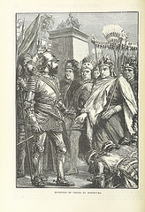
Hernán Cortés
Spanish explorer and conquistador who led the conquest of Aztec Mexico in 1519-1521 for Spain.

Conquistador
Generic term for a Spanish conqueror of the Americas.
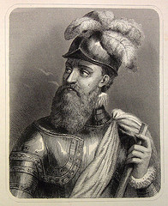
Francisco Pizarro
Spanish explorer who conquered the Incas in what is now Peru and founded the city of Lima (1475-1541).

Viceroy
Governor of a country or province who rules as the representative of his or her king or sovereign; think Spanish colonies.

Audiencias
Courts appointed by the king who reviewed the administration of viceroys serving Spanish colonies in America.

Mestizo
A person of mixed Spanish and Native American ancestry.

Zambos
According to Spanish and Portuguese colonizedrs, these are people of mixed Native American and African descent. Lowest tier of social class in colonial America.

Peninsulares
Spanish-born, came to Latin America; ruled, highest social class.
Creoles
Descendents of Spanish-born but born in Latin America; resented inferior social, political, economic status.

Mita System
The system recruiting workers for particularly difficult and dangerous chores that free laborers would not accept.

Quinto
One-fifth: amount the Spanish crown was to receive of all precious metals mined in the Americas.

Hacienda
Spanish colonists formed large, self-sufficient farming estates known as these.

Encomienda
A grant of authority over a population of Amerindians in the Spanish colonies. It provided the grant holder with a supply of cheap labor and periodic payments of goods by the Amerindians. It obliged the grant holder to Christianize the Amerindians.

Indentured Servitude
A contractual system in which someone sells his or her body (services) for a specified period of time in an arrangement very close to slavery, except that it is voluntary entered into.

Triangular Trade
A three way system of trade during 1600-1800s Africa sent slaves to America, America sent raw materials to Europe, and Europe sent guns and rum to Africa.

Middle Passage
The voyage that brought enslaved Africans across the Atlantic Ocean to North America and the West Indies.
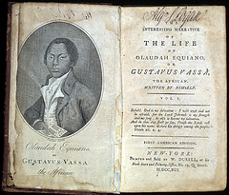
Olaudah Equiano
An antislavery activist who wrote a famous account of his enslavement.

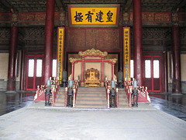
Qing Dynasty
(1644-1911 CE), the last imperial dynasty of China which was overthrown by revolutionaries; was ruled by the Manchu people: began to isolate themselves from Western culture,
Manchurians
Federation of Northeast Asian (from Manchuria) peoples who founded the Qing Empire.

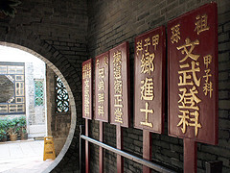
Civil Service Exam
In Imperial China starting in the Han dynasty, it was an exam based on Confucian teachings that was used to select people for various government service jobs in the nationwide administrative bureaucracy.
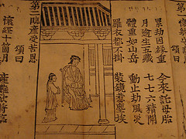
Filial Piety
In Confucian thought, one of the virtues to be cultivated, a love and respect for one's parents and ancestors.

Foot Binding
Practice in Chinese society to mutilate women's feet in order to make them smaller; produced pain and restricted women's movement; made it easier to confine women to the household.

Daimyo
A Japanese feudal lord who commanded a private army of samurai; warlord but not as powerful as a shogun.

Floating Worlds
Centers of Tokugawa urban culture; called ukiyo; where entertainment and pleasure quarters housed teahouses, theaters, brothels, and public baths to offer escape from social responsibilities and the rigid rules of conduct that governed public behavior.

Ottoman Empire
Islamic state founded by Osman in northwestern Anatolia. After the fall of the Byzantine Empire, the Ottoman Empire was based at Istanbul (formerly Constantinople) from 1453-1922. It encompassed lands in the Middle East, North Africa, the Caucasus, and eastern Europe.
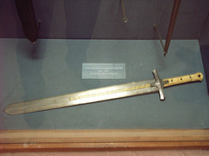
Mehmed the Conqueror
(r.1451-1481), he captured Constantinople in 1453, which later became Istanbul, the Ottoman capital; Ruled with an absolute monarchy and centralized his power; Expanded into Serbia, Greece, and Albania (attacked Italy).

Safavids
A Shi'ite Muslim dynasty that ruled in Persia (Iran and parts of Iraq) from the 16th-18th centuries that had a mixed culture of the Persians, Ottomans and Arabs.

Twelver Shiism
A belief that there were 12 infallible imam (religious leaders) after Muhammad and the 12th went into hiding and would return to take power and spread the true religion.

Battle of Chaldiran
16th Century. The Safavids vs the Ottomans; Ottomans won, and this symbolized the two greatest world powers at the time clashing together; religious war (Shi'ites Vs. Sunnis).
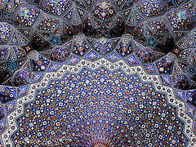
Abbas the Great
Safavid ruler from 1587 to 1629; extended Safavid domain to greatest extent; created slave regiments based on captured Russians, who monopolized firearms within Safavid armies; incorporated Western military technology.
Mughal Empire
Muslim state (1526-1857) exercising dominion over most of India in the sixteenth and seventeenth centuries; a minority of Muslims ruled over a majority of Hindus.

Akbar
Most illustrious sultan of the Mughal Empire in India (r. 1556-1605). He expanded the empire and pursued a policy of conciliation with Hindus.

Aurangzeb
Mughal emperor in India and great-grandson of Akbar 'the Great', under whom the empire reached its greatest extent, only to collapse after his death.

Istanbul
Capital of the Ottoman Empire; named this after 1453 and the sack of Constantinople.

Isfahan
Capital of the Safavid Empire.
Taj Mahal
Beautiful mausoleum at Agra built by the Mogul emperor Shah Jahan (completed in 1649) in memory of his favorite wife.

Osman
Founder of the Ottoman Empire.

Suleyman the Magnificent
(r.1520-1566 CE) He promoted Ottoman expanison, conquered Baghdad in 1543, and subjected Vienna to siege in 1529.

Shah Ismail
Founder of Safavid Empire in 1501, ruled until 1524; made Twelver Shiism the official religion of the empire and imposed it upon his Sunni subjects; his followers became known as qizilbash.

Babur
First sultan of the Mughal Empire; took lots of land in India.

Sikhism
A monotheistic religion founded in northern India in the 16th century by Guru Nanak. It is not a part of Islam or Hinduism.

Enlightenment
A movement in the 18th century that advocated the use of reason in the reappraisal of accepted ideas and social institutions.

American Revolution
This political revolution began with the Declaration of Independence in 1776 where American colonists sought to balance the power between government and the people and protect the rights of citizens in a democracy.

Declaration of Independence
Signed in 1776 by US revolutionaries; it declared the United States as a free state.

French Revolution
The revolution that began in 1789, overthrew the absolute monarchy of the Bourbons and the system of aristocratic privileges, and ended with Napoleon's overthrow of the Directory and seizure of power in 1799.

Estates General
An assembly that represented the entire French population through three groups, known as estates; King Louis XVI called this in May 1789 to discuss the financial crises.

Louis XVI
King of France (r.1774-1792 CE). In 1789 he summoned the Estates-General, but he did not grant the reforms that were demanded and revolution followed. Louis and his queen, Marie Antoinette, were executed in 1793.

National Assembly
French Revolutionary assembly (1789-1791). Called first as the Estates General, the three estates came together and demanded radical change. It passed the Declaration of the Rights of Man in 1789.

Declaration of the Rights of Man and the Citizen
Adopted August 26, 1789, created by the National Assembly to give rights to all (except women).

The Convention
Legislative body created by revolutionary leaders that abolished the monarchy & proclaimed France a republic; rallied French population by instituting levée en masse ("mass levy"); basically the French equivalent of the draft); frequently used the guillotine on enemies.

Reign of Terror
This was the period in France where Robespierre ruled and used revolutionary terror to solidify the home front. He tried rebels and they were all judged severely and most were executed.

Maximilien Robespierre
Young provincial lawyer who led the most radical phases of the French Revolution; his execution ended the Reign of Terror.

The Directory
Established after the Reign of Terror / National Convention; a five man group as the executive branch of the country; incompetent and corrupt, only lasted for 4 years.

Napoleonic Wars
A series of wars fought between France (led by Napoleon Bonaparte) and alliances involving England and Prussia and Russia and Austria at different times (1799-1812).

Haitian Revolution
A major influece of the Latin American revolutions because of its successfulness; the only successful slave revolt in history; it is led by Toussaint L'Ouverture.

Toussaint Louverture
Was an important leader of the Haïtian Revolution and the first leader of a free Haiti; in a long struggle again the institution of slavery, he led the blacks to victory over the whites and free coloreds and secured native control over the colony in 1797, calling himself a dictator.

Simon Bolivar
The most important military leader in the struggle for independence in South America; born in Venezuela, he led military forces there and in Colombia, Ecuador, Peru, and Bolivia.

Conservatism
A political or theological orientation advocating the preservation of the best in society and opposing radical changes.

Liberalism
A political ideology that emphasizes the civil rights of citizens, representative government, and the protection of private property. This ideology, derived from the Enlightenment, was especially popular among the property-owning middle classes.

Zionism
A policy for establishing and developing a national homeland for Jews in Palestine.

Congress of Vienna
(1814-1815 CE) Meeting of representatives of European monarchs called to reestablish the old order after the defeat of Napoleon.

Rebellions of 1848
A series of rebellions throughout Europe in 1848; they were crushed by the conservative powers.

Camillo di Cavour
The political mastermind behind all of Sardinia's unification plans, he succeeded in creating a Northern Italian nation state.

Giuseppe Garibaldi
Italian patriot whose conquest of Sicily and Naples led to the formation of the Italian state (1807-1882).

Otto von Bismarck
(1815-1898) German prime minister who intentionally provoked three wars to provide the people with a sense of nationalism.

James Watt
Scottish engineer and inventor whose improvements in the steam engine led to its wide use in industry (1736-1819).

Eli Whitney
United States inventor of the mechanical cotton gin (1765-1825).

Henry Ford
United States manufacturer of automobiles who pioneered mass production (1863-1947).

Corporation
A business owned by stockholders who share in its profits but are not personally responsible for its debts.

Demographic Transition
The process of change in a society's population from a condition of high crude birth and death rates and low rate of natural increase to a condition of low crude birth and death rates, low rate of natural increase, and a higher total population.

Karl Marx
German philosopher, economist, and revolutionary. With the help and support of Friedrich Engels he wrote The Communist Manifesto (1848) and Das Kapital (1867-1894). These works explain historical development in terms of the interaction of contradictory economic forces, form the basis of all communist theory, and have had a profound influence on the social sciences.

Communist Manifesto
A socialist manifesto written by Marx and Engels (1848) describing the history of the working-class movement according to their views.

Communism
A theory or system of social organization based on the holding of all property in common, actual ownership being ascribed to the community as a whole or to the state.

Socialism
A theory or system of social organization that advocates the vesting of the ownership and control of the means of production and distribution, of capital, land, etc., in the community as a whole.

Mexican-American War
(1846-1848) The war between the United States and Mexico in which the United States acquired one half of the Mexican territory.

US Civil War
The violent conflict between Union and confederate forces over states rights and slavery.

Abraham Lincoln
16th president of the United States; helped preserve the United States by leading the defeat of the secessionist Confederacy; an outspoken opponent of the expansion of slavery.

War of 1812
A war (1812-1814) between the United States and England which was trying to interfere with American trade with France.

Mexican Revolution
(1910-1920 CE) Fought over a period of almost 10 years form 1910; resulted in ouster of Porfirio Diaz from power; opposition forces led by Pancho Villa and Emiliano Zapata.

1830
The Greeks gained independence from the Ottoman Empire in this year.

1867
The Serbians gained independence from the Ottoman Empire in this year.

Muhammad Ali
Albanian soldier in the service of Turkey who was made viceroy of Egypt and took control away from the Ottoman Empire and established Egypt as a modern state (1769-1849).

Tanzimat Reforms
A set of reforms in the Ottoman Empire set to revise Ottoman law to help lift the capitulations put on the Ottomans by European powers.

Crimean War
(1853-1856) Russian war against Ottomans for control of the Black Sea; intervention by Britain and France cause Russia to lose; Russians realize need to industiralize.

1861
Tsar Alexander II (r.1855-1881) emancipated the serfs in this year. (Hint:18_1)

Russo-Japanese War
War between Russia and Japan; Japan wins and takes parts of Manchuria under its control.

Opium War
War between Britain and the Qing Empire that was, in the British view, occasioned by the Qing government's refusal to permit the importation of opium into its territories; the victorious British imposed the one-sided Treaty of Nanking on China.

Treaty of Nanjing
1842, ended Opium war, said the western nations would determine who would trade with china, so it set up the unequal treaty system which allowed western nations to own a part of chinese territory and conduct trading business in china under their own laws; this treaty set up 5 treaty ports where westerners could live, work, and be treated under their own laws; one of these were Hong Kong.

Hundred Days Reforms
Led by Kang Youwei and Liang Qichao . Established Imperial University of Beijing and an all new education system. They innitialted many new Chiefs for offices. They also made a government budget. It ended without much success by Cixi.

Boxer Rebellion
1899 rebellion in Beijing, China started by a secret society of Chinese who opposed the "foreign devils". The rebellion was ended by British troops.

Meiji Restoration
The political program that followed the destruction of the Tokugawa Shogunate in 1868, in which a collection of young leaders set Japan on the path of centralization, industrialization, and imperialism.

Westernization
An adoption of the social, political, or economic institutions of Western—especially European or American—countries.

Sepoy Rebellion
The revolt of Indian soldiers in 1857 against certain practices that violated religious customs in India against the Brisith; also known as the Sepoy Mutiny.

The Great Game
Used to describe the rivalry and strategic conflict between the British Empire and the Russian Empire before WWI.

Scramble for Africa
The European's flurry of colonializations in Africa.

Boer War
Lasting from 1899 to 1902, Dutch colonists and the British competed for control of territory in South Africa.

Berlin Conference
A meeting from 1884-1885 at which representatives of European nations agreed on rules colonization of Africa.

Monroe Doctrine
An American foreign policy opposing interference in the Western hemisphere from outside powers.

Social Darwinism
The application of ideas about evolution and "survival of the fittest" to human societies - particularly as a justification for their imperialist expansion.

Ram Mohan Roy
Father of modern India; he called for the construction of a society based on both modern Euorpean science and the Indian tradition of devotional Hindusim.

Indian National Congress
A movement and political party founded in 1885 to demand greater Indian participation in government. Its membership was middle class, and its demands were modest until World War I. Led after 1920 by Mohandas K. Gandhi, appealing to the poor.

World War I
A war between the allies (Russia, France, British Empire, Italy, United States, Japan, Rumania, Serbia, Belgium, Greece, Portugal, Montenegro) and the central powers (Germany, Austria-Hungary, Turkey, Bulgaria) from 1914 to 1918.

Central Powers
In World War I the alliance of Germany and Austria-Hungary and other nations allied with them in opposing the Allies.

Schlieffen Plan
Attack plan by Germans, proposed by Schliffen, lightning quick attack against France. Proposed to go through Belgium then attack France, Belgium resisted, other countries took up their aid, long fight, used trench warfare.

Triple Entente
An alliance between Great Britain, France and Russia in the years before WWI.

Vladimir Lenin
Russian founder of the Bolsheviks and leader of the Russian Revolution and first head of the USSR (1870-1924).

Russian Revolution
The revolution against the Tsarist government which led to the abdication of Nicholas II and the creation of a provisional government in March 1917.

Treaty of Brest-Litovsk
Treaty in which Russia lost substantial territory to the Germans. This ended Russian participation in the war (1918).

Paris Peace Conference
The great rulers and countries excluding Germany and Russia met in Versailles to negotiate the repercussions of the war, such leaders included Loyd George (Britain), Woodrow Wilson (America), Cleamancu (France) and Italy. The treaty of Versailles was made but not agreed to be signed and the conference proved unsuccessful.

Fourteen Points
The war aims outlined by President Wilson in 1918, which he believed would promote lasting peace; called for self-determination, freedom of the seas, free trade, end to secret agreements, reduction of arms and a league of nations.

League of Nations
An international organization formed in 1920 to promote cooperation and peace among nations; suggested in Wilson's Fourteen Points.

Mandate System
Allocation of former German colonies and Ottoman possessions to the victorious powers after World War I; to be administered under League of Nations supervision.

Adolf Hitler
This dictator was the leader of the Nazi Party in Germany; he believed that strong leadership was required to save Germanic society, which was at risk due to Jewish, socialist, democratic, and liberal forces.

Albert Einstein
Physicist born in Germany who formulated the special theory of relativity and the general theory of relativity.

Sigmund Freud
Austrian physician whose work focused on the unconscious causes of behavior and personality formation; founded psychoanalysis.

Great Depression
A time of utter economic disaster; started in the United States in 1929.

John Keynes
Published a book that discussed the causes of recessions. He argued that the government should spend heavily during a recession even if it had to run a deficit in order to jump start the economy. Although FDR was reluctant he did buy into the idea.

New Deal
The historic period (1933-1940) in the U.S. during which President Franklin Roosevelt's economic policies were implemented.

Joseph Stalin
Russian leader who succeeded Lenin as head of the Communist Party and created a totalitarian state by purging all opposition (1879-1953).

First Five Year Plan
Stalin's economic plan to build heavy industry.

Great Purge
(1934), Stalin cracked down on Old Bolsheviks, his net soon widened to target army heroes, industrial managers, writers and citizens, they were charged with a wide range of crimes, from plots to failure to not meeting production quotas.

Fascism
A political theory advocating an authoritarian hierarchical government (as opposed to democracy or liberalism).

Benito Mussolini
Fascist dictator of Italy (1922-1943). He led Italy to conquer Ethiopia (1935), joined Germany in the Axis pact (1936), and allied Italy with Germany in World War II. He was overthrown in 1943 when the Allies invaded Italy.

Mohandas Gandhi
A philosopher from India, this man was a spiritual and moral leader favoring India's independence from Great Britain. He practiced passive resistance, civil disobedience and boycotts to generate social and political change.

Sun Yatsen
Chinese physician and political leader who aimed to transform China with patriotic, democratic, and economically progressive reforms.

Chiang Kaishek
Took control of the Guomindang. Led troops on the Northern Expedition to end warlord era and unify China.

World War II
War fought from 1939 to 1945 between the Allies and the Axis, involving most countries in the world. The United States joined the Allies in 1941, helping them to victory.

Rape of Nanjing
Japanese attack on Chinese capital from 1937-1938 when Japanese aggressorts slaughtered 100,000 civilians and raped thousands of women in order to gain control of China.

Francisco Franco
Spanish general whose armies took control of Spain in 1939 and who ruled as a dictator until his death (1892-1975).

Treaty of Versailles
The treaty imposed on Germany by the Allied powers in 1920 after the end of World War I which demanded exorbitant reparations from the Germans.

Operation Barbarossa
Codename for Nazi Germany's invasion of the Soviet Union during World War II.

Pearl Harbor
Base in hawaii that was bombed by japan on December 7, 1941, which eagered America to enter the war.

Holocaust
The Nazi program of exterminating Jews under Hitler.

Cold War
A conflict that was between the US and the Soviet Union. The nations never directly confronted eachother on the battlefield but deadly threats went on for years.

Truman Doctrine
President Truman's policy of providing economic and military aid to any country threatened by communism or totalitarian ideology.

Marshall Plan
A United States program of economic aid for the reconstruction of Europe (1948-1952).

NATO
An international organization created in 1949 by the North Atlantic Treaty for purposes of collective security.

Warsaw Pact
Treaty signed in 1945 that formed an alliance of the Eastern European countries behind the Iron Curtain; USSR, Albania, Bulgaria, Czechoslovakia, East Germany, Hungary, Poland, and Romania.

United Nations
An organization of independent states formed in 1945 to promote international peace and security; it replaced the League of Nations.

Berlin Wall
A wall separating East and West Berlin built by East Germany in 1961 to keep citizens from escaping to the West.

Korean War
The conflict between Communist North Korea and Non-Communist South Korea. The United Nations (led by the United States) helped South Korea.

Cuban Missile Crisis
The 1962 confrontation bewteen US and the Soviet Union over Soviet missiles in Cuba.

Fidel Castro
Cuban socialist leader who overthrew a dictator in 1959 and established a Marxist socialist state in Cuba (born in 1927).

Space Race
A competition of space exploration between the United States and Soviet Union.

Sputnik
The world's first space satellite. This meant the Soviet Union had a missile powerful enough to reach the US.

Prague Spring
The term for the attempted liberation of Czechoslovakia in 1968.

Vietnam War
A prolonged war (1954-1975) between the communist armies of North Vietnam who were supported by the Chinese and the non-communist armies of South Vietnam who were supported by the United States.

Domino Theory
The US theory that stated, if one country would fall to Communism then they all would.

Mikhail Gorbachev
Soviet statesman whose foreign policy brought an end to the Cold War and whose domestic policy introduced major reforms (born in 1931).

1991
The year of the collapse of the Soviet Union.

Geneva Conference
A conference between many countries that agreed to end hostilities and restore peace in French Indochina and Vietnam.

Great Leap Forward
Started by Mao Zedong, combined collective farms into People's Communes, failed because there was no incentive to work harder, ended after 2 years.

Cultural Revolution
Campaign in China ordered by Mao Zedong to purge the Communist Party of his opponents and instill revolutionary values in the younger generation.

Islamism
A fundamentalist Islamic revivalist movement generally characterized by moral conservatism and the literal interpretation of the Quran and the attempt to implement Islamic values in all aspects of life.

Ayatollah Khomeini
Shiite religious leader of Iran, led the 1979 Islamic Revolution in Iran and ordered the invasion of the US Embassy.

Apartheid
A social policy or racial segregation involving political and economic and legal discrimination against non-whites.

Gulf War
A dispute over control of the waterway between Iraq and Iran broke out into open fighting in 1980 and continued until 1988, when they accepted a UN cease-fire resolution.

World Trade Organization
Administers the rules governing trade between its 144 members. Helps producers, importers, and exporters conduct their business and ensure that trade flows smoothly.

Four Asian Tigers
South Korea (largest), Taiwan (moving towards high tech), Singapore (Center for information and technology), Hong Kong(Break of Bulk Point): Because of their booming economies.

European Union
An international organization of European countries formed after World War II to reduce trade barriers and increase cooperation among its members.

OPEC
An organization of countries formed in 1961 to agree on a common policy for the production and sale of petroleum.

NAFTA
North American Free Trade Agreement; allows open trade with US, Mexico, and Canada.

AIDS
A serious (often fatal) disease of the immune system transmitted through blood products especially by sexual contact or contaminated needles.

Saddam Hussein
Was a dictator in Iraq who tried to take over Iran and Kuwait violently in order to gain the land and the resources. He also refused to let the UN into Iraq in order to check if the country was secretly holding weapons of mass destruction.

Feminism
A female movement for gender equality.

Industrialization
This gradually changed the way that things were produced, starting in the mid 18th century, but escalating greatly by the mid 19th century.

Textiles
The first industry to be industrialized in the 18th century.

Britain
In the mid 1700s this place was the first to develop industrialized methods.

Atlantic Ocean
This body of water contributed to Britain, the United States, France, and eventually Germany becoming industrialized

coal
Access to rivers, iron ore, timber, and _____ was a major determining factor in which countries were able to industrialize during this period.

population
Demographically, a dramatic increase in _______ during the 1600s and 1700s in Northern Europe contributed to the rise of industry there.

urbanization
A shift in population toward cities--corresponds to the rise of industrialization and was also a consequence of industrialization.

enclosure
A movement in England during the 1600s and 1700s in which the government took public lands and sold them off to private landowners--contributing to a population shift toward the cities and a rise in agricultural productivity.

Four-field rotation
Crop rotation methods are ancient but this Dutch method from the 1500s was popularized in Britain in the 1700s and led to a large increase in agricultural productivity. It typically involved rotating wheat, turnips, barley and clover, and allowed livestock to be bred year-round.

private property
Many liberals of the Enlightenment era believed, such as that citizens have _____ _____ rights and that people should generally be free to do what they want with their own possessions. Laws began to increasingly protect ____ ____. This contributed to the rise of Capitalism.

canals
Governments in northern Europe, especially in Britain, built these man-made waterways in the 1700s and 1800s to benefit commerce. It contributed to the rise of industrialization.

imperialism
Industrialization was not only associated with increased trade for foreign resources, but by the mid 1800s it also caused and increase in ______. Industrialized countries would exploit weaker countries for their resources.

fossil fuels
This new source of energy powered steam engines and internal combustion engines and greatly increased the energy available to industrial societies.

factory system
This new system gradually replaced localized cottage industry. Workers were paid by the hour instead of for what they produce. On one hand it decreased the need for skilled labor, but in other ways it increased the amount of specialization due to labor being concentrated in factories.

Japan
During the 19th century, industrialization spread significantly to new places in Europe, the United States, to Russia, and also to this East Asian country.

Second Industrial Revolution
Steel, chemicals, electricity. This is the name for the new wave of more heavy industrialization starting around the 1860s.

monoculture
Cotton, rubber, palm oil, sugar, whale blubber, minerals etc. Industrialization led to an increased demand for foreign raw resources. This is a term for countries relying solely on the exportation of mainly one raw resource.

Opium Wars
Industrial countries sought new places to sell their goods. This is seen around the world. This military conflict in Between China and Britain illustrates this.

South Africa
Rare metals are needed for industry such as seen with the increased mining activity in the British colony of ______ ______.

Adam Smith
Seen as the Father of Capitalism. Published The Wealth of Nations in 1776.

stock markets
New financial instruments--especially ways for businesses to raise money--were developed in this period. This includes insurance, corporations, and ____ ____, exchanges where corporate shares could be sold.

transnational
Some businesses in this period became _________ in that their ownership and organization were not confined to a particular country, such as with the United Fruit Company.

telegraph
The major 19th century communication development.

socialism
Industrialization led to groups that opposed what they saw as exploitation of workers and instead promoted an alternative vision of society where everyone would be equal. What is this belief called?

Marxism
Emerged as the most famous socialist belief system during the 19th century. Saw all of history as the story of class struggle.

Anarchism
Many groups including the socialists and Marxists of the 19th century often opposed the idea of a state. They believed society would function better without a government and that governments do nothing but promote exploitation. What is this belief system called?

Qing
The Chinese government is ruled by this ethnically Manchurian dynasty during this period. They attempted to hold on to pre-industrial ways and resisted foreign involvement in their country (without success).

Ottoman Empire
Called the "Sick Man of Europe" due to their slow imperial decline and inability to adapt to the new political and economic developments of the nineteenth century.

Meiji Restoration
In 1868, a Japanese state-sposored industrialization and westernization effort that also involved the elimination of the Shogunate and power being handed over to the Japanese Emperor, who had previously existed as mere spiritual/symbolic figure.

Muhammad Ali
Not a modern nationalist, but this leader of Egypt is seen as the father of modern Egypt and made modernizing reforms in the military, economic and cultural spheres during the 19th century.

suffrage
Industrial societies such as in Britain, France, and the US produced a lot of criticism, so some governments were forced to respond with reforms such as free public education and expanded ________ for all men.

Middle Class
The _____ ______ also called the bourgeoisie, became the most powerful social class within industrialized societies. They were the wealthy but non-aristocratic class of property owners and the biggest beneficiaries of industrial prosperity. Meanwhile the Marxists saw them as exploiters of the working class.

Working Class
19th century Industrial societies developed the idea that there were only really two social classes: property-owning middle class and then the _____ _____. Before industrialization, poorer people had more varied ideas about social ranks.

Divine right
Enlightenment ideas such as the social contract, natural rights, and the general will were a challenge to this traditional basis of rule by monarchs.

Jacobins
The most radical political faction of the French Revolution who ruled France during the Reign of Terror.

Congress of Vienna
Following Napoleon's exile, this meeting of European rulers in Austria established a system by which the balance of power would be maintained, liberal revolutions would be repressed, as would imperial expansion, and the creation of new countries in Europe.

Toussaint L'Overture
The main leader of the Haitian independence movement.

Simon Bolivar
South American revolutionary leader, who helped organize revolutions in many countries but was unsuccessful in fulfilling his dream of a unified South American nation.

caudillos
By the 1830s, following several hopeful decades of Enlightenment-inspired revolution against European colonizers, Latin America was mostly ruled by these creole military dictators.

Neocolonialism
Also called economic imperialism, this is the domination of newly independent countries by foreign business interests that causes colonial-style economies to continue, which often caused monoculture (a country only producing one main export like sugar, oil, etc).

Franco-Prussian War
This was a major war between the French and the Germans in 1871 that brought about the unification of Germany. It was caused by Otto Von Bismarck altering a telegram from the Prussian King to provoke the French into attacking Prussia, thus hoping to get the independent German states to unify with Prussia (which they did, thus creating Germany).

Crimean War
19th century war between the Ottomans and Russia. France, Britain, and Italians helped the Ottomans to defeat Russia but it ultimately proved the growing weakness of the Ottoman Empire.

zollverein
The name of the free trade zone that German states created in the early 19th century, decades prior to their unification.

Java War
In this war (1825-1830), the people of the Island of Java rebelled against their Dutch colonizers. The Dutch won after suffering 8000 deaths and killing perhaps as many as 200,000 islanders.

Suez Canal
Egyptians with funding from France and later Britain created this major transportation project completed in 1869.

family wage
As industrialization gradually became more intense in certain areas, men displaced women in factories and were paid more, partly because men were seen as requiring a _____ _____.

public education
With increased birthrates, urbanization, the outlawing of child labor, the increase of voting rights, and the influence of socialism, families were changed by the children spending much of their time in free community-sponsored ______ ______.

industrialization
From the 1500s to the 1700s, trans-oceanic empires expanded for mercantilist policies and to enrich land-owning nobles. Now during the 1800s, trans-oceanic empires were expanding due to this economic motivation.

1857
In what year did the Indians attempt a widespread but disorganized rebellion against the British, resulting in even more intense colonization of India more directly by the British Government?

British Raj
The name for the British government's military rule of India between 1858 and 1947.

Indonesia
The Dutch had a presence in in this place, which they called the East Indies from 1595. But during the 19th century their control of this set of islands expanded and became their biggest colony.

Spain and Portugal
While many new empires were on the rise during the nineteenth century, these the European kingdoms of _________ and _______ lost most of their colonies during this period.

France
This European nation lost colonies in the Americas but expanded its presence in Indochina and Africa in the 19th century.

Russia
This kingdom expanded its territory thousands of miles Eastward during the 19th century and also sought to take advantage of a weakened Ottoman Empire.

Belgium
King Leopold II of this country acquired the massive territory of the Congo as his own private possession, which became one of the most brutal episodes of African colonial history and has left violent legacy in places like Congo and Rwanda today.

Berlin Conference
In 1884, European powers met in Germany for this gathering. They created a plan for dividing up the remaining territory in Africa.

settlers
Some colonies in the 19th century imperialism involved large numbers of ______ such as in South Africa, Australia, New Zealand, and Algeria.

economic
Although the the US did not attempt to settle or colonize South America like other imperialistic nations had done, they did exert ________ influence that in an imperialistic way.

United States
Japan's Meiji restoration was influenced by the imperialist actions of this country, who arrived and essentially forced them to negotiate a trade agreement.

Balkans
Various peoples in this area of Eastern Europe rebelled against Ottoman rule, contributing to their imperial decline.

Egypt
In the early 19th century, the Ottoman Empire lost this North African country which had been part of it's empire.

Siam
The Kingdom of _____, known today as Thailand, remained relatively independent during through the nineteenth century because they served as a buffer between the colonies of Britain and France in Indochina.

Nomadic
Prior to agriculture, this type of group traveled looking for food and shelter.

Agriculture
The switch to ______ created a more reliable and stable food supply.

Neolithic Revolution
The switch from nomadic lifestyles to a settled agricultural lifestyle is this revolution.

Irrigation
With the invention of this tecnique, lands were able to be farmed that previously could not have been

Labor
Neolithic farmers and pastoralists learned to rely on Animals for food, clothes, and _________.

cultural
Because more people stayed in one place instead of having to keep moving, it helped build a stronger sense of _________ tradition.

Pastoral
______ societies were characterized by the domestication of animals but they usually did not settle down and farm or build towns.

Bronze
Some people call the later part of the Neolithic Age the ______ Age because of the advancements in metalurgy and tools.

Population
____ increased as a result of the Agricultural Revolution because more people could be fed reliably.

Pastoralism
developed at various sites in the grasslands of Afro-Eurasia because these places supported large mobile herds and nomadic lifestyle but not farming or cities.

Thesis
A _____ is used to define and direct an essay and is worth 1 point. In it you must answer all parts of the question and then prove it to be true within the remainder of your essay.

All
How many documents must you use in the DBQ?

2
The minimum number times must you analyze the Point of View in documents within a DBQ essay?

2
You must group documents in at least 2 or 3 ways within the DBQ essay. What is the minimum number documents in a group?

groups
In the DBQ essay, you need at least 2-3 of these, which allow you to answer the question by analyzing comparisons between documents.

Document
Expressing and explaining the need for an additional _______ is worth 1 point on a DBQ Essay,

parts
Always makes sure your thesis and essay has answered all _____ of the question in any AP World essays.

Support
You need to use the documents as evividence to ______ your thesis. Doing this with all documents is worth 2 points on the DBQ essay.

Historical
Additional _____ evidence helps support an argument and is worth an expanded core point on the DBQ essay.

None
Amount of historical evidence outside of the documents that is required to write a DBQ

3
a good rule of thumb for essay writing is to do everything ____ times (3 body paragraphs, three POV, three supporting facts for each paragraph, etc).

False
True/False: You cannot get the point for using all documents in the DBQ if you do not cite which document the information came from.

True
True//False: A thesis can be more than one sentence long.

10
On the AP Exam, the essay portion of the exam starts with a __ minute reading period, in which you can scribble notes, plan, and read DBQ documents but not yet write any essays.

Conclusion
A _____ at the end of a DBQ essay is not required for points but it can be used to help reiterate your thesis or perhaps to get certain expanded core points.

Desertification
The process by which fertile land becomes desert,typically as a result of drought, deforestation, or agriculture.

Germanic
The Roman Empire fought ______________ people on their Northern boarder but never conquered them.borders.

385
the year the Roman Empire Split. (Hint _85)

Christianity
Official Religion during the declining century of the Roman Empire.

Wine
Romans were very fond of this beverage and it was a major part of the Mediterranean economy and was assiminated by the places they conquered as they Romanized the Mediteranean region.

Urbanization
During the nineteenth century, migrants were relocating towards cities. This process is called _______.

Labor
Coerced _______ migration continued in the nineteenth century even after atlatic slavery ended, such as with indentured servidude.

Steamship
The 19th century had new forms of transportation. This new type of water transportation used steam instead of sails.

Potato Famine
The _____ ______ caused Irish citizens to migrate because of starvation.

1880s
Europeans scramble for Africa colonies started in this decade

Enclaves
Ethnic ________ were territories or communities with a distinct ethnicity, often developing during the mass migration to big cities in the 19th century. Examples, "China Towns," "Little Italies" etc

Centralized
Empires and states developed increasingly _________ governments to administer and organize their subjects (600 BCE to 600 CE, in China, Persia, Rome etc.)

Cities
Served as centers of trade, public performance, and political administration (for example Athens, Carthage, and Teotihucan)

Hierarchies
A Social structure that organizes ranks people such as in a class system.

Pax Romana
State of prevailing peace within Roman Empire (27 BCE to 180 CE)

Confucianism
Ideology used within the Chinese government. Officials had to pass exams on the subject to take part in government.

Citizenship
A limited form of _______ was awarded to allies and new territories of the Roman Empire as a form of control, foreign policy, and recruitment.

Assimilation
Ethnic groups lost their distinctive culture through the domination of newly expanding empires. This process is called ______.

Paterfamilias
Patriarchy continued to shape gender and family relations in imperial societies. An example is the role of the _______ in the Roman family, also known as the father of the extended family.

Slavery
Classical empires saw a rise in _____. This form of labor was a major part of the production of food and other goods (Corvée for example). Although some civilizations relied greatly on this (like Rome) while in others such as China it was an extremely small percentage of the population.

Gandhi
while many places were using violence to promote political change, this man famously did not.

Video Games
intensified global conflict influence this popular form of entertainment

civilians
carpet bombing, fire bombing, and nuclear bombs were dropped on ______ as an act of violence to acheive political aims

governments
war bonds are an example of ____ trying to mobilize their populations for war

Ethnic
_____ conflicts were common within places after they win their independence, especially if they have diverse populations and differing national identities.

proxy wars
after WWII many powerful countries used smaller countries to fight one another in wars called _____ wars.
partition of India
This led to the movement of millions of people in South Asia after India got its independence from Britian.

Analyze
A type of thinking. To determine various component parts and examine their nature and relationship.

Evaluate
A type of thinking. Judging the value or character of something; discussing the positive and negative advantages or disadvantages.

Compare
A type of thinking. To examine the similarities and/or differences.

Culture
One of the 5 AP World themes is focused on this. Includes diffusion and the development of ideas, religions and other belief systems and philosophies, science and technology, art, language, and architecture.

Politics
One of the 5 AP World themes is focused on this. Includes state-building, expansion, war, types of government and political structures, Empires, nationalism, revolts and revolutions, international organizations.

Social
One of the 5 AP World themes is focused on ______ structure/systems. Includes development of family groups, gender roles and relations, ethnic and racial constructions and economic class.

Economics
One of the 5 AP World themes is focused on ______ structure/systems. Includes systems or trade and exchange, economic theories, agricultural and pastoral production, trade and commerce, labor systems, industrialization, capitalism, socialism, and related economic ideologies.

Environment
One of the 5 AP World themes is focused on human interaction with this. Also includes things such as large-scale demographics and disease, human migration, and patterns of settlement.

Egypt
This early empire has its home along Africa's longest river, with a detailed form of writing.

Akkad
Sargon of _____ began taking over Mesopotamian city-states in 2200BC to form the worlds first empire.

Pharaohs
_______ were the rulers of Egypt, believed by their people to be descended of the sun god.

Hittites
Groups like the _______ in Anatolia gained control over iron weapons and were able to subjugate their less powerful neighbors.

Iron weapons
_________ were the strongest and most advanced weapon material of the ancient times, introduced by pastoral people.

compound bow
Also introduced to the Mesopotamian city states by pastoralists, this ranged weapon was stronger than any of its counter parts.

horseback riding
This skill allowed ancient people in Mesopotamia to move faster and have better armies, another trait introduced by pastoralists.

chariots
A strong military unit of the ancient time, combining pastoralist technologies of horseback riding and wheels.

Monumental
________ architecture is an art used by governments display political power.

rituals
Rulers used religious ideas to legitimize their rule. In China emperors' public performance of Confucian _____ was an example of this.

Trade
By 1750 there were states on the rise (like European empires) and declining states (like the Ottomans and Mughals). This occurred because of change in global ____ patterns

Trans Atlantic Slave Trade
New Atlantic trade systems were made because of European empires in the Americas. This system was mainly from Africa to the Americas and mainly took people out of Africa.

Indian Ocean
Between 1450-1750 in this body of water European empires (particularly the Portuguese and Dutch) had many interconnected trading posts and enclaves.

Tax farming
To generate money for territorial expansion rulers used new methods to get money like Tribute systems and _____ _____. Under this system the government hires private individuals to go out and collect taxes for them.

Chinese Examination system
To maintain centralized control, rulers recruited and use bureaucratic elites and the development of military professionals. For example the Chinese used this system.

rebellions
Empires and states wanted centralization and more efficient tax systems. Because of this there were strains on peasant producers which sometimes led to ___.

Exclusion
In the 1880s the United States passed the The Chinese _______ Act, which banned Chinese immigration.

White Australia Policy
A policy that intentionally restricted non-white immigration to Australia

immigrants
The Chinese Exclusion Act and the White Australia Policy were both examples of the regulation of ________ based on ethnicity and were caused by growing racial and nationalist attitudes during the 19th century.

Assimilation
Adopting the traits of another culture. Often happens over time when one immigrates into a new country.

Migration
Due to large-scale ______ during the 19th century, women were left to take on new roles in the home society that had been formerly occupied by men

Male
During the nineteenth century due to the physical nature of the labor and other reasons, most migrants tended to be ___.

Prejudice
Socieites who received immigrants from other countires did not always embrace them, as seen in the various degrees of ethnic and racial _____

Culture
Ethnic enclaves helped transplant the migrants' _______ into their new environments.

Qanat
A water management system that originated in Perisa thousands of years ago. It provided water to people even in hilly, desert, hot, and arid areas (like Iran).

Small pox
As one of the earliest kinds of vaccinations, the people of Ancient China would swallow powdered fleas on infected cows to help prevent a popular disease, that is currently extinguished, known as ____ ____.

Scientific
New ______ paradigms such as the theory of relativity, quantum mechanics and psychology transformed human understanding of the world from 1900 to the present.

Production
New energy sources utilized from 1900 to the present, such as oil and nuclear power, increased the _______ of goods and services.

Communication
From 1900 to the present, science has lead to an influx of technological development. _________ between regions became easy through utilization of the telephone, television, radio, and internet.

Transportation
Scientific developments in ________ since 1900 have led to the elimination of the problem of geographic distance through innovations such as automobiles, jets, and subways.

Green Revolution
The worldwide campaign to increase agricultural production from the 1940s to 60s, stimulated by new fertilizers and strains of wheat such as that by Norman Borlaug. The movement saved millions from starvation.

Big Bang Theory
Cosmological model that explains the sudden development of the universe through expansion from a hot, dense state.

Genetically Modified
_____ _____ Crops have been altered to grow and interact a certain way with new environments. These crops utilized during the Green Revolution.

Small Pox
Developments in science and medicine have made it possible for humans to wipe out entire diseases such as ___ ___.

Influenza
The last global pandemic in history that killed millions was that of _______ in 1918.

Archeology
The field of study that tells us about wow humans lived in the Paleolithic Era.

Migration
Hunting-gathering bands did this in order to find food and shelter. It defines nomadic existence and explains the spread of humanity throughout the earth in prehistoric times.

Tools
Stone age peope made new _____ in order to adapt to different environments as groups migrated.

Fire
A new technology discovered in the stone age used for protection against cold and predators and was a major develop on the path toward other future technologies such as metallurgy.

Mesoamerica
A geographic region in the western hemisphere that was home of the Mayan and Aztec civilizations.

Andes Mountains
the largest mountain range in the world; home of the Chavin and Inca civilizations.

Chavin
A pre-Incan South American civilization developed in Peru; famous for their style of architecture and drainage systems to protect from floods.

Theocracy
A government ruled by or subject to religious authority.

Hajj
A pilgrimage to Mecca, made as an objective of the religious life of a Muslim.

Bureaucracy
Organized system of administration of a government chiefly through bureaus or departments staffed with non elected officials.

Buddha
Means "Enlightened One." He is said to have found a path for overcoming suffering.

BCE
Dates that countdown backwards to the year zero.

CE
Represents dates after the year zero. Stands for Common Era.

Neolithic Revolution
A turning point in the stone age when humans began farming.

Fertile Crescent
The swath of land in the Middle East where agriculture and later urbanization and later the first empires began.

Civilization
A traditional and somewhat controversial term to describe an urbanized society with written language, complex social, political, and religious institutions.

Harappans
The first river valley civilization of India on the Indus River. They mysteriously disappeared.

Sumerians
The name of the first culture in the world to develop cities.

Indo-Europeans
In about the 1500s BCE these people were migrating tribes from present-day southeast Russia. Some traveled to Europe, some to Persia, and some to India. Thus, today many people in Europe, Perisa, and India share some lingustic, cultural, and biological roots.

Persian Wars
Two failed attempts by the Persian Empire in the 400s BCE to conquer the Greeks in the 400s BCE

Karma
A Hindu and Buddhist concept that by doing good to others, good will happen to you (and vise versa)

Greeks
Known for their culture (such as art, architecture and philosophy). Made up of city-states. Didn't have a large empire or military.

Daoism
Chinese religion from 500s BCE that emphasized following the mystical and indescribable "Way." It celebrated the chaos and contradictions of reality as well as the harmony of nature. The Yin and Yang symbolizes many aspects of this religion.

Qin
Chinese dynasty in 200s BCE. Lasted 15 years. Unified Chinese kingdoms, built the Great Wall and its emperor was the legalistic Shi Huangdi.

Persian Empire
Greatest empire in the world up to 500 BCE. Spoke an Indo-European language. A multi-ethnic and multi-religious empire. Fell to Alexander the Great.

Roman Empire
Existed from 27 BCE to about 400 CE. Conquiered entire Mediterranean coast and most of Europe. Ruled by an emperor. Eventually oversaw the rise and spread of Christianity.

Reincarnation
Hindu and Buddhist belief that souls are reborn into new bodies over and over.

Confucianism
Chinese belief system from 500s BCE that emphasized family loyalty, respecting elders, education, obedience, and ancestors.

Buddhism
Belief system that started in India in the 500s BC. Happiness can be achieved through removal of one's desires. Believers seek enlightenment and the overcoming of suffering.

Ashoka
Leader of the Mauryan dynasty of India who conquered most of India but eventually gave up violence and converted to Buddhism.

Gupta Dynasty
Indian Empire (320 CE-550 CE) known for re-establishing Hinduism and for achievements in math and science.

Aqueducts
Famous example of Roman engineering that also made possible the existence of large cities. http://farm1.staticflickr.com/35/282555316_0b4babb19d.jpg

roads
Classical Rome and China both had new foreign religions that spread widely in their empires due to the fact that both had built networks of these.

Han
Chinese Dynasty (206 BCE - 220 CE) ruled a centralized and growing empire for 400 years. Complex centralized buraucracy with Civil service system based on Confucianism. Traded on Silk Road.

universal
Christianity and Buddhism, though fundamentally very different both are offshoots of older exclusive ethnic-based religions. Each spread throughout the reminents of a great classical empire of the time. Because anyone could join these new religions, they could be described as _______.

Tigris and Euphrates
Mesopotamia is the land between what two rivers?

Black Sea
This body of water is North of present-day Turkey. http://farm4.staticflickr.com/3529/3278977531_f628aa09e2.jpg

Persian Gulf
This body of water separates the Arabian peninsula from the more mountainous land of Persia

Mediterranean
The Phonecian traders brought the first alphabet from the Middle East to the Greeks because both were seafaring traders in this sea.

Roman Republic
This city state was ruled by a senate, spoke Latin, and borrowed heavily from Greek culture. They militarily expanded their territory for centuries but the senate eventually was overthrown by an imperial system.

Alexander the Great
He and his father defeated and united the weakened Greek city-states and he defeated the Persian Empire in 330 BCE thus spreading Greek culture and influence throughout Western Asia.

Agricultural Revolution
Resulted not only in a more reliable food source, but also in a shifting of dependancy and power to males over females, the claiming and defending of land, and the establishment of the first political and religious institutions.

Himalayas
These mountains separate India from China and are the tallest in the world. http://farm3.staticflickr.com/2100/2493908853_8c7fe35e8b.jpg

Christianity
Although initially it was seen as a bizarre cult and was violently persecuted, eventually it gained acceptance and in the 300s became the official religion of the Roman state.

Julius Caesar
During a civil war the Roman Senate allowed him to become a dictator but he refused to give it up and the senate eventually killed him. But his name came to mean "emperor".

Shi Huangdi
Called himself the First Emperor. He united China and buried himself with hundreds of terracotta soldiers. http://farm1.staticflickr.com/212/451749790_9d457059e5.jpg

Yellow
Chinese civilization began as small kingdoms and dynasties on this river, named after the color of the loess-type soil.

Huns
All three of the classical empires (Romans, Han, and Gupta) faced the threat of invasion by this central Asian pastoral nomadic group.

Empire
Starting in approximately 2500 BC, the Akkadians invaded the Sumerians and created what is probably the first ______, which is when societies are in some way taken over and dominated by a central authority.

Historiography
The study of how history is done, such as how different people perceive past events and how a source's point-of-view impacts its portrayal of the past.

Americas
People in this region developed complex urban societies and empires without the benefit of large pack animals or Iron technology.

Inca
Although it had a rich and sophisticated civilization, this American empire did not have a written language. http://farm3.staticflickr.com/2418/2047811379_bbbcd5baa1.jpg

Maya
This American civilization is most famous for its many pyramids, and its relative mathematical and scientific accomplishment of the time.

pyramids
The Sumerians, Egyptians, and Americans all built different types of this kind of structure because they all had a heavily centralized governments with emperors who were seen as closely tied to religion or were even seen as gods.

Urban Revolution
Between approximately 4000 and 1500 BCE human societies in certain river valleys transformed from Neolithic farming villages into more complex urban societies. What might this transition be called?

The Middle East
Christianity first developed in Palestine on the Eastern Mediterranean Sea, which is in what general region of the world? http://farm4.staticflickr.com/3655/3333898964_b06a06dda7.jpg

Patriarchal
Before agriculture, men and women are believed to have a greater degree of equality. But after the rise of agriculture, most human societies became ________

The Red Sea
This body of water separates the Arabian Peninsula from Africa.

Mediterranean Sea
This body of Water separates Europe and Africa

imported
Both Greece and Japan owe their advancement to the fact that they ______ ideas from other more sophisticated regions (China in the case of Japan and the Middle East in the case of Europe)

India
Rapid industrialization hurt the economies of places that were still agriculturally based. For example, textiles in _____ , a British colony.

John Stuart Mill
Arguably the most famous English philosopher and politician of the 1800s. Champion of liberty over unlimited state control. Also famous for adding falsification as a key component of the scientific method.

railroads
Steamships and _______ were the major transportation developments of the 19th century.

Marxism
Emerged as the most famous socialist belief system during the 19th century. Saw all of history as the story of class struggle.

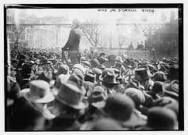
Anarchism
Many groups including the socialists and Marxists of the 19th century often opposed the idea of a state. They believed society would function better without a government and that governments do nothing but promote exploitation. What is this belief system called?

Qing
The Chinese government is ruled by this ethnically Manchurian dynasty during this period. They attempted to hold on to pre-industrial ways and resisted foreign involvement in their country (without success).

Ottoman Empire
Called the "Sick Man of Europe" due to their slow imperial decline and inability to adapt to the new political and economic developments of this period.

Meiji Restoration
The state-sposored industrialization and westernization effort in the late 19th century that also involved the elimination of the Shogunate and power being handed over to the Japanese Emperor, who had previously existed as mere spiritual/symbolic figure.

Muhammad Ali
Not a modern nationalist, but this Egpytian figure is seen as the father of modern Egypt and made modernizing reforms in the military, economic and cultural spheres during the 19th century.

suffrage
Industrial societies such as in Britain, France, and the US produced a lot of criticism, so some governments were forced to respond with reforms such as free public education and expanded ________ for all men.

Middle Class
The _____ ______ also called the bourgeoisie, was essentially a new and extremely powerful social class within industrialized societies. They were the wealthy but non-aristocratic class of property owners and the biggest beneficiaries of industrial prosperity. But the Marxists saw them as exploiters of the working class.

Working Class
19th century Industrial societies developed the idea that there were only really two social classes: property-owning middle class and then the _____ _____. Before the factory system poorer people though of themselves in more diverse terms.

Divine right
Enlightenment ideas such as the social contract, natural rights, and the general will were a challenge to this traditional basis of rule by monarchs.
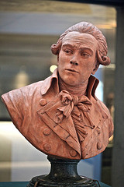
Jacobins
The most radical political faction (party) of the French Revolution who ruled France during the Reign of Terror.

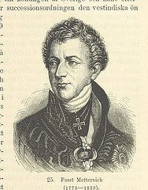
Congress of Vienna
Following Napoleon's exile, this meeting of European rulers in Austria established a system by which the balance of power would be maintained, liberal revolutions would be repressed, as would imperial expansion, and the creation of new countries in Europe.

Toussaint L'Overture
The main leader of the Haitian independence movement.
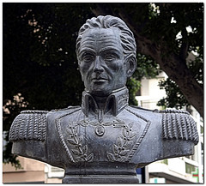
Simon Bolivar
South American revolutionary leader, who helped organize revolutions in many countries but was unsuccessful in fulfilling his dream of a unified South American nation.
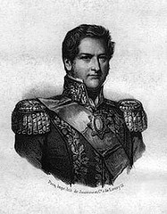
caudillos
By the 1830s, Latin America was mostly ruled by these military dictators from the creole class (American-born European-descendant).

Neocolonialism
Also called economic imperialism, this is the domination of newly independent countries by foreign business interests that causes colonial-style colonies to continue, such a monoculture.
Franco-Prussian War
This was a major war between the French and the Germans in 1871 that brought about the unification of Germany. It was caused by Otto Von Bismarck altering a telegram from the Prussian King to provoke the French into attacking Prussia.
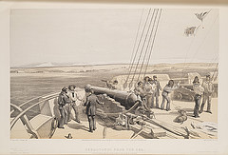
Crimean War
19th century war between the Ottomans and Russia. France, Britain, and Italians helped the Ottomans to defeat Russia but it proved the growing weakness of the Ottoman Empire.

zollverein
The name of the free trade zone that German states created prior to their unification.

Java War
In this war (1825-1830), the people of the Island of Java rebelled against their Dutch colonizers. The Dutch won after suffering 8000 deaths and killing perhaps as many as 200,000 islanders.

Suez Canal
Egyptians with funding from France and later Britain created this major transportation project completed in 1869.

family wage
As industrialization gradually became more intense in certain areas men displaced women in factories and were paid more partly because men were seen as requiring a _____ _____.

public education
With increased birthrates, urbanization, the outlawing of child labor, the increase of voting rights, and the influence of socialism, families were changed by the children spending much of their time in free community-sponsored ______ ______.

industrialization
From the 1500s to the 1700s, trans-oceanic empires expanded for mercantilist policies and to enrich land-owning nobles. Now during the 1800s trans-oceanic empires are expanding due to this economic motivation.

1857
In what year did the Indians attempt a widespread but disorganized rebellion against the British, resulting in even more intense colonization of India by the British?

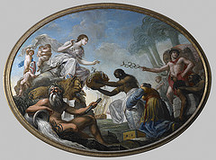
British East India Company
The Indian Rebellion of 1857 caused the British Government to take direct control over the Indian colony, which had previously been controlled by this organization.

United States and Russia
Both the ______ _____ and _____ emulated European imperialism by expanding their borders and conquering new territories.

Britain
After Egypt became independent from the Ottomans, it still had to contend with the influence of European imperialists, particularly this nation.

Zulu
New states emerged on the edge of expanding empires. As the British expanded their South African colony, the ____ Kingdom came into being, led by a man named Shaka.
Cherokee
In response to the rapid expansion by the United States, this native tribal group formed a national government, sought to modernize their society, but were forcibly relocated in the 1830s.

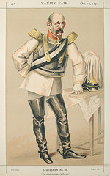
Germany
The spread of nationalism led to the unification of this central European nation, following the Franco-Prussian War in 1871

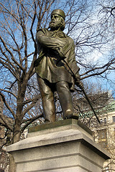
Italy
The spread of nationalism led to the creation of this European nation thanks to figures like Count Cavour and Giuseppe Garibaldi.
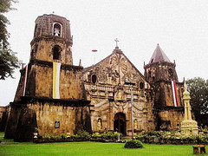
Philippines
After decades of nationalist resistance against the Spanish (and violent repression of activists) this Pacific Island nation proudly declared independence in 1898. But the Spanish had handed control over to the USA, who had no plans to recognize their independence.
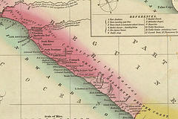
Liberia
In 1820, the American Colonization Society created a colony in West Africa for freed slaves to go. By the 1840s this colony had its own constitution and became and independent nation.
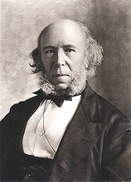
Social Darwinism
A description often applied to the late 19th century belief of people such as Herbert Spencer and others who argued that "surival of the fittest" justifies the competition of laissez-faire capitalism and imperialist policies.

