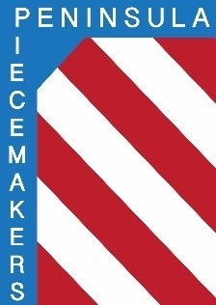
Peninsula Piecemakers Quilt Guild
P.O. Box 1295
Newport News, VA 23601

Board of Directors Meeting April 18, 2022

Attendance:
Board
President: Rhonda Gianturco Vice President: Karen Carr (abs)
Executive Treasurer: Natalie Hutchinson Executive Secretary: Lois Bates
Day Coordinator: Mark Fowler Day Treasurer: Lori Murdock
Day Secretary: Linda Tozier Night Coordinator: Kitty Tully
Night Treasurer: Debbie Martin (abs) Night Secretary: Susan Waddles

1. President Rhonda Gianturco called the meeting to order at 5:08 p.m.

2. Mark made a motion to approve the minutes of the March board meeting. Linda seconded. Motion approved.

3. Mark made a motion to accept the treasurer’s report. Lori seconded. Motion approved. Natalie noted the $316 income to Symposium was raffle basket sales.
Balances: Executive account $19,357.97 Day account $2,031.33
Night account $1,746.47

4. Old business:
a. Retreat: Kitty discussed the possibility of have a retreat in 2023. The facility’s maximum is 28 people.

b. There are no new nominations for the 2022-2023 board. May board meeting with the old and new board members will be at Rhonda’s house.

c. Symposium: The May newsletter will contain all the information about the symposium. Registration will start June 1.

5. New business:
a. Meeting locations: Our former meeting locations, Riverside and Courthouse Way Community Center, may be available soon. Rhonda will see if there will be a cost and if internet is available. Rhonda will also see if our insurance cost would change if we meet at 2 locations. If the locations are suitable it was suggested to get membership input as to whether one or both meetings should be moved.

b. Natalie will write a check for $250 for the first 6 months of 2022 as a facility donation to Hilton Baptist Church.

c. Rhonda has reserved this library for board meetings through December 2022.

6. Meeting was adjourned at 6:08 p.m.

Respectfully submitted,

Lois A. Bates
Executive Secretary.

