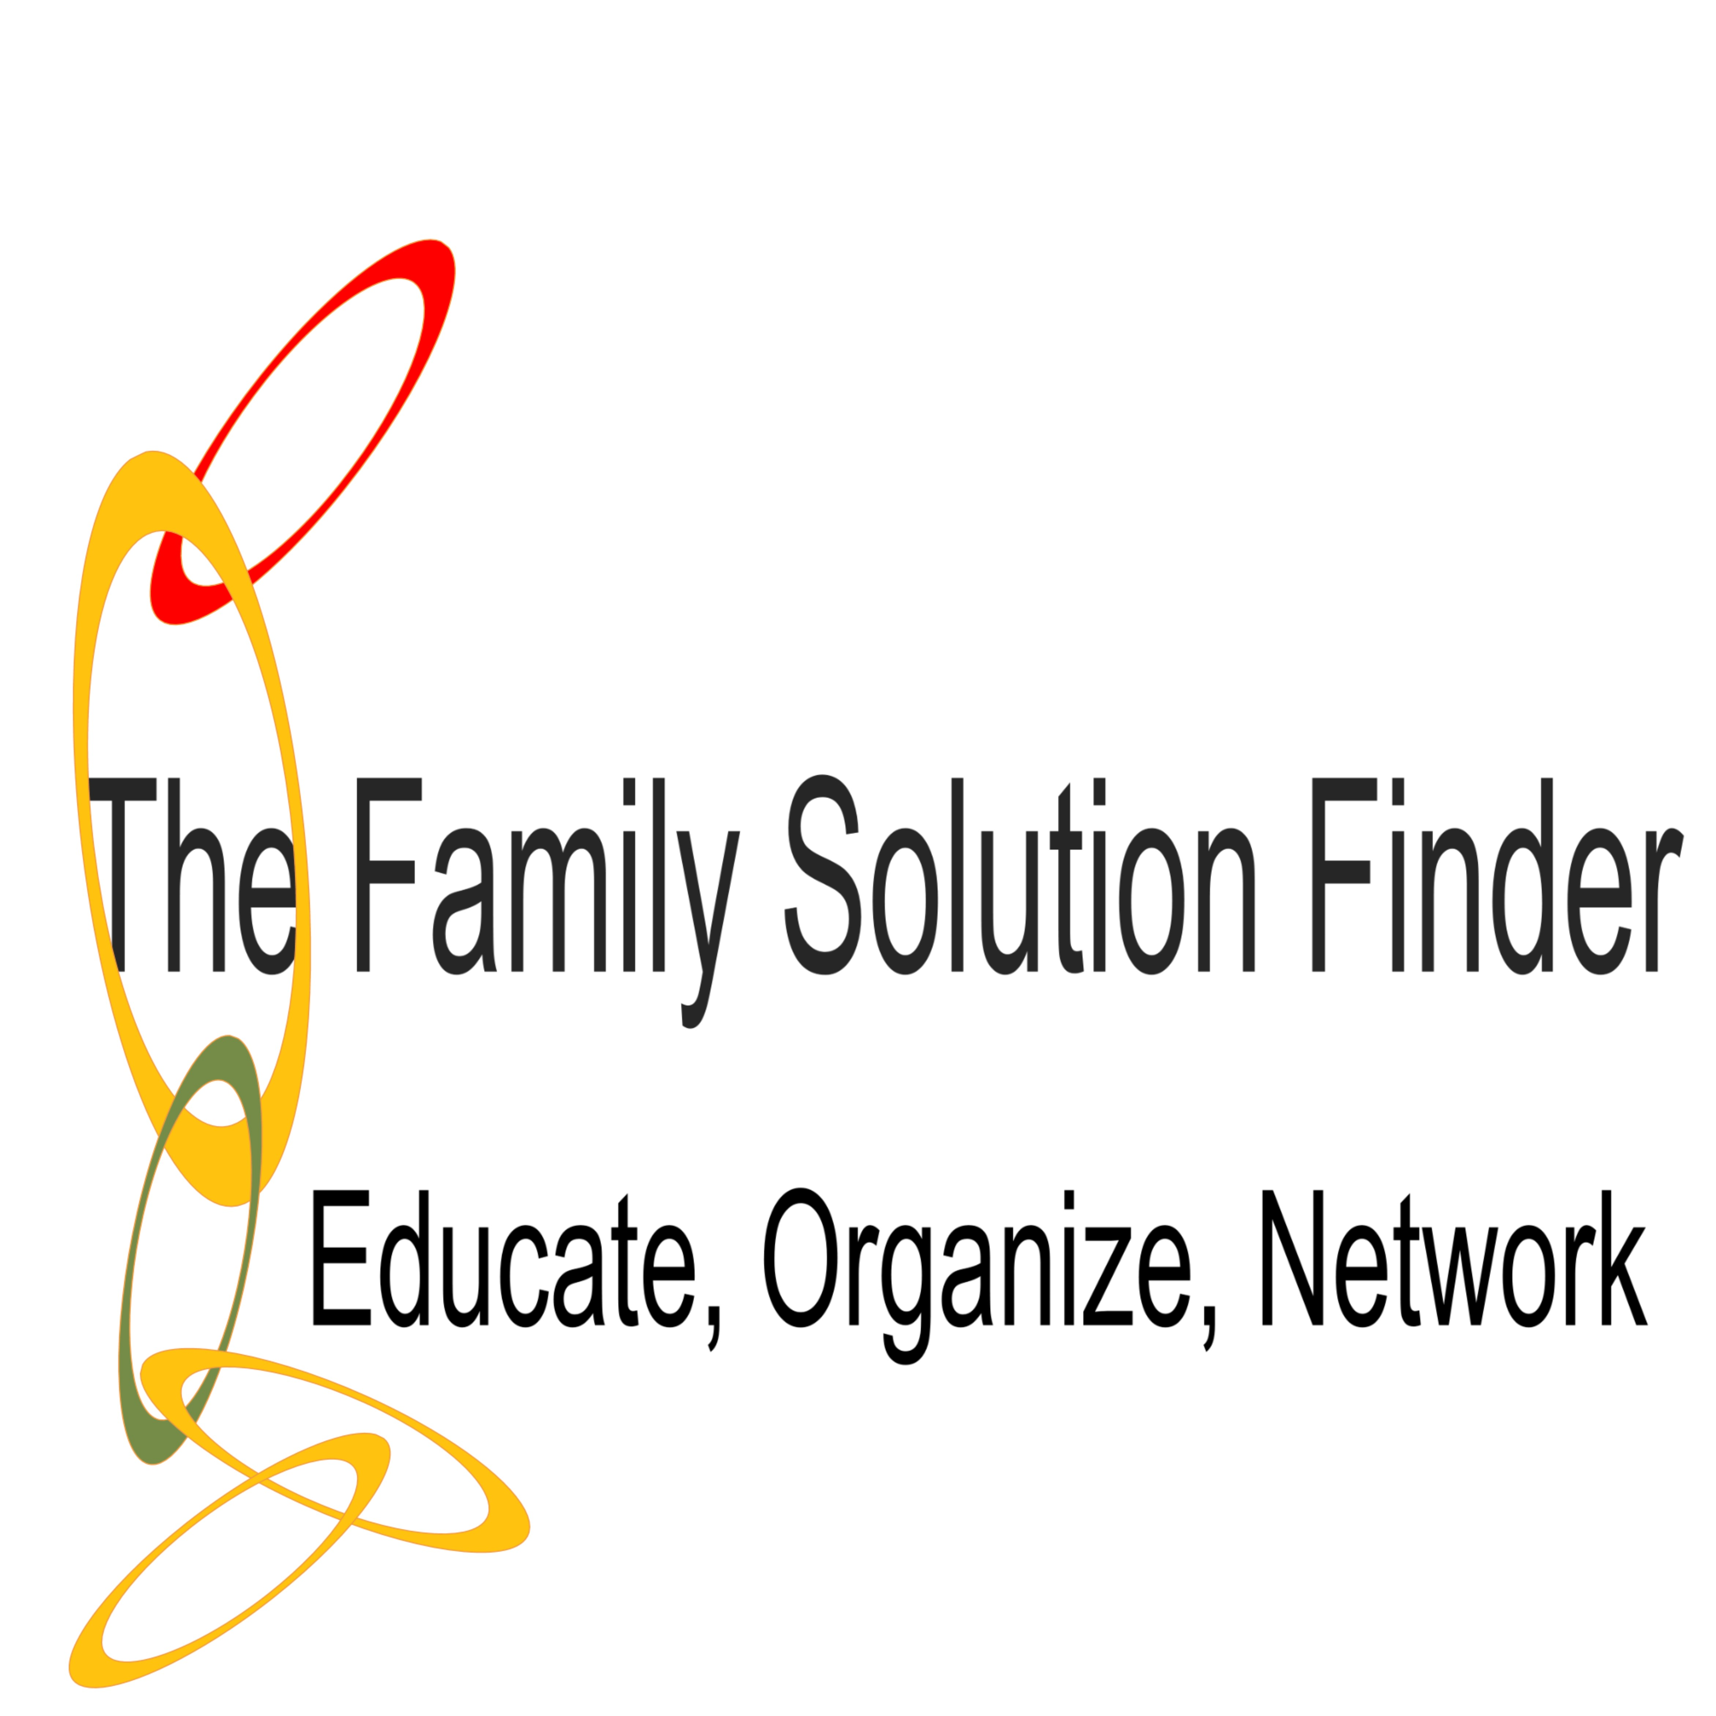

MONTHLY MEETING’s AGENDA

Treatment Center Intervention
Location: Address or Room Number
Date: Date
Point of Contact: Name(s) number or email address.
Time: Time
- Weekly Meeting 1 Treatment Center Intervention
Attendee Review and Print: On-Line www.familiesimpactedbyopioids.com tab 32 seminar downloads
            - Seminar Handout
            - Practical Exercises and Video Worksheets
            - Families Best Practices Model and Plan of Action.
- Weekly Meeting 2 Speaker, The Family is a System.
Invited a Family Therapist from our referral network list to speak on Characteristics of Family Interaction and the awareness of Treatment Center Intervention.
- Weekly Meeting 3 Personal Testimony, The Family Dynamic
One of our own members will volunteer to share their family dynamic story.
- Weekly Meeting 4 The Workshop, with Group Family Therapist
Meeting leader will assist the group in worksheet experiences to examine their individual family dynamics.

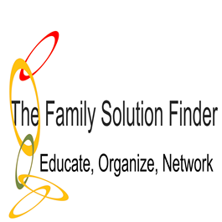

WEEKLY MEETING AGENDA

Weekly Meeting # 1 1.5hrs duration

  - Pre-Meeting Reading Assignment Family Solution Finder Learning Seminar Study Guide
  - Presentation Power Point Seminar #16
  - Family Solution Finder Learning Seminar Workbook
    - Practical Exercise # 1-3
    - Video worksheets
  - Group Discussions

MONTH MEETING AGENDA

The Family Solution Finder Monthly Learning System
Seminar 3: Treatment Center Intervention
Prior to Week # 1. The instructor will review and print: Go On-Line www.familiesimpactedbyopioids.com Tab “32 seminars” the following downloads:
- Download Study Guide for Seminar # 16 Treatment Center Intervention. (Website Step 2)
- Download Power Point Presentation Seminar # 16 Treatment Center Intervention. (Website Step 3)
- Download Workbook for Seminar # 16. (Website Step 4)
- Download Family 3-D’s Coping Skills Worksheet Seminar # 16 Treatment Center Intervention . (Website Step 5)
- Download Family Local Resource Connections Workbook Seminar # 16 Treatment Center Intervention. (Website Step 6)
- Download Clinical Paper Seminar # 16. (Website Step 7)

Week 1 Meeting: A Power Point Presentation Seminar #16 “Treatment Center Intervention”. It is preferred the family has read The Family Solution Finder, Study Guidebook Learning Module I for Seminar # 16 Treatment Center Intervention, prior to the meeting. This can be sent via email as an attachment for those that do not have books.
Week 2 Meeting: An invited guest Speaker, and The Family Solution Finder Workbook Learning Module II. Complete the Family Practical Life Exercises in the Workbook. (Handout)
Week 3 Meeting: A Personal Testimony, and/or The Family Solution Finder, 3-D’s Coping Skills Workbook Learning Module III. Seminar # 16 Childhood Trauma in the Family System. (Handout)
Week 4 Meeting: The Workshop, The Family Solution Finder, Local Resource Connections Workbook Learning Module IV, Seminar # 16 Treatment Center Intervention. (Handout)
The instructor will prepare the room with welcome table, sign-in sheet, refreshments, and handouts. The audio/visual will be tested ahead of the meeting and meeting agenda made available through social media channels. It is a good idea to have a “Welcome Packet” for new attendees.

MEETING AGENDA

Week 1

  - Pre-Meeting Reading Assignment Family Solution Finder Learning Study Guidebook Learning Module I, Seminar # 16
  - Presentation Power Point Seminar #16.
  - Group Discussions.

MEETING AGENDA

Week 2

- Presentation Guest Speaker Treatment Center Intervention.
- The Family Practical Life Exercises in The Family Solution Finder Workbook Learning Module II Seminar # 16. (Handout)
- Group Discussions.

MEETING AGENDA

Week 3

- Guest Personal Testimony of the Topic “Treatment Center Intervention”. Or
- The Family 3-D’s Core Skills Workbook Learning Module III Seminar # 16. (Handout)
- Group Discussion.

*We say “or” because the Family 3-D’s Core Skills Workbook takes most of a meet to complete. Determine a Solution, Develop a Decision and Design a Family Plan of Action.

MEETING AGENDA

Week 4

- The Family Local Resource Connections Workbook Learning Module IV Seminar # 16. (Handout)
- Group Discussions.

