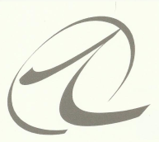Style and Substance x Ten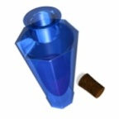 ...Because looking good is only half the picture
September Workshop

We would really appreciate your feedback on this event so that we can make future ones even better.
Your name: Email address:
Telephone number

What have you found helpful and/or enjoyable about the workshop?
_______________________________________________________________________________________________

What would you have liked us to spend more time on?

________________________________________________________________________________________________
Can you suggest ways that we might improve the workshops and our service to you?
_
_________________________________________________________________________________________________

Other comments:___________________________________________________________________________________
_________________________________________________________________________________________________
_________________________________________________________________________________________________

Please email your completed forms to cindy@styleandsubstancecoaching.co.uk or martine@styleandsubstancecoaching.co.uk

Thank you, we value your opinion!
Warm regards,

Cindy and Martine

