PBL: GAME ON!
Within your flexible groupings…
ROLES: Designate who is going to be responsible for various tasks.
RESEARCH: What is the purpose? What does it look like? What information is to be
provided? What questions are to be asked? How is it to be distributed?
RECORD: Itemize a list of specifics for your final product; materials, resources?
RESPOND: Make a plan of action to create your GAME story line. Steps, timeline,
duties, etc… Create! Write a script…produce, direct your game!
DELIVER: Present your final product.
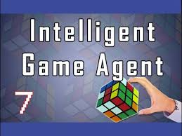
Get to it! You are going to be working together to create a “teaching” GAME using the Learning Objectives and Essential Questions for the chapter – that would be applicable for the setting (time & place) of your topic. Keep in mind your historical context! First, you must TEACH the content! HOW will you teach? How will you assess? that is how you win the game! add a commercial! What about additional marketing and business opportunities?

Scoring Rubric Guidelines: Accuracy, Completeness, Neatness, Originality, Presentation

