**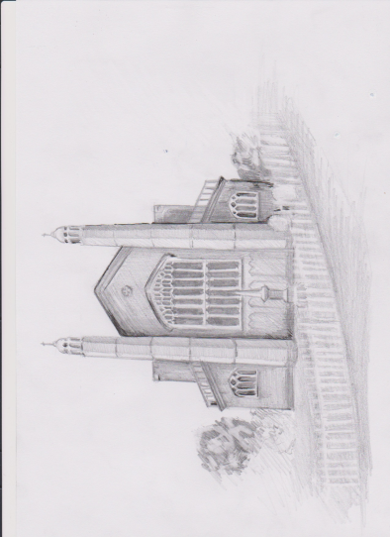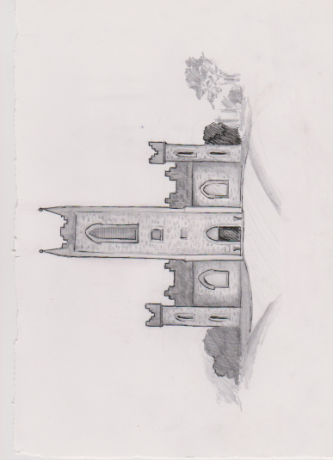**

**Drogheda, ardee and collon, kilsaran unions**

**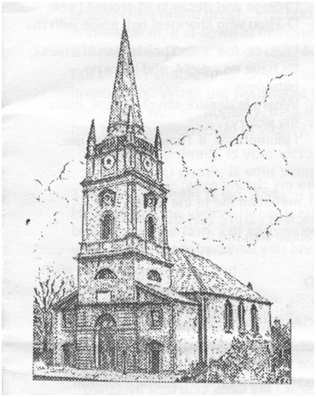**



ALL SAINTS’ DAY 2020

**Dunleerclip_image001**

HYMN 372 v1

Through all the changing scenes of life

*Page 201 Richard*

**THE GREETING**

Grace, mercy and peace from God our Father and the Lord Jesus Christ be with you all.

**and also with you.**

**WELCOME**

**SENTENCE OF SCRIPTURE**

Since we are surrounded by so great a cloud of witnesses, let us also lay aside every weight, and the sin which clings so closely and let us run with perseverance the race that is set before us, looking to Jesus the pioneer and perfecter of our faith. *Hebrews 12: 1,2*

HYMN

593 O Jesus, I have promised

*Richard*

**THE COLLECT FOR PURITY**

[Let us pray]

**Almighty God, to whom all hearts are open, all desires known, and from whom no secrets are hidden; Cleanse the thoughts of our hearts by the inspiration of your Holy Spirit, that we may perfectly love you, and worthily magnify your holy name; through Christ our Lord. Amen.**

*Richard*

**PENITENTIAL KYRIES**

Christ calls us to share the heavenly banquet of his love with all the saints in earth and heaven.

Knowing our unworthiness and sin, let us ask from him both mercy and forgiveness.

Lord, you are gracious and compassionate

*Sung Kyrie, kyrie, eleison*

You are loving to all and your mercy is over all your creation.

*Sung Christe, kyrie, eleison*

Your faithful servants bless your name, and speak of the glory of your kingdom.

*Sung Kyrie, kyrie, eleison*

*Richard*

**GLORIA IN EXCELSIS**

**Glory to God in the highest, and peace to God’s people on earth. Lord God, heavenly king, almighty God and Father, we worship you, we give you thanks, we praise you for your glory.**

**Lord Jesus Christ, only Son of the Father, Lord God, Lamb of God, you take away the sin of the world: have mercy on us; you are seated at the right hand of the Father: receive our prayer.**

**For you alone are the Holy One: you alone are the Lord: you alone are the Most High, Jesus Christ, with the Holy Spirit, in the Glory of God the Father. Amen.**

**THE COLLECT** of All Saints’ Day

Almighty God, you have knit together your elect in one communion and fellowship in the mystical body of your Son Christ our Lord; Grant us grace so to follow your blessed saints in all virtuous and godly living that we may come to those inexpressible joys that you have prepared for those who truly love you; through Jesus Christ our Lord. **Amen.**

**FIRST READING**  **Jeremiah 31:31-34**

*Jane:* The Lesson is from the Book of the Prophet Jeremiah, chapter 31, beginning at verse 31.

**31**The days are surely coming, says the Lord, when I will make a new covenant with the house of Israel and the house of Judah. **32**It will not be like the covenant that I made with their ancestors when I took them by the hand to bring them out of the land of Egypt—a covenant that they broke, though I was their husband,[[a](https://www.biblegateway.com/passage/?search=Jeremiah%2031%3A31-34&version=NRSV#fen-NRSV-19724a)] says the Lord.

*Margaret:*  **33**But this is the covenant that I will make with the house of Israel after those days, says the Lord: I will put my law within them, and I will write it on their hearts; and I will be their God, and they shall be my people. **34**No longer shall they teach one another, or say to each other, “Know the Lord,” for they shall all know me, from the least of them to the greatest, says the Lord; for I will forgive their iniquity, and remember their sin no more.

This is the word of the Lord

**Thanks be to God**

*Joyce and Richard*

Psalm 34: 1 – 10 *page 628*

1. I will bless the Lord at all times; ♦︎

His praise shall ever be in my mouth.

2 My soul shall glory in the Lord; ♦︎

Let the humble hear and be glad.

3 O magnify the Lord with me; ♦︎

Let us exalt his name together.

4 I sought the Lord and he answered me♦︎

And delivered me from all my fears.

5 Look upon him and be radiant♦︎

And your faces shall not be ashamed.

6 This poor soul cried, and the Lord heard me♦︎

And saved me from all my troubles.

7 The angel of the Lord♦︎

Encamps around those who fear him and delivers them.

8 O taste and see that the Lord is gracious; ♦︎

Blessed is the one who trusts in Him.

9 Fear the Lord, all you his holy ones,♦︎

And those who fear him lack nothing.

10 Lions may lack and suffer hunger, ♦︎

But those who seek the Lord lack nothing that is good.

# THE EPISTLE Revelation 7:9-17

*Charlie*:

The Epistle is written in the Book Revelation, in the seventh chapter, beginning at the ninth verse.

*Charlie*:After this I looked, and there was a great multitude that no one could count, from every nation, from all tribes and peoples and languages, standing before the throne and before the Lamb, robed in white, with palm branches in their hands. **10**They cried out in a loud voice, saying,

*Wendy:* “Salvation belongs to our God who is seated on the throne, and to the Lamb!”

*Charlie:* And all the angels stood around the throne and around the elders and the four living creatures, and they fell on their faces before the throne and worshiped God, **12**singing,

*Wendy:* “Amen! Blessing and glory and wisdom  
and thanksgiving and honour  
and power and might  
be to our God forever and ever! Amen.”

*Charlie:* Then one of the elders addressed me, saying,

*Annemarie:* “Who are these, robed in white, and where have they come from?” 

*Charlie:*I said to him, “Sir, you are the one that knows.”

*Charlie:* Then he said to me,

*Alex* “These are they who have come out of the great ordeal; they have washed their robes and made them white in the blood of the Lamb.

**15**For this reason they are before the throne of God,  
    and worship him day and night within his temple,  
    and the one who is seated on the throne will shelter them.  
**16**They will hunger no more, and thirst no more;  
    the sun will not strike them,  
    nor any scorching heat;  
**17**for the Lamb at the centre of the throne will be their shepherd,  
    and he will guide them to springs of the water of life,  
and God will wipe away every tear from their eyes.”

*Wendy:* This is the Word of the Lord.

**Thanks be to God.**

THE GRADUAL HYMN

250 All hail the power of Jesus’ name

# THE HOLY GOSPEL Matthew 5:1-12

Hear the Gospel of our Saviour Christ, according to St Matthew, in the fifth chapter, beginning at the first verse.

**Glory to you, Lord Jesus Christ.**

**5**When Jesus[[a](https://www.biblegateway.com/passage/?search=Matthew+5%3A+1+-+12&version=NRSV#fen-NRSV-23236a)] saw the crowds, he went up the mountain; and after he sat down, his disciples came to him. **2**Then he began to speak, and taught them, saying:

**3**“Blessed are the poor in spirit, for theirs is the kingdom of heaven.

**4**“Blessed are those who mourn, for they will be comforted.

**5**“Blessed are the meek, for they will inherit the earth.

**6**“Blessed are those who hunger and thirst for righteousness, for they will be filled.

**7**“Blessed are the merciful, for they will receive mercy.

**8**“Blessed are the pure in heart, for they will see God.

**9**“Blessed are the peacemakers, for they will be called children of God.

**10**“Blessed are those who are persecuted for righteousness’ sake, for theirs is the kingdom of heaven.

**11**“Blessed are you when people revile you and persecute you and utter all kinds of evil against you falsely[[b](https://www.biblegateway.com/passage/?search=Matthew+5%3A+1+-+12&version=NRSV#fen-NRSV-23246b)] on my account. **12**Rejoice and be glad, for your reward is great in heaven, for in the same way they persecuted the prophets who were before you.

This is the Gospel of the Lord.

**Praise to you, Lord Jesus Christ.**

**SUNDAY SCHOOL** *Ian*

**SERMON** *Joyce*

**THE NICENE CREED** *Stand*

**We believe in one God, the Father, the Almighty, maker of heaven and earth, of all that is, seen and unseen.**

**We believe in one Lord, Jesus Christ, the only Son of God, eternally begotten of the Father, God from God, Light from Light, true God from true God, begotten, not made, of one Being with the Father. Through him all things were made. For us and for our salvation he came down from heaven, was incarnate by the Holy Spirit of the Virgin Mary, and was made man. For our sake he was crucified under Pontius Pilate; he suffered death and was buried. On the third day he rose again in accordance with the Scriptures; he ascended into heaven and is seated at the right hand of the Father. He will come again in glory to judge the living and the dead, and his kingdom will have no end.**

**We believe in the Holy Spirit, the Lord, the giver of life, who proceeds from the Father and the Son, who with the Father and the Son is worshipped and glorified, who has spoken through the prophets. We believe in one holy catholic and apostolic Church. We acknowledge one baptism for the forgiveness of sins. We look for the resurrection of the dead, and the life of the world to come. Amen.**

**PRAYERS OF INTERCESSION** ALL SAINT’S DAY YEAR A

*David*

United in the company of all the faithful and looking for the coming of the kingdom, let us offer our prayers to God, the source of all life and holiness.

Merciful Lord, strengthen all people by your Holy spirit, that we may live as a royal priesthood and a holy nation to the praise of Jesus Christ our Saviour.

Lord, in your mercy

**Hear our prayer.**

Bless John our Archbishop and all ministers of your church, that by faithful proclamation of your works, we may be built on the foundations of the apostles and prophets into a holy temple in the Lord.

Lord, in your mercy

**Hear our prayer.**

Empower us by the gift of your Holy and life-giving Spirit, that we may be transformed into the likeness of Christ from glory to glory.

Lord, in your mercy

**Hear our prayer.**

Give to the world and its peoples the peace that comes from above, that they may find Christ’s way of freedom and life.

Lord, in your mercy

**Hear our prayer.**

*Victor*

Hold in your embrace all who witness to your love in the service of the poor and the needy; all who minister to the sick and the dying; and all who bring light to those in darkness.

Lord, in your mercy

**Hear our prayer.**

Touch and heal all those whose lives are scarred by sin or disfigured by pain, that, raised from death to life in Christ, their sorrow may be turned to eternal joy.

Lord, in your mercy

**Hear our prayer.**

Remember in your mercy all those gone before us who have been well-pleasing to you from eternity; preserve in your faith your servants on earth, guide us to your kingdom and grant us your peace at all times.

Lord, in your mercy

**Hear our prayer.**

Hasten the day when many will come from east and west, from north and south, and sit at table in your kingdom.

Lord, in your mercy

**Hear our prayer.**

We give you thanks for the whole company of your saints in glory, with whom in fellowship we join our prayers and praises; by your grace may we, like them, be made perfect in your love.

*Joyce and Richard*

**Merciful Father, accept these our prayers for the sake of your Son, our Saviour, Jesus Christ. Amen.**

**PRAYER OF HUMBLE ACCESS**

**We do not presume to come to this your table, merciful Lord, trusting in our own righteousness but in your manifold and great mercies. We are not worthy so much as to gather up the crumbs under your table. But you are the same Lord, whose nature is always to have mercy. Grant us, therefore, gracious Lord, so to eat the flesh of your dear Son Jesus Christ, and to drink his blood, that our sinful bodies may be made clean by his body, and our souls washed through his most precious blood, and that we may evermore dwell in him and he in us. Amen.**

**THE PEACE** *Iain*

We are fellow-citizens with the saints and of the household of God through Christ our Lord, who came and preached peace to those who were far off and those who were near.

The peace of the Lord be always with you

**and also with you.**

**AT THE PREPARATION OF THE TABLE**

To you we come, Father of lights, with angels and saints, where heaven and earth unite. May Jesus meet us in the breaking of the bread. **Amen.**

**THE TAKING OF THE BREAD AND WINE**

*Stand. The Presiding Minister takes the bread and wine and may say*

Christ our passover has been sacrificed for us

**therefore let us celebrate the feast.**

**THE GREAT THANKSGIVING: EUCHARISTIC PRAYER 2**

The Lord is here.

**His Spirit is with us.**

Lift up your hearts.

**We lift them to the Lord.**

Let us give thanks to the Lord our God.

**It is right to give our thanks and praise.**

All glory and honour, thanks and praise be given to you at all times and in all places, Lord, Holy Father, true and living God, through Jesus Christ our Lord.

For he is your eternal Word through whom you have created all things from the beginning and formed us in your own image.

In your great love you gave him to be made man for us and to share our common life.

In obedience to your will you Son our Saviour offered himself a perfect sacrifice, and died on the cross for our redemption. Through him you have freed us from the slavery of sin and reconciled us to yourself, our God and Father.

He is our great high priest whom you raised from death and exalted to your right hand on high where he ever lives to intercede for us.

You have called us into the fellowship of all your saints, and set before us the example of their witness and of the fruit of your Spirit in their lives.

He passed beyond our sight, not to abandon us but to be our hope, that where he is, we might also be and reign with him in glory.

Through him you have sent upon us your holy and life-giving Spirit and made us a royal priesthood called to serve you for ever.

Therefore, with angels and archangels, and with all the company of heaven, we proclaim your great and glorious name, for ever praising you and saying

:

**Holy, holy, holy Lord, God of power and might, heaven and earth are full of your glory. Hosanna in the highest.**

Merciful Father, we thank you for these gifts of your creation, this bread and this wine, and we pray that we who eat and drink them

in the fellowship of the holy Spirit

in obedience to our Saviour Christ

in remembrance of his death and passion

may be partakers of his body and his blood,

who on the night he was betrayed took bread; and when he had given you thanks he broke it, and gave it to his disciples, saying,

\* Take, eat, this is my body which is given for you. Do this in remembrance of me.

After supper \* he took the cup; and again giving you thanks, he gave it to his disciples, saying, Drink from this, all of you \* This is my blood of the new covenant which is shed for you and for many for the forgiveness of sins. Do this, as often as you drink it, in remembrance of me.

Father, with this bread and this cup we do as our Saviour has commanded:

We celebrate the redemption he has won for us;

we proclaim his perfect sacrifice,

made once for all upon the cross,

his mighty resurrection and glorious ascension;

and we look for his coming to fulfil all things according to you will.

**Christ has died; Christ is risen; Christ will come again.**

Renew us by your Holy Spirit, unite us in the body of you Son, and bring us with all your people into the joy of your eternal kingdom; through Jesus Christ our Lord, with whom and in whom, by the power of the Holy Spirit,, we worship you, Father almighty, in songs of never-ending praise:

**Blessing and honour and glory and power are yours for ever and ever. Amen.**

**THE LORD'S PRAYER**

As our Saviour Christ has taught us, so we pray

**Our Father, who art in heaven, hallowed be thy name; thy kingdom come; thy will be done; on earth as it is in heaven. Give us this day our daily bread. And forgive us our trespasses, as we forgive those who trespass against us. And lead us not into temptation; but deliver us from evil. For thine is the kingdom, the power and the glory, for ever and ever. Amen.**

**THE BREAKING OF THE BREAD**

The bread which we break is a sharing in the body of Christ.

**We being many are one body, for we all share in the one bread.**

**AGNUS DEI**

**Jesus, Lamb of God, have mercy on us.**

**Jesus, bearer of our sins, have mercy on us.**

**Jesus, Redeemer of the world, grant us peace.**

**THE COMMUNION**

Draw near with faith. Receive the body of our Lord Jesus Christ which he gave for you, and his blood which he shed for you. Remember that he died for you, and feed on him in your hearts by faith with thanksgiving.

 HYMN 418 Here O my Lord

The body of Christ keep you in eternal life. **Amen**

The blood of Christ keep you in eternal life. **Amen**

**THE GREAT SILENCE**

**PRAYER AFTER COMMUNION**

God the source of all holiness and giver of all good things:

May we who have shared at this table as strangers and pilgrims here on earth be welcomed with all your saints to the heavenly feast on the day of your kingdom; through Jesus Christ our Lord. **Amen.**

**POST COMMUNION PRAYER**

**Almighty God, we thank you for feeding us with the spiritual food of the body and blood of your Son Jesus Christ. Through him we offer you our souls and bodies to be a living sacrifice. Send us out in the power of your Spirit to live and work to your praise and glory. Amen.**

**HYMN** 459 For all the saints

*Iain*

**THE BLESSING**

God give you grace to share the inheritance of his saints in glory:

and the blessing of God almighty, the Father, the Son and the Holy Spirit, be upon you and remain with you always. **Amen**.