Belgian Shepherd Dog
d
BHCP/Version 1/October 2021

Breed Health and
Conservation Plan

CONTENTS

INTRODUCTION 3
DEMOGRAPHICS 3
BREED HEALTH CO-ORDINATOR ANNUAL HEALTH REPORT 4
BREED CLUB HEALTH ACTIVITES 4
BREED SPECIFIC HEALTH SURVEYS 5
LITERATURE REVIEW 5
INSURANCE DATA 9
BREED WATCH 13
PERMISSION TO SHOW 13
ASSURED BREEDERS SCHEME 14
BREED CLUB BREEDING RECOMMENDATIONS 14
DNA TEST RESULTS 14
CANINE HEALTH SCHEMES 14
REPORTED CAESAREAN SECTIONS 21
GENETIC DIVERSITY MEASURES 22
CURRENT RESEARCH 30
PRIORITIES 31
ACTION PLAN 31
REFERENCES 32

[Breed]
Evidence Base

INTRODUCTION

The Kennel Club launched a new resource for breed clubs and individual breeders – the Breed Health and Conservation Plans (BHCP) project – in September 2016. The purpose of the project is to ensure that all health concerns for a breed are identified through evidence-based criteria, and that breeders are provided with useful information and resources to raise awareness of current health and welfare concerns in their breed, and support them in making balanced breeding decisions.
The Breed Health and Conservation Plans take a complete view of breed health with consideration to the following issues: known inherited conditions, complex conditions (i.e. those involving many genes and environmental effects such as nutrition or exercise levels, for example hip dysplasia), conformational concerns and population genetics.
Sources of evidence and data have been collated into an evidence base which gives clear indications of the most significant health conditions in each breed, in terms of prevalence and impact. Once the evidence base document has been produced it is discussed with the relevant Breed Health Co-ordinator and breed health representatives where applicable. Priorities are agreed based on this data and incorporated into a list of actions between the Kennel Club and the breed to tackle these health concerns. These actions are then monitored and reviewed on a regular basis.

DEMOGRAPHICS

The number of Belgian Shepherd Dogs (BSDs) registered by year of birth between 1990 and 2020 are shown in Figure 1, with a breakdown of the numbers registered per year of birth by variety. The Malinois has shown a marked increase in registration from 2003 onwards, and the Tervueren and Groenendael having reduced in numbers. The Laekenois has remained consistently small in numbers of this period analysed.

Figure 1: Registrations for the BSD by variety from 1990-2020.

BREED HEALTH CO-ORDINATOR ANNUAL HEALTH REPORT

Breed Health Co-ordinators (BHCs) are volunteers nominated by their breed to act as a vital conduit between the Kennel Club and the breed clubs with all matters relating to health.
The main work of the BHC at present has been to monitor the top conditions:
- Epilepsy
- Cancers
- Genetic diversity
The BHC has continued to monitor research and any new or emerging conditions in the breed.

BREED CLUB HEALTH ACTIVITES

The BSD has an active Breed Health Coordinator (BHC), and a webpage dedicated to health on the club website, which can be found at:
- https://bsdaofgb.co.uk/health-matters
- http://www.nbsdc.co.uk/bsd.htm

BREED SPECIFIC HEALTH SURVEYS

Kennel Club Purebred and Pedigree Dog Health Surveys Results
The Kennel Club Purebred and Pedigree Dog Health Surveys were launched in 2004 and 2014 respectively for all of the recognised breeds at the time, to establish common breed-specific and breed-wide conditions.
2004 Morbidity results: Health information was collected for 261 live Belgian Shepherds (all varieties) of which 174 (67%) were healthy and 87 (33%) had at least one reported health condition. The top categories of diagnosis were reproductive (16.0, 20 of 125 reported conditions), musculoskeletal (15.2%, 19 of 125 reported conditions), dermatologic (11.2%, 14 of 125 reported conditions), ocular (8.8%, 11 of 125 reported conditions) and neurologic (8.8%, 11 of 125 reported conditions).
2004 Mortality results: A total of 113 deaths were reported for the Belgian Shepherd (all varieties). The median age at death for Belgian Shepherds was 12 years and 6 months (min = 1 year and 6 months, max = 18 years and 2 months). The most frequently reported causes of death by organ system or category were cancer (23.0%, 26 of 113 deaths), cerebral vascular (13.3%, 15 deaths), old age (13.3%, 15 deaths) and combinations (8.0%, 9 deaths).
2014 Morbidity results: Health information was collected for 176 Belgian Shepherd (all varieties). Overall 117 (66.5%) of dogs were free from any condition, and 59 (33.5%) were reported to be affected by at least one condition. The most commonly reported specific conditions were epilepsy (7.7%, 6 cases), hypersensitivity (allergic) skin disorder (7.7%, 6 cases), arthritis (5.1%, 4 cases), and cryptorchidism (5.1%, 4 cases).
2014 Mortality results: A total of 43 deaths were reported for the breed (all varieties), with a mean age at death of 10 years 10 months. The most common causes of death were cancer – unspecified (8 deaths, 18.6%), followed by gastric tumour (5 deaths, 11.6%), old age (5 deaths, 1.6%), and old age combinations (3 deaths, 7.0%).

LITERATURE REVIEW

The literature review lays out the current scientific knowledge relating to the health of the breed. We have attempted to refer primarily to research which has been published in peer-reviewed scientific journals. We have also incorporated literature that was released relatively recently to try to reflect current publications and research relating to the breed.
Genetic diversity: A Finnish paper used SNP analysis to determine differentiations between six breeds, including 142 BSDs (Lampi et al, 2020). The authors noted that by allowing the registration of different varieties within a litter this allows a flow in genes between the subpopulations and should be continued to preserve genetic diversity. Interestingly, the US Groenendaels (termed Belgian Sheepdogs in the US and seen as a separate breed) were omitted from the analysis as they showed population differentiation caused by founder effect. The Malinois also showed some differentiation, thought to be driven by its selection as a working/ military dog, although Laekenois also fell under this cluster, due to the allowance of cross-mating between these varieties in Finland. Some Finnish Groenendaels and Tervuerens were genetically indistinguishable from each other. Overall the breed had low genetic variability (measured through degrees of heterozygosity) across the four varieties.
Cancer conditions
Gastric cancers: The breed has been suggested to be at an increased risk of developing gastric cancers, with a suggested mean age of 9.5 years (Gualtieri et al, 1999). In this Italian paper, a total of 18 BSD made up 42 gastric cancers, suggesting an overrepresentation. Sadly, given the aggressive nature of the disease, prognosis is fairly poor in affected individuals. Tervuerens and Groenendaels were also suggested to have a high proportional morbidity ratio for disease in a Norwegian paper, with these being 56.1 (95% CI 24.7 – 127.2) and 34.5 (95% CI 10.8 – 110.5) respectively (Seim-Wikse et al, 2013).
More recently a Finnish study surveyed 232 BSD owners to determine any association between clinical signs, test results and gastric carcinoma in the breed (Candido et al, 2021). Six of the dogs were found to have presence of gastric tumours, but no strong association was found between clinical signs and disease, suggesting that the condition can have an occult stage. The dogs were all over the age of 5.5 years when diagnosed, again supporting that this is a later-onset disease in the breed.
General cancers: A retrospective study of 106 working Malinois used by the US Department of Defence in 1992 were studied to determine the lifetime occurrence of cancers (Peterson et al, 2000). The breed had an average longevity of 7.9 years and mean age of 7.0 ± 1.7 years at presentation of first cancer, with 31% of the BSDs developing a cancer at some time in their life. The breed was 4.21 times more likely to be euthanised due to aggressive cancer than working GSDs, however it should be noted that 88.7% of euthanisers were due to other causes, and the remaining 11.3% as a result of malignant cancer. Lymphosarcoma and mast cell tumour were the most common cancers, but only affected three dogs respectively.
Cardiovascular conditions
Cardiomyopathy and juvenile mortality: A case report of three related puppies was undertaken following unexpected death, with no obvious cause other than general vomiting and shortness of breath ( ). Post-mortem identified enlarged hearts in the deceased puppies, as well as cellular malformations. Pedigree analysis suggested an autosomal recessive mode of inheritance. A genomes of the affected puppies were sequenced, with a mutation in the YARS2 gene found to be associated with disease. Further sequencing was undertaken in 471 dogs of the breed, with a mutation frequency of 14.1 across the four varieties%. A DNA test is available but not yet recognised by the Kennel Club.
Musculoskeletal conditions
Hip and elbow dysplasia: Hip dysplasia has long been acknowledged a significant and prevalent condition in a number of breeds and is a consequence of malformation in the hip joints, resulting in a loose fitting structure and eventual wearing of the joint over time, leading to osteoarthritis and degenerative joint disease. The British Veterinary Association (BVA)/ Kennel Club (KC) Hip Dysplasia Scheme was launched in 1965, and has been operating in its current from since 1983, with radiographic images taken of an individual to assess nine distinct features of each hip, and a final score established through the sum of the total score for both the left and right hip. These nine features have been demonstrated to have high heritability amongst themselves, indicating significant genetic similarity, and value in being used as predictors of hip dysplasia (Lewis et al, 2010b).
Elbow dysplasia is also a heritable disease involving different lesions including fragmented coronoid process (FCP), ununited anconeal process (UAP), osteochondritis dissecans (OCD) and incongruity of the elbow joint which may occur together or alone leading to osteoarthritis of the joint and forelimb lameness. The heritability of the British Veterinary Association (BVA)/ Kennel Club (KC) Elbow Score was estimated as 0.18 ± 0.06 for the GSD (Lewis et al, 2013). As with hip dysplasia, the complex nature of this condition means the use of estimated breeding values (EBVs - values which are given for an individual dog to estimate its genetic risk for disease) are currently the best way to predict and select away from elbow dysplasia. Unfortunately EBVs are not available for BSDs at this time, but further information on dogs scored to date can be found on page 15.
An American study of 20 BSDs with no clinical signs of disease were assessed via ground reaction forces and weight distribution, to determine whether those that had borderline hip dysplasia had differing gait to those with no radiographic signs of disease (Bockstahler et al, 2007). A significantly reduced hip flexion and stifle motion were observed in those with no signs of disease, with the borderline dogs also having a higher angle velocity of the stifle and tarsal joints, suggesting that hip dysplasia does alter the movement of dogs even at borderline levels.
Neurological conditions
Spongy degeneration with cerebellar ataxia (SDCA1/SDCA2): This inherited neurodegenerative disease was first reported in 13 Malinois puppies from five different litters, with clinical signs of a wide-based imbalanced gait, exaggerated movement, stumbling, tremors, bunny hopping, muscle spasms, and seizures, appearing from 4.5 - 8.5 weeks of age (Mauri et al, 2017). Due to the progressive nature of the disease, all puppies were sadly euthanised by 17 weeks of age. Samples were taken from 12 puppies with disease, 32 non-affected relatives and 248 other BSDs (including other varieties). A mutation in the KCNJ10 was determined as a candidate gene, but the authors did note it is likely more than one form of cerebellar disease occurs in the breed, as some affected dogs were not homozygous for this mutation. A latter paper by the team identified a further mutation in ATP1B2 and termed this form SDCA2, with the clinical signs were consistent with the type 1 form (Mauri et al, 2017). Again, the authors noted they could not account for all affected dogs with these two mutations, and suggested further research is warranted to explore the complexity of the condition further.
Central nervous system atrophy with cerebellar ataxia (CACA): More recently another paper investigated a litter of puppies presenting with neurodegenerative signs similar to the above, including imbalance, elevated muscle tone, poor swallowing reflux, and episodic fits (Christen et al, 2021). Genetic sequencing of 10 relatives was undertaken and identified a mutation in the SELENOP gene. A DNA test has been recently released but not yet recognised by the Kennel Club.
Spinal malformations: A recent American paper assessed military working BSDs and GSDs to determine any differences in incidence and severity of spinal malformations in dogs that had undergone a CT scan (Dragicevich et al, 2020). A total of 18 dogs were submitted, with the most common reason for scan being problems with hindlimbs (n=6), and lumbosacral pain (n=5). Whilst severity and range were significantly reduced in the BSD compared to the GSD, specific malformations such as articular process dysplasia and funnel-shaped vertebrae were determined in the breed. Dogs with a lower weight presented less frequently with disease.
Epilepsy: Epilepsy has been identified in the breed for some time, with a Danish study estimating the prevalence to be 9.5% in a cohort of 519 Groenendael and Tervueren dogs born between 1995 and 2004 (Berendt et al, 2008). The mean age at first episode was 3.3 years (range 0.5 – 8.0 years), with the most common seizure reported being focal seizures with secondary generalisation (53%). There was a suggested protective factor of neutering, with intact animals found to be significantly more at risk of being euthanised. A later follow up study looking at the longevity of epileptic dogs found that the lifespan of affected dogs was not significantly shortened to their unaffected counterparts, but epilepsy was the predominant cause of death (25% of 75 dogs) (Gullov et al, 2012). Epilepsy remission was seen in 13.7% of dogs. These findings suggest the disease may have a more mild presentation in the breed compared to others with high prevalence of epilepsy.
Subsequent familial analysis on 199 related dogs by the group suggested that the disease shows a strong hereditary component in the breed, and may be inherited in an autosomal recessive manner (Berendt et al, 2009). However, this has been disputed and instead the condition is suggested to be polygenic (multiple genes interplaying), with several regions of different chromosomes suggested to play a role in disease development (Oberbauer et al, 2010). A particular region (locus) on chromosome 37, specifically within ADAM23, has been suggested to predispose BSDs to focal epilepsy, but again these studies commentated that the disease is likely to have a polygenic basis (Seppala et al, 2012; Koskinen et al, 2015). Further work is needed to continue to explore this association with disease and determine any further interplaying genes.

INSURANCE DATA

There are some important limitations to consider for insurance data:
- Accuracy of diagnosis varies between disorders depending on the ease of clinical diagnosis, clinical acumen of the veterinarian and facilities available at the veterinary practice
- Younger animals tend to be overrepresented in the insured population
- Only clinical events that are not excluded and where the cost exceeds the deductible excess are included
However, insurance databases are too useful a resource to ignore as they fill certain gaps left by other types of research; in particular they can highlight common, expensive and severe conditions, especially in breeds of small population sizes, that may not be evident from teaching hospital caseloads.
Swedish Agria Data
Swedish morbidity and mortality insurance data were available from Agria for the BSD (Tervueren, Groenendael and Malinois reported on separately). Reported rates are based on dog-years-at-risk (DYAR) which take into account the actual time each dog was insured during the period (2011-2016) e.g. one DYAR is equivalent to one whole year of insurance. For the Groenendael the DYAR were 1,000 < 2,500 and for the Tervueren, Malinois the DYAR were 2,500 < 5,000. Given the small DYAR these data provided should be considered with caution.
A summary is given below with the full reports available at: https://dogwellnet.com
Swedish Agria insurance morbidity data
Specific causes for veterinary care episodes
The most common specific causes of veterinary care episodes (VCEs) for Agria-insured the Groenendael, Malinois and Tervueren in Sweden between 2011 and 2016 are shown below.
For the Groenendael the top reported conditions were vomiting/ diarrhoea/ gastroenteritis, pyometra/ endometritis, skin trauma, symptoms of pain during movement and dermatitis/ pyoderma/ folliculitis.
Figure 2: The most common specific causes of VCEs for the Groenendael compared to all breeds in Sweden between 2011 and 2016, from Swedish Agria insurance data.
For the Malinois, the top five specific causes of VCEs were skin trauma, vomiting/ diarrhoea/ gastroenteritis, teeth disorder, symptoms of pain during movement and skin tumour.
Figure 3: The most common specific causes of VCEs for the Malinois compared to all breeds in Sweden between 2011 and 2016, from Swedish Agria insurance data.
For the Tervueren, the top five specific causes of VCEs were vomiting/ diarrhoea/ gastroenteritis, pyometra/ endometritis, skin trauma, symptoms of pain during movement and teeth disorder.
Figure 4: The most common specific causes of VCEs for the Tervueren compared to all breeds in Sweden between 2011 and 2016, from Swedish Agria insurance data.

Relative risk for veterinary care episodes
The specific causes of VCEs ordered by relative risk were also produced for three of the four varieties. These are shown in the figures below.
For the Groenendael the top conditions by relative risk were trachea/ bronchial/ pneumonia, infection/ inflammation – male reproductive, lower respiratory – various, epilepsy, and dead/ euthanised.
It is worth noting that with relative risk analysis some less frequently reported conditions may appear with a high relative risk, particularly due to the small dataset.

Figure 5: The specific causes of VCEs for the Groenendael ordered by relative risk compared to all breeds in Sweden between 2011 and 2016, from Swedish Agria insurance data. The yellow line indicates the baseline risk for all breeds.
For the Malinois, the top five specific causes of VCEs ordered by relative risk were phalanx trauma, hock pain/ symptoms, myositis/ bursitis/ tendonitis, joint/ ligament/ tendon/ muscle trauma and phalanx pain/ symptoms.
Figure 6: The specific causes of VCEs for the Malinois ordered by relative risk compared to all breeds in Sweden between 2011 and 2016, from Swedish Agria insurance data. The yellow line indicates the baseline risk for all breeds.
For the Tervueren, the top five specific causes of VCEs ordered by relative risk were anal tumour, vestibular/ balance disorder, stomach/ intestinal tumour, prostate hypertrophy/ plasia/ cyst and female reproductive discharge.
Figure 7: The specific causes of VCEs for the Tervueren ordered by relative risk compared to all breeds in Sweden between 2011 and 2016, from Swedish Agria insurance data. The yellow line indicates the baseline risk for all breeds.

BREED WATCH

The BSD is a category one breed, meaning judges are not required to complete mandatory monitoring forms following an appointment as championship certificate level. To date one optional report has been received with respect to several Groenendaels presenting with incorrect toplines in 2014.

PERMISSION TO SHOW

As of the 1st January 2020 exhibits for which permission to show (PTS) following surgical intervention has been requested will no longer be published in the Breed Record Supplement and instead will be detailed in BHCPs, and a yearly report will be collated for the BHC. In the past five years, two reports have been received for the BSD (excluding neutering or caesarean sections), one for teeth/ tooth removal due to trauma and one mammary gland removal.

ASSURED BREEDERS SCHEME

There are currently the following requirements for the breed (all varieties) under the Assured Breeders Scheme:
- Hip dysplasia screening under the BVA/KC Hip Dysplasia Scheme
- Eye testing under the BVA/KC/ISDS Eye Scheme

BREED CLUB BREEDING RECOMMENDATIONS

The following are the current breed club breeding recommendations:
- Members are recommended only to breed from dogs and bitches of sound temperament that have been BVA/KC hip scored and have a current (within 12 months) BVA/KC clear eye test certificate up to 7 years.
- Members will not knowingly breed from a dog or bitch which has a serious hereditary defect.
- Members will not breed from bitches either before the age of 2 years or the 3rd season, whichever is the earlier, nor will they breed from bitches on consecutive season if the seasons are less than 12 months apart. Exceptional circumstances accepted.
- Stud dogs will not be used on bitches knowing that a point of the Code of Ethics would be broken.

DNA TEST RESULTS

No DNA tests are currently available for the breed.
Whilst other DNA tests may be available for the breed, results from these will not be accepted by the Kennel Club until the test has been formally recognised, the process of which involves collaboration between the breed clubs and the Kennel Club in order to validate the test’s accuracy.

CANINE HEALTH SCHEMES

All of the British Veterinary Association (BVA)/Kennel Club (KC) Canine Health Schemes are open to dogs of any breed with a summary given of dogs tested to date below.
HIPS
To date (Dec 2021) some 1,884 dogs of the breed have been tested (991 Tervurens, 361 Malinois, 22 Laekenois, and 510 Groenendael) with an overall 15-year breed median of 9.0 (range 0 – 63) and 5-year median of 8.0 (range 0 – 63). The mean hip scores by year of birth for each variety and the breed as a whole are shown in Figure 8 below.
It is worth noting that fewer dogs born in the more recent years will have been tested due to their young age, and not yet being used for breeding, and further that there will have been fewer years for disease to manifest so will generally have a lower score. the mean score has remained fairly level over this period analysed.

Figure 8: Mean hip scores per year of birth for the BSD.
Similarly, the proportion of dogs tested per year of birth is shown in Figure 9 below. Overall the breed’s proportion tested has gradually decreased overtime.

Figure 9: Proportion of dogs registered that are hip scored per year of birth.
ELBOWS
Within the past 15 years some 178 dogs of the breed have been tested, with the results of individual grades shown in Figure 10. Overall some 8.9% of dogs have been graded with some form of dysplasia.

Figure 10: Count of BSDs elbow scored per year of birth and grades received.
The proportion of dogs tested per year has shown to be consistently increasing over time (Figure 11), with almost 6% of dogs born in 2019 having been tested. As with the hip data, it is expected that the proportion of dogs tested in the more recent years will be reduced due to the dogs still being relatively young and not yet being used for breeding.

Figure 11: Proportion of BSDs elbow scored per year of birth.
EYES
The breed (all varieties) is currently listed on the BVA/KC/ISDS Known Inherited Ocular Disease (KIOD) list (formally Schedule A) for hereditary cataracts (HC) under the BVA/KC/International Sheep Dog Society (ISDS) Eye Scheme.
KIOD lists the known inherited eye conditions in the breeds where there is enough scientific information to show that the condition is inherited in the breed, often including the actual mode of inheritance and in some cases even a DNA test.
To date within the past 15 years, 846 dogs of the breed have been tested, of which 14 (1.6%) have been identified as affected for HC (Figure 12).

Figure 12: Count of BSDs eye scored per year.
As well as the KIOD list, the BVA record any other conditions affecting a dog at the time of examination, which is incorporated into an annual sightings report. The sightings reports from the breed between 2012 to 2018 are shown in Table 1 below. Please note 2019 onwards are still pending and will be added when available.

Table 1: Sightings reports received for the BSD to date.
Year | Count | Comments
2012 | 94 adults  1 litter | 4 – persistent pupillary membranes (PPM)  6 – other cataract
2013 | 75 adults | 1 – corneal lipid deposition  5 – PPM  1 – PHPV  1 – nuclear cataract  4 – other cataract
2014 | 87 adults  1 litter | 1 – PPM  1 – PHPV  2 – other cataract  1 (litter) – hyaloid remnant
2015 | 50 adults | No comments
2016 | 59 adults | 1 – PPM  1 – PPSC  1 – other cataract  1 – CPRA-like lesion  1 – retinopathy
2017 | 44 adults | 1 – PPM  1 – post capsular cataract  2 – chorioretinopathy
2018 | 57 adults | 3 – PPM  1 – anterior cortical cataract

AMERICAN COLLEGE OF VETERINARY OPHTHALMOLOGISTS (ACVO)

Results of examinations through ACVO are shown in Table 2 below for conditions affecting over 1% of the examined population. The US recognise the breed differently, with the Groenendael (known as the Belgian Sheepdog), seen as a separate breed to Malinois, Tervuerens and Laekenois, and so the varieties have been split accordingly.
Whilst it is important to note that these data represent dogs in America, the organisation tend to examine a higher number of dogs than that in the UK, and therefore are a valuable source of information.

Table 2: ACVO examination results for BSDs, 1991 – 2019
Groenendael
Disease Category/Name | % of Dogs Affected
 | 1991-2014  (n= 5,457) | 2015-2019  (n= 1,014)
Cornea
Corneal pannus | 0.8% | 2.1%
Uvea
Persistent pupillary membranes (iris to iris) | 7.2% | 8.7%
Persistent pupillary membranes (lens pigment foci/ no strands) | 0.1% | 1.0%
Lens
Cataract, suspect not inherited/ significance unknown | 3.5% | 3.9%
Significant cataracts (summary) | 4.3% | 3.6%
Normal globe | 86.1% | 75.1%
Laekenois
Disease Category/Name | % of Dogs Affected
 | 1991-2014  (n= 144) | 2015-2019  (n= 60)
Nictitans
Prolapsed gland of the third eyelid | 0.0% | 3.3%
Uvea
Persistent pupillary membranes (iris to iris) | 0.7% | 3.3%
Persistent pupillary membranes (lens pigment foci/ no strands) | 0.0% | 1.7%
Lens
Cataract, suspect not inherited/ significance unknown | 9.0% | 8.3%
Significant cataracts (summary) | 0.0% | 3.3%
Retina
Retinal dysplasia, folds | 4.2% | 0.0%
GPRA | 0.0% | 1.7%
Normal globe | 82.6% | 81.7%
Malinois
Disease Category/Name | % of Dogs Affected
 | 1991-2014  (n= 2,439) | 2015-2019  (n= 833)
Uvea
Persistent pupillary membranes (iris to iris) | 1.2% | 2.0%
Lens
Cataract, suspect not inherited/ significance unknown | 4.1% | 6.1%
Significant cataracts (summary) | 4.7% | 5.3%
Normal globe | 81.9% | 89.1%
Tervueren
Disease Category/Name | % of Dogs Affected
 | 1991-2014  (n= 12,100) | 2015-2019  (n= 2,019)
Cornea
Corneal pannus | 0.6% | 1.9%
Uvea
Persistent pupillary membranes (iris to iris) | 7.3% | 11.7%
Persistent pupillary membranes (lens pigment foci/ no strands) | 0.2% | 1.8%
Lens
Cataract, suspect not inherited/ significance unknown | 5.1% | 7.7%
Significant cataracts (summary) | 4.5% | 6.0%
Normal globe | 84.0% | 68.2%
Adapted from: https://www.ofa.org/diseases/eye-certification/blue-book

REPORTED CAESAREAN SECTIONS

When breeders register a litter of puppies, they are asked to indicate whether the litter was delivered (in whole or in part) by caesarean section. In addition, veterinary surgeons are asked to report caesarean sections they perform on Kennel Club registered bitches. The consent of the Kennel Club registered dog owner releases the veterinary surgeon from the professional obligation to maintain confidentiality (vide the Kennel Club General Code of Ethics (2)).
There are some caveats to the associated data;
- It is doubtful that all caesarean sections are reported, so the number reported each year may not represent the true proportion of caesarean sections undertaken in each breed.
- These data do not indicate whether the caesarean sections were emergency or elective.
- In all breeds, there was an increase in the number of caesarean sections reported from 2012 onwards, as the Kennel Club publicised the procedure to vets.
The number of litters KC registered per year for the breed and the number and percentage of reported caesarean sections in the breed for the past 10 years are shown in Table 3.

Table 3: Number of BSD litters registered per year, and number and percentage of caesarean sections reported per year, 2010 to 2020.
Year | Number of Litters Registered | Number of C-sections | Percentage of C-sections | Percentage of C-sections out of all KC registered litters (all breeds)
2010 | 113 | 0 | 0.00% | 0.35%
2011 | 94 | 1 | 1.06% | 1.64%
2012 | 97 | 2 | 2.06% | 8.69%
2013 | 110 | 4 | 3.64% | 9.96%
2014 | 106 | 2 | 1.89% | 10.63%
2015 | 114 | 4 | 3.51% | 11.68%
2016 | 119 | 1 | 0.84% | 13.89%
2017 | 109 | 0 | 0.00% | 15.00%
2018 | 93 | 2 | 2.15% | 17.21%
2019 | 86 | 2 | 2.33% | 15.70%
2020 | 92 | 2 | 2.17% | 14.41%

GENETIC DIVERSITY MEASURES

The effective population size is the number of breeding animals in an idealised, hypothetical population that would be expected to show the same rate of loss of genetic diversity (rate of inbreeding) as the population in question; it can be thought of as the size of the ‘gene pool’ of the breed.
An effective population size of less than 100 (inbreeding rate of 0.50% per generation) leads to a dramatic increase in the rate of loss of genetic diversity in a breed/population (Food & Agriculture Organisation of the United Nations, “Monitoring animal genetic resources and criteria for prioritization of breeds”, 1992). An effective population size of below 50 (inbreeding rate of 1.0% per generation) indicates the future of the breed many be considered to be at risk (Food & Agriculture Organisation of the United Nations, “Breeding strategies for sustainable management of animal genetic resources”, 2010).
Groenendael
In the population analysis undertaken by the Kennel Club in 2022, an estimated effective population size of NA was reported (estimated using the rate of inbreeding over the period 1990-2020). Where the rate of inbreeding is negative (implying increasing genetic diversity in the breed), effective population size is denoted as NA. However, the figures produced for each variety should also be considered in tandem with this information, and it should also be noted that the small number of dogs registered for each variety will result in some fluctuation in the effective population size.
Annual mean observed inbreeding coefficient (showing loss of genetic diversity) and mean expected inbreeding coefficient (from simulated ‘random mating’) over the period 1990-2020 for the Groenendael are shown in Figure 13. The observed inbreeding coefficient has somewhat plateaued, and possibly beginning to decline, albeit with a degree of fluctuation.
It should be noted that, while animals imported from overseas may appear completely unrelated, this is not always the case. Often the pedigree available to the Kennel Club is limited in the number of generations, hampering the ability to detect true, albeit distant, relationships.
For full interpretation see Lewis et al, 2015 https://cgejournal.biomedcentral.com/articles/10.1186/s40575-015-0027-4.
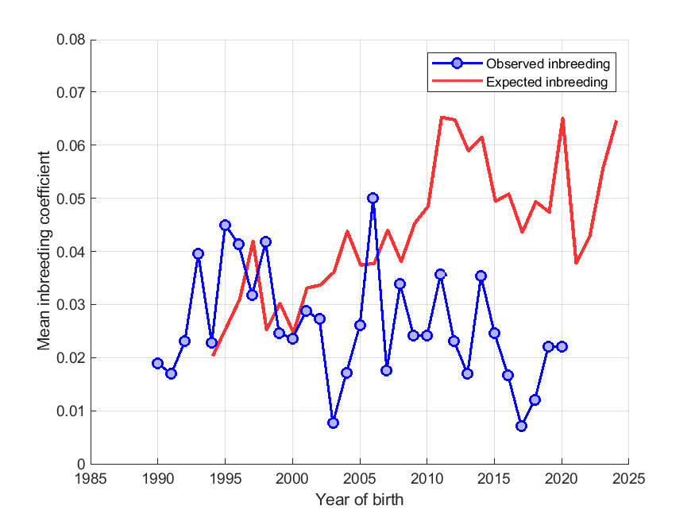
Figure 13: Annual mean observed and expected inbreeding coefficients for the Groenendael.
Below is a histogram (‘tally’ distribution) of the proportion of progeny per sire and dam over each of seven 5-year blocks (Figure 14) for the Groenendael. A longer ‘tail’ on the distribution of progeny per sire is indicative of ‘popular sires’ (few sires with a very large number of offspring, known to be a major contributor to a high rate of inbreeding). Throughout the period analysed, there is evidence of the number of popular sires decreasing, however as of 2015-2020 one sire was responsible for just over a fifth of all progeny registered for the variety.

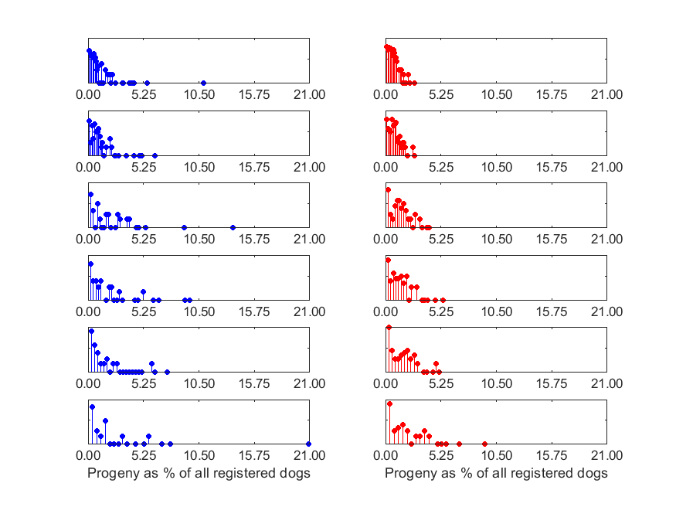
1985-1989
1990-1994
1995-1999
2000-2004
2005-2009
2010-2014
2015-2020
Figure 14: Distribution of the proportion of progeny per sire (blue) and per dam (red) over 5-year blocks (1985-89 top, 2015-20 bottom). Vertical axis is a logarithmic scale
Laekenois
In the population analysis undertaken by the Kennel Club in 2022, an estimated effective population size of NA was reported for the Laekenois (estimated using the rate of inbreeding over the period 1990-2020). This suggests that the trend of inbreeding in the variety is negative, and could possibly be a restoration of genetic diversity.
Annual mean observed inbreeding coefficient and mean expected inbreeding coefficient over the period 2000-2020 for the Laekenois are shown in Figure 115. The observed inbreeding coefficient has shown a wide amount of fluctuation, which will be due to the small number of dogs available for analysis.
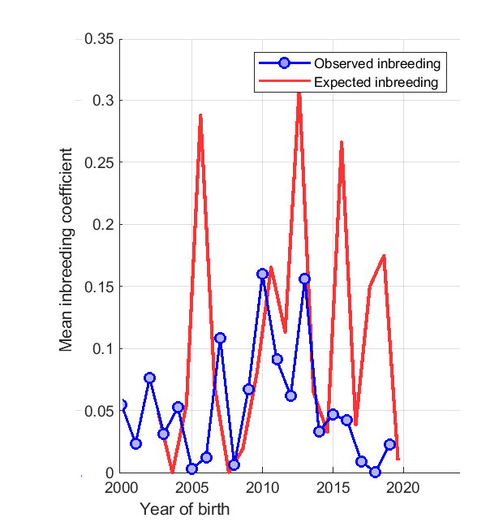
Figure 15: Annual mean observed and expected inbreeding coefficients for the Laekenois.

Below is a histogram of the proportion of progeny per sire and dam over each of six 5-year blocks (Figure 16) for the Laekenois. Throughout the period analysed, there is evidence of the number of popular sires has remained sporadic, with as of 2015-20 one sire responsible for over half of the progeny registered.

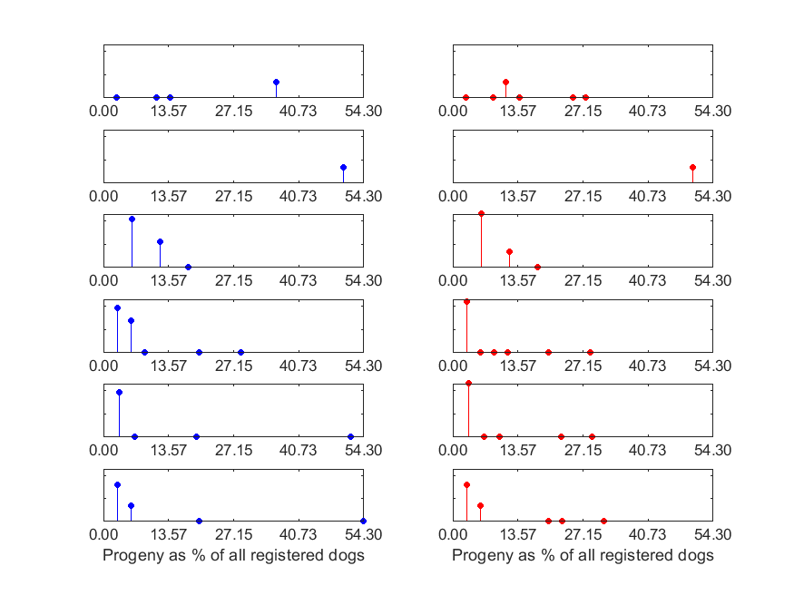
Figure 16: Distribution of the proportion of progeny per sire (blue) and per dam (red) over 5-year blocks (1990-4 top, 2015-20 bottom). Vertical axis is a logarithmic scale
Malinois
In the population analysis undertaken by the Kennel Club in 2022, an estimated effective population size of NA was reported for the Malinois (estimated using the rate of inbreeding over the period 1990-2020). This suggests that the trend of inbreeding in the variety is negative, and could possibly be a restoration of genetic diversity.
Annual mean observed inbreeding coefficient and mean expected inbreeding coefficient over the period 2000-2020 for the Malinois are shown in Figure 17. The observed inbreeding coefficient has shown a notable reduction in trend, and has plateaued from approximately 2008. This will be in conjunction with the Malinois’ relatively recent and notable increase in popularity.
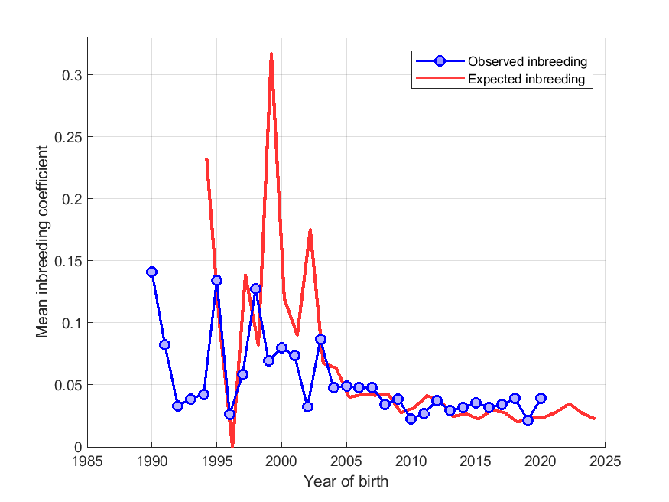
Figure 17: Annual mean observed and expected inbreeding coefficients for the Malinois.
The proportion of progeny per sire and dam over each of six 5-year blocks (Figure 18) for the Malinois are shown below. Throughout the period analysed, the use of popular sires has generally decreased overtime, although in the most recent block three sires are clearly contributing to a higher proportion of progeny registered.
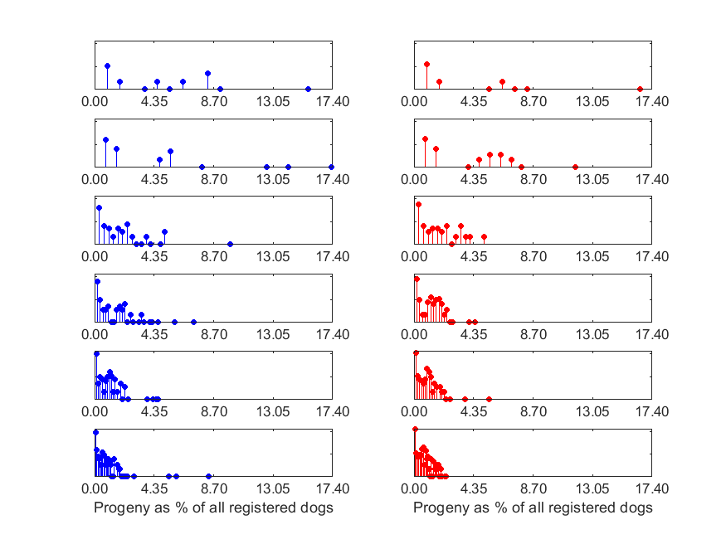
Figure 18: Distribution of the proportion of progeny per sire (blue) and per dam (red) over 5-year blocks (1990-4 top, 2015-20 bottom). Vertical axis is a logarithmic scale

Tervueren
In the population analysis undertaken by the Kennel Club in 2022 for the Tervueren, an estimated effective population size of 256.2 was reported (estimated using the rate of inbreeding over the period 1990-2020).
Annual mean observed inbreeding coefficient (showing loss of genetic diversity) and mean expected inbreeding coefficient (from simulated ‘random mating’) over the period 1990-2020 are shown in Figure 19. The observed inbreeding coefficient has gradually increased overtime, albeit with notable fluctuation.
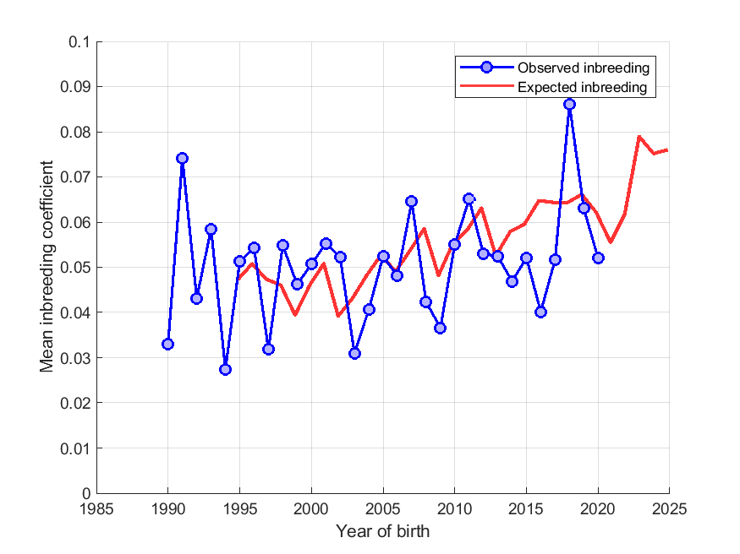
Figure 19: Annual mean observed and expected inbreeding coefficients for the Tervueren.
The proportion of progeny per sire and dam over each of six 5-year blocks (Figure 20) for the Tervueren are shown below. Throughout the period analysed, the use of popular sires has shown some fluctuation, with as of 2015-20 a handful of dogs contributing between 3.0% and ~7.0% of progeny registered each.
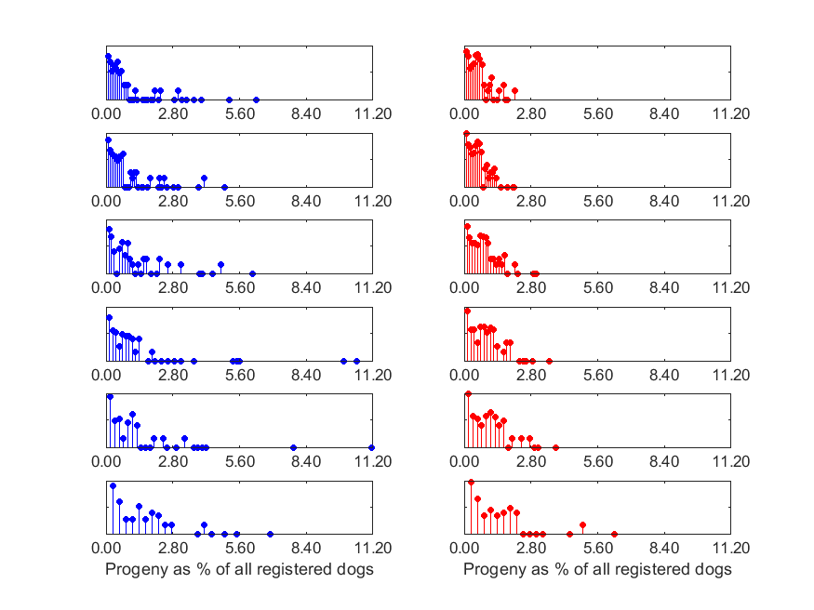
Figure 20: Distribution of the proportion of progeny per sire (blue) and per dam (red) over 5-year blocks (1990-4 top, 2015-20 bottom). Vertical axis is a logarithmic scale
Breeders of all varieties should continue to monitor and put maintenance of genetic diversity at the forefront of their breeding practices to continue to maintain and improve diversity in the breed. Continued importation of less-related stock will help, as well as encouraging inter-variety matings.

CURRENT RESEARCH

Whilst the UK breed community are not currently involved in research, their American counterparts have been working with researchers at the University of California to continue to explore the genetic basis for epilepsy in the breed.
The breed are also keen to begin to explore a possible familial kidney disease.

PRIORITIES

Discussion between the breed health co-ordinator and the Kennel Club was undertaken in January 2022 to discuss the evidence base of the BHCP and agree the priority issues for the health of the breed. The group agreed from the evidence base that the priorities for the BSD were:
- Gastric cancers (and other cancers)
- Epilepsy
- Monitoring health conditions in the breed
- Genetic diversity

ACTION PLAN

Following the correspondence between the Kennel Club and the breed regarding the evidence base of the Breed Health & Conservation Plans, the following actions were agreed to improve the health of the BSD. Both partners are expected to begin to action these points prior to the next review.
Breed Club actions include:
- The Breed Clubs to continue to encourage uptake of hip, elbow and eye testing prior to breeding

- The Breed Clubs monitor epilepsy research and opportunities for the breed to be included in further genomic research

- The Breed Clubs to consider proposing the recognition of known DNA tests in the breed

- The Breed Clubs to undertake a breed health survey, with the Kennel Club to support, where needed
Kennel Club actions include:
- The Kennel Club to investigate whether the breed can be included in the epilepsy research at the KC Genetics Centre
- The Kennel Club to organise “rare-breed” heart testing days to allow for the collection of heart data in the breed
- The Kennel Club to explore options for kidney disease, following the results of the breed health survey

REFERENCES

Berendt, M., Gullov, C.H., Christensen, S.L.K., Gudmundsdottir, H., Gredal, H., Fredholm, M., Alban, L. (2008) Prevalence and characteristics of epilepsy in the Belgian shepherd variants Groenendael and Tervueren born in Denmark 1995-2004. Acta Veterinaria Scandinavica 50: 51 https://doi.org/10.3389/fvets.2020.00275
Berendt, M., Gullov, C.H., Fredholm, M. (2009) Focal epilepsy in the Belgian shepherd: evidence for simple Mendelian inheritance. Journal of Small Animal Practice 50: 655-661 DOI: 10.1111/j.1748-5827.2009.00849.x
Bockstahler, B.A., Henninger, W., Muller, M., Mayrhofer, E., Peham, C., Podbregar, I. (2007) Influence of borderline hip dysplasia on joint kinematics of clinically sound Belgian Shepherd dogs. American Journal of Veterinary Research 68(3): 271-6 doi: 10.2460/ajvr.68.3.271.
Candido, M.V., Syrja, P., Hanifeh, M., Lepajoe, J., Salla, K., Kilpinen, S., Noble, P-J, M., Spillmann, T. (2021) Gastric mucosal pathology in Belgian Shepherd dogs with and without clinical signs of gastric disease. Acta Veterinaria Scandinavica. 63:7 https://doi.org/10.1186/s13028-021-00570-6
Christen, M., Hogler, S., Kleiter, M., Leschnik, M., Weber, C., Thaller, D., Jagannathan, V., Leeb, T. (2021) Deletion of the SELENOP gene leads of CNS atrophy with cerebellar ataxia in dogs. PLOS Genetics 17(8): e1009716 https://doi.org/10.1371/journal
Dragevich, C.J., Jones, J.C., Bridges, W., Dunn, H. (2020) Computed tomographic measures of funnel-shaped lumbar vertebral canal and articular process dysplasia malformations differ between German Shepherd and Belgian Malinois military working dogs. Frontiers in Veterinary Science 7: 275 https://doi.org/10.3389/fvets.2020.00275
Gualtieri, M., Monzeglio, M.G., Scanziani, E. (1999) Gastric neoplasia. Progress in Gastroenterology 29(2): 415-440
Gullov, C.H., Toft, N., Berendt, M. (2012) A longitudinal study of survival in Belgian Shepherds with genetic epilepsy. Journal of Veterinary Internal Medicine 26: 1115-1120 10.1111/j.1939-1676.2012.00977.x
Gurtner, C., Hug, P., Kleiter, M., Kohler, K., Dietschi, E., Jagannathan, V., Leeb, T. (2020) YARS2 missense variant in Belgian Shepherd Dogs with cardiomyopathy and juvenile mortality. Genes 11: 313 http://dx.doi.org/10.3390/genes11030313
Koskinen, L.L.E., Seppala, E.H., Belanger, J.M., Arumilli, M., Hakosalo, O., Jokinen, P., Nevalainen, E.M. Viitmaa, R., Jokinen, T.S., Oberbauer, A.M., Lohi, H. (2015) Identification of a common risk haplotype for canine idiopathic epilepsy in the ADAM23 gene. BMC Genomics 16: 465 DOI 10.1186/s12864-015-1651-9
Lampi, S., Donner, J., Anderson, H., Pohjoismaki, J. (2020) Variation in breeding practices and geographic isolation drive subpopulation differentiation, contributing to the loss of genetic diversity within dog breed lineages. Canine Medicine and Genetics 7:5 https://doi.org/10.1186/s40575-020-00085-9
Lewis, T.W., Woolliams, J.A., Blott, S.C. (2010b) Genetic evaluation of the nine component features of hip score in UK Labrador Retrievers. PLOSone 5(10): e13610
Mauri, N., Kleiter, M., Leschnik, M., Hogler, S., Dietschi, E., Wiedmer, M., Dietrich, J., Henke, D., Steffen, F., Schuller, S., Gurtner, S., Gurtner, C., Stokar-Regenscheit, N., O’Toole, D., Bilzer, T., Herden, C., Oevermann, A., Jagannathan, V., Leeb, T. (2017) A missense variant in KCNJ10 in Belgian Shepherd dogs affected by spongy degeneration with cerebellar ataxia (SDCA1). G3 Genes| Genomes| Genetics 7 doi: 10.1534/g3.116.038455
Mauri, N., Kleiter, M., Leschnik, M., Hogler, S., Dietschi, E., Wiedmer, M., Dietrich, J., Henke, D., Steffen, F., Schuller, S., Gurtner, S., Gurtner, C., Stokar-Regenscheit, N., O’Toole, D., Bilzer, T., Herden, C., Oevermann, A., Jagannathan, V., Leeb, T. (2017) A SINE insertion in ATP1B2 in Belgian Shepherd dogs affected by spongy degeneration with cerebellar ataxia (SDCA12. G3 Genes| Genomes| Genetics 7 https://doi.org/10.1534/g3.117.043018
Oberbauer, A.M., Belanger, J.M., Grossman, D.I., Regan, K.R., Famula, T.R. (2010) Genome-wide linkage scan for loci associated with epilepsy in Belgian shepherd dogs. BMC Genetics. 11: 35 http://www.biomedcentral.com/1471-2156/11/35
Peterson, M.R., Frommelt, A., Dunn, D.G. (2000) A study of the lifetime occurrence of neoplasia and breed differences in a cohort of German Shepherd dogs and Belgian Malinois military working dogs that died in 1992. Journal of Veterinary Internal 14: 140-145
Seim-Wikse, T., Jorundsson, E., Nodtvedt, A., Grotmol, T., Bjornvad, C.R., Kristensen, A.T., Skancke, E. (2013) Breed predisposition to canine gastric carcinoma – a study based on the Norwegian canine cancer register. Acta Veterinaria Scandinavica 55: 25 http://www.actavetscand.com/content/55/1/25
Seppala, E.H., Koskinen, L.L.E., Gullov, C.H., Jokinen, P., Jarlskov-Mortensen, P., Bergamasco, L., Korberg, I.B., Cizinauskas, S., Oberbauer, A.M., Berendt, M., Fredholm, M., Lohi, H. (2012) Identification of a novel idiopathic epilepsy locus in Belgian Shepherd dogs. PLOS ONE 7(3): e33549 doi:10.1371/journal.pone.0033549

