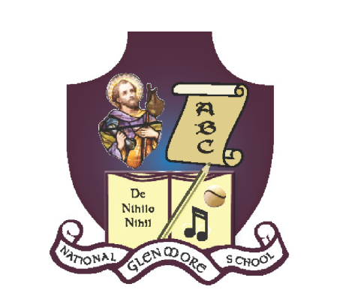
GLENMORE NATIONAL SCHOOL
S.N. SEAMUS NAOFA
GLENMORE, CO. KILKENNY

051 – 880269 glenmorens@gmail.com Roll No: 18158L

School Uniform Policy

It is the policy of Glenmore National School (Roll No: 18158L) that all children attending school should wear the full school uniform as specified below. This uniform should be worn on all schooldays except those days nominated for P.E. The only exceptions to this rule will be days nominated by teachers e.g., in the case of a visit by the Kilkenny hurling team, sports coaching, World Book Day, Halloween dress up day etc.

If a child is not wearing the correct uniform, a note should be given to the class teacher explaining the particular circumstances. In the absence of a note it will be treated as a minor misdemeanour and an appropriate sanction will be applied by the class teacher or Principal. The correct uniform is available at Kennedy’s Drapery, New Ross.

Uniform for Girls | Uniform for Boys
Blue shirt  Grey V neck jumper or cardigan  Grey skirt, pinafore or trousers  School Tie  School tracksuit on P.E. days etc. | Blue shirt  Grey V neck jumper  Grey trousers  School Tie  School tracksuit on P.E. days etc.

This policy was ratified by the Board of Management of Glenmore National School on

Date: 01/06/11
Signed: __________________________________________
Very Rev. Michael O Connor, Chairperson B.O.M.

This policy was reviewed by staff in February 2019.

Signed: ___________________________ Date: ____________
Fr. T. O’ Toole, Chairperson BOM

Signed: ___________________________ Date:_____________
Laura Kelly, Principal

