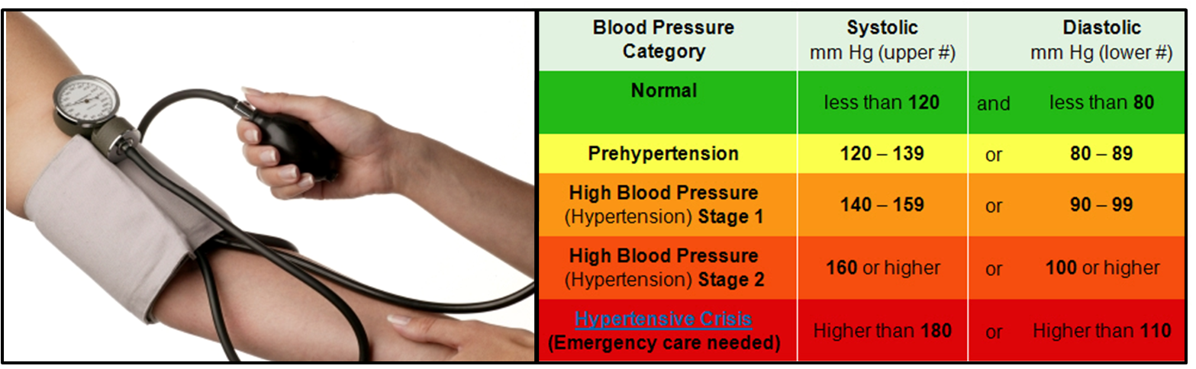

High Blood Pressure (Hypertension)
When the heart pumps the blood through the arteries, the blood presses against the walls of the blood vessels. In people who suffer from hypertension, this pressure is abnormally high.
Blood pressure is dependent on many factors:
- the output from the heart
- the resistance to blood flow of the blood vessels
- the volume of blood
- the activity of the nervous system
- the balance of hormones
- the health of your kidneys
- arteriosclerosis or atherosclerosis (the blood vessels are constricted due to a build-up of plaque on the inside walls of the vessel)
- hyperthyroidism
- side effects of certain drugs ... NSAIDs such as Ibuprofen, Advil, Motrin, Naproxen, Aleve, Naprosyn, Aspirin; cough & cold medications, decongestants, antihistamines, headache medication, oral contraceptives, etc. (http://www.webmd.com/hypertension-high-blood-pressure/guide/medications-cause?)

According to public health services in North America, more than half of the population over the age of 65 suffer with elevated blood pressure.
Because high blood pressure usually causes no symptoms until complications develop, it is known as the "silent killer".
Warning signs associated with advanced hypertension may include:
- headaches
- sweating
- rapid pulse
- shortness of breath
- dizziness
- visual disturbances
Lifestyle factors that can increase the risk of, or trigger high blood pressure include:
- cigarette smoking or exposure to second-hand smoke
- stress
- obesity
- excessive use of coffee
- drug abuse
- high sodium intake
- use of oral contraceptives
Natural Health Recommendations:
STEP 1:
- Shaklee Life Plan
- Shaklee Blood Pressure 2 - 4 per day at the beginning (then reduce to 2 as a maintenance when your blood pressure is under control)
- OmegaGuard (4-6 per day) ... some people have taken a larger amount for 30 days with good success
- Shaklee CoQHeart - 1 to 3 per day
STEP 2:
- Shaklee VitalMag ... take the max you can without getting diarrhea (2 or 3 ... split them up - morning & night, or morning, noon & night)
- Shaklee Lecithin - helps to break down plaque in the arteries
- Optimize Vita-E - 1 or 2 per day
STEP 3:
- Garlic - helps to keep the blood thinner, and reduces the risk of clots
- Alfalfa - very supportive to healthy kidneys, which make a hormone called vasopressin that impacts your blood pressure
- Stress Relief Complex - if stress seems to be a part of the underlying problem
- Optimize Vitamin D3

