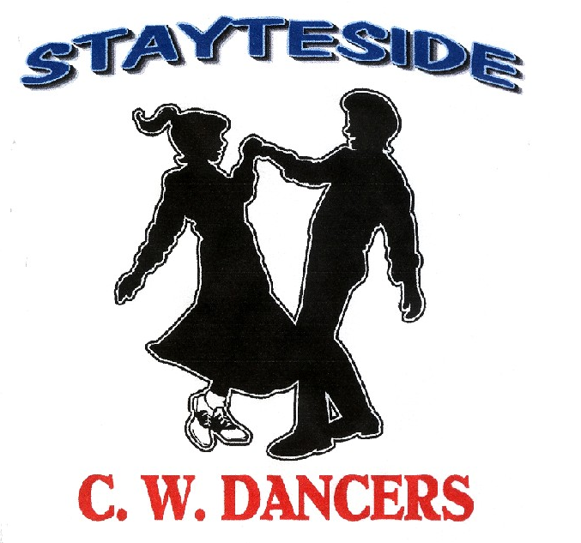

Small Talk
Description: Partner Dance. ( 64 Counts)
Start Position: Right Side by Side (Sweetheart) Gent’s and Lady’s footwork the same throughout unless otherwise stated.
Choreographers: Carol* & George Stayte, (UK). *Qualified D & G Instructor. 02392 423925 carol.stayte@ntlworld.com
Music: I’ve Been Loved By The Best by Don Williams. CD: I Believe In You (88 bpm.16 Count Intro.) Available from ITunes & Amazon.
Alternative: Come A Little Closer by Don Williams. CD: Love Stories (84 bpm.16 Count Intro) CD Available from Amazon.
What Dancin’s For by Derek Ryan. CD: The SimpleThings. (96 bpm.16 Count Intro) Available from ITunes & Amazon.
Raggle Taggle Gypsy by Derek Ryan. CD Country Soul. (96 bpm.32 Count Intro) Available from ITunes & Amazon

1 STEP FORWARD TOUCH, STEP BACK TOUCH. COASTER STEP, LEFT SHUFFLE FORWARD.
1 – 4 Step fwd on right, touch left next to right. Step back on left, touch right next to left.
5 & 6 Step back on right, together on left, step fwd on right.
7 & 8 Left shuffle fwd LRL

2 WALK, WALK. SHUFFLE FORWARD. ROCK STEP, TRIPLE ¼ TURN.
1 – 2 Walk fwd on right, left.
3 & 4 Right shuffle fwd.RLR
5 – 6 Rock fwd on left, recover on right.
7 & 8 Triple ¼ turn LRL (Gent: turning right to OLOD, Lady: Turning left to ILOD)
(Right hands over Lady’s head then release left hands, (Right shoulder to right shoulder)

3 BOTH: ½ TURN PINWHEEL. GENT: ½ TURN WALKING ROUND LADY.
LADY: ½ TURN PINWHEEL. SIDE ROCK, SHUFFLE FORWARD.
1 – 2 Pinwheel ½ turn right on right, left, (Rotating Clockwise)
3 & 4 Right shuffle fwd.RLR
5 – 6 Gent: ½ turn right on a left, right, Walking round the back of the lady. Rejoin hands into Indian position.
Lady: Rock to the side on left, recover on right.
7 & 8 Both: Left shuffle fwd LRL. OLOD

4 SIDE ROCK, BEHIND SIDE CROSS. SIDE ROCK ¼ BACK ROCK.
1 – 2 Rock to the side on right, recover on left.
3 & 4 Step right behind left. Step to side on left. Cross right over left.
5 – 6 Rock to the side on left, recover on right.
7 – 8 Rock back on left making ¼ turn left, recover on right. Sweetheart Position LOD

5 SHUFFLE FWD. SHUFFLE ¼ TURN (X2) BACK ROCK.
1 & 2 Left shuffle fwd LRL
3 & 4 Shuffle ¼ turn left RLR to ILOD Release left hands, right over Lady’s head. Rejoin into Reverse Indian Position.
5 & 6 Shuffle ¼ turn left LRL travelling backward down LOD. Right hands behind Gent’s back hammerlock.
7 – 8 Rock back on right, recover on left.

6 PADDLE TURN PIVOTING ¼ TURN (X2) STEP POINT (X2).
1 – 4 Step fwd on right, pivot ¼ turn left, step fwd on right, pivot ¼ turn left. Release right hands, left over Lady’s head
Rejoin into Sweetheart Position. LOD
5 – 8 Cross right over left, point left to the side, cross left over right, point right to the side.

7 GENT: ROCK FORWARD, SHUFFLE BACK, ROCK BACK SHUFFLE FORWARD.
LADY: ROCK STEP SHUFFLE ½ TURN. PIVOT ½ TURN SHUFFLE FORWARD.
1 – 2 Rock fwd on right, recover on left.
3 & 4 Gent: Right shuffle back RLR.
Lady: Shuffle ½ Turn right on a RLR. Release left hands, right over Lady’s head.
5 – 6 Gent: Rock back on left, recover on right.
Lady: Step fwd on left pivot ½ turn right.
7 & 8 Left shuffle fwd LRL. Rejoin hands into Sweetheart Position LOD.

8 GENT : STEP TO THE SIDE, STEP TOGETHER. (CHANGING SIDES) SHUFFLE FORWARD. (X2)
LADY: CROSS SIDE, SHUFFLE FORWARD. (X2)
1 – 2 Gent: Step to side on right. Slide left next to right Crossing behind Lady, left hands over lady’s head cross hands left on top.
Lady: On left diagonal fwd, cross right over left, side to side on left.
3 & 4 Both: Right shuffle fwd. RLR
5 – 6 Gent: Step to side on left. Slide right next to left. Crossing behind Lady, left hands over Lady’s head into Sweetheart.
Lady: On right diagonal fwd, cross left over right, step to side on right.
7 & 8 Both: Left shuffle fwd. LRL.

START AGAIN.

