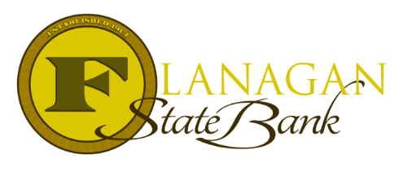
Mortgage Tidbits

Keeping you informed and in the know….

Escrow for Repairs/Completion

There are so many homes on the market needing TLC and extra maintenance. It is important to have flexibility in order to keep these deals working.

For minor conditions that do not affect the safety and livability of a property, the appraisal will be completed “as is” and must be reflected in the appraiser’s opinion of the home value. For properties that are appraised “subject to” the completion of specific repairs to support the value of the home, Flanagan State Bank offers Escrows for Repair options.

Existing Properties
- $5,000 allowed; must include bid and 150% of bid(s)- funds may come from buyer, seller or if a USDA loan, be financed
- Repairs to be made are ones noted by appraiser to meet product guidelines
- Closing Disclosure must reflect holdback
- Repairs must be completed within 30 days of loan closing
- Final inspection required to verify repairs are complete before any funds will be released
- Repair agreement signed by all parties prior to the loan closing. This will be needed for underwriting.
- Loan must be locked through duration of completing repairs
- Repairs to be completed by licensed contractor, not the borrower

Call us today for the best answers to the mortgage questions!
Insert photo here or delete box when ready to use
~ Provided to you by ~
Name: Phone:
Title: Email:
Address: City, State, Zip
Apply Now Link:

